The URL to access my prototype can be accessed on <http://cssrvlab01.utep.edu/Classes/cs3360/arodriguez103/index.php>

A helpful website that furthered my understand of PHP can be found by Googling “ PHP Tutorial – w3schools “ (HIGHLY RECOMMEND THIS WEBESITE)

Feature Description:

Presenting the personal patient scheduler that allows the user to input a set of patients’ information and creates schedule of appointments that are scheduled the next following day. The patient information that the program will request is patient’s name, address, time preference, and if they are a new patient or not. The program will allow the user to add one patient’s information at a time and then the program will create a draft schedule of appointments once you added all the patients into the system and clicked the Create Schedule button. Once the user clicks the Create Schedule, the system will calculate travel distance time between the current appointment location to the next based on their coordinates that the system identified during calculation time. The map coordinate system that our system uses is a 10 square by 10 square which encapsulates the entire area that the medical office tends to. The system will always assign a patient’s starting time appointment in a quarter of an hour format, while also giving new patients 90-minute appointments and 30-minutes for existing patients. The added features the system is equipped with is the ability to delete any patient on the schedule that might have canceled and an optimize feature that rearranges the patient schedule order in which it reduces total driving time.

Feature Use Explanation:

The system will allow the user to add any number patients and their information one at time into the system and the system will keep looping back to fresh add patient form every time a patient is added to the system for scheduling. The system will create a schedule of appointments with all the patients that were added when the user clicks on the create schedule button. To delete a patient from the schedule, the schedule must first be created and then the user will be able to delete a patient from the schedule by clicking on the patient’s assigned number at the end of their row. To optimize the schedule in which the system arranges the patient’s appointments that will minimize the total driving time, the schedule must be first create and then the user must click on the “Optimize” button that is located below the schedule. Once the optimize button is pressed, the system will go through every patient and compare their map coordinate to all the other patience and will pair two patients and their appointment consecutively who have the minimum driving time between them over all the other patients.

Unusual Behavior or Property that Affected My Code:

My program doesn’t display the o’clock properly on the appointment’s time on the schedule where it only contains/represent all o’clock times with only one zero after the colon instead of two. Example is 9:00 will be represented as 9:0.

Example 1: index.php page

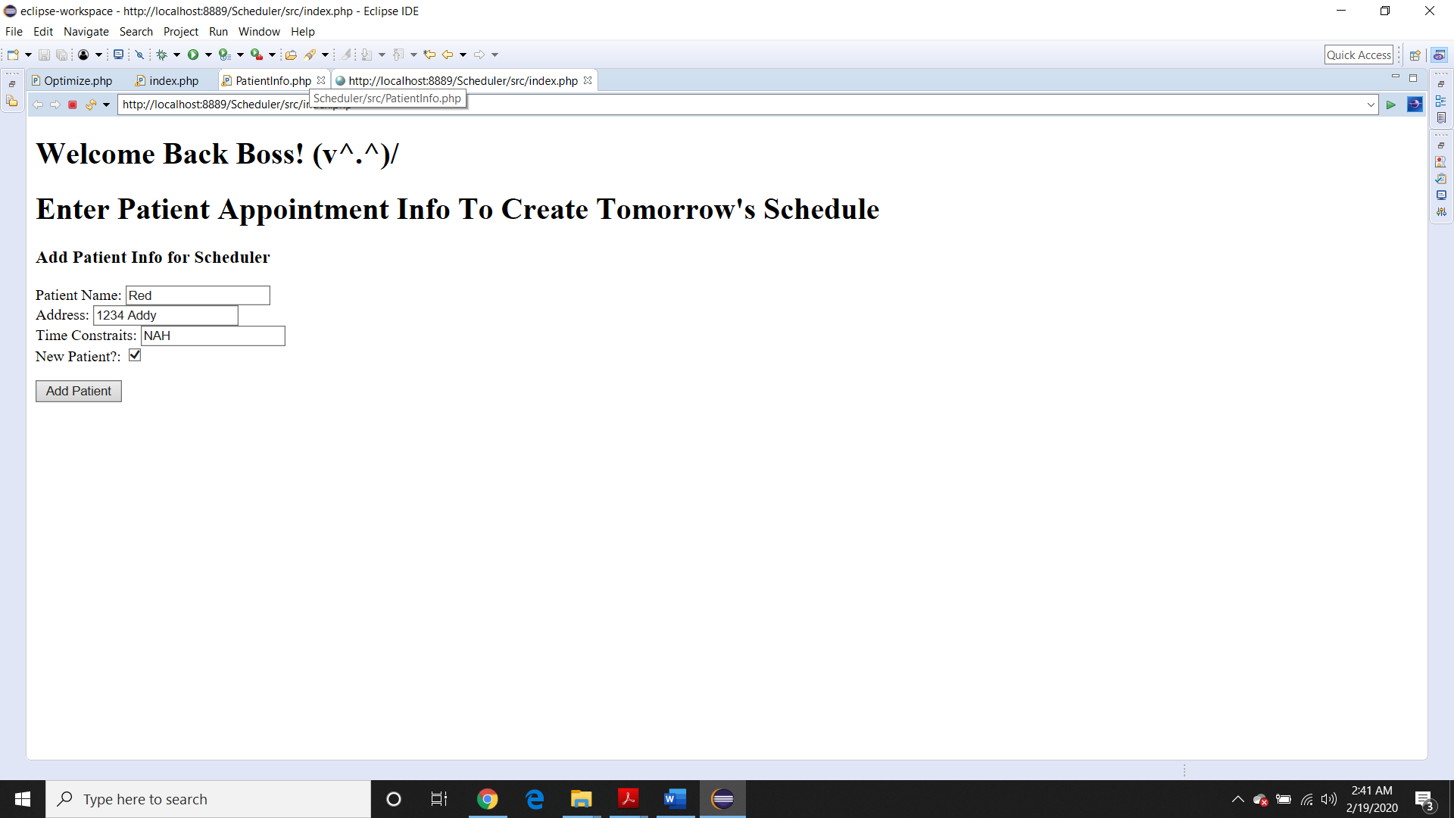

Example 2: AddAndCreate.php page

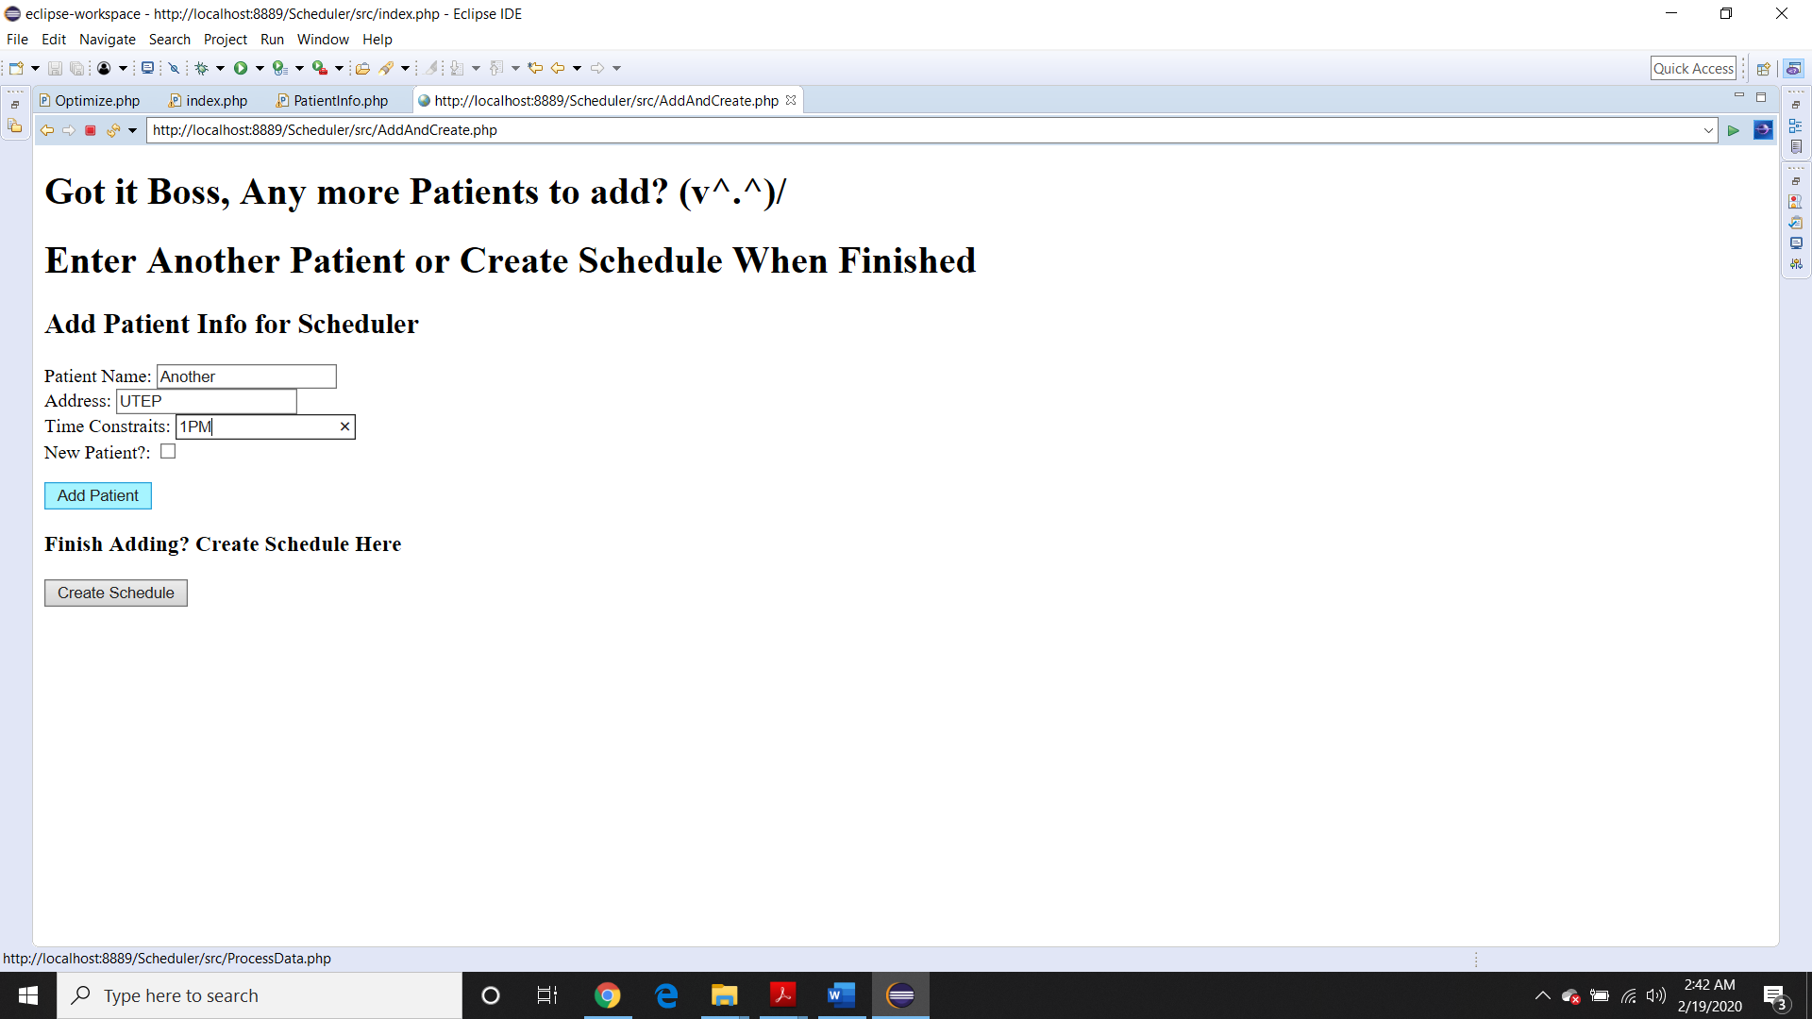

Example 3: Schedule.php page

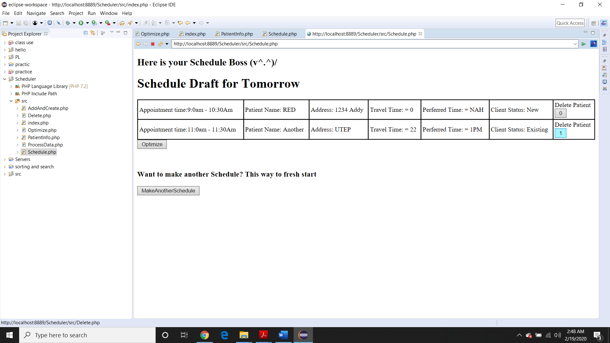

Example 4: Deleted a Patient from Schedule in Example 3 in row 2 (or index 1)

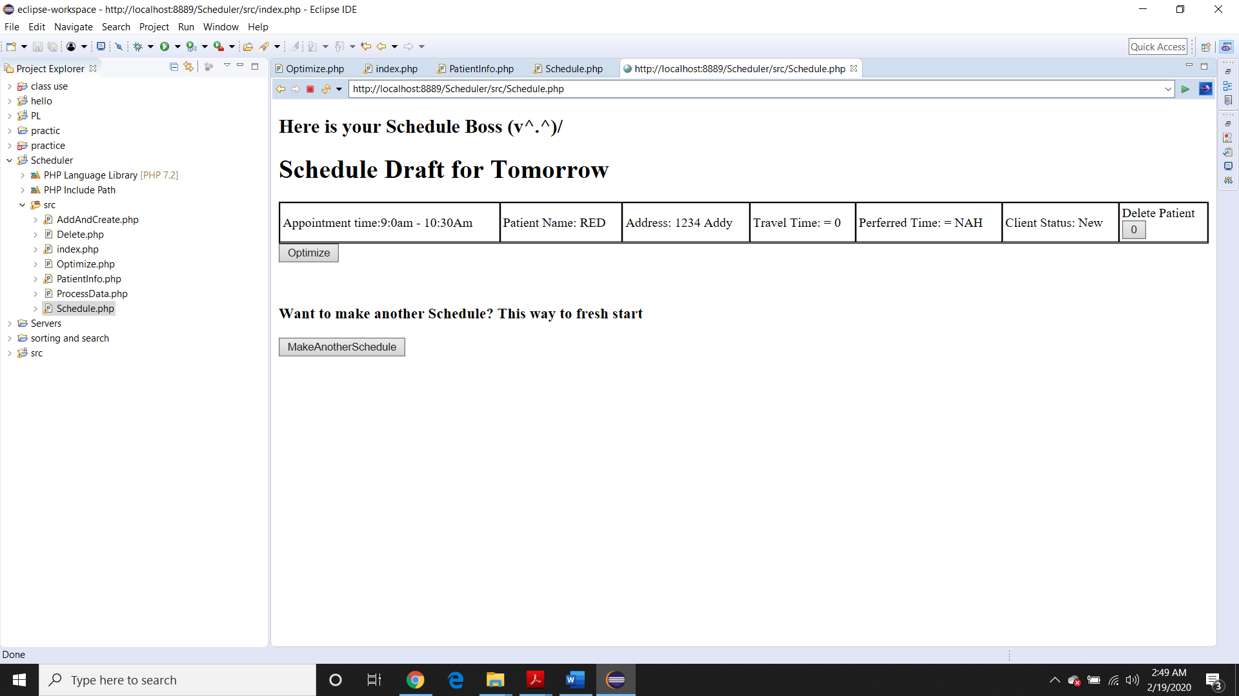

Example 6: Schedule with more patients to test the Optimize Feature (reduce total driving time)

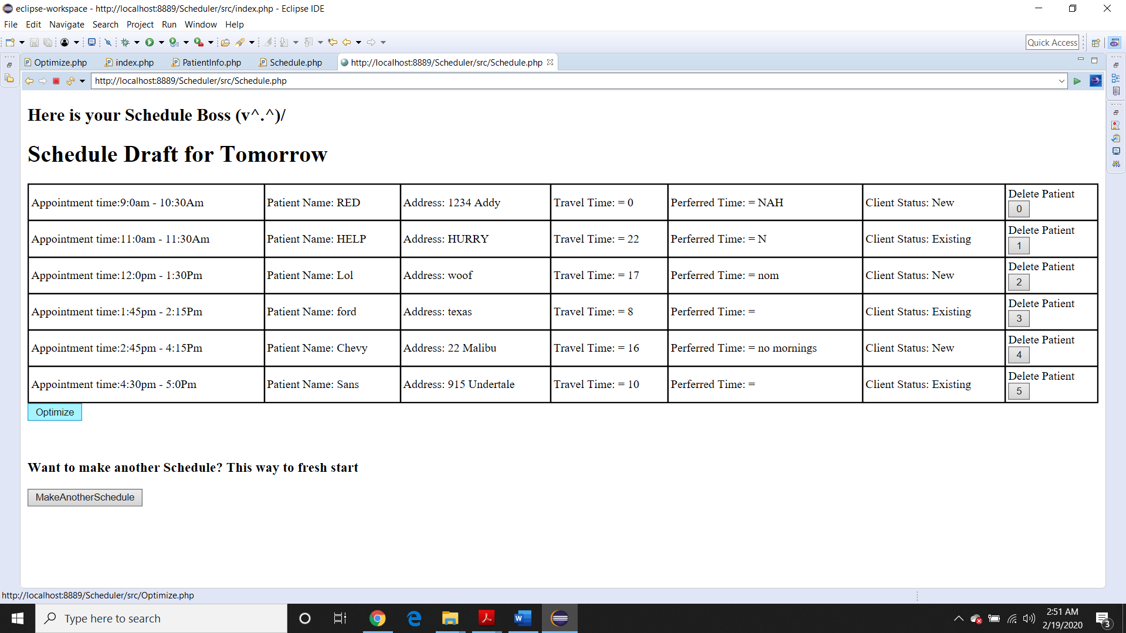

Example 7: Schedule from Example 6 has been successfully Optimized

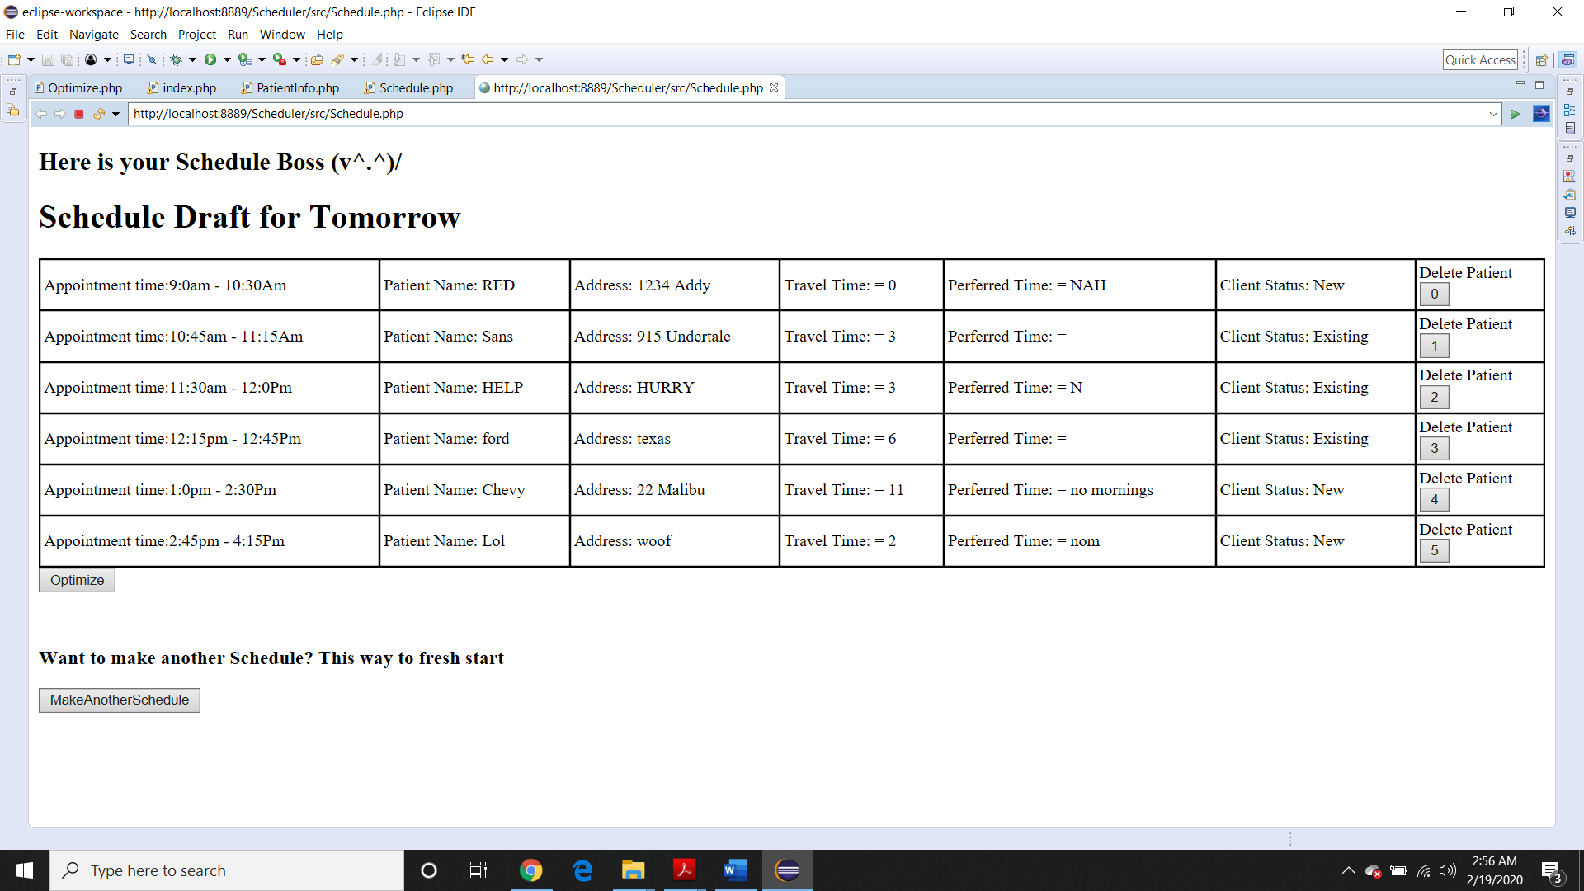

Example 8: UML of how each php file is directed or called upon to help process or completes a specific task or goal to help the program complete it’s purpose

