## 2.2 Specifications

General specifications given for the task are listed below:

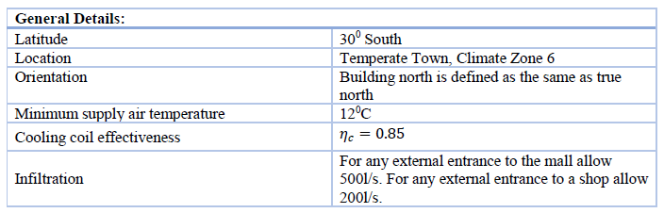

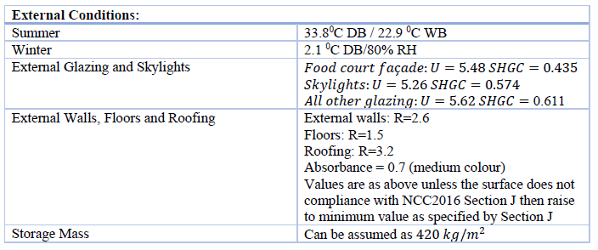

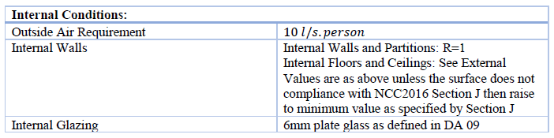

Condition requirement for room T.0.6:

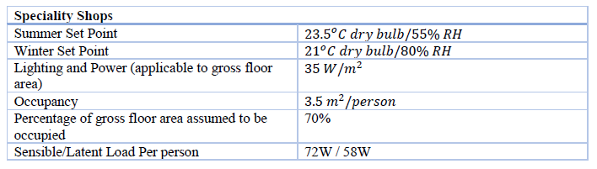

For M.0.3:

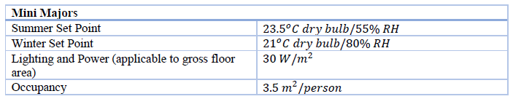

Variations and further discussions will be performed in relevant section.