

MECH4880

Refrigeration and Air Conditioning

**Assignment 2**

Name: Hengcheng Zhang

Number: z5130844

**Abstract**

This laboratory report is based on experiments on refrigeration demonstration system and air conditioner demonstration system. A comprehensive understanding of the compression process is developed through this project.

In the first part, the location and function of each component in the refrigeration system is discussed. The associated parameter and their influence on the performance of the system is investigated through experiment data in p-h diagrams.

In the second part, characters of the air conditioner demonstration system are calculated according to the experiment data. The refrigeration cycle is drawn on the p-h diagram. The performance of this system and possible improvement methods are discussed accordingly.

Contents

1. Introduction 2

2. Refrigeration Demonstration System 3

3. Air Conditioner Demonstration System 5

Appendix 8

# 1. Introduction

The purpose of this laboratory report is to have a comprehensive understanding of the vapour compression process with the help of the refrigeration demonstration system and the air conditioner demonstration system.

The demonstration system has four major components: the compressor, condenser, throttling device and the evaporator. The four of them compose a full circle. The evaporator absorbs heat and evaporates the refrigerant to vapour state, and then the pressure of the refrigerant is increased by the compressor. The compressed refrigerant vapour release heat and condensed to liquid in the condenser. At last, the refrigerant goes through the throttle, expanses and goes back to the evaporator.

# 2. Refrigeration Demonstration System

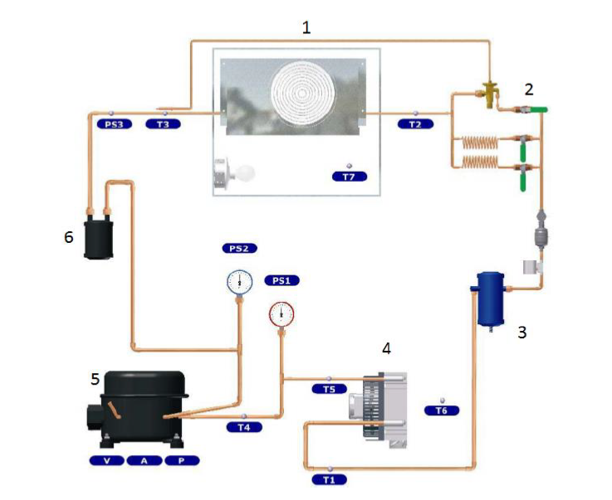

*Figure 1: Refrigeration Demonstration System*

The major components are numbered in figure 1. The major components and their functions are:

1. Evaporator: The function of the evaporator is to receive heat and evaporate refrigerant to gas state.
2. Expansion valves: The expansion valves decrease the pressure of the refrigerant.
3. Liquid Receiver/filter: The liquid receiver/filter is located between condenser and the expansion valves. It can gather the refrigerant at liquid state and guarantee all the refrigerant transferred to the expansion valves is liquid.
4. Condenser: The role of the condenser it to condense the pressed vapour into liquid state.
5. Compressor: The function of the compressor is to increase the pressure of the refrigerant vapour.
6. Accumulator: Accumulator locates between evaporator and compressor. It is able to store liquid, in order to guarantee only the vapour refrigerant can be transported to the compressor.

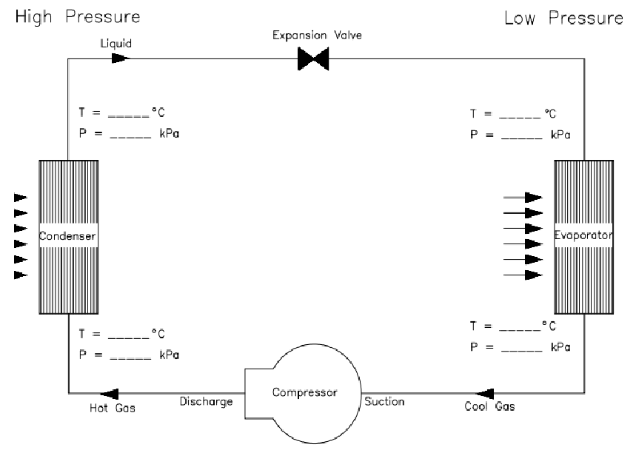

*Figure 2: Simplified Refrigeration System*

Comparing to Figure 2, the liquid receiver and accumulator are not shown in Figure 1. Beside these main components, some other components are shown in Figure 1.

* Sight glass: the sight glass locate at downstream of liquid receiver. It is used to identify the status of the system. Bubbles in the sight glass may indicate leaking.
* Electronic magnetic valve: It is used to automatically control the flow rate of the refrigerant.
* Capillary: The capillary is used to decrease the pressure of the refrigerant. Different capillaries could give different pressure drop in the demonstration system.

According to the experiment data, which is shown in the diagrams in appendix, the parameter change would have effect on the p-h diagram.

Comparing A1, A2 and A3, it is able to see that, when the evaporator fan is turned slow or even off, the pressure of the refrigerant decrease. This is because the efficiency of the evaporator decrease and less refrigerant is change into vapour. The enthalpy at point 1 and 2 decreased accordingly.

Seen from A4 and A5, low speed of condenser fan would lead to pressure and enthalpy increase of the refrigerant.

According to figure A6 and A7, closed capillary would results in larger pressure drop in the expansion process. This is because of less refrigerant going through the throttle.

Capillary tubes and thermostatic expansion valve are used as throttling device in the demonstration system. Between the inlet and outlet of the throttling device, the pressure of the refrigerant drops and at the same time the temperature decrease too.

The thermostatic expansion valve is used to control the flow rate of the refrigerant automatically. If the refrigerant temperature at the outlet of evaporator is higher than set, it would increase the flow rate, and vice versa.

Looking into the sight glass, if there are bubbles, it indicates the refrigerant is not totally condensed, which means the condenser is not working at its full efficiency. Another possible reason is leakage exists.

The given data for the sub-cooling value is T=30.5 °C and P=9.43 bar. The refrigerant is R-134a. Its saturated temperature is able to be found in the table to be 37.2 °C in 9.43 bar. So the sub-cooling value is 37.2-30.5= 6.7 °C. The superheat value is 5.1°C.

When the condenser fan fails, the heat of the condenser cannot be released and spread out efficiently. As a result, less refrigerant is condensed and the pressure and entropy of the refrigerant will increase. This effect is shown in the former discussion and the plot in A4 and A5.

When the evaporator fan fails to work, the heat change rate decrease and the evaporator cannot extract enough heat from the environment. Then less refrigerant is evaporated and the pressure and enthalpy of the refrigerant will decrease. This effect could be seen through figure A1, A2 and A3 in appendix.

If the capillary is blocked, less refrigerant would go through and the evaporator is starved. There is less refrigerant goes into the condenser. The pressure at the inlet of the evaporator is decreased and the whole system is undercharged.

In an overcharged system, the pressure of the refrigerant is increased. This may lead to a lower efficient cooling process and increase the temperature of the refrigerant. The liquid accumulator could be filled up by and the liquid may come into the compressor. The compressor would be destroyed.

# 3. Air Conditioner Demonstration System

The experiment data of the air conditioner demonstration system is recorded in Table 1. The refrigerant is R410A. In the p-h diagram, point 3 and point 4 could be found based on the data in Table 1.

Assumptions are made that no sub-cooling in this system and pressure in the condensing process would not change. Then point 1 is found. With constant enthalpy in the expansion process and constant pressure in the evaporator, point 2 could also be drawn on the p-h diagram.

*Table 1: Air Conditioner Experiment Data*

|  |  |  |
| --- | --- | --- |
| Location | Temperature (°C) | Pressure (Mpa) |
| Suction Line | 10.6 | 0.85 |
| Discharge Line | 48.5 | 1.95 |

The p-h diagram is shown below in Figure 3.

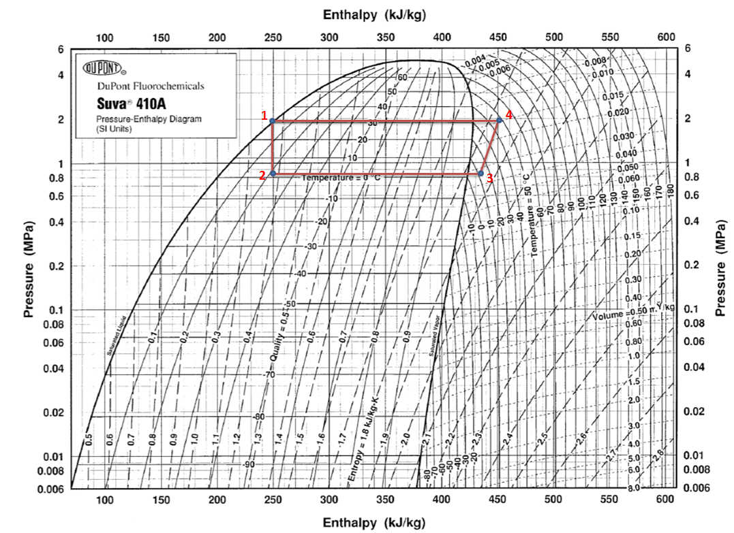

*Figure 3: p-h Diagram*

Read from the p-h diagram, it is able to find enthalpy for each point.

The enthalpy change for the refrigeration effect is:

The enthalpy change for the heat rejected at the condenser is:

The enthalpy change during the compression process is:

EER of the system is:

In order to improve EER and performance of the system, there are some methods could be performed.

1. The outdoor unit is less sensitive of its size and noise. So one possible way is to increase the coil area or air flow rate of the condenser. These two parameters could be changed together in a reasonable range.
2. Make sure the filter of the indoor unit (evaporator) is clean.
3. Make sure the cooling coil and fins of the outdoor unit is in good condition.

# Appendix

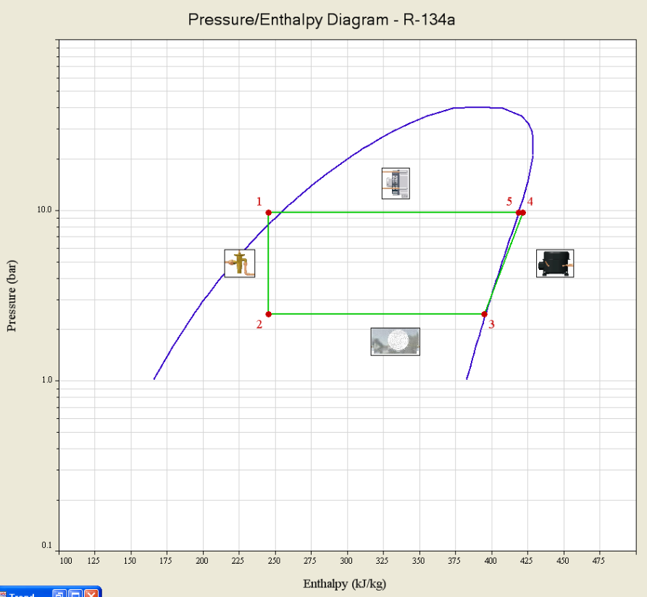

A1: Pressure/Enthalpy Diagram in Steady State 1

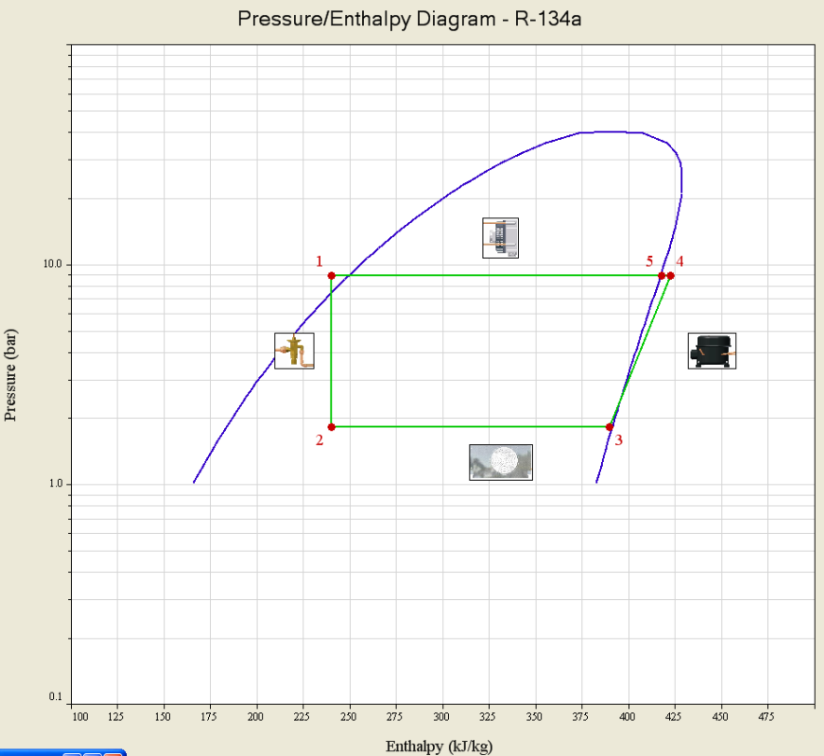

A2: Pressure/Enthalpy Diagram with Low Speed Evaporator Fan

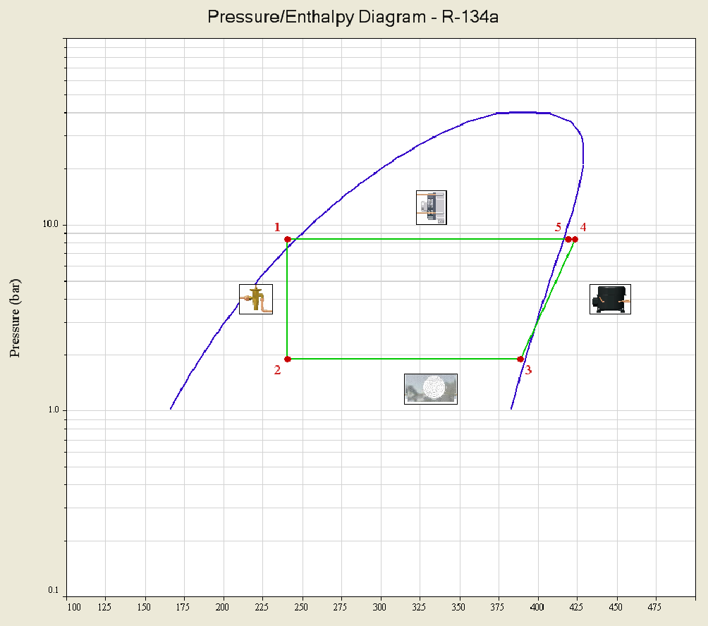

A3: Pressure/Enthalpy Diagram with Evaporator Fan off

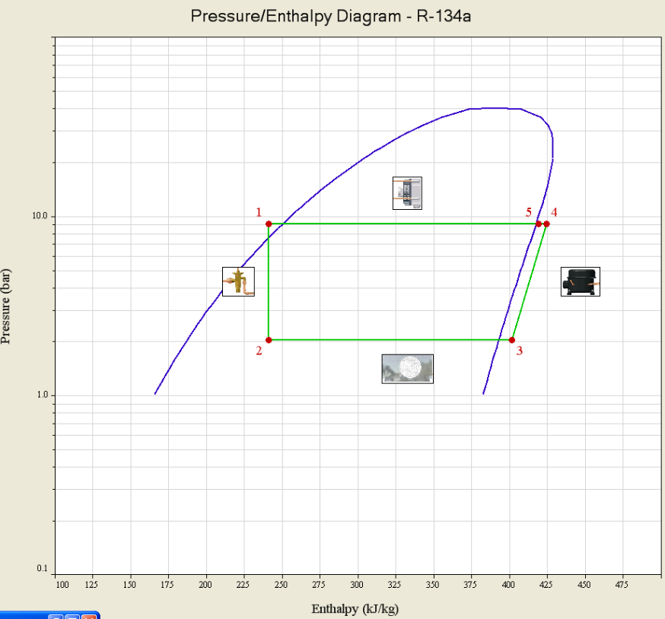

A4: Pressure/Enthalpy Diagram in steady state 2

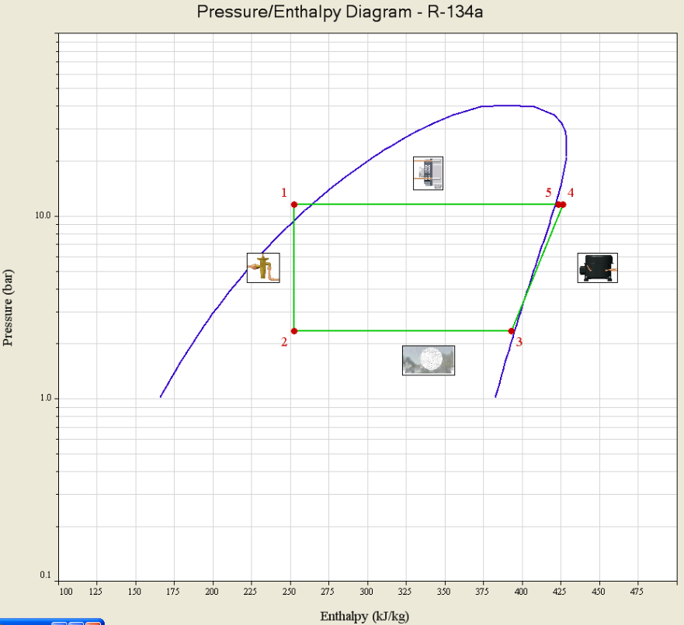

A5: Pressure/Enthalpy Diagram with low speed condenser fan

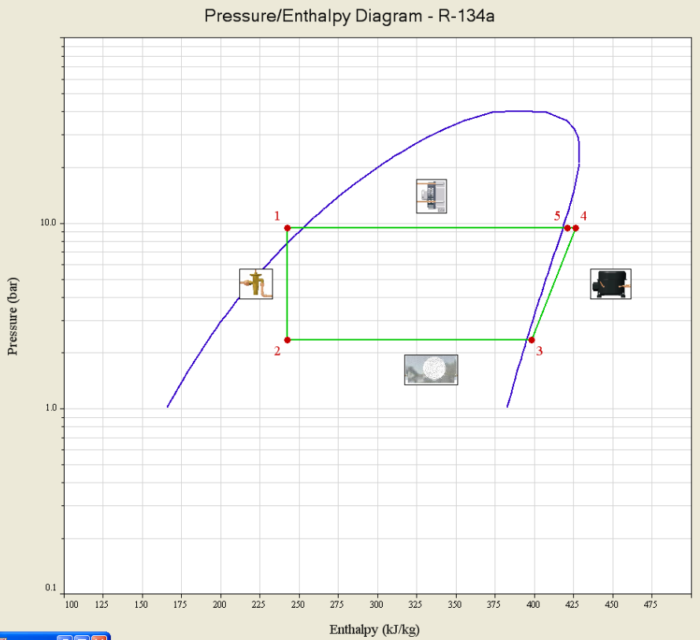

A6: Pressure/Enthalpy Diagram in steady state 3

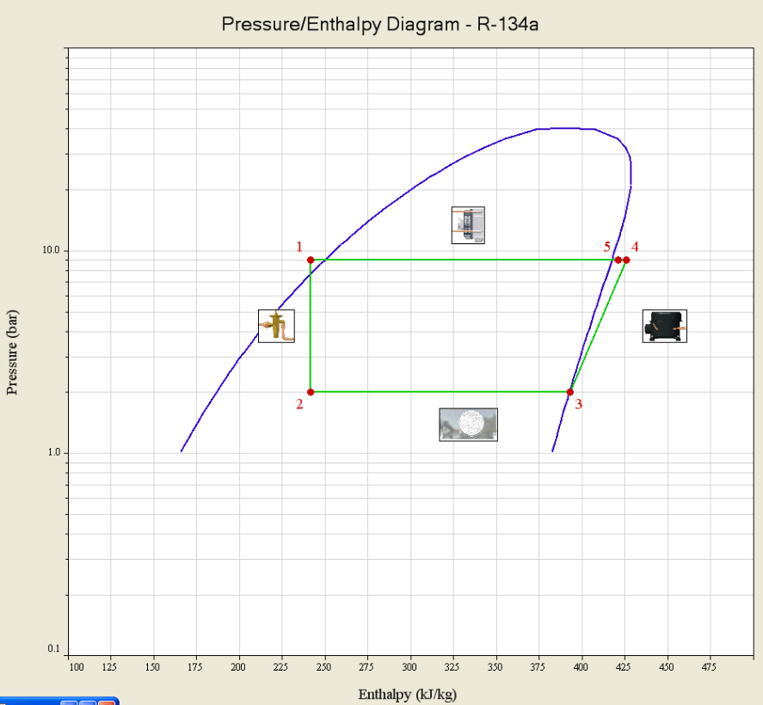

A7: Pressure/Enthalpy Diagram with cap2 closed

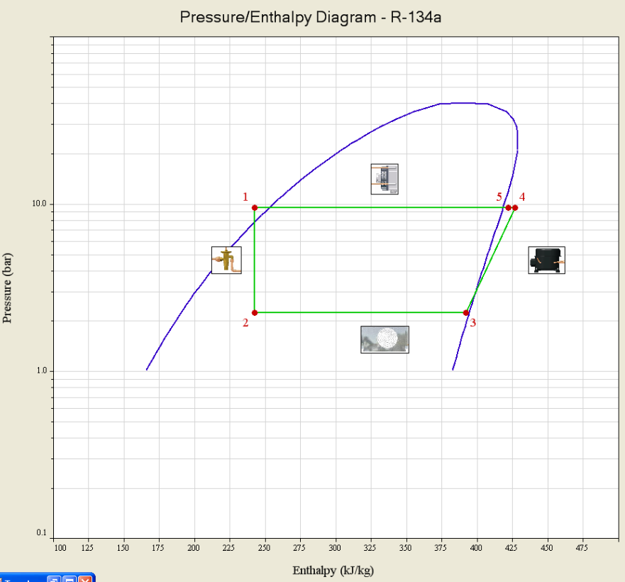

A8: Pressure/Enthalpy Diagram in steady state 4