

MECH9223

Machine Condition Monitoring

**Assignment 2**

Name: Hengcheng Zhang

Number: z5130844

# Executive summary

The aim of this project is to find out the hidden fault type in a bearing set on UNSW gear test rig. Vibration based condition monitoring method is utilized to perform the diagnostic process.

The fault bearing vibration and tacho signals are provided together with good bearing signals are reference. The most frequently used method to detect bearing fault is envelop analysis. In order to perform this method, a section of frequency band of the FFT domain needs to be selected.

Contents

Executive summary 2

1. Introduction 2

2. Experimental Setup 2

3. Data Processing and Technical Discussion 3

3.1 Shaft Speed & Fault Frequencies 4

3.2 Diagnostic Methodology 5

4. Conclusions and Recommendations 8

References 9

Appendix A 9

# Introduction

The aim of this project is to perform bearing diagnosis based on vibration and tachometer data measured on UNSW gear test rig. Two data sets are provided: one is bearing in good condition and another taken from a bearing with a fault. The fault type is not known, one of our aim is to find it out.

# Experimental Setup

The experiment is implemented in the UNSW gear test rig, which is illustrated in Figure 1. [1] The test rig is driven by a 3-phase induction motor on the right. Power is transfer through a gearbox to a hydraulic pump. One of the bearings in the gearbox is seeded with an unknown fault. An acceleration sensor is located near the faulty bearing. The bearing parameters are as follows:

* Ball diameter d = 7.12 mm
* Pitch circle diameter D = 38.5 mm
* Number of rolling elements n = 12
* Contact angle Φ = 0°

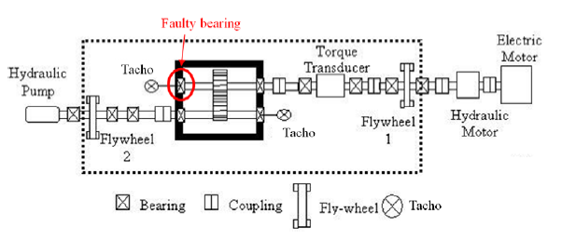

*Figure 1: UNSW gear test rig*

Location of the tachometer is as shown in Figure 1. The motor is running on a steady speed, but the shaft speed is unknown. It needs to be figured out based on the tacho signal. Signal of both acceleration sensor and tachometer are recorded and saved in a Matlab data file. The sample rate of the signals is 48 kHz and the record length is 100,000 for each record. Two sets of data are given. One is ‘bg.mat’, which is taken from a good bearing as bench mark. Another is ‘bf.mat’ taken from the faulty bearing. Each set of data has two columns. Column 1 contains the vibration signals and column 2 is signals of once-per-rev Tacho. For vibration signal, the sensitivity of the sensor is not given, and the data are in a scale of m/s2. (Seen from figure 1 and 2, doubt exists that the sensitivity is missing, for the amplitude is two high)

# Data Processing and Technical Discussion

The first step to perform vibration diagnosis of the bearing is to take a look the given data to have a general impression. Signals of vibration and Tacho for good bearing and faulty bearing are plot in time domain in figures below.

Figure 1 shows the acceleration signal of the good bearing while Figure 2 is that for the faulty bearing. As seen from these two plots, the faulty bearing vibration has higher amplitude than that of good bearing and both signals contains periotic part. But other than this, other information is hard to be seen directly from the time domain signal. That is why FFT and other methods are utilized to identify the fault signal.



*Figure 2: Vibration Signal of Good Bearing*



*Figure 3: Vibration Signal of Faulty Bearing*

## 3.1 Shaft Speed & Fault Frequencies

Signal from tachometer is shown in figure 4. It could be seen from the plot that there are 20 peaks in this 2.08s range. The shaft speed could be calculated as the inverse of the average time domain. It is calculated in Matlab. The code could be found in appendix A. The average shaft speed is 10.01 Hz.



*Figure 4: Signal of Tacho*

With the parameters of the bearing given in chapters and the computed shaft speed, it is able to get the fault frequencies of the rolling element bearing. The formula for four types of fault frequencies are listed below: [2]

* Ballpass frequency, outer race: $BPFO= \frac{n*fr}{2}*(1-\frac{d}{D}*cos∅)$
* Ballpass frequency, inner race: $BPFI= \frac{n*fr}{2}*(1+\frac{d}{D}*cos∅)$
* Fundamental train frequency (cage speed): $FTF= \frac{fr}{2}*(1-\frac{d}{D}*cos∅)$
* Ball spin frequency: $BSF= \frac{D}{2d}*(1-{(\frac{d}{D}*cos∅)}^{2})$

Calculate in Matlab, the results are:

* BPFI = 71.04
* BPFO = 48.87
* FTF = 4.07
* BSF = 26.09

## 3.2 Diagnostic Methodology

Spectrum of the raw signal usually contains little diagnostic information about bearing faults. [2] A recommended technique for bearing diagnostics is envelope analysis, which is a signal bandpass filtered in a high carrier frequency band where resonances of fault impulses are found, and then amplitude demodulated to time domain envelop signal. The spectrum of the envelop signal would clearly show the diagnostic information.

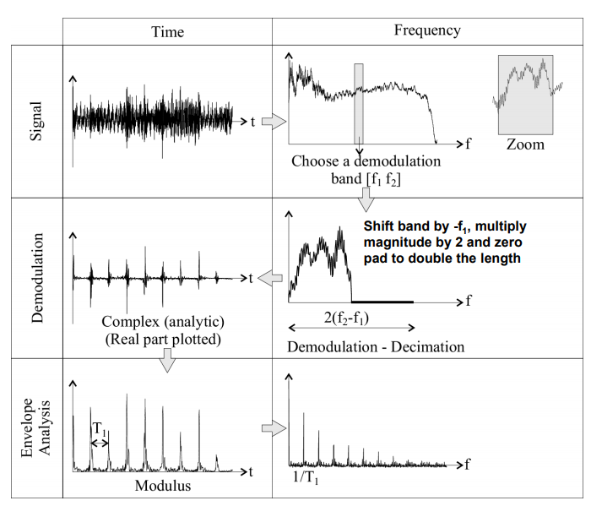

*Figure 5: Procedure of Hilbert Transform method*

Instead of the analogue techniques of envelope analysis, the Hilbert transform technique is used for the digital signal. The procedure is shown in Figure 5. [2] Similar to analog envelope analysis, the process of Hilbert transform is to select a frequency band in the frequency domain or PSD of the original signal. This step could be seen as a digital bandpass filter. These data are then shifted to the origin of frequency axis and zero pad to double of its length. The shifted spectrum is inverse Fourier transformed to time domain to obtain the analytic signal, whose amplitude is the envelope. Squared envelop signal is converted to frequency at last. The diagnostic information is now clearly to be identified.

### 3.2.1 Selection of Demodulation Frequency Band

In order to perform this Hilbert transform, the demodulation spectrum band is required to be selected. There are usually two ways: Spectral Kurtosis or the comparing of PSD to the baseline record. Since the good bearing signal is provided, the later method is more efficient.



*Figure 6: Demodulation Band Selection*

The PSD of fault bearing is compared to good bearing, as illustrated in Figure 6. Seen from the plot, the difference occurs in a wide range from 10 kHz to 23 kHz. A section from 15 kHz to 16 kHz is selected as no such wide range is required. Another section from 12 kHz to 13 kHz is selected for comparing.

The PSD method is performed in Matlab by the PWELCH function. A Hamming window of 1024 point length is used. The overlap rate is chosen as 50%.



*Figure 7: Comparing of Linear Amplitude*

These two signals are also compared in linear amplitude scale beside logarithmic (dB). It could be seen that the difference is quite small in linear amplitude. It is unable to select the demodulation band on the linear amplitude plot. Though the fault bearing amplitude is higher than the good bearing in some frequencies, it is much more obvious in the logarithmic amplitude. Comparing Figure 6 and 7, another knowledge is known that the fault bearing increase high frequency response in the vibration. But the acceleration amplitude is generally higher in low frequency range. So it is hard to see the amplitude change of high frequency range in linear amplitude. That is why the dB scale is utilized here.

The selection process is performed on the PSD spectrum. But the selected data is from the FFT spectrum of the original signal. That is because the PSD spectrum is acquired by methods like windowing and overlapping, which would cause information loss of the original signal.

### 3.2.2 Envelop Analysis

Seen from Figure 6, it is obvious the fault bearing mainly rise the band from 8 kHz to 24 kHz. The valid bandwidth below the anti-aliasing filter is 20kHz, so the selection of the envelop band should be lower than 20kHz. The width of the band is required to be at least higher than 3.5 times of the highest potential bearing fault frequency. As shown in chapter 3.1, the highest potential bearing fault frequency is 71.4 Hz of the BPFI, so the width of the band should be larger than 250 Hz.

Based on these knowledge, a 0-20 kHz band pass filter is performed on the original vibration signal. And the selected bandwidth is determined to be 1000 Hz to provide more modulation information.



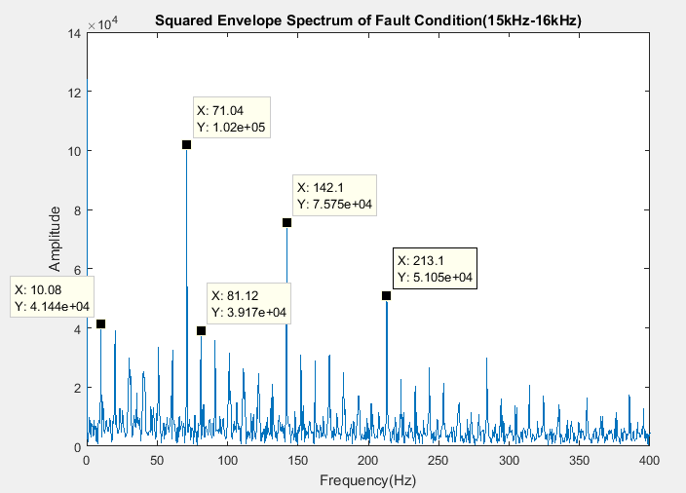

*Figure 7: Envelope Spectrum Faulty Bearing (15-16 kHz)*

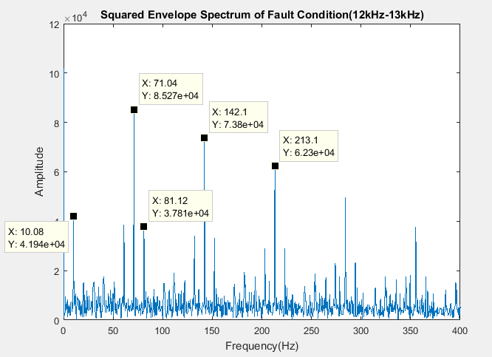

*Figure 8: Envelope Spectrum of Faulty Bearing (12-13 kHz)*

The same procedures are performed on the good bearing. The result is shown in Figure 9. Only first order frequency is seen in this figure. No bearing fault frequency or other information is to be seen. This forms sharp contract with the fault spectrum in Figure 7 and Figure 8.

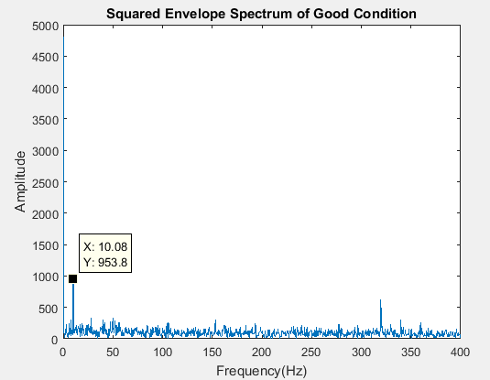

*Figure 8: Envelope Spectrum of Good Bearing*

# Conclusions and Recommendations

As seen from Figure 7 and Figure 8, the obvious frequency is 71.04Hz and its harmonics, which fits perfectly to BPFI calculate in chapter 3.1. Thus it is determined that the inner race of the bearing is with fault.

Another obvious peak is shaft speed frequency. Figure 8 shows only an obvious first order, while in Figure 7, harmonics of shaft speed also exists. The harmonics are results of Fourier transform.

The side band frequencies show clearly in Figure 8. In Figure 7, the side band frequencies smear into harmonics of shaft speed frequency. The side band frequencies state the existing of modulation. Since the amplitude modulation is demodulated by Hilbert transform, it is highly likely to be frequency modulation. The reason for this phenomenon could be the slightly variation of shaft speed. It could be fixed by order tracking or frequency demodulation, which are not implemented in this project.

Recommendation is to replace the faulty bearing as soon as possible.

# References

[1] W. Smith, MECH4305 Problem Set#4

[2] Robert Bond Randall, Vibration Based Condition Monitoring, 2011

[3] Robert Bond Randall, Rolling element bearing diagnostics—a tutorial

# Appendix A: Matlab Code

clc

clear all

close all

load('bf.mat');

load('bg.mat');

%Task 1

%system parameters

d = 7.12*10^(-3);

D = 38.5*10^(-3);

n = 12;

phi = 0;

T = 100000/48000;

t = linspace(0,T,100000);

fs=48000;

N=100000;

df=fs/N;

faxail = [0:N-1]*df;

figure(1);

plot(t,bg(:,2));

xlim([0 T])

xlabel('Time(s)');

ylabel('Amplitude(m/s^2)');

title('Tacho');

figure(2);

plot(t,bg(:,1));

xlim([0 T])

xlabel('Time(s)');

ylabel('Amplitude(m/s^2)');

title('Acceleration(Good)');

figure(3);

plot(t,bf(:,1));

xlabel('Time(s)');

xlim([0 T])

ylabel('Amplitude(m/s^2)');

title('Acceleration(Fault)');

%find the peaks and their locations

[pk,tpk] = findpeaks(bf(:,2),t,'MinPeakProminence',0.6);

%The average shaft speed

fr = 1/((tpk(length(pk))-tpk(1))/(length(pk)-1));

%calculate bearing fault frequencies

BPFO = n*fr/2*(1-d/D*cos(phi));%Outer race

BPFI = n*fr/2*(1+d/D*cos(phi));%Inner race

FTF = fr/2*(1-d/D*cos(phi));%Cage

BSF = fr*D/2/d*(1-(d/D*cos(phi))^2);%Rolling element

%PSD of bg and bf

[Gxxf,f] = pwelch(bf(:,1),1024,512,1024,48000);

[Gxxg,f] = pwelch(bg(:,1),1024,512,1024,48000);

GxxfdB = 20*log10(Gxxf/(10^(-6)));

GxxgdB = 20*log10(Gxxg/(10^(-6)));

%plot and compare PSD

figure(4);

plot(f,GxxfdB)

hold on

plot(f,GxxgdB);

legend('Fault Bearing','Good Bearing');

xlabel('Frequency(Hz)');

ylabel('PSD(dB)');

title('Comparing of PSD');

%Envenlope analysis, Hilbert transform of fault bearing

bF=bf(:,1);

bF1=fft(bF);

bF2=zeros(4000,1);

for ii=1:2000

bF2(ii,1)=bF1((31250+ii),1);%15000Hz-15960Hz

end

bF3=ifft(bF2);

bF4=(abs(bF3)).^2;

bF5=fft(bF4);

f1=(0:length(bF5)-1)*df;

%plot envelope spectrum

figure(5)

plot(f1,abs(bF5));

xlim([0 400]);

xlabel('Frequency(Hz)');

ylabel('Amplitude');

title('Squared Envelope Spectrum of Fault Condition(15kHz-16kHz)')

%Envenlope analysis, Hilbert transform of good bearing

bG=bg(:,1);

bG1=fft(bG);

bG2=zeros(4000,1);

for ii=1:2000

bG2(ii,1)=bG1((31250+ii),1);

end

bG3=ifft(bG2);

bG4=(abs(bG3)).^2;

bG5=fft(bG4);

f2=(0:length(bG5)-1)*df;

figure(6)

plot(f2,abs(bG5));

xlim([0 400]);

xlabel('Frequency(Hz)');

ylabel('Amplitude');

title('Squared Envelope Spectrum of Good Condition')

bF=bf(:,1);

bF1=fft(bF);

bF2=zeros(4000,1);

for ii=1:2000

bF2(ii,1)=bF1((25000+ii),1);%12000Hz-12960Hz

end

bF3=ifft(bF2);

bF4=(abs(bF3)).^2;

bF5=fft(bF4);

f1=(0:length(bF5)-1)*df;

figure(7)

plot(f1,abs(bF5));

xlim([0 400]);

xlabel('Frequency(Hz)');

ylabel('Amplitude');

title('Squared Envelope Spectrum of Fault Condition(12kHz-13kHz)')