

School of mechanical and manufacturing engineering

**Laboratory 2: Measurement of Sound Power Levels by The Direct and The Comparison Methods**

Name: Hengcheng Zhang

Student ID: z5130844

# 1. Introducion:

The aim of the second laboratory session is to measure the sound power level of a noise source, which is an electric drill located hard surface of a semi-reverberant field. Two methods were used to correct the reverberation effects: the direct method and the comparison method. The whole experiment procedure followed the instruction of Australian Standard AS 1217.5. AS 1217 is a series of standards which set out various of methods to determine the sound power levels of machines and equipment. These documents specify the measuring requirements for different test environment. Among them, AS1217.5 is specified for the environment of outdoor or in large room, which is suitable for this experiment.

# 2. Apparatus:

The equipment used in this laboratory session is listed below.

## 2.1 Sound Level Meter (SLM): *Brüel & Kjær* Type 2250

The B&K 2250 is a hand-held sound level meter, which contains a B&K type 4189 Free field microphone and a preamplifier to transfer sound pressure to voltage level, a 3 Hz – 20KHz broadband filter and other post processing circuits to give out needed sound level on the screen.

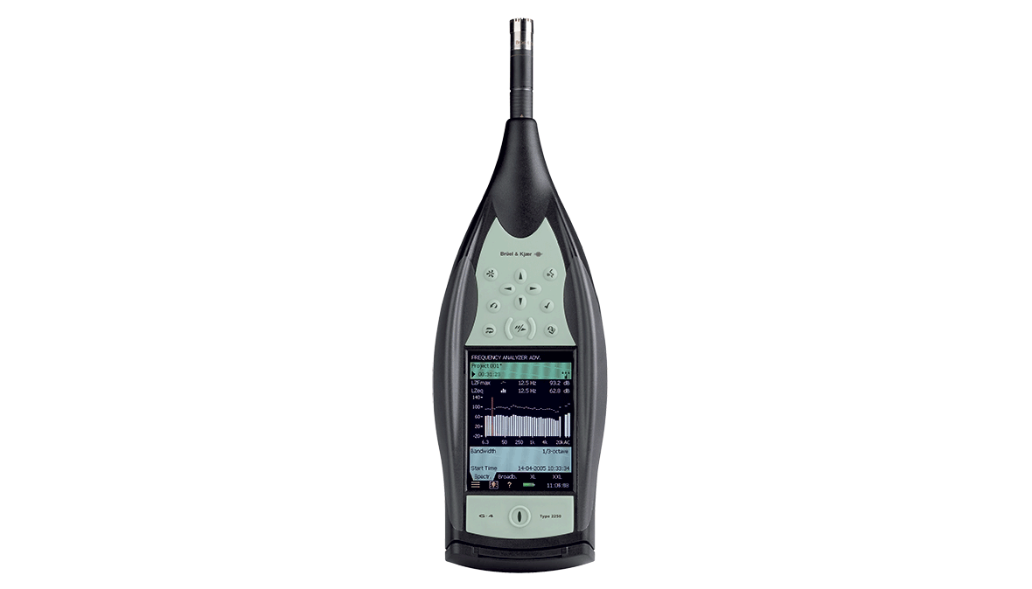

*Figure 2: B&K Type 2250 Sound Level Meter*

## 2.2 Microphone

## 2.3 Sound Level Calibrator: Brüel & Kjær Type 4231

The sound level calibrator is used to calibrate the SLM. It could generate a SPL of 94 dB at 1000Hz. The calibration process is easy and automatic, which will be shown in the procedure part.

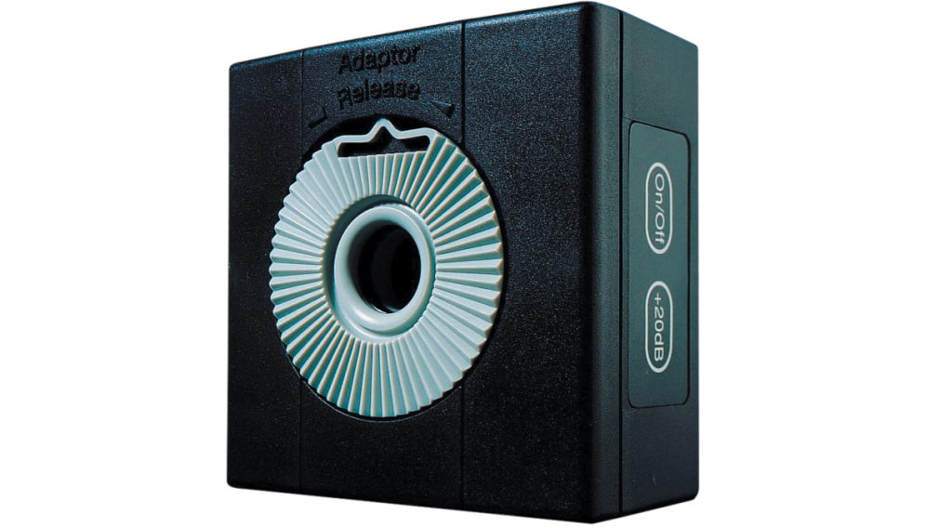

*Figure 3: B&K Type 4231 Sound Level Calibrator*

## 2.4 B&K Reference Sound Source Type 4204

This instrument is used in the comparison method. It has been located next to the drill from the beginning while the drill was operated, is switched on and octave band sound pressure level measurements are made at the same ten locations (the drill is switched off).



*Figure 1. Reference Sound Source Type 4204*