Proceedings of the Solar Thermal Energy Design Course
MECH9720
01 May, 2018, Sydney, NSW, Australia
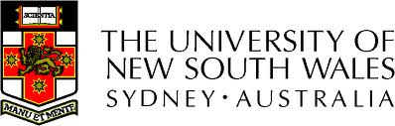
z5130844

Solar powered absorption cooling system

Hengcheng Zhang
School of Mechanical and Manufacturing Engineering,
The University of New South Wales
Kensington, NSW 2052, Australia

Abstract
Put abstract text here.

INTRODUCTION
Early prior research demonstrated the superiority of ceramics for bearings (1, 2) and the existence of elasto- hydrodynamic (ehd) lubricant films at ball and roller contacts (3), the calculation of which is now an accepted part of bearing engineering. These new concepts are now used in the design of lubrication systems with solid lubricants that operate in much more severe environments than oils and greases (4, 5). Proprietary computer codes and unique patented bearing configurations for optimizing the performance of bearing/solid-lubricant systems have been developed (6, 7 and 8). In this way, patented self-contained solid-lubricated all-steel and hybrid-ceramic ball and roller bearings are now available for environments that do not contribute to their lubrication, such as in air or vacuum.
Nomenclature
Put nomenclature here.
Discussion
Put your findings here - feel free to add more sections in this part - the following format can be used:

Section 1
There are several types of...

Section 2
There are several types of...

Acknowledgments
Put acknowledgments here.
References
Put references here. Make sure to reference ALL images and tables taken from research papers here AND in the body of the text!

Annex 1
Put Annex title here

Put text of Annex here (optional section)

