Proceedings of the Solar Thermal Energy Design Course
MECH9720
01 May, 2018, Sydney, NSW, Australia

z5130844

Solar powered absorption cooling system

Hengcheng Zhang
School of Mechanical and Manufacturing Engineering,
The University of New South Wales
Kensington, NSW 2052, Australia

Abstract
Put abstract text here.

1. INTRODUCTION
Absorption cooling is a system which uses external thermal energy (solar energy, waste heat or other heating system) as resource to run a vapor absorption cycle to provide cooling effect. Different from vapor compression cycle, which uses a compressor to bring the refrigerant to a high temperature and high pressure condition, vapor absorption cycle utilizes another fluid (absorbent) to absorb the gaseous refrigerant into fluid and then heat the refrigerant-saturated liquid to regenerate the hot gaseous refrigerant.
Absorption cooling system actually has a longer history than the widely used vapor compression cooling system. It was invented by Ferdinand Carré in 1858, [1] and brought into commercial production in nineteen twentieth. [2] But because of its low coefficient of performance, the vapor absorption cooling system is taken place by compression cooling systems in most conditions nowadays.
In recent years, environment problems and global warming emission are taken more and more seriously. As is known, refrigeration and air conditioning are significant electricity consumption. Thus, the environment friendly solar absorption cooling system attracted people’s attention once again and many researches are carried out in this area. [4-7] Comparing to compression cooling systems, solar absorption cooling system could save electricity consumption. It is more quiet and dependable because of its simpler structure and less moving parts containing. Another advantage is that it is able to provide larger cooling effect in summer thanks to the higher level of solar irradiation.
This report is to discuss the concept and application of solar absorption cooling system. In order to improve the performance of the solar absorption system, investigations on the types of absorption chillers, structure of the solar absorber and effect of absorbents-refrigerants pairs are presented.
2. Nomenclature

COP: coefficient of performance
FPC: flat-plate collectors
ETC: evacuated tube collector
CPC: compound parabolic collector
PTC: parabolic through collector
LiBr: lithium bromide salt
3. Discussion
The classification of solar cooling system is shown in Figure 1 according to Henning [8]. The topic of this paper is mainly focused on closed cycle heat transformation thermal processes. Comparing to photovoltaic electric process, the thermal process is easier to access and cheaper in expensis. The close cycle process is able to provide higher heating resource temperature than the open cycle process and thus has a higher coefficiency of performance.
For closed cycle processes, there are liquid sorbent system and solid sorbent system, which are also known as absorption system and adsorption system. The difference of absorption system and adsorption system in structure is that the adsorption system has an adsorbent bed replacing the absorber, heat exchanger and generator in absorption system. Without the pump, there is no moving part in adsorption system except valves. It is also expected to have higher coefficient of performance (COP) for adsorption system rather than absorption system. [9] The advantage of absorption system is that it is less sensitive to temperature change than adsorption system. It is able to operate at relatively low temperature conditions. The investigation in this article is focused on the absorption cooling system.

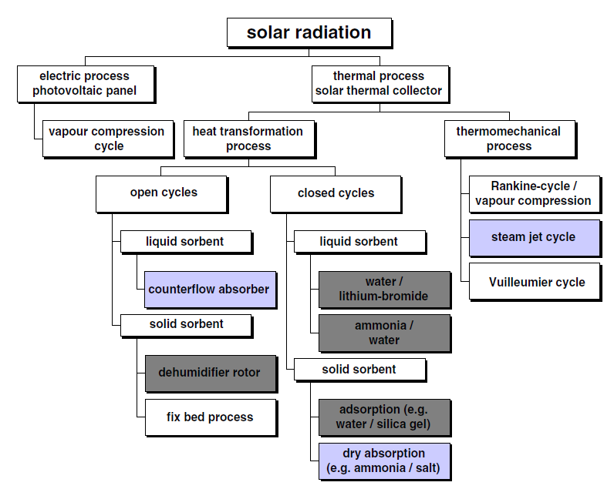
Figure.1 Classification of solar cooling system [8]
3.1 Structure
The basic structure of solar absorption cooling system is shown in Figure 2. Seen from the figure, the main parts of solar absorption system are solar collector, storage tank, absorber, heat exchanger, generator, pump, expansion valve, evaporator and condenser.
The condenser, evaporator and throttle valve are of no much difference to the vapor compression system. The main difference lies in the solar collector and the refrigeration chamber, which includes the absorber and heat exchanger system. The solar collector is a heat exchanger which is able to transfer solar radiation into thermal energy and store it in the heat transfer fluid. The heat transfer fluid, which is usually water, receives thermal energy in the solar collector and heats the refrigerant in the generator. The storage tank is optional. It is used to store the heat transfer fluid, and also works as a buffer. An auxiliary heating device could be installed in the storage tank to provide heat for the generator in low solar irradiation circumstances.
The evaporated refrigerant vapor is absorbed by the absorbent in the absorber. The absorbent-refrigerant solution is then pumped to the heat exchanger and generator to be heat up by the secondary heat transfer fluid. The refrigerant transfer back to vapor in the generator again.

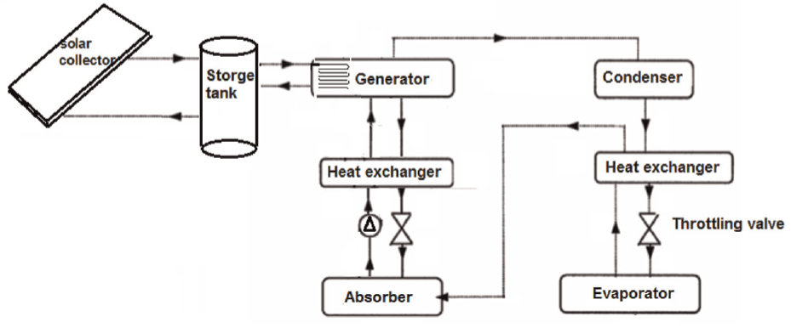
Figure.2 Basic configuration of solar absorption cooling System[6]
3.2 performance metrics
The performance of the solar absorption cooling system could be firstly measured by the coefficient of performance (COP). COP is equal to the heat transferred from the evaporator divided by the thermal energy gained in the generator. It is shown in the following equation.
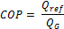
Where:
Q_{ref} is the refrigerate effect energy,
Q_{G} is the heat gained from the generator
Another indicator is the performance of the solar collector. It is defined as the ratio between the absorbed energy and the solar irradiation. [10] When an auxiliary heater is installed, the solar fraction is used to express the ratio of solar heat to the total heat provided to the generator.
There are many factors affecting the performance of the solar absorption cooling system, including external temperature, solar irradiance, cooling load scheduling, control logic and so on. But the factors which have the largest influence and are able to be controlled are solar collector types, absorbent-refrigerant pair and the absorption chiller.
3.3 Solar collector
The solar collector is used to transfer the solar energy into useful thermal energy to drive the whole solar absorption cooling system. Its performance has a direct influence on how much solar energy is able to be absorbed.
There are many types of solar collectors, the efficiency of the solar collector mainly depends on the choice of types. Four main types are usually applied, which are flat plate collectors, evacuated tube collectors, compound parabolic collector (CPC) and parabolic through collector (PTC). [6]
3.3.1 Flat-Plate collector
Flat-plate collectors (FPC) have the advantages of simpler operation mechanism, lower expenses and larger collecting surface. But due to their structure, they are not able to achieve high temperature to the heat transfer fluid. The flat-plate collector is composed of absorber plates, recuperating tubes, covers (which are usually made of glass) and insulation layers to minimize transmission heat losses.
The temperature of heat transfer fluid for single effect flat-plate collector cooling system could reach highest at about 90°C [12]. This type of absorption cooling system is more suitable for hot areas where solar energy is sufficient. D.S. Kim [11] investigated such a cooling system in extremely hot weathers. According to their simulation, the COP is 0.37 for 90°C hot water in 35°C ambient temperature. The chiller could provide 7.0°C chilled water. Another study carried out in Moroccan by Y. Agrouaz [13] indicated that the tilt angle and the surface area of the solar collector have influence to the total performance. Their simulation investigated the surface area range from 20 m² to 80 m². It is found that the solar fraction stop to increase at 60 m². The simulated tilt angle varies from 10 to 60 degrees. It is found that smaller angle (10 – 20 degree) is suitable for summer and large tilt angle (40-60 degree) could provide higher incident solar irradiation.
3.3.2 Evacuated tube collector
The heat absorbed in the flat plat collector loss through conduction to the ambient. This could be largely reduced by mounting the absorber into a transparent vacuum container. [14] To simplify the manufacturing process, the vacuum container is usually a glass cylinder, and thus forms the evacuated tube collector. The operating temperature of the evacuated tube collector is able to reach 180°C. The higher temperature of heat transfer fluid could significantly improve the overall efficiency. The structure of evacuated tube is shown in figure 3.

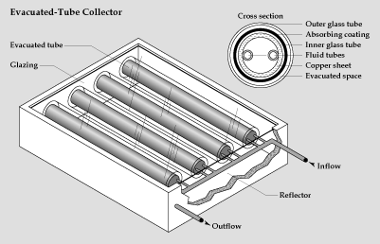
Figure.3 Structure of evacuated tube collector
An evacuated tube collector solar absorption cooling system in Shanghai [14] has a solar cooling COP of 0.35 with a cooling capacity of 8.5 KW. It has two kind of evacuated solar collector types, the heat pipe evacuated tubular collector and the U-type evacuated tubular solar collector. By comparing of these two kinds of solar collectors, it was found that The U-type collector has a lower but steadier instantaneous efficiency with different inlet temperature.
Another study carried out by Ahmed Hamza in Oberhausen [16], Germany has a 35 kW absorption chiller with a 108 m² solar collector. Its collector efficiency is 35.2% to 49.2% and its COP is from 0.37 to 0.81. The work fluid is heated up to 97-105°C in the solar collector. The heating capacity is 50 kW with 1000 W/m² solar insolation at the collector plane.
3.3.3 parabolic through collector
The concentrating collectors could concentrate the light to provide higher fluid temperature. The concentrating temperature is able to reach as high as 220-400°C. There are many kinds of concentrating solar collectors. As said in previous, two most widely used types are discussed here, the parabolic through collector or PTC and the compounded parabolic collector (CPC).
As shown in figure 4, the parabolic through collector has a parabolic shaped reflective material under the receiver tube. When the sun rays are directly hitting the collector, they are concentrated to receiver on the focal line. A tracking mechanism could effectively improve the collecting efficiency by aiming the solar collector directly to the sun as it moves.
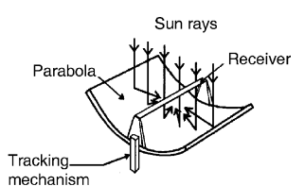
Figure.4 Structure of parabolic through collector [17]
Paper by Nidal H. Abu-Hamdeh [18] give an example of parabolic through collector system. Its COP is 0.75 with the solar radiation of 56.2 MJ/day m². The surface area of the PTC is 3.7 m², and its optical efficiency is 76.5%. The experiment shows that the maximum temperature of the generation is 120°C, and the evaporating temperature is 8°C under an ambient temperature of 25°C. It was also found that increasing the collector area would improve the coefficient of performance. The optimum area in this case is 3.5 to 5 m².
3.3.4 Compounded parabolic collector
The compounded parabolic collector, as seen if figure 5, has circular reflecting surface at the lower part and parabolic surface at the upper portions. The receiver tube is located at the bottom of the structure. This set made it able to accept relatively wider range of angles. Seen from the schematic diagram in figure 5, it is seen that longer parabolic part of the reflecting surface would decrease the acceptance angle and it has little contribution to the radiation to reach the absorber. Thus it is truncated usually to form a thinner absorber.
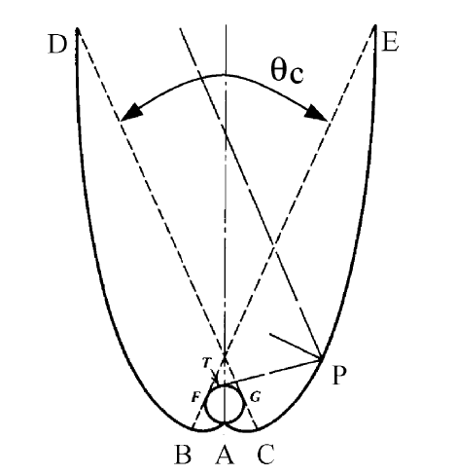
Figure.5 Schematic diagram of compound parabolic collector [17]
An example of this kind of solar collector is given by N.O. Omisanya. [19] Two CPC collectors with a total 1.029 m² surface area are utilized. The concentration ration is 1.8. When the average daily hourly insolation is 170W/m², the daily-hourly mean COP varies from 0.838 to 1.48 in the test. The maximum absorber temperature of 110°C is measured at 13:00 pm. The evaporator temperature is 11°C for this experiment.
Comparing with FTC, the compounded parabolic collector is more expensive in manufacturing. The collection efficiency of CPC is about 45%, which is relatively low comparing to that of PTC and ETC. The COP of CPC is also lower than that of PTC and ETC in the same circumstance.
3.3.5 comparison
A comparison between these four solar collector types, FPC, ETC, PTC and CPC are performed by E. Bellos [20] in Greece. The collectors are investigated under the same condition. The cooling capacity is 100kW and the temperature requirement is 10°C. The absorbent-refrigerant pair is LiBr-H₂O. The daily solar radiation is 4.35 kW/m². The ambient temperature is 35°C.
This experiment shows that the system with PTC has the highest solar collecting efficiency, and accordingly the highest COP. ETC took the second place, and it is followed by CPC and FPC. But the ETC collector has the lowest cost. The price of each absorber type for 100kW of cooling capacity is as below:
- ETC: 60 k€;
- FPC: 66k€;
- PTC: 78 k€;
- CPC: 84 k€.
Besides the low cost, another advantage of the system with ETC absorber is that it requires the smallest surface area. The author made the conclusion the ETC is the best type of collector in this paper.
3.4 absorption chiller configuration
Comparing to vapor compression cycle, the different devices appear in the absorption cooling system are the absorber, the pump, the heat exchanger, the expansion valve and the generator. It is applied to replace the compressor. In another way, these devices could be seen as a thermal compressor. According to the different thermodynamic cycle, it can be divided into single effect cycle, double defect cycle, triple-effect cycle and half effect cycle. In general, single effect cycle has simpler structure, while double effect and triple effect cycle has larger COP. Their performance difference is as shown in figure 4. Their structures, characteristics and differences are discussed below.

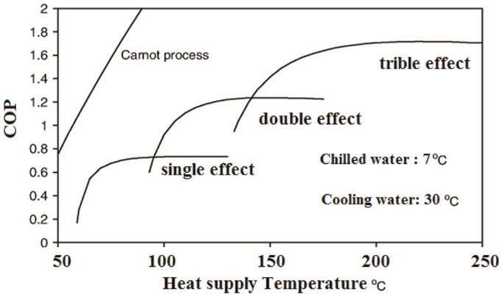
Figure.4 Performance of different types of absorption chillers[6]
3.4.1 Single effect cycle
The single effect absorption cooling cycle is the most common one comparing to the others. The structure of the single effect cycle is as shown in figure 2.
The refrigerant vapor from the evaporator mix with the absorbent in the absorber. It is absorbed to form the rich absorbent-refrigerant solution. The absorber is operating under low pressure. The solution pump brings the rich solution to the generator. By receiving heat from the hot water provided by solar collector, the refrigerant desorbs from the rich solution, and left the poor solution. This process increased pressure in the generator. The poor solution goes back to the absorber through a pressure release valve. The pressure of the poor solution is decreased. The heat exchanger between absorber and generator is utilized to improve the efficiency. The cold solution from absorber is preheated by the hot poor solution coming back from the generator.

3.5 absorbent & refrigerant
The difference between the absorption cooling system and the vapor compression cooling system lies on their different working fluid. In the vapor compression cooling system, it is the refrigerant, while in the absorption cooling system, they are the absorbent-refrigerant pair in the cooling cycle.
There are many requirements for the absorbent-refrigerant pair:
- High latent heat for the refrigerant to minimize circulation rate and improve performance.
- No crystallization during operation

There are many different kinds of absorbent-refrigerant pair available for the cooling system. A review presented by Macriss [21] show us 200 absorbents and 40 refrigerants. The most commonly used absorbent-refrigerant pairs are the water-ammonia pair and the LiBr-H₂O pair.
The H₂O/NH₃ absorption cooling system runs under moderate pressure. The pressure in the system is higher than the outside pressure, which prevent vapor to come in and provided a dry cooler to avoid corrosion. Another advantage is that ammonia could solute completely in water at any concentration, which means crystallization would never happen. On the other hand, one of its disadvantages is that ammonia is toxic and flammable. [22]
For the LiBr-H₂O pair, the advantages are:
- Safety. Water and vapor are nontoxic.
- Higher COP than water-ammonia pair. As the latent heat of water is very high.
- Low generator temperature requirement. This make it possible to have wider choice of solar collector types.
- The low pressure of the cycle requires less energy from the pump.
Its disadvantages are:
- Corrosion. The low pressure working condition and the corrosive property of lithium bromide solution bring the corrosion problem. Protection methods must be taken.
- High chiller temperature. The freezing point of water is 0°C. So it is not possible to be used as low temperature refrigerator. It could only be used for air conditioning.
Characteristics of other absorbent-refrigerant pairs are studied in recent years, such as ternary and quaternary salt mixtures including LiBr, LiNO₃, LiCl and LiI. For example, LiCl-water pair may have higher exergetic efficiency than the LiBr-H₂O pair.
A list of available absorbent – refrigerant pairs are shown in table 1.

Table 1:Absorbent-refrigerant pairs available [22]
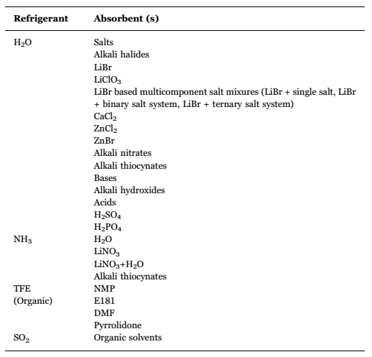

3.6 storage tank
As discussed previously, the storage tank is optional. The storage tank is a link between the absorption chiller and the solar collector. The heated water from the solar collector flow to the top of the tank and the then goes to the generator. Low temperature water from the absorption chiller flow into the bottom of the tank then return to the lower side of the solar collector. The storage tank runs as a buffer, and it is able to stabilize the water temperature.
An investigation was carried out by Zhai [14] to analyze the influence of the existing of the storage tank. The experiment was performed on a solar absorption cooling system which is able to switch between with or without storage tank. It has a cooling capacity of 35 kW. The volume of the storage tank is 6.8 m³. It was found that the system without storage tank has larger variation of temperature for both inlet and outlet of the solar collector. It could also be seen that the average collector inlet water temperature of the system with storage tank is higher than that without storage tank. The difference is about 4°C. In conclusion, the system without storage tank has a higher solar collecting efficiency, and thus a higher COP with a relatively simple structure. On the other side, it is less stable comparing to system with storage tank. The system without storage tank is more suitable for areas where sufficient solar energy exists.
The size of the storage tank could affect the performance too. Experiment by Nidal H. Abu-Hamdeh [18] shows that the optimum volume is 0.2 to 0.3 m³ in their test equipment.

4. Conclusion

Acknowledgments
Put acknowledgments here.
References

[1] Eric Granryd & Björn Palm, Refrigerating engineering, Stockholm Royal Institute of Technology, 2005, see chap. 4-3
[2] Absorption refrigerator, wiki, https://en.wikipedia.org/wiki/Absorption_refrigerator
[3] Bataineh K and Fayez N. Thermal performance of building attached sunspace in Jordan climate. In: The 1st international nuclear and renewable energy conference (INREC’10), Amman, Jordan, 21–24 March 2010, pp.1–6. New York: IEEE.
[4] T. N. Mittal V, Kasana KS, “The study of solar absorption air-conditioning systems,” J. Energy South. Africa @BULLET, vol. 16, no. 4, pp. 59–66, 2005
[5] C. Carlson, M. Coulter, C. Kunkle, and P. Watson, “Solar absorption chiller,” Santa Clara University, 2014.
[6] K. M. Bataineh, S. Alrifai, “Recent trends in solar thermal sorption cooling system technology,” Adv. Mech. Eng., vol. 7, no. 5, pp. 1–20, 2015.
[7] K. Bataineh, Y. Taamneh, “Review and recent improvements of solar sorption cooling systems,” Energy Build., vol. 128, pp. 22–37, 2016.
[8] Henning H-M. “Solar assisted air conditioning of buildings—an overview,” Appl Therm Eng 2007; 27: 1734–1749.
[9] Fan Y, Luo L, SOUYRI B, “Review of solar sorption refrigeration technologies: development and applications”, Renewable and sustainable energy reviews, 2007, 11(8):1758~1775.
[10] Qu, Yin H and Archer DH. A solar thermal cooling and heating system for a building: experimental and model based performance analysis and design. Sol Energ 2010; 84: 166–182.
[11] D.S. Kim, C.A. Infante Ferreira Air-cooled LiBr–water absorption chillers for solar air conditioning in extremely hot weathers, Energy Conversion and Management, 2008, 50(4) :1018-1025.
[12] Balaras CA, Grossman G, Henning HM, Infante Ferreira CA, Podesser E, Wang L,et al. Solar air conditioning in Europe – an overview. Renew Sustain Energy Rev 2007;11:299–314.
[13] Y. Agrouaz, T. Bouhal, A. Allouhi, T. Kousksou, A. Jamil, and Y. Zeraouli, “Energy and parametric analysis of solar absorption cooling systems in various Moroccan climates,” Case Stud. Therm. Eng., vol. 9, no. June 2016, pp. 28–39, 2017.
[14] X.Q. Zhai, R.Z. Wang, Experimental investigation and performance analysison a solar adsorption cooling system with/without heat storage, Appl. Energ.87 (2010) 824–835. B.
[15] Wikimedia Commons. (August 10, 2015). Evacuated Tube Collector [Online]. Available: https://upload.wikimedia.org/wikipedia/commons/4/47/Evacuated_tube_collector.gif
[16] A. Hamza, H. Ali, P. Noeres, C. Pollerberg, Performance assessment of an integrated free cooling and solar powered single-effect lithium bromide-water absorption chiller, Sol. Energy 82 (2008) 1021–1030.
[17] S. A. Kalogirou, Solar thermal collectors and applications, vol. 30, no. 3. 2004.
[18] N.H. Abu-Hamdeh, K.A. Alnefaie, K.H. Almitani, Design and performance characteristics of solar adsorption refrigeration system using parabolic trough collector: experimental and statistical optimization technique, Energy Convers. Manage. 74 (2013) 162–170.
[19] N.O. Omisanya, C.O. Folayan, S.Y. Aku, S.S. Adefila, Performance of a zeolite water adsorption refrigerator, Adv. Appl. Sci. Res. 3 (6) (2012) 3737–3745.
[20] E. Bellos, C. Tzivanidis, and K. A. Antonopoulos, “Exergetic, energetic and financial evaluation of a solar driven absorption cooling system with various collector types,” Appl. Therm. Eng., vol. 102, pp. 749–759, 2016.
[21] Macriss RA, Gutraj JM, Zawacki TS. Absorption fluids data survey: final report on worldwide data. Inst Gas Technol, Chic 1988.
[22] G. Leonzio, “Solar systems integrated with absorption heat pumps and thermal energy storages: state of art,” Renew. Sustain. Energy Rev., vol. 70, no. December 2016, pp. 492–505, 2017.

