Table of Contents

1. Menu 3

2. User 4

2.1. Add user 4

2.2. Add user2 5

2.3. Edit user 6

2.4. Search User 6

3. ManageSessions 7

3.1. Schedule Session 1 7

3.2. Schedule Session 2 8

3.3. Schedule Session 3—Add student 8

3.4. Schedule Session 4—Add student 9

3.5. Schedule Session 5—Add proctor 10

3.6. Schedule Session 6—Add proctor 10

3.7. Session – View Status 12

3.8. Modify Session 1 12

3.9. Modify Session 2 13

4. Manage Students 13

4.1. Add student -1 14

4.2. Add student -2 15

4.3. Add student -2 16

# Menu

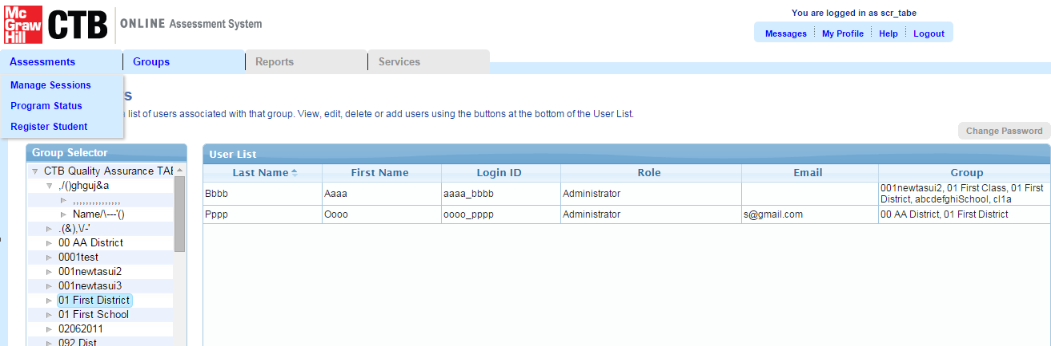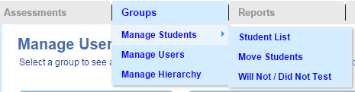

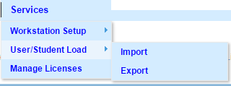

# User

## Add user

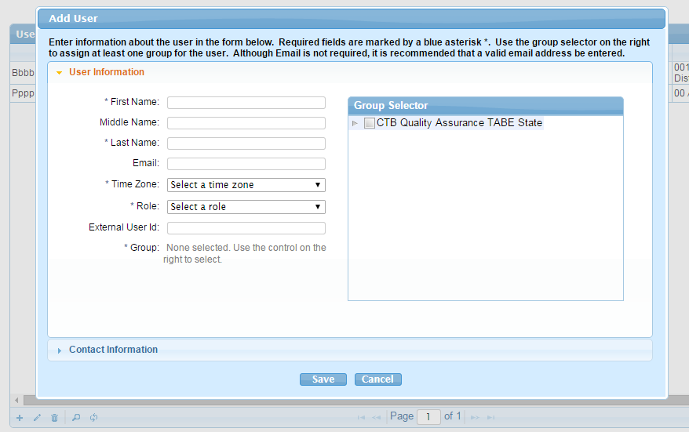

## Add user2

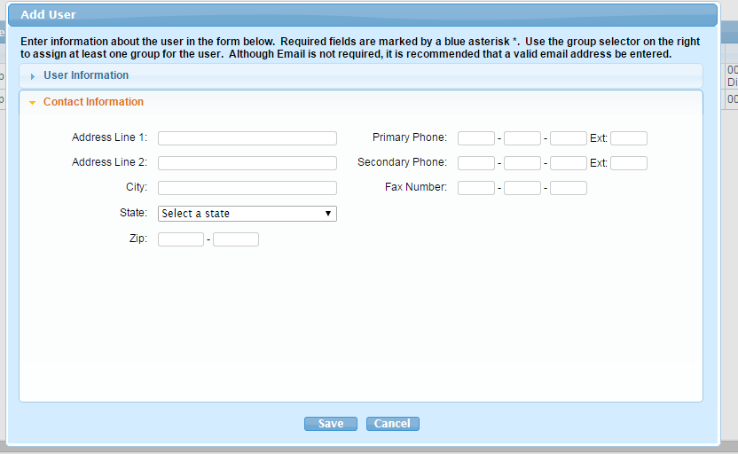

## Edit user

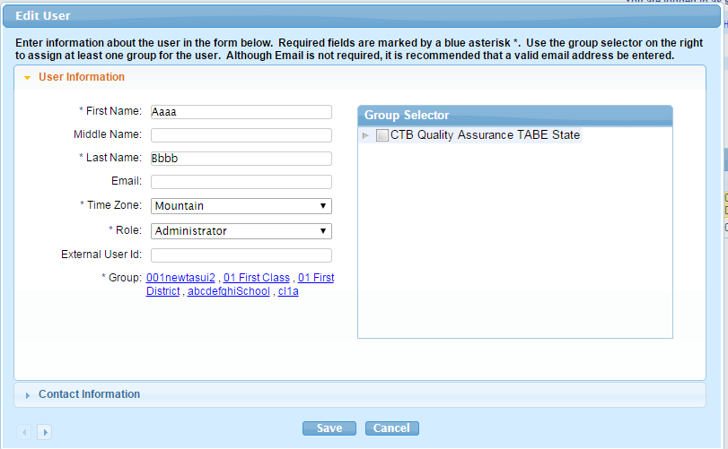

## Search User

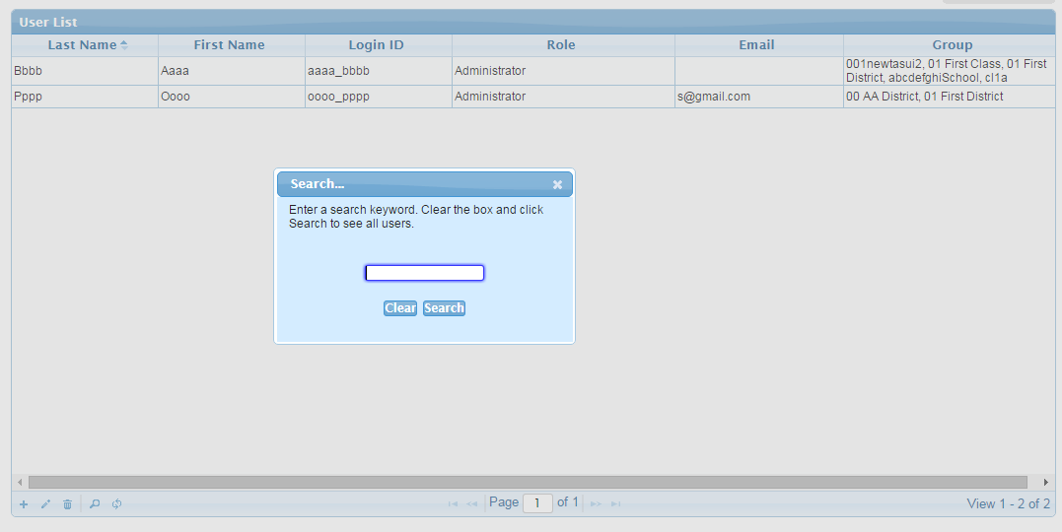

# ManageSessions

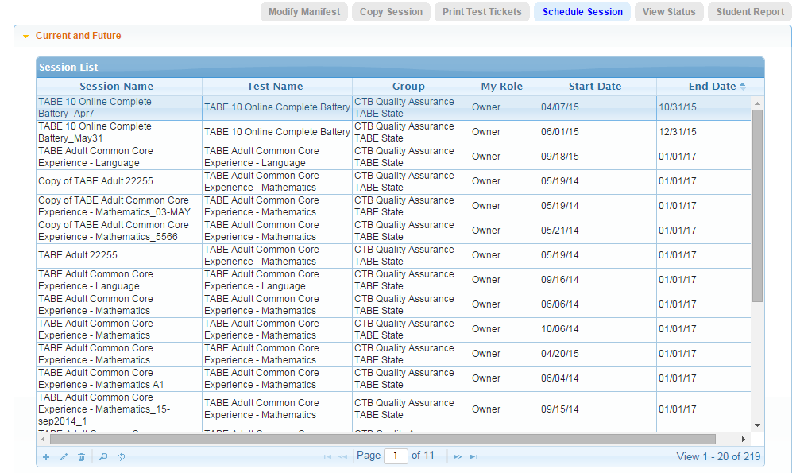

## Schedule Session 1

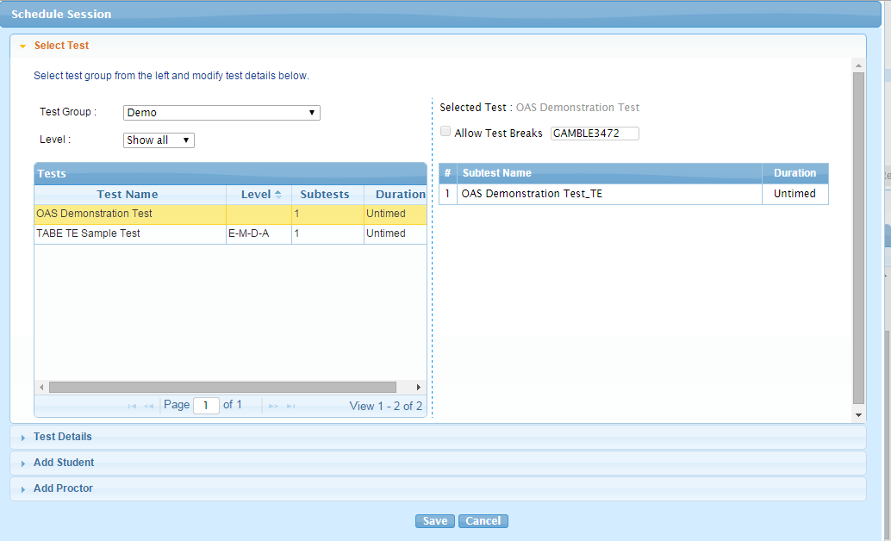

## Schedule Session 2

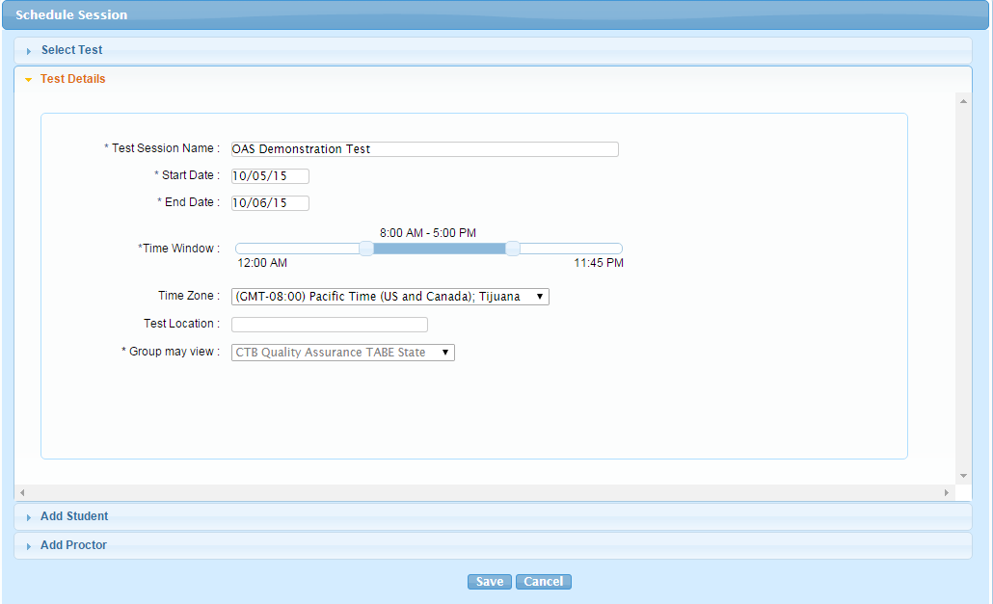

## Schedule Session 3—Add student

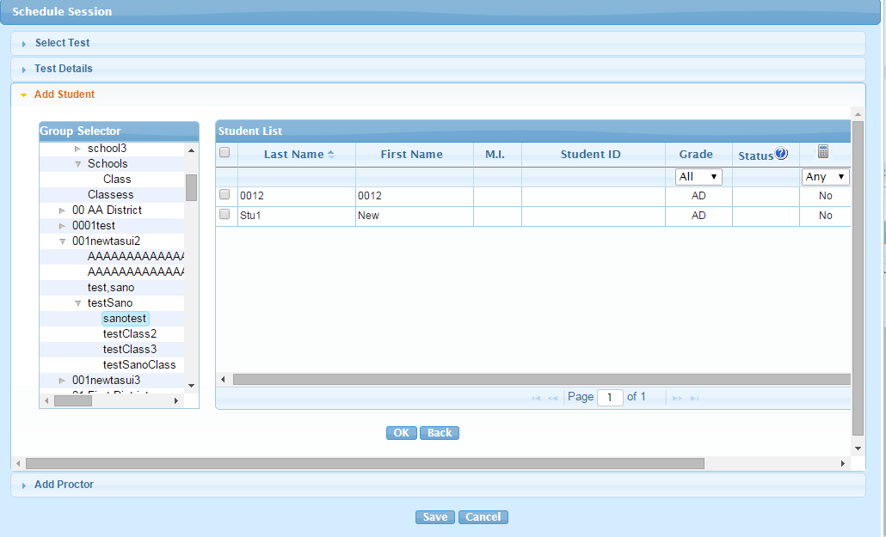

## Schedule Session 4—Add student

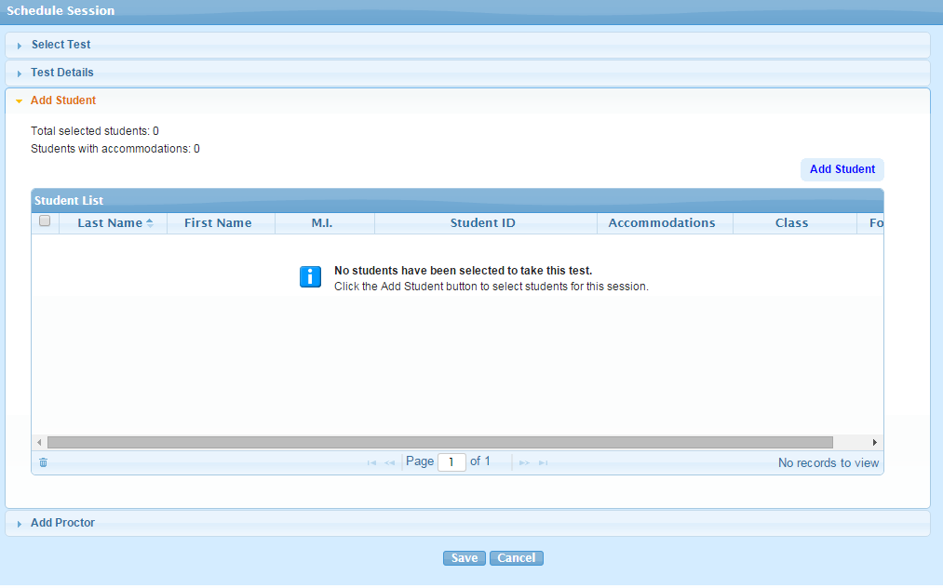

## Schedule Session 5—Add proctor

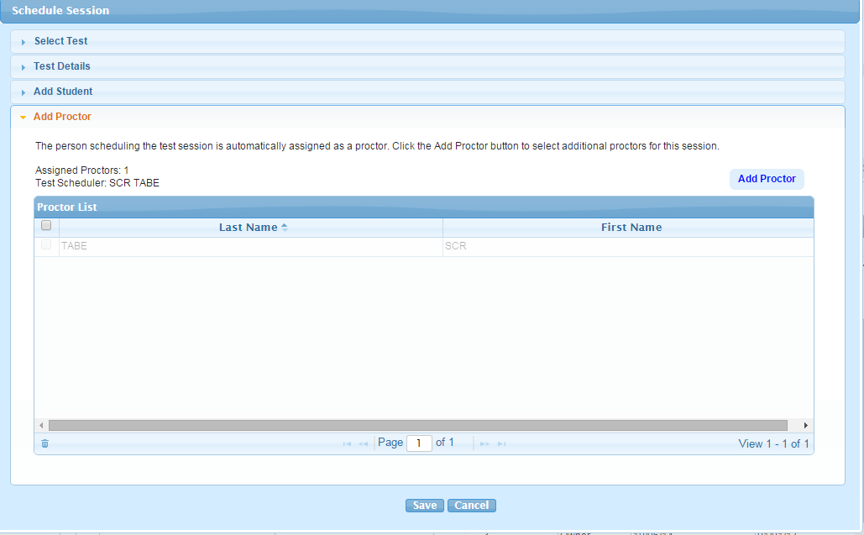

## Schedule Session 6—Add proctor

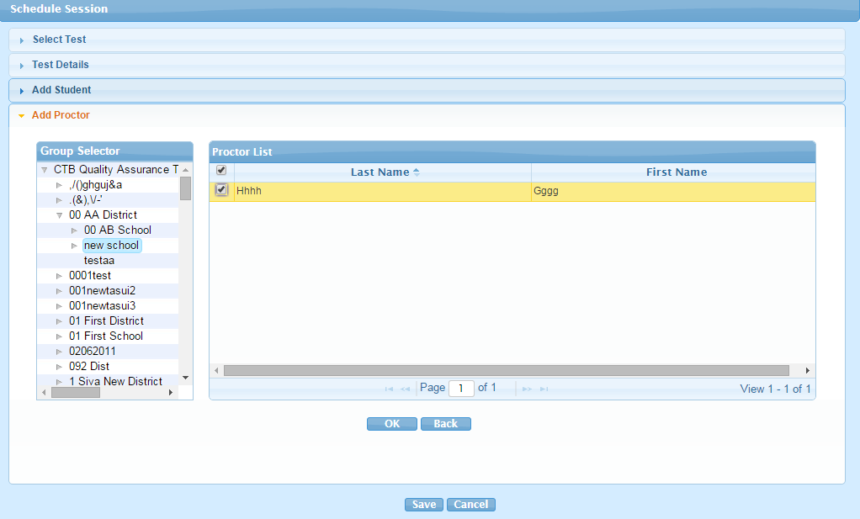

Session – View Status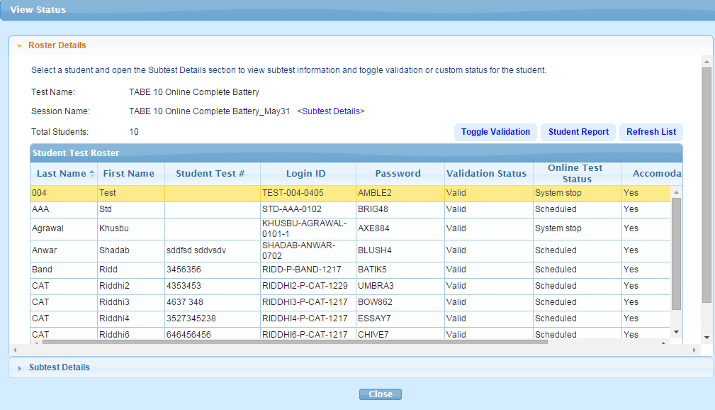

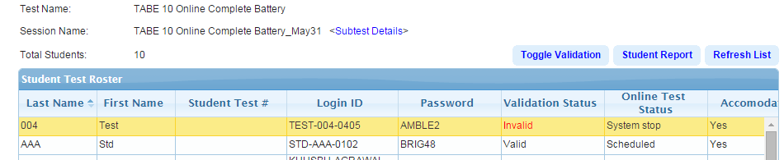

## Session – View Status

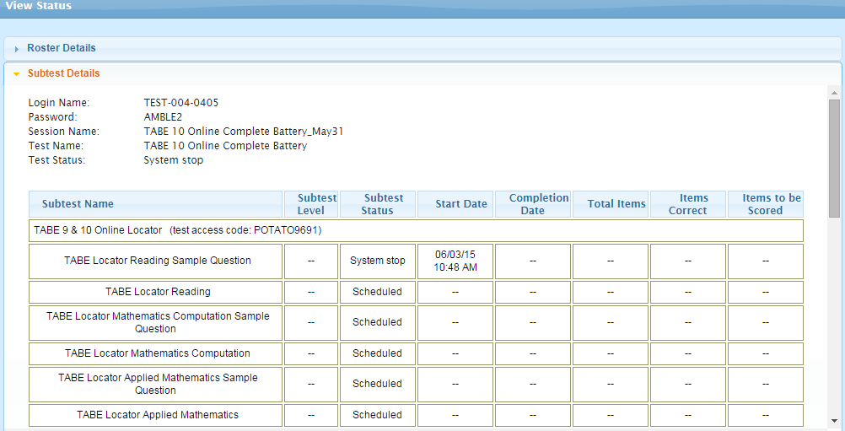

## Modify Session 1

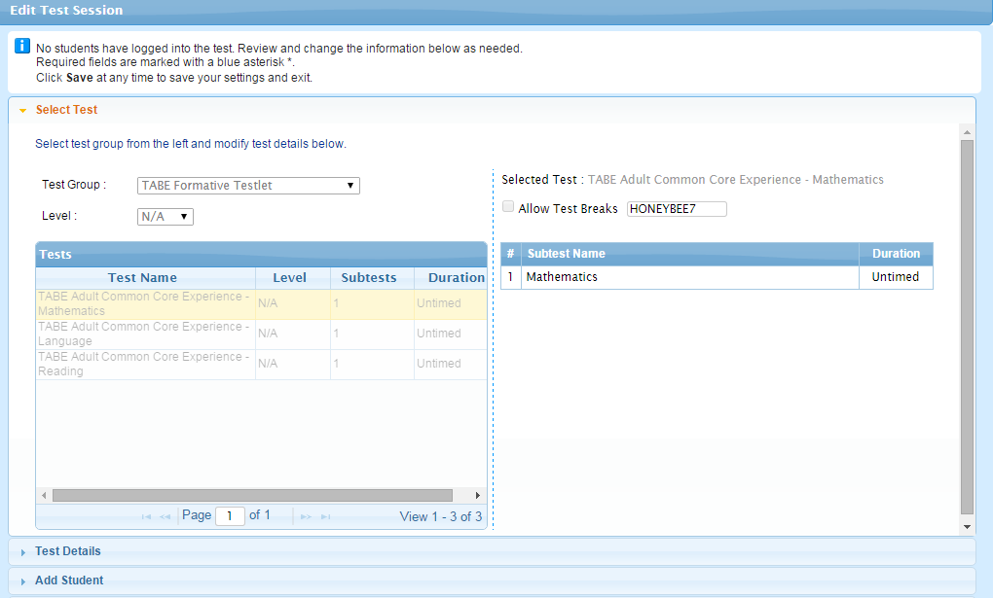

## Modify Session 2

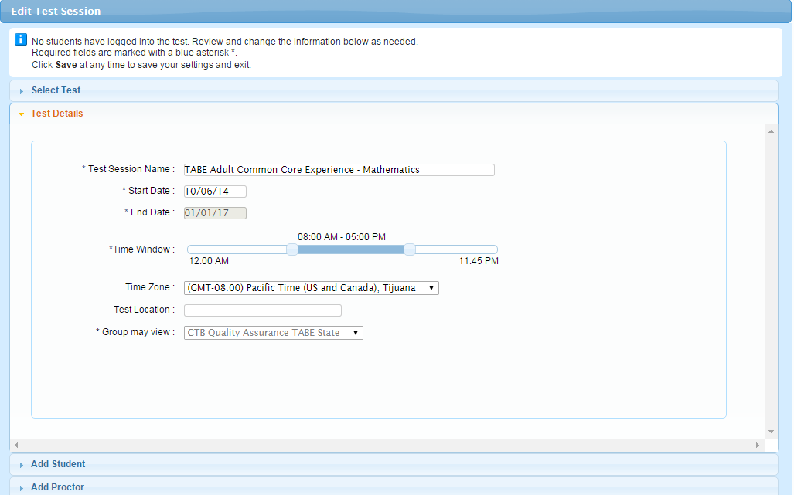

# Manage Students

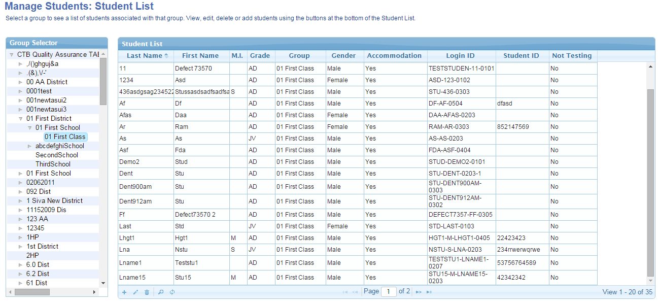

## Add student -1

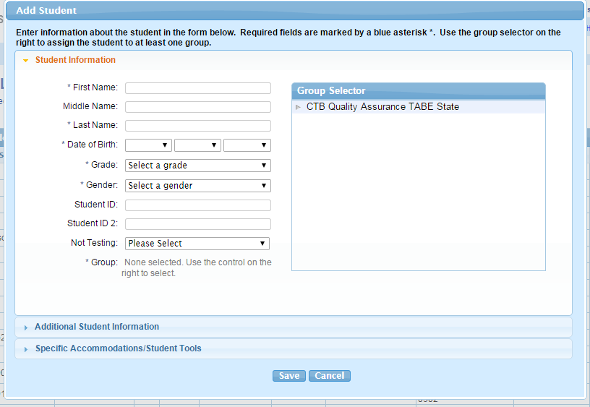

## Add student -2

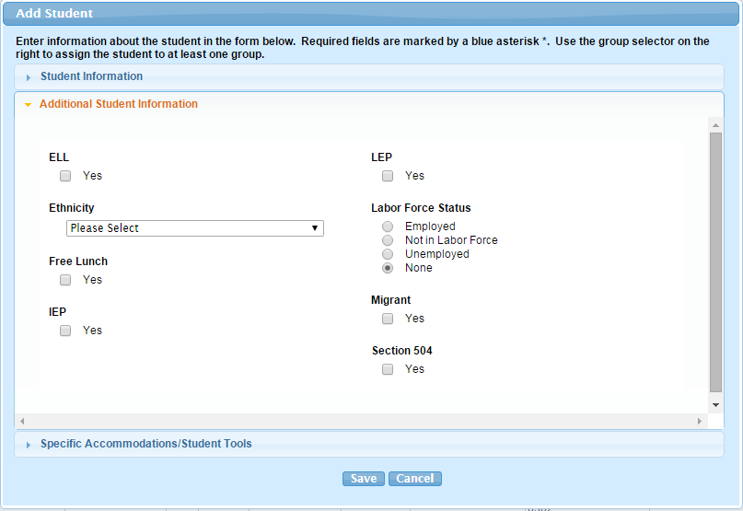

## Add student -2

