Data Model



Figure Error! No text of specified style in document.‑2: Data Model- User

**Data Model User -**

The details of the users who log into TAS are stored in the “USERS” table. Username, password, name, and created_date_time etc. details are present in the users table. The address details of a user are present in the “ADDRESS” table. The “PASSWORD_HISTORY” table stores the last five passwords used by the user and the “PASSWORD_HINT_QUESTION” holds the password hint question and its answer as given by the user. The users in TAS can have different types of roles (Administrator, Administrative Coordinator, Coordinator and Proctor). These different roles are present in the master table named “ROLE”. The “ROLE_TYPE” table specifies whether a role is a Standard application role or it belongs to some other application specific role. The “USER_ROLE” table holds the association between a user and its role. This table also holds the org_node_id of the org_node with which the user is associated.



Figure Error! No text of specified style in document.‑3: Data Model- Customer

**Data Model Customer -**

The details of the customers of OAS are stored in the “CUSTOMER” table. Customer_name, contact, created_date_time etc. details are present in this table. The address details of a customer are present in the “ADDRESS” table. The customers are given some demographics (such as Ethnicity, Race, Free or Reduced Price Meals etc.) according to their specifications. The students for that customer can be given only those demographics that are given to the customer. The demographics given to the customer are stored in the “CUSTOMER_DEMOGRAPHIC” table. The possible values for each demographic is present in the “CUSTOMER_DEMOGRAPHIC_VALUE” table. The program table stores the program data for each customer. Each customer can have one or more programs such as – Fall, Winter etc.

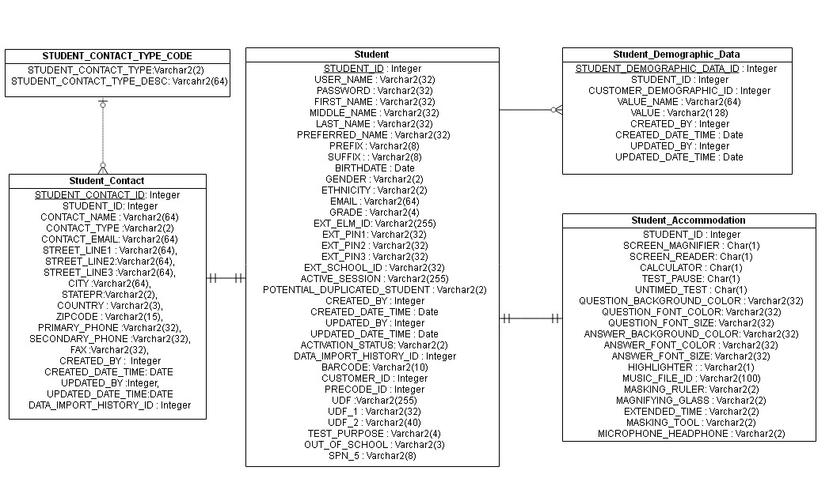

Figure Error! No text of specified style in document.‑4: Data Model Student

**Data Model Student -**

The details of the students are stored in the “STUDENT” table. Username, name, created_date_time etc. details are present in this table. The address details of a student are present in the “STUDENT_CONTACT” table. The “STUDENT_CONTACT_TYPE_CODE” is the master table for different types of contact type codes (such as P for Parent, G for Guardian etc.). The “STUDENT_DEMOGRAPHIC_DATA” table holds the demographics (such as Ethnicity, Race etc.) assigned to the students. The “STUDENT_ACCOMMODATION” table holds the accommodations (such as Calculator, Extended Time and Screen Reader etc.) assigned to the students which the students can use during exam.

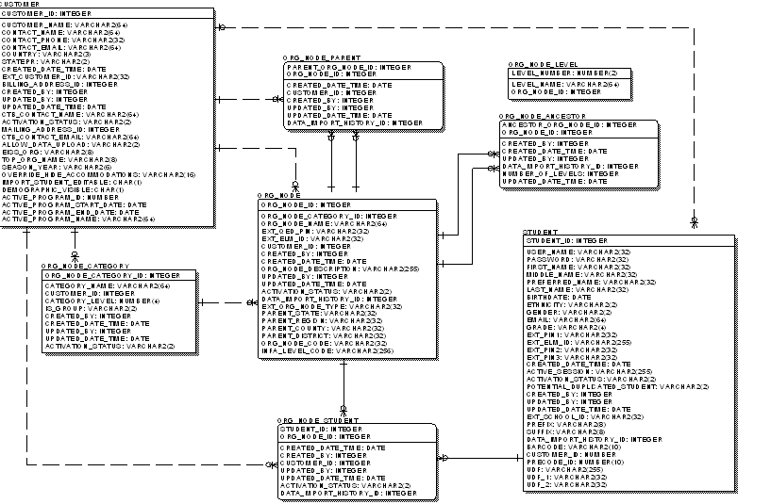

Figure Error! No text of specified style in document.‑5: Data Model OrgNode

**Data Mode OrgNode -**

The organization details such as organization name, created_date_time, org_node_code etc. are stored in the “ORG_NODE” table. The org_nodes can belong to different categories (Such as, State, District, School, Class etc.). The category details are stored in the “ORG_NODE_CATEGORY” table. The categories can be different for different customers. The organizations have parent child relationship among them. For example, District is the child of a State and parent of School. The “ORG_NODE_ANCESTOR” table holds the parent-child relationship among all the organizations of a customer, whereas the “ORG_NODE_PARENT” table holds only the immediate parent-child relationship between two org_nodes of a customer. Students are assigned to the leaf level org nodes. The “ORG_NODE_STUDENT” table stores the association of students with org_nodes.

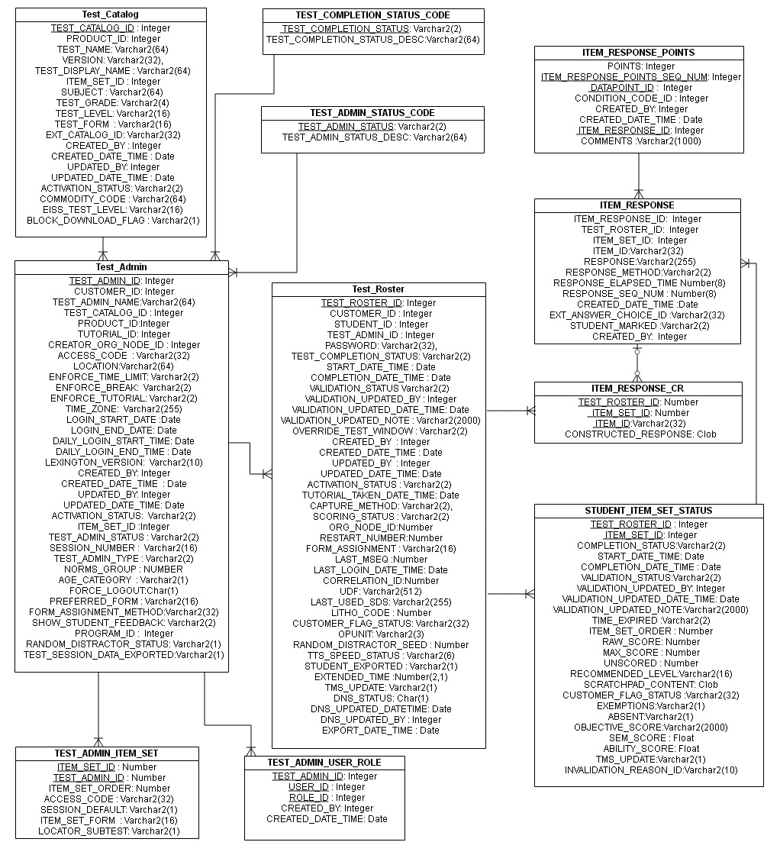

Figure Error! No text of specified style in document.‑6: Data Model Test Session

**Data Model Test Session -**

The “TEST_CATALOG” table holds all the tests that are published according to product. When a test session is scheduled one entry goes to the “TEST_ADMIN” table for the session. This table holds test session related details such as access_code, login_start_time, login_end_time etc. A test session can have different test_admin_status based on the session is current, future or past (CU, FU, PA). The different test_admin_status codes are present in the master table “TEST_ADMIN_STATUS_CODE”. The “TEST_ADMIN_ITEM_SET” table contains the Subtest (TS) level item_sets that are scheduled in a session. The “TEST_ADMIN_USER_ROLE” table shows the role of the user who creates the test session. Students are added to the session as test sessions are created. For each student added to a session a new entry is created in the “TEST_ROSTER” table. This table holds roster level details such as student's login password, completion_date_time, last_login_date_time etc. The “STUDENT_ITEM_SET_STATUS” table contains the Deliverable Unit (TD) level item_sets that are scheduled for a student. It also holds the completion_status of each TD level item_set, validation_status, absent/exemption status etc. The student response are stored in “ITEM_RESPONSE” and “ITEM_RESPONSE_CR” table. When handscoring is done then the scores are stored in “ITEM_RESPONSE_POINTS” table.

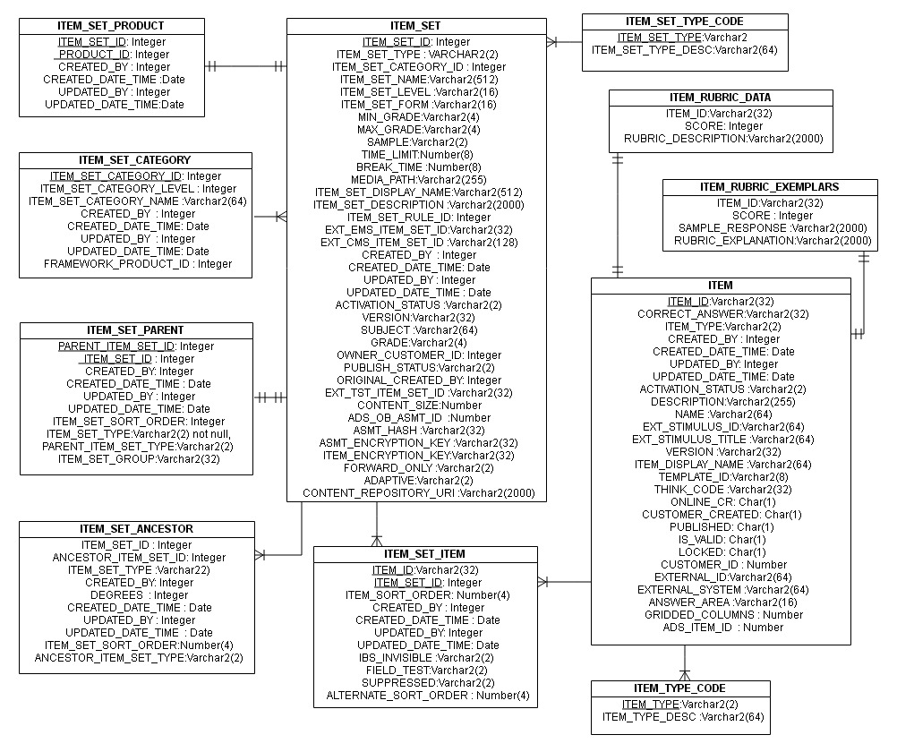

Figure Error! No text of specified style in document.‑7: Data Model Items

**Data Model Items -**

The test structure is divided in different levels such as – TC, TS, TD, RE. These are called item sets. The “ITEM_SET” table stores all these item sets. The item sets belong to different products. The relation between product and item_set is shown in the “ITEM_SET_PRODUCT” table. The item_sets can belong to different categories (Such as, TC, TS, TD etc.). The category details are stored in the “ITEM_SET_CATEGORY” table. The item_sets have parent child relationship among them. For example, 'TS' is the child of a 'TC' and parent of 'TD'. The “ITEM_SET_ANCESTOR” table holds the parent-child relationship among all the item_sets, whereas the “ITEM_SET_PARENT” table holds only the immediate parent-child relationship between two item_sets. The “ITEM_SET_TYPE_CODE” table is the master table that describes the different item_set_type_codes (TC, TS etc.). The “ITEM” table stores the individual items (i.e. questions). The “ITEM_SET_ITEM” table depicts the relationship among the item_sets and items. Items can be of different types (SR, CR etc.). These item_type_codes are described in the master table “ITEM_TYPE_CODE”. There are two tables named “ITEM_RUBRIC_DATA” and “ITEM_RUBRIC_EXEMPLARS”. These two tables store instructions and ideal responses which are used when handscoring is done.

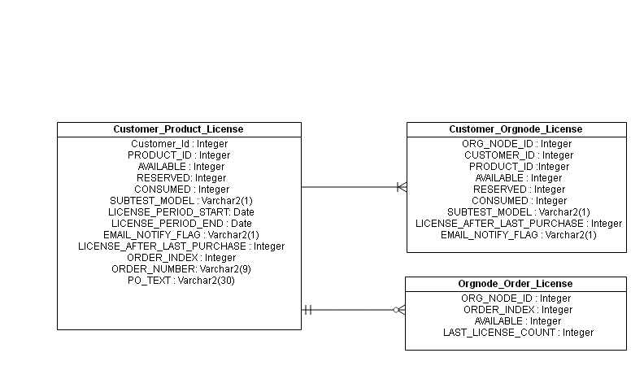

Figure Error! No text of specified style in document.‑8: Data Model License

**Data Model License -**

The License feature mainly uses three tables - “CUSTOMER_PRODUCT_LICENSE”, “CUSTOMER_ORGNODE_LICENSE” and “ORGNODE_ORDER_LICENSE”. When license is given to a customer the primary information is stored in the “CUSTOMER_PRODUCT_LICENSE” table. This table is used for both TABE and LASLINKS customers. For LASLINKS this table also holds the purchase order details. The “CUSTOMER_ORGNODE_LICENSE” table stores the license detail for each org_node of a customer. This table is also used for TABE and LASLINKS customers. The “ORGNODE_ORDER_LICENSE” table is used to store license information combined with the purchase orders. This table is used for LASLINKS only. So, for TABE this table does not hold any data.