The Application of Artificial Intelligence Algorithms in E-Learning: Personalization and Automation of Educational Processes
Marcin Albiniak
Introduction

Contemporary education is undergoing a profound transformation, driven by the rapid advancement of digital technologies that increasingly shape modern instructional models. One of the most prominent manifestations of this transformation is the development of e-learning, defined as remote education facilitated by internet-based platforms. E-learning not only provides ubiquitous access to knowledge regardless of time and place but also addresses the growing societal demand for flexibility, individualization, and scalability in educational processes. In an era of globalization and the rapid expansion of knowledge-based economies, online education is gaining strategic importance across formal education systems, professional training, and lifelong learning sectors (Zawacki-Richter et al., 2019 (Zawacki-Richter et al., 2019); Bond et al., 2018 (Bond et al., 2018)).

Figure 1. Evolution of e-learning from traditional to AI-driven methods.
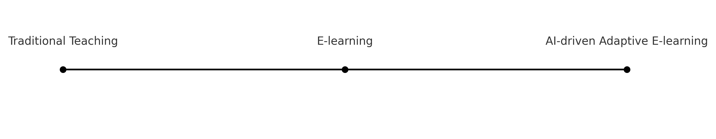
Parallel to the expansion of e-learning, the field of Artificial Intelligence (AI) has witnessed accelerated development, with its algorithms being increasingly integrated across various domains of social and economic life. Within the educational sphere, AI opens new perspectives for enhancing the learning process by automating many tasks traditionally performed by instructors, such as assessment, progress monitoring, or content recommendation (Chen et al., 2020 (Chen et al., 2020); Holmes et al., 2019 (Holmes et al., 2019)). Furthermore, AI introduces a unique potential for the personalization of instruction in e-learning environments by dynamically adjusting the pace, scope, and format of educational content to the individual needs, preferences, and learning styles of each learner (Pérez-Marín, 2021 (Pérez-Marín, 2021)).
However, the application of AI in e-learning extends far beyond the simple support of didactic processes. AI is becoming the foundation of a new generation of educational systems capable of not only dynamically analyzing user learning data but also predicting potential difficulties, proposing personalized learning pathways, and adapting instructional methods in real time (Luckin et al., 2016 (Luckin et al., 2016); Griffiths et al., 2022 (Griffiths et al., 2022)). Examples of such applications include intelligent recommendation systems, educational chatbots, competency gap detection tools, and automated test generators, all of which are increasingly integrated into modern e-learning platforms (Winkler & Söllner, 2018 (Winkler & Söllner, 2018); Roll & Wylie, 2016 (Roll & Wylie, 2016)).
The purpose of this chapter is to examine how AI algorithms contribute to two key aspects of e-learning development: the personalization and automation of educational processes. Specifically, the chapter explores the role of AI in tailoring instructional content and delivery to the individual learner and in automating tasks that traditionally required significant involvement from teachers and mentors. Particular attention is devoted to learning analytics mechanisms, adaptive systems, and the challenges and limitations associated with AI implementation in digital learning environments. This analysis aims to provide a deeper understanding of the potential and future directions of AI technologies in the context of digital education.

Artificial Intelligence in Education: Fundamental Concepts
Figure 2. Concept map of AI applications in education.
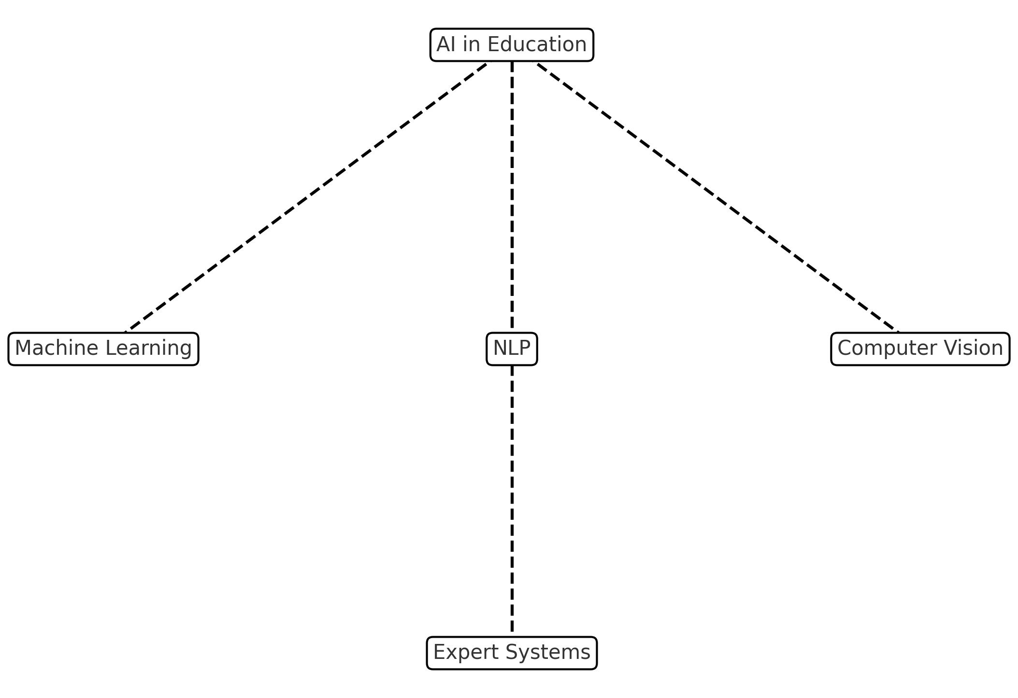
Artificial Intelligence (AI) constitutes an interdisciplinary research domain encompassing methods and technologies designed to enable machines to perform tasks that traditionally require human-like intelligence. The classical definition of AI, proposed by John McCarthy, characterizes it as “the science and engineering of making intelligent machines” (McCarthy, 2007 (McCarthy, 2007)). Within the educational context, AI refers to systems capable of analyzing educational data, supporting pedagogical decision-making, and interacting with users in adaptive and personalized ways.
Among the core algorithms employed in AI systems, machine learning (ML) plays a central role, enabling models to improve their performance through the analysis of historical data. Tasks such as classification, regression, and clustering are widely applied in student performance analysis and in predicting educational behaviors (Zawacki-Richter et al., 2019 (Zawacki-Richter et al., 2019)). An advanced branch of ML involves artificial neural networks (ANNs), computational structures inspired by the human brain. ANNs have been utilized in image recognition, educational analytics, and the modeling of learning processes (Chen et al., 2020 (Chen et al., 2020)).
An increasingly significant area of AI in education is Natural Language Processing (NLP), which allows machines to understand, analyze, and generate human language. NLP technologies are integral to intelligent tutoring systems, educational chatbots, automated essay scoring systems, and personalized content recommendation engines. For example, the OpenEssayist system structurally analyzes student essays and provides guidance on improving argumentation and logical coherence (Whitelock et al., 2014 (Whitelock et al., 2014)).
Commercial platforms also integrate AI technologies into educational applications. Socratic by Google combines NLP and image recognition to analyze student-photographed assignments and generate contextual hints with explanations. Content Technologies Inc. develops AI-driven systems that automatically generate personalized digital textbooks based on user profiles. Another prominent example is Duolingo, which employs machine learning models to dynamically adjust the difficulty of language tasks and predict the probability of a correct student response.
Applications of AI in education are diverse and growing. Intelligent Tutoring Systems (ITS), for instance, analyze student interactions with educational content and adapt the level of difficulty and delivery format to individual learner needs (Woolf, 2010 (Woolf, 2010)). Learning analytics systems leverage AI algorithms to identify students at risk of failure and to predict the effectiveness of specific instructional strategies. Meanwhile, educational chatbots, such as Jill Watson developed at the Georgia Institute of Technology, are capable of answering student queries in virtual courses, significantly reducing the workload of instructors (Goel & Polepeddi, 2016 (Goel & Polepeddi, 2016)).
Figure 1 presents the most commonly cited applications of AI in e-learning, as identified in the UNESCO report (2021):
Figure 1. Applications of AI in e-learning (based on UNESCO, 2021 (UNESCO, 2021))
- 35% — Personalization of learning pathways
- 25% — Automated assessment of assignments
- 15% — Content recommendation systems
- 10% — Chatbots and virtual assistants
- 15% — Prediction of learning success and learning analytics
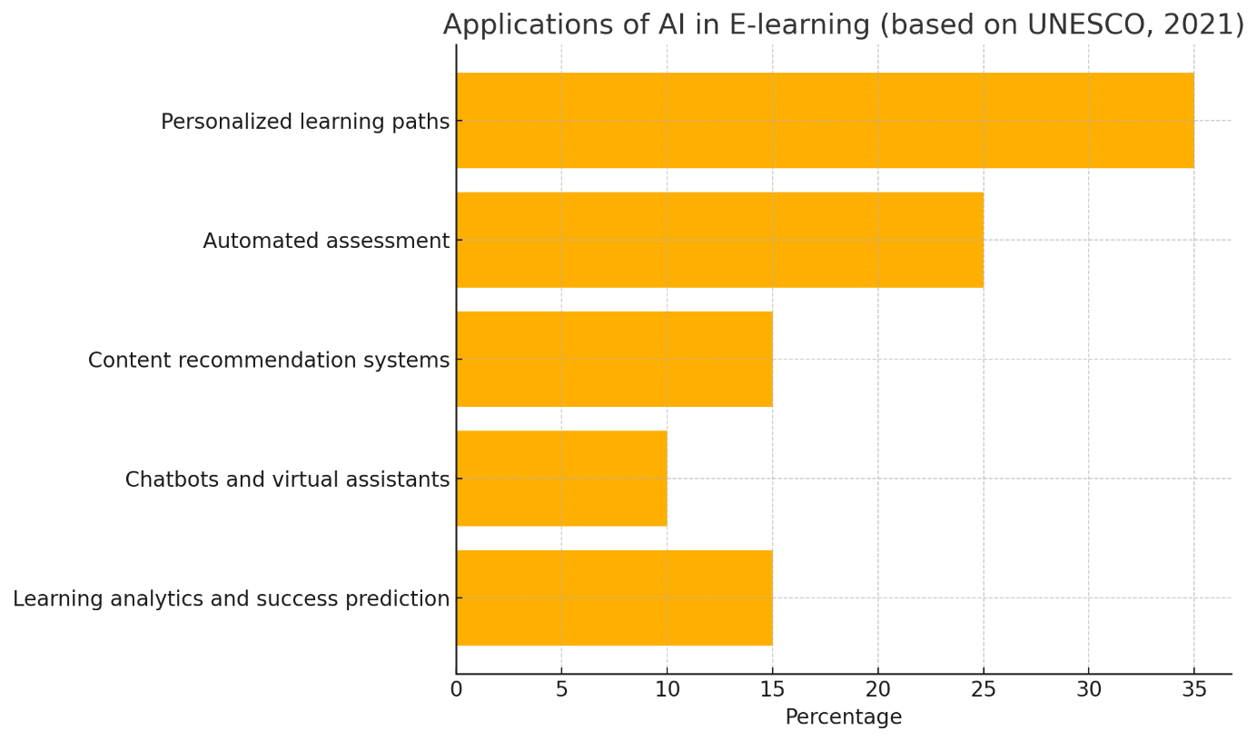
The dynamic development and increasing accessibility of AI algorithms are transforming these technologies into integral components of modern educational ecosystems. When applied effectively, AI unlocks new opportunities for personalizing instruction, automating educational processes, and optimizing learning pathways, ultimately contributing to improved efficiency and quality of education.

Adaptive Educational Systems
Figure 3. Flow diagram of adaptive educational system.
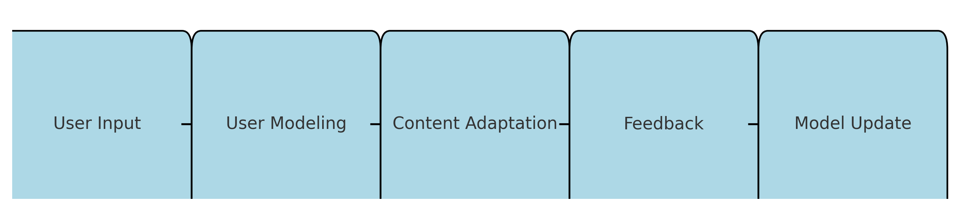
Adaptive educational systems represent a significant advancement in the field of e-learning, enabling personalized and dynamic adjustment of educational content, methods, and pathways to the unique needs and preferences of individual learners. These systems leverage artificial intelligence (AI) and machine learning (ML) algorithms to continuously analyze learner behavior, performance, and engagement data, adapting the instructional process in real time to maximize learning outcomes and maintain student motivation.
The Concept of Adaptive Educational Systems
Adaptive educational systems, also known as adaptive learning environments, are designed to provide customized learning experiences by adjusting various components of the educational process based on the learner’s profile. This profile typically includes prior knowledge, learning pace, preferences, cognitive abilities, and even emotional states. By incorporating AI-driven analytics, adaptive systems monitor learners’ interactions with content, analyze their progress, and identify areas requiring additional support or alternative instructional strategies (Brusilovsky & Millán, 2007 (Brusilovsky & Millán, 2007)).
The core functionality of adaptive systems relies on the integration of user modeling, content adaptation, and real-time feedback mechanisms. User modeling involves creating dynamic profiles of learners that evolve as the system gathers more data on their behaviors and achievements. Content adaptation refers to modifying the sequence, difficulty, and presentation of learning materials based on the user model. Finally, real-time feedback ensures that learners receive immediate guidance, corrections, and recommendations, fostering a more effective and engaging learning experience.
How Algorithms Tailor Content to Individual Learners
The ability of adaptive systems to personalize the learning experience is largely driven by sophisticated AI and ML algorithms. These algorithms process large volumes of learning data, including quiz results, time spent on tasks, interaction patterns, and even physiological signals in more advanced systems (e.g., eye tracking or heart rate monitoring).
One common approach is the use of reinforcement learning models, where the system treats the learner’s progress as a sequence of actions and outcomes, adjusting future recommendations based on observed success rates. Bayesian networks are also widely utilized to estimate the learner’s knowledge state and predict the probability of correct answers, enabling the system to select the most appropriate next task or concept to reinforce understanding.
For example, systems can detect when a learner struggles with a particular concept and automatically provide additional resources, simplified explanations, or alternative learning paths. Conversely, if a student demonstrates proficiency, the system may accelerate content delivery or introduce more complex problems to maintain an optimal challenge level—a phenomenon known as the "zone of proximal development" (Vygotsky, 1978 (Vygotsky, 1978)).
Natural Language Processing (NLP) algorithms further enhance adaptability by enabling systems to interpret open-ended responses, essays, or dialogue interactions. Such capabilities allow the system to generate contextual feedback, suggest related resources, or engage the learner in a simulated conversation to deepen understanding.
Case Studies: Examples of Adaptive Platforms
Numerous educational platforms have successfully implemented adaptive learning technologies, illustrating the practical benefits of this approach across various educational contexts.
1. Knewton Alta
Knewton Alta is a well-known adaptive learning platform primarily used in higher education. It utilizes data-driven models to assess student proficiency in real-time and dynamically adjust content delivery. As students work through exercises, the system analyzes their responses and determines the knowledge gaps, immediately offering supplementary materials or prerequisite reviews. Studies have shown that Knewton’s adaptivity significantly improves student retention and course completion rates, particularly in STEM subjects (Knewton, 2020 (Knewton, 2020)).
2. DreamBox Learning
Targeted at K-8 mathematics education, DreamBox Learning combines intelligent adaptive engines with engaging game-based environments. The system continuously collects over 48,000 data points per student per hour, analyzing factors such as problem-solving strategies, errors, and time on task. Based on this analysis, DreamBox adjusts the difficulty and sequencing of math problems, providing just-in-time scaffolding and challenges that cater to each student’s mathematical understanding and learning pace (Pane et al., 2015 (Pane et al., 2015)).
3. ALEKS (Assessment and Learning in Knowledge Spaces)
ALEKS is an adaptive learning platform rooted in knowledge space theory and Bayesian modeling. It offers personalized learning paths by continuously assessing what a student knows and what they are ready to learn next. ALEKS is widely used in mathematics and chemistry courses to optimize learning sequences, helping students focus on topics that yield the greatest learning gains. Research indicates that ALEKS effectively reduces time to mastery and improves long-term retention (Falmagne et al., 2013 (Falmagne et al., 2013)).
4. Smart Sparrow
Smart Sparrow provides an adaptive e-learning platform that enables educators to design custom adaptive pathways and rich interactive content. Unlike fully automated systems, Smart Sparrow offers instructor-driven adaptivity, allowing educators to define specific triggers and responses based on student input. This hybrid model empowers teachers while leveraging AI to enhance the learning experience dynamically.
5. Duolingo
Although widely recognized as a language-learning app, Duolingo exemplifies adaptive system principles by using AI algorithms to personalize vocabulary and grammar exercises. The system predicts the likelihood of a user recalling a word or concept and schedules reviews accordingly, optimizing retention through spaced repetition. Duolingo’s adaptive engine keeps learners engaged by balancing difficulty and success, which is critical for language acquisition (Settles & Meeder, 2016 (Settles & Meeder, 2016)).
Adaptive educational systems represent a transformative application of artificial intelligence in e-learning. By continuously analyzing learner data and dynamically adjusting content, these systems create personalized learning experiences that enhance engagement, efficiency, and effectiveness. From K-12 education to higher education and corporate training, adaptive platforms demonstrate measurable improvements in learning outcomes, offering promising avenues for future educational innovations.
However, the implementation of adaptive systems also raises challenges, including concerns about data privacy, algorithmic bias, and the need for transparency in adaptation mechanisms. Ensuring that adaptive technologies serve educational goals ethically and inclusively remains a key priority for researchers and practitioners.

Automation of Educational Processes
Figure 4. Distribution of AI applications in e-learning.
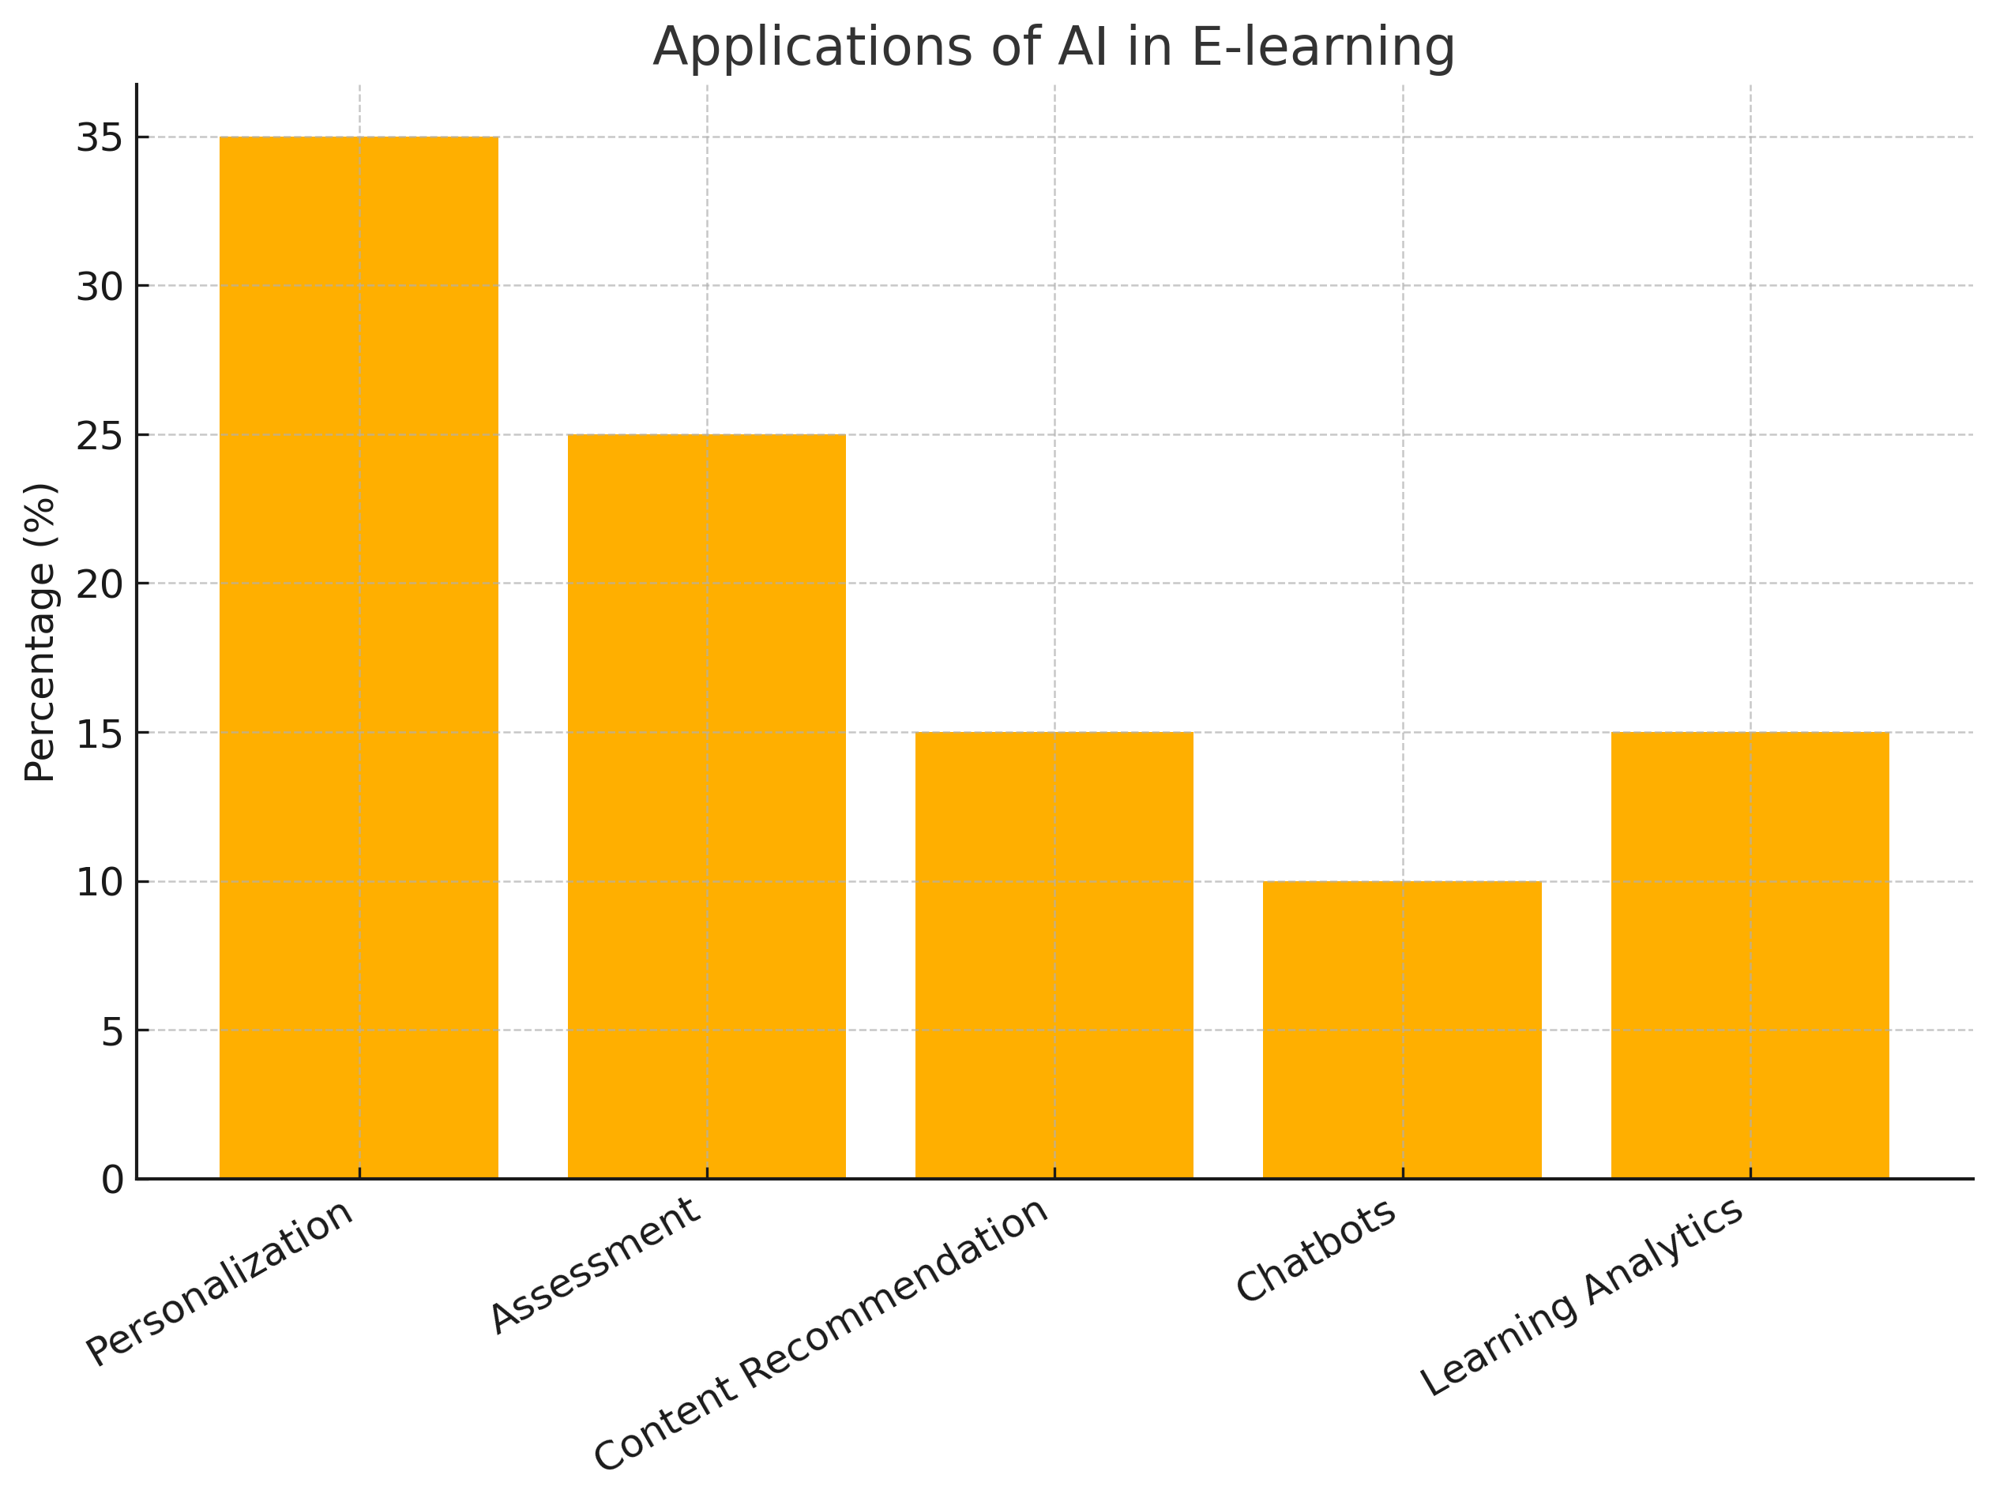
The integration of artificial intelligence (AI) into e-learning has profoundly transformed educational processes, particularly in the domain of automation. Tasks traditionally performed by educators—such as assessment, feedback generation, content recommendation, and answering student inquiries—are increasingly being supported or fully automated by AI-driven systems. Automation not only reduces the workload for teachers but also enhances scalability, consistency, and real-time responsiveness in digital learning environments.
Automated Grading of Assignments and Tests
One of the most prominent applications of AI in automating educational processes is automated grading. AI-driven assessment tools are capable of evaluating both structured and unstructured responses, ranging from multiple-choice tests to essays and mathematical problem-solving tasks.
Machine learning algorithms, especially natural language processing (NLP) models, enable systems to analyze written content for grammar, coherence, argumentation quality, and conceptual correctness. Systems like OpenEssayist or e-rater® by ETS exemplify this approach, providing students with instant formative feedback on their writing and assisting teachers in grading large volumes of submissions (Whitelock et al., 2014 (Whitelock et al., 2014)).
In STEM education, automated systems assess mathematical derivations, code correctness, or physics simulations. Platforms such as CodeRunner evaluate programming assignments by running student code against predefined test cases, ensuring objectivity and scalability in assessment. Similarly, MyLab Math by Pearson provides instant feedback on mathematical exercises, guiding students toward correct solutions through hints and scaffolded steps.
The benefits of automated grading systems are substantial:
- Scalability: Capable of handling thousands of submissions simultaneously.
- Consistency: Eliminates subjective biases and grading inconsistencies.
- Timeliness: Provides immediate feedback, reinforcing learning at the moment of knowledge construction.
- Data generation: Creates detailed performance analytics, aiding instructors in identifying learning gaps.
However, challenges remain, particularly in evaluating creativity, critical thinking, or nuanced argumentation. Hybrid models that combine AI-based initial grading with human oversight are increasingly recommended to maintain assessment quality.
Educational Chatbots: Functions and Benefits
Another rapidly developing area of automation in e-learning is the use of educational chatbots—AI-powered conversational agents designed to interact with learners in natural language. These bots perform a wide range of functions that traditionally required instructor involvement.
Educational chatbots can:
- Answer frequently asked questions (FAQs) about course content, deadlines, and logistics.
- Provide personalized explanations of complex topics.
- Facilitate self-assessment by posing quiz questions and delivering instant feedback.
- Recommend additional resources based on learner queries and performance.
- Maintain engagement through reminders, motivational messages, and gamified interactions.
A notable example is "Jill Watson", a virtual teaching assistant developed at Georgia Institute of Technology. Powered by IBM Watson, Jill was deployed in an online course to answer student questions in discussion forums, achieving high accuracy and student satisfaction (Goel & Polepeddi, 2016 (Goel & Polepeddi, 2016)). Students often could not distinguish the bot from a human instructor, showcasing the potential of AI-driven conversational agents in education.
The benefits of educational chatbots include:
- 24/7 availability: Ensures continuous support regardless of time zones or instructor availability.
- Instant responses: Reduces learner frustration by eliminating waiting times for answers.
- Personalization: Adapts responses based on user profiles and interaction history.
- Scalability: Supports massive open online courses (MOOCs) with thousands of participants.
Nevertheless, chatbot design must prioritize pedagogical soundness and ethical considerations, such as data privacy and avoidance of reinforcing biases in AI-generated responses.
Automated Content Recommendation Systems
AI also enables automated content recommendation, enhancing the personalization of learning paths. By analyzing vast datasets on learner behavior, preferences, performance, and even emotional engagement, recommendation engines suggest educational materials most relevant to each student.
Recommendation algorithms, inspired by those used in e-commerce or streaming services, utilize collaborative filtering, content-based filtering, or hybrid approaches to:
- Identify knowledge gaps and recommend targeted readings or exercises.
- Suggest multimedia resources—videos, podcasts, simulations—that match the learner’s style.
- Propose peer discussion groups or learning communities based on shared interests or goals.
Platforms like Coursera and edX employ AI-driven recommendation systems that suggest courses, supplementary materials, or skill paths aligned with learner profiles and career aspirations. Similarly, Knewton Alta dynamically recommends prerequisite reviews or advanced topics based on ongoing learner performance.
Key benefits of AI-driven recommendation systems include:
- Enhanced personalization: Tailors content to the learner’s pace, preferences, and needs.
- Improved engagement: Keeps learners motivated by offering relevant and diverse materials.
- Learning efficiency: Optimizes time-on-task by minimizing irrelevant content exposure.
Despite their advantages, recommendation systems in education must be carefully designed to avoid creating "filter bubbles" that limit exposure to diverse perspectives. Transparency in how recommendations are generated is critical for maintaining learner trust.
The automation of educational processes through AI has ushered in a new era of scalable, efficient, and responsive e-learning environments. Automated grading systems, educational chatbots, and content recommendation engines collectively enhance the learning experience while reducing the administrative burden on educators.
By providing immediate feedback, personalized support, and adaptive content delivery, these systems foster deeper engagement and more effective learning. However, their design and deployment must carefully balance efficiency with pedagogical integrity, ensuring that automation enhances rather than diminishes educational quality.
Future research should explore integrating these systems within holistic learning ecosystems that combine human and AI strengths, ensuring ethical, equitable, and impactful applications in education.

Educational Data Analytics
Figure 5. Types of educational data collected for analysis.
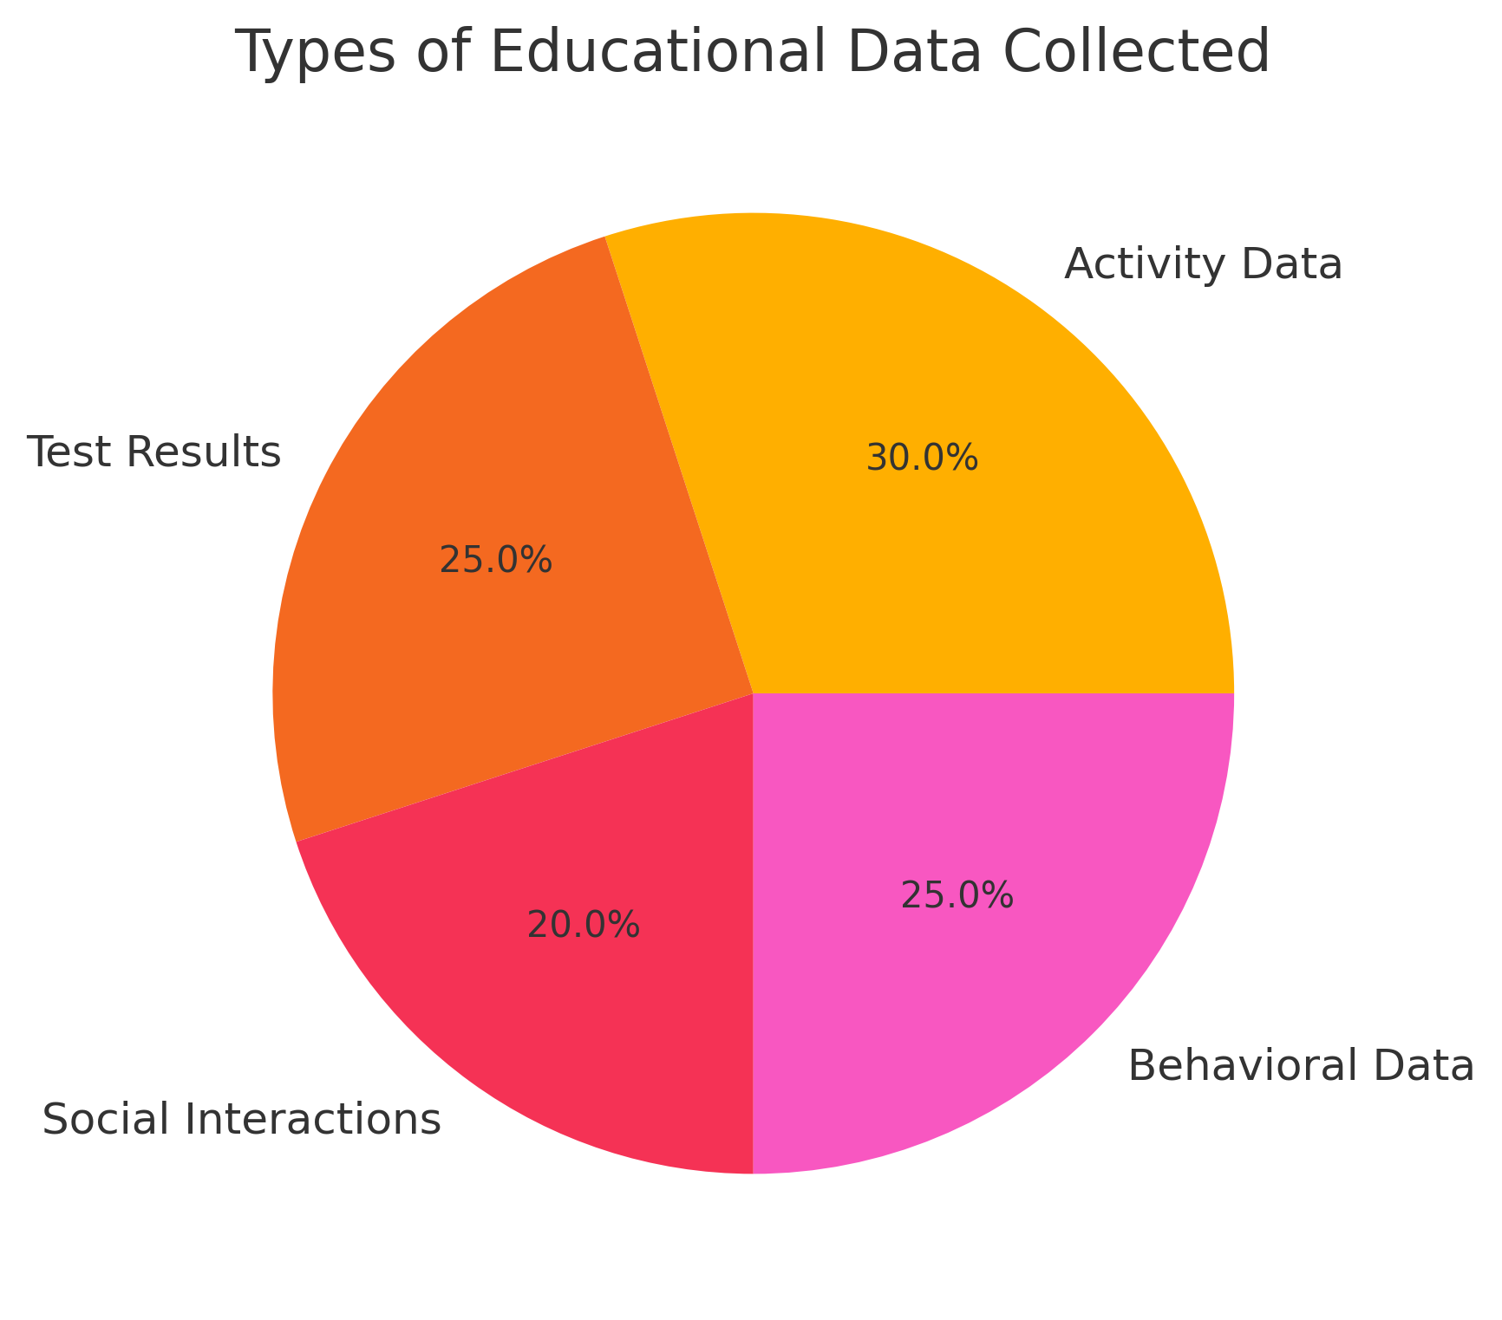
The rapid development of digital learning environments has resulted in the generation of vast amounts of educational data, encompassing every learner's interaction with content, assessments, and social activities within online platforms. Educational Data Analytics (EDA), often referred to as Learning Analytics (LA), has emerged as a key area of artificial intelligence (AI) application in e-learning. Its primary objective is to leverage data to improve teaching effectiveness, personalize learning pathways, and support evidence-based decision-making in education.
The Role of Data Analytics in Enhancing Learning Effectiveness
Educational data analytics involves collecting, processing, and interpreting data generated by learners in digital environments. This data-driven approach allows educators and AI systems to gain deep insights into learning behaviours, preferences, and challenges, ultimately enhancing the efficiency and quality of instruction.
Key benefits of educational data analytics include:
- Identifying learning patterns: Analysis of engagement metrics, completion rates, and time-on-task helps detect effective learning strategies and problematic areas.
- Early intervention: Predictive models identify students at risk of dropping out or underperforming, enabling timely support and targeted interventions.
- Optimizing instructional design: Data-driven feedback allows continuous improvement of course materials, instructional methods, and assessment strategies.
For instance, platforms like Canvas Analytics or Blackboard Predict provide instructors with dashboards that visualize student progress, enabling proactive teaching decisions. At the system level, institutions use analytics to assess curriculum effectiveness and resource allocation.
Application of Algorithms in Monitoring Student Progress
AI-powered algorithms play a central role in transforming raw educational data into actionable insights. Machine learning models are trained to detect patterns in student activity logs, quiz scores, forum participation, and assignment submissions. These models support:
- Real-time progress monitoring: Continuous analysis of student actions helps track mastery of concepts and knowledge gaps.
- Competency mapping: Algorithms evaluate student performance against learning outcomes, offering precise diagnostics of strengths and weaknesses.
- Personalized recommendations: Based on the analysis, systems propose remedial actions, suggest new resources, or adjust learning paths.
A notable example is Deep Knowledge Tracing (DKT), a recurrent neural network model that predicts future student responses based on historical data, effectively modeling individual learning trajectories (Piech et al., 2015 (Piech et al., 2015)). Such models enable platforms to dynamically adapt difficulty levels and content sequencing.
Moreover, AI-driven dashboards enhance transparency, providing students with self-regulation tools. Learners can monitor their progress, set goals, and reflect on their learning strategies, fostering metacognitive skills critical for lifelong learning.
Ethical Considerations in the Use of Educational Data
While educational data analytics offers significant benefits, it also raises serious ethical concerns that must be addressed to ensure responsible AI deployment in education.
1. Data Privacy and Security
The collection and processing of sensitive educational data, including personal information, performance records, and behavioral patterns, pose risks of data breaches and unauthorized use. Compliance with regulations such as the General Data Protection Regulation (GDPR) is essential to protect student privacy.
2. Algorithmic Bias and Fairness
AI models trained on biased datasets may reinforce existing inequalities by unfairly assessing students from underrepresented groups or those with different learning styles. Ensuring transparency in algorithmic decision-making and regular auditing of AI systems is crucial to mitigate these risks.
3. Informed Consent and Data Ownership
Learners should be fully informed about what data is collected, how it is used, and who has access to it. Educational institutions must establish clear policies regarding data ownership, storage, and sharing to empower students in controlling their data.
4. Over-surveillance and Autonomy
Excessive data monitoring can lead to a "surveillance culture" that undermines student autonomy and trust. It is vital to strike a balance between effective analytics and preserving the learner's sense of agency and privacy.
Educational data analytics represents a powerful tool for improving teaching and learning processes in digital environments. By harnessing AI algorithms to monitor student progress and optimize instructional strategies, educators can create more effective, personalized, and responsive learning experiences.
However, the ethical deployment of data analytics in education requires careful consideration of privacy, fairness, transparency, and student autonomy. Future research and policy development should focus on establishing robust ethical frameworks that guide the responsible use of educational data, ensuring that AI serves as a tool for empowerment rather than control.

Challenges and Limitations of AI in E-learning
Figure 6. Key ethical challenges in educational AI.
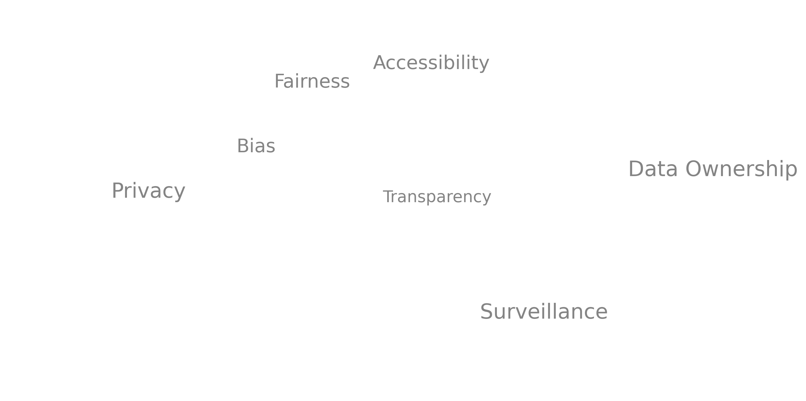
While the integration of Artificial Intelligence (AI) in e-learning offers transformative potential, it also presents several challenges and limitations that require careful consideration by educators, technologists, and policymakers. Addressing these issues is essential to ensure the ethical, effective, and sustainable deployment of AI-driven educational technologies.
Technical Challenges: Algorithm Complexity and Implementation Costs
The development and deployment of AI systems in education are inherently complex and resource-intensive processes. Advanced models such as deep neural networks, natural language processing systems, and recommendation engines require significant computational power, specialized expertise, and continuous maintenance.
1. Algorithmic Complexity
Many AI algorithms used in adaptive learning, automated grading, and data analytics operate as "black boxes," meaning their internal decision-making processes are not easily interpretable. This opacity can hinder educators' understanding of how learning recommendations or assessments are generated, reducing trust in the system. The complexity of AI models also makes debugging, validation, and updates more difficult, potentially leading to unintended instructional consequences.
2. High Development and Maintenance Costs
Creating robust AI-powered educational platforms involves considerable financial investment. Costs include:
- Hiring interdisciplinary teams of data scientists, AI engineers, and education specialists.
- Developing large, high-quality datasets for training models.
- Ensuring cybersecurity and system reliability.
- Regular updates to accommodate new educational standards or curricula.
For many educational institutions, especially in low-resource settings, these costs pose significant barriers to AI adoption. This risks exacerbating existing digital divides, where wealthier institutions have access to advanced AI tools while others fall behind.
Algorithmic Bias and the Risk of Reinforcing Inequalities
AI systems are only as fair as the data and assumptions they are built upon. A critical concern in AI-driven education is algorithmic bias, where systems inadvertently favor certain groups of students or perpetuate existing inequalities.
1. Sources of Bias
Bias can originate from several sources:
- Historical training data that reflects societal inequalities.
- Oversimplified models that fail to capture the diversity of learning styles, cultural contexts, or linguistic backgrounds.
- Design choices that prioritize efficiency over inclusivity.
For example, recommendation systems might suggest advanced content predominantly to students who perform well early, thereby compounding advantages and sidelining learners who initially struggle—a phenomenon known as the "Matthew Effect" in education.
2. Implications for Learners
Biased algorithms can lead to:
- Misclassification of students' abilities.
- Reduced access to challenging or enriching materials for marginalized groups.
- Over-reliance on AI decisions, diminishing human judgment and pedagogical flexibility.
Mitigating algorithmic bias requires deliberate design strategies, including diverse datasets, fairness audits, and continuous monitoring to ensure equitable learning experiences for all students.
Student Data Privacy and Ethical Concerns
AI in e-learning relies heavily on collecting, storing, and processing vast amounts of personal and performance data from students. This data-driven approach raises significant privacy and ethical challenges.
1. Scope of Data Collection
Educational AI systems often gather sensitive information, including:
- Learning behaviors and engagement patterns.
- Assessment results and knowledge profiles.
- Personal identifiers and, in some cases, biometric data (e.g., facial recognition for proctoring).
The potential misuse or breach of such data can have severe consequences, including identity theft, discrimination, or psychological harm.
2. Regulatory Compliance and Data Ownership
Institutions must comply with regulations such as the General Data Protection Regulation (GDPR) or Family Educational Rights and Privacy Act (FERPA), which govern the collection, processing, and sharing of educational data. However, many e-learning platforms operate globally, complicating jurisdictional compliance.
Moreover, issues of data ownership and student consent remain ambiguous. Students often have limited control over how their data is used, shared, or monetized by educational technology providers.
3. Surveillance Risks
The use of AI for monitoring, such as automated proctoring or behavioral tracking, raises concerns about creating surveillance-like environments that undermine student autonomy and trust. Balancing the need for data-driven insights with respect for student privacy is an ongoing challenge.
The adoption of AI in e-learning is accompanied by significant technical, ethical, and social challenges. The complexity and cost of implementing AI systems can limit accessibility and scalability, while algorithmic bias risks reinforcing educational inequalities. Furthermore, the reliance on extensive data collection poses threats to student privacy and autonomy.
Addressing these challenges requires a multidisciplinary approach that combines technological innovation with ethical foresight and robust regulatory frameworks. Educational institutions, AI developers, and policymakers must collaborate to ensure that AI technologies serve as tools for enhancing learning rather than amplifying existing disparities or compromising fundamental rights.

The Future of E-learning with Artificial Intelligence

Figure7. Projected AI adoption in e-learning by 2030.
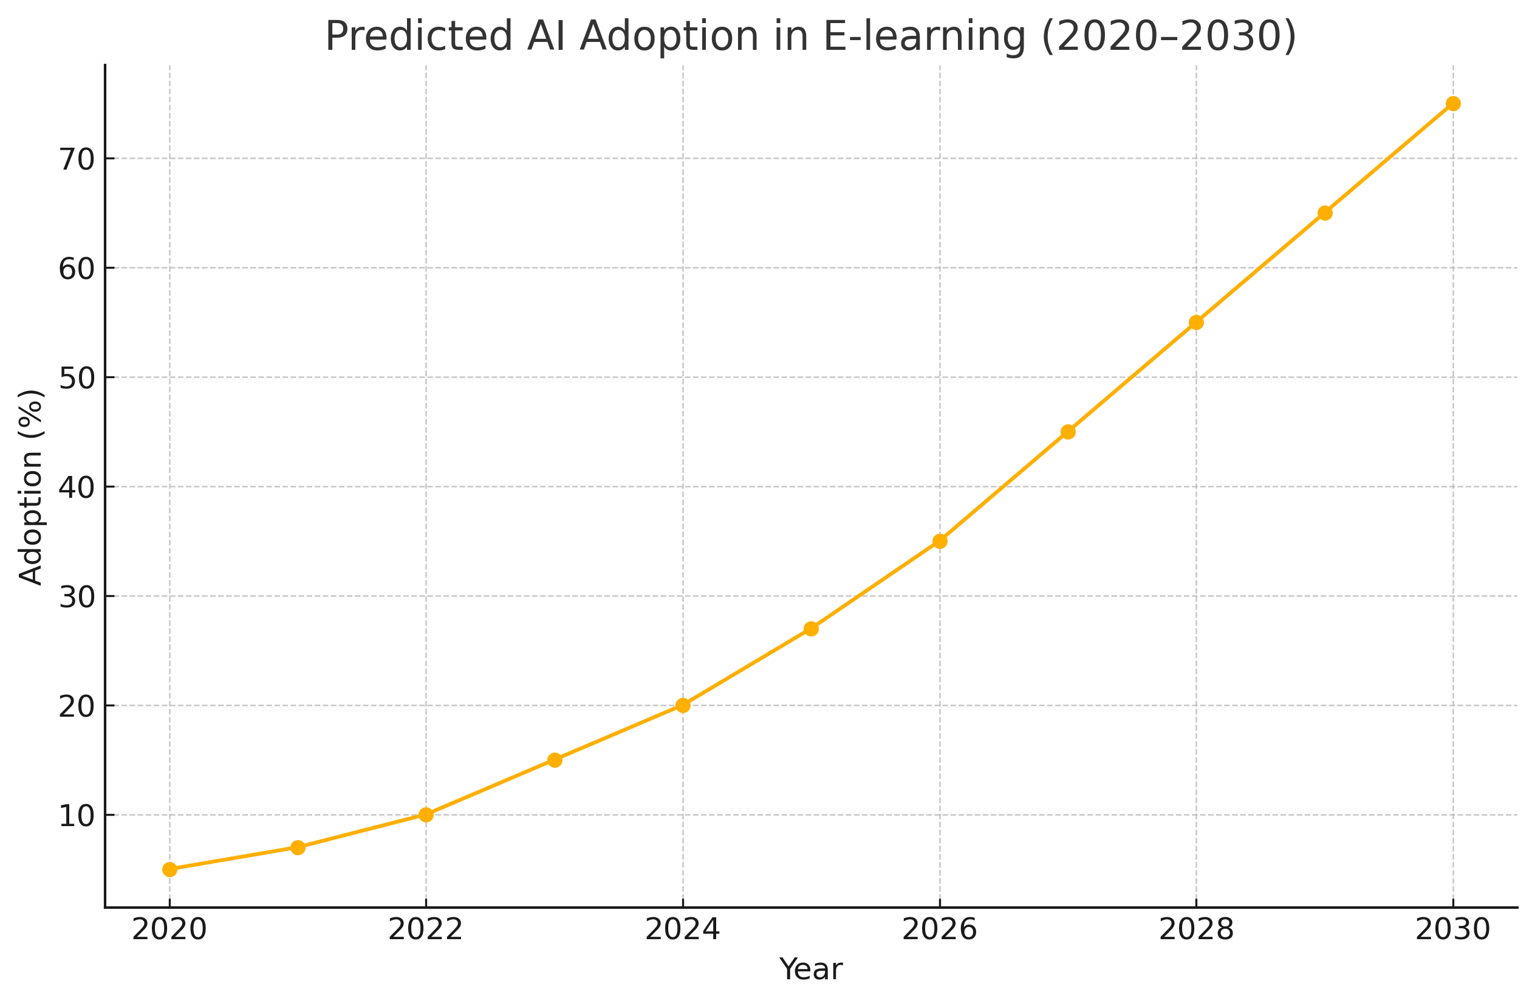
The rapid advancement of Artificial Intelligence (AI) continues to reshape the educational landscape, offering increasingly sophisticated tools for personalizing, automating, and enhancing learning experiences. As AI technologies mature, their integration into e-learning environments promises a transformative future, marked by hyper-personalization, immersive learning experiences, and redefined models of virtual education.
Advancements in Adaptive Technologies
The next generation of adaptive learning systems will leverage increasingly powerful AI models capable of understanding complex learner behaviors, cognitive states, and even emotional engagement. Future systems are expected to move beyond simple performance-based adaptations toward a more holistic approach that incorporates:
- Affective computing to detect learners' emotions, stress levels, or motivation in real time and adjust content delivery accordingly.
- Advanced learner modeling that accounts for prior knowledge, learning preferences, cultural context, and even neurological profiles.
- Predictive analytics that anticipate learning difficulties before they manifest, enabling preemptive support.
For example, AI could analyze voice tones, facial expressions, and eye movements to gauge confusion or frustration, offering instant clarification or switching teaching strategies. This level of personalization will not only improve learning outcomes but also promote learner well-being and sustained motivation.
Adaptive technologies will also evolve to support lifelong learning, tailoring educational pathways dynamically as individuals progress through various stages of their personal and professional lives. Micro-credentialing and just-in-time learning modules will become standard features of future adaptive platforms.
Integration of AI with Virtual and Augmented Reality
The convergence of AI with Virtual Reality (VR) and Augmented Reality (AR) technologies is poised to revolutionize e-learning by creating fully immersive, interactive educational environments.
1. AI-enhanced Virtual Reality Classrooms
VR environments enable learners to experience simulated worlds where they can interact with AI-driven characters, objects, and scenarios. For instance, medical students might practice surgeries on AI-responsive virtual patients, while history students explore historically accurate reconstructions guided by AI-driven narrators.
AI will play a critical role in dynamically generating content, adjusting the difficulty of tasks, and providing personalized feedback in VR settings. These intelligent virtual tutors will monitor learner behavior within the environment and adapt the experience in real time.
2. Augmented Reality for Contextual Learning
AR overlays digital information onto the physical world, allowing learners to interact with real-world objects augmented by AI-driven insights. Examples include:
- AI-guided AR applications that provide step-by-step instructions for complex tasks in engineering or science labs.
- Real-time translation and contextual explanations during language learning or cultural immersion experiences.
By integrating AI, AR systems will be able to personalize the information presented, recommend additional resources, and assess learner performance within authentic contexts.
The Vision of Future Online Classrooms
The future of online classrooms, driven by AI, VR, and AR technologies, envisions a learning space that transcends traditional boundaries of time, space, and pedagogy. Key characteristics of these next-generation virtual classrooms include:
1. Hyper-personalized Learning Journeys
AI will design individualized curricula for each student, dynamically adapting content, pace, and assessment based on real-time performance and long-term learning goals. Learners will have greater autonomy, choosing learning paths that align with their interests, strengths, and career aspirations.
2. AI-powered Collaborative Spaces
Virtual classrooms will feature intelligent collaboration tools that facilitate group projects, discussions, and peer-to-peer learning. AI agents will moderate debates, suggest resources, and ensure inclusive participation, creating equitable and engaging online learning communities.
3. Seamless Integration of Real and Virtual Worlds
Future platforms will enable fluid transitions between physical and digital learning environments. For example, a learner could conduct a real-world experiment while receiving AI-driven guidance through AR glasses, then analyze results within a virtual lab setting.
4. Continuous Assessment and Skill Mapping
Assessment will become an unobtrusive, continuous process embedded within learning activities. AI will map skills acquired in real time, creating dynamic learner profiles that inform both educators and learners about progress and areas for improvement.
5. Ethical AI and Data Governance
As these technologies evolve, ethical frameworks and robust data governance models will be integral. Learners will have greater control over their data, and AI systems will prioritize fairness, inclusivity, and psychological well-being.
The future of e-learning, powered by AI, VR, and AR, holds immense potential to create rich, immersive, and highly personalized educational experiences. Adaptive technologies will become more sophisticated, responding not only to cognitive but also emotional and contextual cues. Virtual classrooms will evolve into intelligent ecosystems where learning is continuous, collaborative, and seamlessly integrated with real-world activities.
However, realizing this vision requires sustained investment in technological infrastructure, interdisciplinary collaboration, and the development of ethical frameworks that ensure AI serves as a tool for empowerment rather than control. By embracing these challenges, the educational community can harness AI’s full potential to create equitable, engaging, and future-ready learning environments.

Final Summary and Conclusions
The integration of Artificial Intelligence (AI) into e-learning marks a significant milestone in the evolution of education, offering unprecedented opportunities for personalization, automation, and scalability. AI-driven systems are reshaping how learners interact with educational content, how educators assess and support students, and how institutions design and deliver learning experiences.
Throughout this study, we have explored the core areas where AI contributes to modern e-learning environments:
- Adaptive learning systems dynamically tailor content and pacing to individual learner needs, promoting personalized and efficient knowledge acquisition.
- Automated processes such as grading, content recommendation, and educational chatbots enhance learning efficiency, reduce teacher workload, and ensure continuous student support.
- Educational data analytics empower instructors with actionable insights for improving course design and learning outcomes, while raising essential ethical considerations around privacy, bias, and data ownership.
- Emerging technologies such as AI integration with Virtual Reality (VR) and Augmented Reality (AR) promise to create immersive, interactive, and hyper-personalized learning environments.
However, these advancements come with significant challenges. Technical complexity, high implementation costs, algorithmic bias, and data privacy risks remain major barriers to widespread adoption. Ethical frameworks and regulatory policies must evolve in parallel to technological progress to ensure responsible and equitable use of AI in education.
The future of e-learning with AI envisions fully immersive, learner-centered environments where education becomes adaptive, continuous, and deeply integrated into everyday life. Achieving this vision requires interdisciplinary collaboration, investment in infrastructure, and a relentless focus on ethical principles that prioritize learner empowerment and well-being.
Artificial Intelligence in e-learning is not merely a technological trend but a transformative force shaping the future of education. With thoughtful implementation, AI holds the potential to make learning more accessible, engaging, and effective for diverse learners worldwide.

Bibliography
Bond, M., Buntins, K., Bedenlier, S., Zawacki-Richter, O., & Kerres, M. (2018). Mapping research in student engagement and educational technology in higher education: A systematic evidence map. International Journal of Educational Technology in Higher Education, 15(1), 1-30. https://doi.org/10.1186/s41239-018-0116-z
Brusilovsky, P., & Millán, E. (2007). User models for adaptive hypermedia and adaptive educational systems. In P. Brusilovsky, A. Kobsa, & W. Nejdl (Eds.), The Adaptive Web (pp. 3-53). Springer. https://doi.org/10.1007/978-3-540-72079-9_1
Chen, L., Chen, P., & Lin, Z. (2020). Artificial Intelligence in Education: A Review. IEEE Access, 8, 75264-75278. https://doi.org/10.1109/ACCESS.2020.2988510
Falmagne, J.-C., Albert, D., Doble, C. W., Eppstein, D., & Hu, X. (2013). Knowledge spaces: Applications in education. Springer Science & Business Media.
Goel, A., & Polepeddi, L. (2016). Jill Watson: A virtual teaching assistant for online education. Georgia Institute of Technology. https://www.cc.gatech.edu/~ashwin/papers/Goel-Polepeddi-AIEd2016.pdf
Griffiths, D., Borthwick, K., & Brna, P. (2022). Artificial intelligence and education futures. British Journal of Educational Technology, 53(3), 443-456. https://doi.org/10.1111/bjet.13173
Holmes, W., Bialik, M., & Fadel, C. (2019). Artificial intelligence in education: Promises and implications for teaching and learning. Center for Curriculum Redesign.
Knewton. (2020). Alta Platform Overview. https://www.knewton.com/alta/
Luckin, R., Holmes, W., Griffiths, M., & Forcier, L. B. (2016). Intelligence unleashed: An argument for AI in education. Pearson Education. https://doi.org/10.13140/RG.2.2.23660.59526
McCarthy, J. (2007). What is artificial intelligence? Stanford University. http://jmc.stanford.edu/articles/whatisai/whatisai.pdf
Pane, J. F., Griffin, B. A., McCaffrey, D. F., & Karam, R. (2015). Effectiveness of Cognitive Tutor Algebra I at Scale. RAND Corporation. https://doi.org/10.7249/RR717
Pérez-Marín, D. (2021). Natural language processing for intelligent tutoring systems. Springer. https://doi.org/10.1007/978-3-030-81396-9
Piech, C., Bassen, J., Huang, J., Ganguli, S., Sahami, M., Guibas, L., & Sohl-Dickstein, J. (2015). Deep Knowledge Tracing. In Advances in Neural Information Processing Systems, 28.
Roll, I., & Wylie, R. (2016). Evolution and Revolution in Artificial Intelligence in Education. International Journal of Artificial Intelligence in Education, 26(2), 582-599. https://doi.org/10.1007/s40593-016-0110-3
Settles, B., & Meeder, B. (2016). A Trainable Spaced Repetition Model for Language Learning. In Proceedings of the 54th Annual Meeting of the Association for Computational Linguistics (Vol. 1, pp. 1848-1858). https://doi.org/10.18653/v1/P16-1174
UNESCO. (2021). AI and education: Guidance for policy-makers. United Nations Educational, Scientific and Cultural Organization. https://unesdoc.unesco.org/ark:/48223/pf0000377074
Whitelock, D., Twining, P., & Harrison, C. (2014). OpenEssayist: A support tool for essay writing. In Proceedings of the 4th Workshop on Intelligent Support for Learning in Groups (pp. 1-6). https://oro.open.ac.uk/39955/
Winkler, R., & Söllner, M. (2018). Unleashing the potential of chatbots in education: A state-of-the-art analysis. In Proceedings of the Academy of Management Annual Meeting. https://doi.org/10.5465/AMBPP.2018.15735abstract
Woolf, B. P. (2010). Building intelligent interactive tutors: Student-centered strategies for revolutionizing e-learning. Morgan Kaufmann.
Zawacki-Richter, O., Marín, V. I., Bond, M., & Gouverneur, F. (2019). Systematic review of research on artificial intelligence applications in higher education – where are the educators? International Journal of Educational Technology in Higher Education, 16(1), 39. https://doi.org/10.1186/s41239-019-0171-0
Vygotsky, L. S. (1978). Mind in society: The development of higher psychological processes. Harvard University Press.

