1.1 Logical Scheme
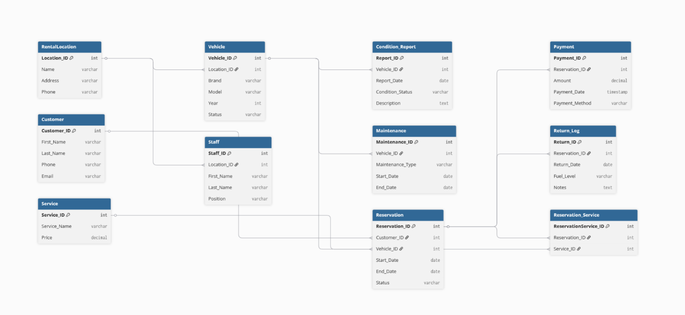

1.2 Objects
Table Description
This database is designed for a Car Rental System.
The system stores information about vehicles, customers, reservations, rental locations, payments, and vehicle maintenance.
It also tracks vehicle return logs, condition reports, and additional services added to reservations.
The database structure follows the Third Normal Form (3NF) to reduce redundancy and maintain data integrity.

Tables
RentalLocation
Table Name | Field Name | Field Description | Data Type / Constraints
RentalLocation | Location_ID | Unique identifier for rental location | Int, PK
 | Name | Name of the rental location | Varchar
 | Address | Address of the location | Varchar
 | Phone | Contact phone number | Varchar

Vehicle
Table Name | Field Name | Field Description | Data Type / Constraints
Vehicle | Vehicle_ID | Unique identifier for vehicle | Int, PK
 | Location_ID | Rental location where the vehicle is stored | Int, FK
 | Brand | Vehicle manufacturer brand | Varchar
 | Model | Vehicle model | Varchar
 | Year | Production year of vehicle | Int
 | Status | Availability status (available, rented, maintenance) | Varchar

Customer
Table Name | Field Name | Field Description | Data Type / Constraints
Customer | Customer_ID | Unique identifier for customer | Int, PK
 | First_Name | Customer first name | Varchar
 | Last_Name | Customer last name | Varchar
 | Phone | Customer phone number | Varchar
 | Email | Customer email address | Varchar

Reservation
Table Name | Field Name | Field Description | Data Type / Constraints
Reservation | Reservation_ID | Unique reservation identifier | Int, PK
 | Customer_ID | Customer who made the reservation | Int, FK
 | Vehicle_ID | Reserved vehicle | Int, FK
 | Start_Date | Reservation start date | Date
 | End_Date | Reservation end date | Date
 | Status | Reservation status | Varchar

Payment
Table Name | Field Name | Field Description | Data Type / Constraints
Payment | Payment_ID | Unique payment identifier | Int, PK
 | Reservation_ID | Related reservation | Int, FK
 | Amount | Payment amount | Decimal
 | Payment_Date | Date of payment | Timestamp
 | Payment_Method | Payment type (card, cash, etc.) | Varchar

Return_Log
Table Name | Field Name | Field Description | Data Type / Constraints
Return_Log | Return_ID | Unique return record | Int, PK
 | Reservation_ID | Related reservation | Int, FK
 | Return_Date | Vehicle return date | Date
 | Fuel_Level | Fuel level when returned | Varchar
 | Notes | Additional notes | Text
Maintenance
Table Name | Field Name | Field Description | Data Type / Constraints
Maintenance | Maintenance_ID | Maintenance record ID | Int, PK
 | Vehicle_ID | Vehicle being serviced | Int, FK
 | Maintenance_Type | Type of maintenance | Varchar
 | Start_Date | Maintenance start date | Date
 | End_Date | Maintenance completion date | Date

Condition_Report
Table Name | Field Name | Field Description | Data Type / Constraints
Condition_Report | Report_ID | Condition report ID | Int, PK
 | Vehicle_ID | Vehicle being inspected | Int, FK
 | Report_Date | Inspection date | Date
 | Condition_Status | Vehicle condition | Varchar
 | Description | Additional notes | Text

Service
Table Name | Field Name | Field Description | Data Type / Constraints
Service | Service_ID | Service identifier | Int, PK
 | Service_Name | Name of service (GPS, child seat) | Varchar
 | Price | Service cost | Decimal

Reservation_Service
Table Name | Field Name | Field Description | Data Type / Constraints
Reservation_Service | ReservationService_ID | Bridge table ID | Int, PK
 | Reservation_ID | Related reservation | Int, FK
 | Service_ID | Added service | Int, FK

Comments on Table Relationships
- One RentalLocation can have many Vehicles and Staff members.
- One Customer can create multiple Reservations.
- Each Reservation is linked to one Vehicle.
- A Reservation can have multiple Services, which creates a many-to-many relationship implemented through the Reservation_Service bridge table.
- Vehicles can have multiple Maintenance records and Condition reports.

Example with Data
for Customer:
Customer_ID | First_Name | Last_Name | Phone | Email
1 | John | Smith | +77010000000 | john@email.com

for Vehicle:
Vehicle_ID | Brand | Model | Year | Status
1 | Toyota | Camry | 2022 | Available

