1. Python Programming

1.1. Create a simple calculator in Python.

first_no=int(input('enter the first number: '))

second_no=int(input('enter the second number: '))

operation=input('enter the operation: supported operations are +, -, *, /:')

if operation=='+':

    print("Addition:",first_no + second_no)

elif operation=='-':

    print('Substraction:',first_no - second_no)

elif operation=='*':

    print('Multiplication:',first_no * second_no)

elif operation=='/':

    if second_no != 0:

        print('Division:',first_no / second_no)

    else:

        print("Error: Division by zero is not allowed")

else:

    print("Invalid operation")

output

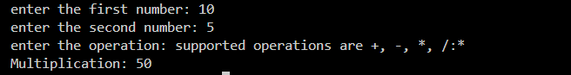

1.2. An electric power distribution company charges domestic customers as

follows: Consumption unit Rate of charge:

1.2.1. 0-200 Rs. 0.50 per unit

1.2.2. 201-400 Rs. 0.65 per unit in excess of 200

1.2.3. 401-600 Rs 0.80 per unit excess of 400

1.2.4. 601 and above Rs 1.00per unit excess of 600

1.2.5. If the bill exceeds Rs. 400, then a surcharge of 15% will be charged,

and the minimum bill should be Rs. 100/-

Create a Python program based on the scenario mentioned above.

def calculate_electricity_bill(units):

    total_bill = 0

    if units <= 200:

        total_bill = units * 0.50

    elif units <= 400:

        total_bill = 200 * 0.50 + (units - 200) * 0.65

    elif units <= 600:

        total_bill = 200 * 0.50 + 200 * 0.65 + (units - 400) * 0.80

    else:

        total_bill = 200 * 0.50 + 200 * 0.65 + 200 * 0.80 + (units - 600) * 1.00

    if total_bill > 400:

        total_bill *= 1.15

    if total_bill < 100:

        total_bill = 100

    return total_bill

units = int(input("Enter the number of units consumed: "))

bill = calculate_electricity_bill(units)

print("The electricity bill is: Rs.", bill)



1.3. Print the pyramid of numbers using for loops.

rows = int(input("Enter the number of rows: "))

for i in range(1, rows+1):

    for j in range(rows-i):

        print(" ", end="")

    for j in range(1, i+1):

        print(j, end=" ")

    print()

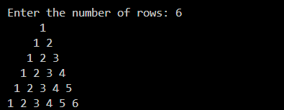

1.4. Write a program to find the number and sum of all integers greater than 100

and less than 200 that are divisible by 7.

count = 0

total_sum = 0

for num in range(101, 200):

    if num % 7 == 0:

        count += 1

        total_sum += num

print("The number of integers greater than 100 and less than 200 that are divisible by 7 is:", count)

print("The sum of these integers is:", total_sum)

Output



1.5. Write a recursive function to calculate the sum of numbers from 0 to 10

def calculate_sum(n):

    if n == 0:

        return 0

    else:

        return n + calculate_sum(n-1)

result = calculate_sum(10)

print("The sum of numbers from 0 to 10 is:", result)



1.6. Write a Python program to reverse the digits of a given number and add them

to the original. If the sum is not a palindrome, repeat this procedure.

def is_palindrome(num):

original_num = num

reversed_num = 0

while num > 0:

digit = num % 10

reversed_num = reversed_num * 10 + digit

num //= 10

return original_num == reversed_num

def reverse_and_add(num):

original_num = num

reversed_num = 0

while num > 0:

digit = num % 10

reversed_num = reversed_num * 10 + digit

num //= 10

return original_num + reversed_num

def main():

num = int(input("Enter a number: "))

while not is_palindrome(num):

num = reverse_and_add(num)

print("The final palindrome is:", num)

if __name__ == "__main__":

main()



1.7. Write a menu-driven program that performs the following operations on

strings

1.7.1. Check if the String is a Substring of Another String

1.7.2. Count Occurrences of Character

1.7.3. Replace a substring with another substring

1.7.4. Convert to Capital Letters

n = 0

while n != 5:

    n = int(input("Enter your choice\n1: Check if the string is a substring of another string\n2: Count the occurrence of a character\n3: Replace a substring with another substring\n4: Convert to capital letters\n5: Exit\n"))

    if n == 1:

        main_string = input("Enter the main string: ")

        sub_string = input("Enter the substring to check: ")

        if sub_string in main_string:

            print(f"'{sub_string}' is a substring of '{main_string}'.")

        else:

            print(f"'{sub_string}' is not a substring of '{main_string}'.")

    elif n == 2:

        main_string = input("Enter the main string: ")

        char = input("Enter the character to count: ")

        count = main_string.count(char)

        print(f"Number of occurrences of '{char}' in '{main_string}': {count}")

    elif n == 3:

        main_string = input("Enter the main string: ")

        old_substring = input("Enter the substring to replace: ")

        new_substring = input("Enter the new substring: ")

        modified_string = main_string.replace(old_substring, new_substring)

        print(f"Modified string: '{modified_string}'")

    elif n == 4:

        main_string = input("Enter the string to convert to capital letters: ")

        capital_string = main_string.upper()

        print(f"String in capital letters: '{capital_string}'")

    elif n == 5:

        print("Exiting the program...")

    else:

        print("Invalid choice. Please enter a number from 1 to 5.")

print("Program ended.")

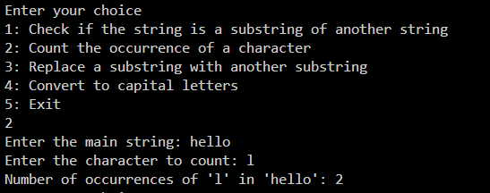

1.8. Write a function to find the factorial of a number but also store the factorials

calculated in a dictionary.

def factorial(n):

    """

    Calculates the factorial of a number and stores the calculated factorials in a dictionary.

    """

    factorials = {}

    def _factorial(x):

        if x in factorials:

            return factorials[x]

        elif x == 0:

            return 1

        else:

            result = x * _factorial(x-1)

            factorials[x] = result

            return result

    return _factorial(n)

print("factorial is:",factorial(5))

print("factorial is:",factorial(10))



1.9. Perform various set operations

1.9.1. Set Union

1.9.2. Set Intersection

1.9.3. Set Difference

def set_union(set1, set2):

    return set1.union(set2)

def set_intersection(set1, set2):

    return set1.intersection(set2)

def set_difference(set1, set2):

    return set1.difference(set2)

# *Example usage:*

if __name__ == "__main__":

    set1 = {1, 2, 3, 4}

    set2 = {3, 4, 5, 6}

    print("Set 1:", set1)

    print("Set 2:", set2)

    choice = 0

    while choice != 4:

        print("\nChoose an operation:")

        print("1: Set Union")

        print("2: Set Intersection")

        print("3: Set Difference")

        print("4: Exit")

        choice = int(input("Enter your choice (1-4): "))

        if choice == 1:

            print("Union of Set 1 and Set 2:", set_union(set1, set2))

        elif choice == 2:

            print("Intersection of Set 1 and Set 2:", set_intersection(set1, set2))

        elif choice == 3:

            print("Difference (Set 1 - Set 2):", set_difference(set1, set2))

        elif choice == 4:

            print("Exiting the program...")

        else:

            print("Invalid choice. Please enter a number from 1 to 4.")

    print("Program ended.")

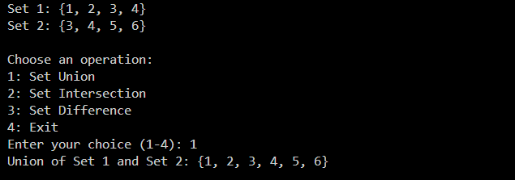

1.10. Create a dictionary to store the name, roll_no, and total_mark of N students.

Now print the details of the student with the highest total_mark.

def main():

    n = int(input("Enter the number of students: "))

    student_dict = {}

    for i in range(1, n + 1):

        print(f"\nEnter details for student {i}:")

        name = input("Enter student's name: ")

        roll_no = input("Enter student's roll number: ")

        total_marks = float(input("Enter student's total marks: "))

        student_dict[i] = {

            'name': name,

            'roll_no': roll_no,

            'total_marks': total_marks

        }

    highest_marks_student = None

    highest_marks = -1

    for student_id, details in student_dict.items():

        if details['total_marks'] > highest_marks:

            highest_marks = details['total_marks']

            highest_marks_student = details

    if highest_marks_student:

        print("\nDetails of the student with the highest total marks:")

        print(f"Name: {highest_marks_student['name']}")

        print(f"Roll Number: {highest_marks_student['roll_no']}")

        print(f"Total Marks: {highest_marks_student['total_marks']}")

    else:

        print("\nNo student records found.")

if __name__ == "__main__":

    main()

Output

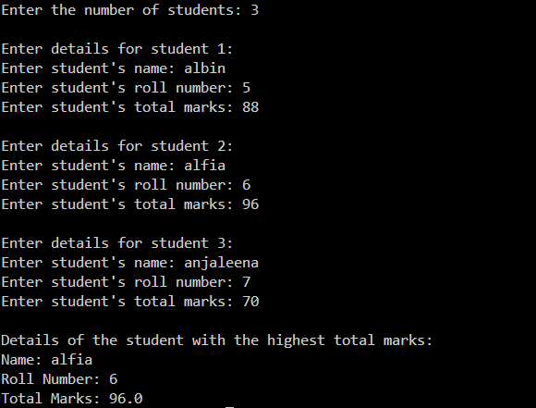

1.11. Write a Python program to copy the contents of a file into another file, line by

line.

1.12. Use the OS module to perform

1.12.1. Create a directory

1.12.2. Directory Listing

1.12.3. Search for “.py” files

1.12.4. Remove a particular file

1.13. Create a simple banking application by using inheritance.