Assignment 1
PCCST501 – Computer Networks
Name: Albin Jumon
Class: S5 CSE A
Roll No: 9
How the Internet Delivers a Web Page
A Case Study on Instagram (www.instagram.com)

1. Draw the TCP/IP protocol stack and explain the role of each layer.
The TCP/IP protocol suite is the foundation of communication on the Internet. It is a hierarchical set of protocols organised into five layers, where each layer is responsible for a specific part of the communication process and relies on the services provided by the layer below it. When a user opens Instagram, every one of these layers plays a part in fetching the feed, photos, and videos that appear on screen.
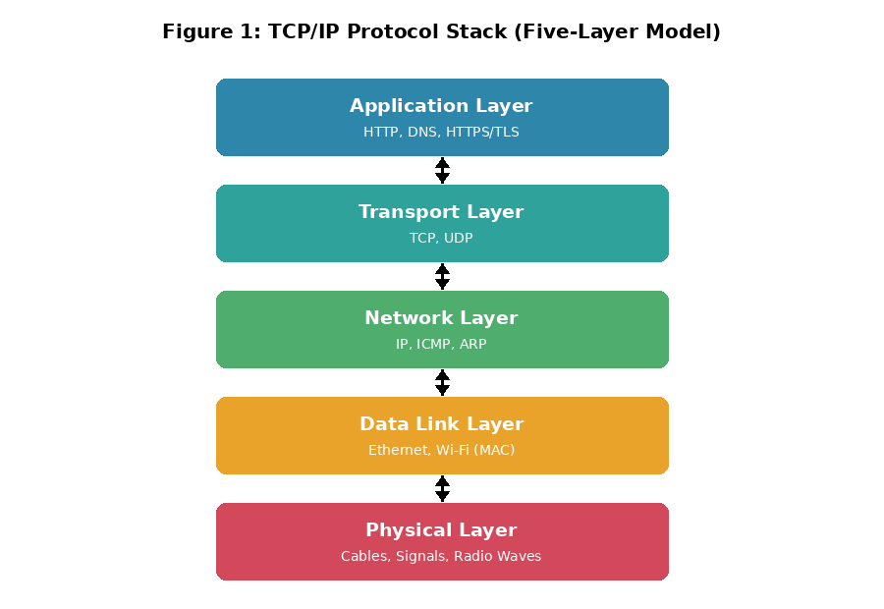
Figure 1: The five-layer TCP/IP protocol stack used to retrieve the Instagram feed.
Application Layer: Provides services directly to the user. When the user opens Instagram, protocols such as HTTP/HTTPS (to fetch the page and media) and DNS (to resolve instagram.com to an IP address) operate at this layer. It is responsible for process-to-process communication between the app/browser and Instagram's servers.
Transport Layer: Responsible for end-to-end delivery of data between the source and destination hosts. TCP is used here to provide reliable, connection-oriented, ordered delivery of the HTTPS request and response, including flow control and error control, which matters when loading photos and reels without corruption.
Network Layer: Responsible for host-to-host delivery of packets (datagrams) across the internet using IP addresses. The IP protocol determines the best path/route for each packet from the user's device to Instagram's servers, possibly through multiple routers and Meta's own backbone network.
Data Link Layer: Responsible for hop-to-hop delivery of frames across a single link (e.g., a Wi-Fi or mobile data link) using physical (MAC) addresses. It takes the datagram from the network layer and encapsulates it into a frame for transmission across a specific link.
Physical Layer: Responsible for transmitting raw bits as electrical, optical, or radio signals across the physical transmission medium (Wi-Fi radio waves, mobile network signals, or fibre-optic cable) connecting two adjacent devices.

2. Explain the role of DNS in converting the domain name into an IP address.
Computers communicate using numeric IP addresses, but humans find domain names such as www.instagram.com easier to remember. The Domain Name System (DNS) is a distributed, hierarchical directory service that maps human-readable domain names to their corresponding IP addresses.
When the user types www.instagram.com and presses Enter (or taps the app icon, which performs the same lookup internally), the browser or app invokes a DNS resolver (client) on the local device. If the mapping is not already cached, the resolver queries a local DNS server, which in turn may contact a root server, a top-level domain (.com) server, and finally the authoritative name server for instagram.com — either recursively or iteratively — until the IP address is found. This IP address is then returned to the client, which uses it to establish a connection with Instagram's actual web/edge server. The result is typically cached (using a Time-To-Live value) to speed up future requests to the same domain.

3. Describe how HTTP is used to request and receive the webpage.
Once the client has the IP address of the Instagram server, it uses the HyperText Transfer Protocol (HTTP), specifically its secure form HTTPS, to communicate with the server. HTTP operates on a request-response model over a TCP connection, using well-known port 443 for HTTPS (port 80 for plain HTTP).
The client (HTTP client) sends a GET request message containing the request line (method, URL, and HTTP version) along with header lines specifying details such as accepted content types, authentication tokens, and device type. The Instagram server (HTTP server) processes this request and returns a response message consisting of a status line (e.g., “200 OK”), response headers (such as content type and length), and the body containing the actual content (HTML/JSON data, CSS, JavaScript, photos, and video thumbnails).
Because the Instagram feed contains many embedded objects (profile pictures, post images, reels, stories), the client issues multiple such GET requests, generally reusing a single persistent HTTP/1.1 (or HTTP/2) connection to retrieve them efficiently.

4. Explain how TCP provides reliable communication for HTTP.
HTTP relies on the Transmission Control Protocol (TCP) at the transport layer because TCP is connection-oriented and reliable. Before any HTTP message is exchanged, the client and the Instagram server perform a three-way TCP handshake (SYN, SYN-ACK, ACK) to establish a logical connection and agree on parameters such as buffer size and initial sequence numbers.
TCP ensures reliability for HTTP communication through the following mechanisms:
- Error control: TCP uses sequence numbers and acknowledgements to detect lost or corrupted segments and retransmits them if needed, ensuring complete photos and videos arrive intact.
- Ordered delivery: Since a webpage or media file may be split across multiple TCP segments, sequence numbers allow the receiving side to reassemble the segments in the correct order.
- Flow control: TCP matches the sender's data rate with the receiver's ability to process data, preventing the Instagram server from overwhelming the client's buffer.
- Congestion control: TCP adjusts its sending rate based on network conditions to avoid congestion collapse on the path between client and server.

5. Identify whether the application follows a Client–Server or Peer-to-Peer architecture and justify your answer.
Instagram follows the Client–Server architecture, not a Peer-to-Peer (P2P) architecture.
Justification:
- The service provider is a set of powerful, always-available Instagram/Meta web servers (the server process) that continuously listen for and respond to requests.
- The user's app or browser acts purely as a client — it initiates a request only when needed (e.g., refreshing the feed) and terminates once the required content (post, story, reel) is received.
- All content (photos, videos, profile data, direct messages) is centrally hosted and served from Meta's data centres and Content Delivery Network (CDN) servers, rather than being shared directly between end-user devices as happens in P2P systems such as BitTorrent.
- The roles of client and server are fixed and cannot be interchanged — a user's phone cannot act as an Instagram server, which is a defining characteristic of the client-server paradigm.

6. Compare HTTP and FTP with at least four differences.
Although both HTTP and FTP are standard, client-server application-layer protocols built on top of TCP, they differ in purpose and operation as summarised below:
Basis | HTTP | FTP
Purpose | Used to request and transfer web pages and embedded objects (HTML, images, scripts, videos) as used by Instagram. | Used specifically for transferring (uploading/downloading) files between a client and server.
Connections | Uses a single TCP connection (persistent by default in HTTP/1.1) for both control and data. | Uses two separate TCP connections — a control connection (port 21) and a data connection (port 20).
State | Originally stateless; state is maintained artificially using cookies and session tokens. | Maintains state throughout the session via the control connection (e.g., current directory).
Port Number | Well-known port 80 (HTTP) or 443 (HTTPS, used by Instagram). | Well-known ports 21 (control) and 20 (data).
Data Handling | Optimised for small, quick request/response exchanges of mixed media (photos, reels, JSON data). | Optimised for transferring large files efficiently, with support for ASCII, binary, and different transmission modes.

7. Explain how cookies improve user experience with one real-world example.
HTTP is inherently a stateless protocol — each request and response is treated independently, with no memory of prior interactions. Cookies were introduced to overcome this limitation by allowing a server to store small pieces of information about a client, which the browser/app sends back with every subsequent request to that server.
How it works: When the server first responds to a client, it includes a Set-Cookie header containing a unique identifier. The browser stores this cookie and automatically includes it in the Cookie header of all future requests to the same domain, allowing the server to recognise the returning user.
Real-world example (Instagram): When a user logs into Instagram, a cookie (or session token) stores information such as the login/session state. On the next visit, this cookie allows Instagram to keep the user logged in automatically, remember language and region settings, and personalise the feed and Explore page based on past activity — without requiring the user to log in or reconfigure preferences every time. This significantly improves user experience by making browsing personalised and seamless.

8. Draw a flow diagram showing the complete communication from the browser to the web server and back.
The figure below illustrates the complete communication flow — from the moment the user opens Instagram, through DNS resolution and TCP connection establishment, to the HTTPS request/response exchange and final rendering of the feed.
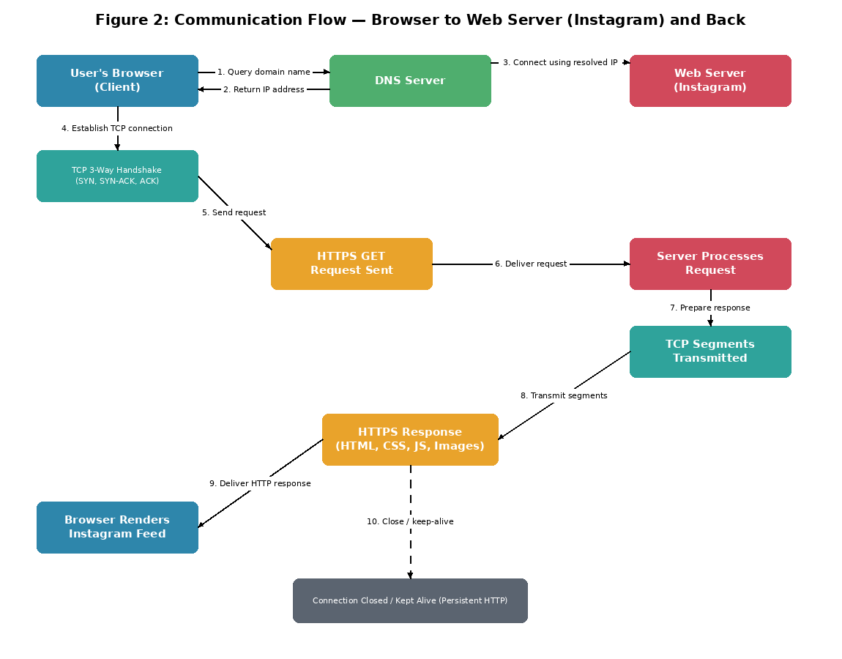
Figure 2: End-to-end communication flow between the client (browser/app) and the Instagram web server.

9. Write a brief conclusion (100–150 words) describing the importance of application-layer protocols in everyday Internet usage.
Application-layer protocols form the backbone of everyday Internet usage, quietly working together to deliver a seamless browsing experience. As demonstrated through the example of accessing Instagram, a single user action — opening the app or typing a URL — triggers a coordinated sequence involving DNS for name resolution, TCP for reliable transport, and HTTP/HTTPS for requesting and delivering content, all built upon the layered TCP/IP architecture. Without these protocols working in harmony, tasks such as browsing feeds, streaming reels, sending direct messages, or uploading photos would be impossible. Furthermore, supporting mechanisms like cookies enhance usability by enabling personalisation and session continuity. Understanding this layered, protocol-driven process highlights how the Internet abstracts immense technical complexity into simple, reliable, and near-instantaneous services that billions of users depend on daily.

