ASSIGNMENT

Submitted by
Albin Mammen Mathew
Roll No : 08

PROJECT – Artificial Intelligence with GenAI

Project Topic: Indian Currency Recognition System using Transfer Learning

Introduction
This project evaluates Deep Learning architectures for Indian currency classification. We compared MobileNetV2 (efficiency-oriented) and ResNet50 (depth-oriented) on a dataset of 8 classes (₹10, ₹20, ₹50, ₹100, ₹200, ₹500, ₹2000, and Background).

Accuracy Comparison
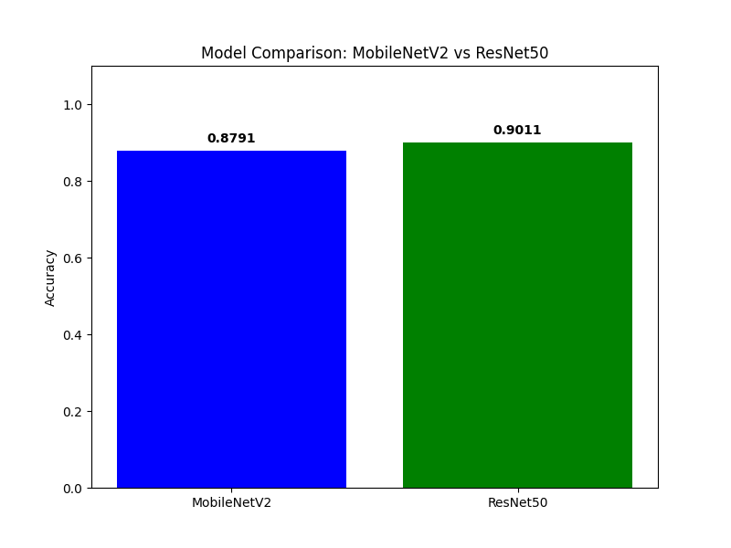

MobileNetV2 - Detailed Metrics
Confusion Matrix:
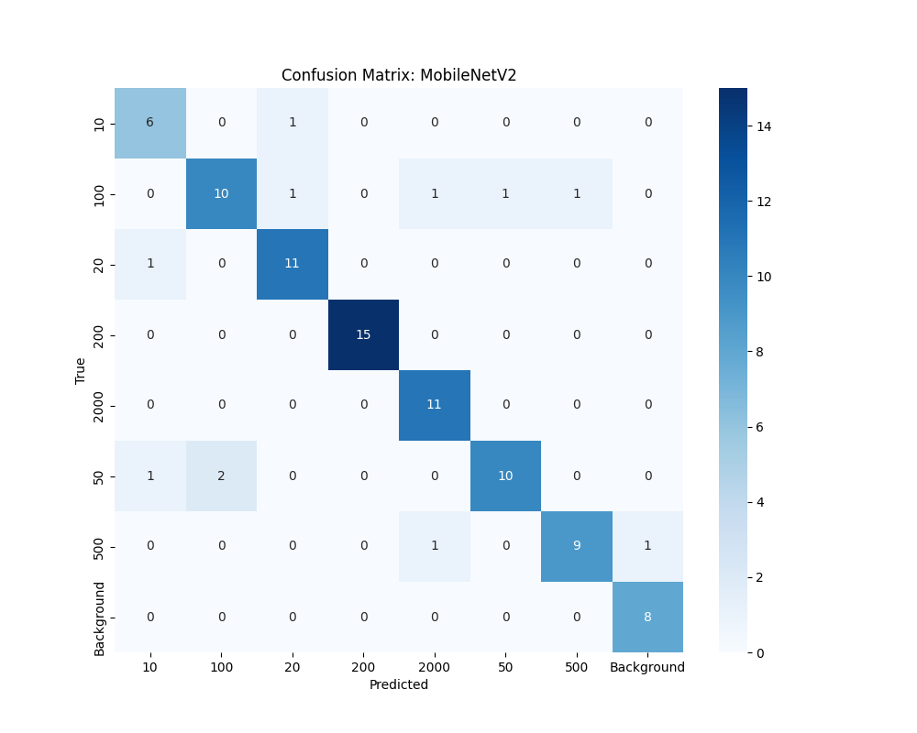

ResNet50 - Detailed Metrics
Confusion Matrix:
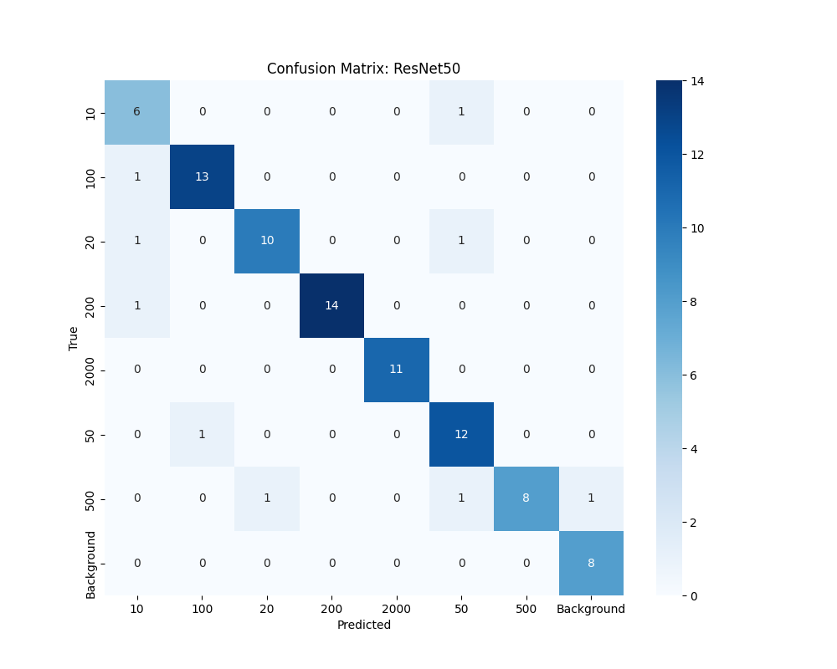

Conclusion
The results demonstrate that both models are highly effective for this task. ResNet50 provides deeper feature extraction, while MobileNetV2 remains a top choice for real-time applications on restricted hardware.

