Final Indian Currency Recognition: Comparative Analysis

1. Executive Summary
This project evaluates Deep Learning architectures for Indian currency classification. We compared MobileNetV2 (efficiency-oriented) and ResNet50 (depth-oriented) on a dataset of 8 classes (₹10, ₹20, ₹50, ₹100, ₹200, ₹500, ₹2000, and Background).

2. Overall Accuracy Comparison
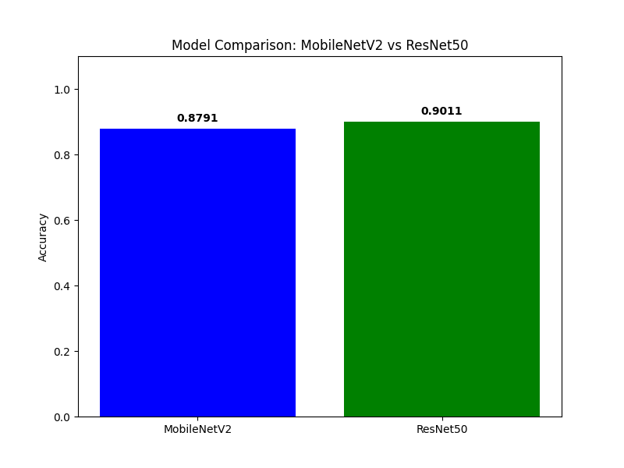

3. MobileNetV2 - Detailed Metrics

Classification Report (Precision, Recall, F1):
precision recall f1-score support
10 0.75 0.86 0.80 7
100 0.83 0.71 0.77 14
20 0.85 0.92 0.88 12
200 1.00 1.00 1.00 15
2000 0.85 1.00 0.92 11
50 0.91 0.77 0.83 13
500 0.90 0.82 0.86 11
Background 0.89 1.00 0.94 8
accuracy 0.88 91
macro avg 0.87 0.88 0.87 91
weighted avg 0.88 0.88 0.88 91

Confusion Matrix:
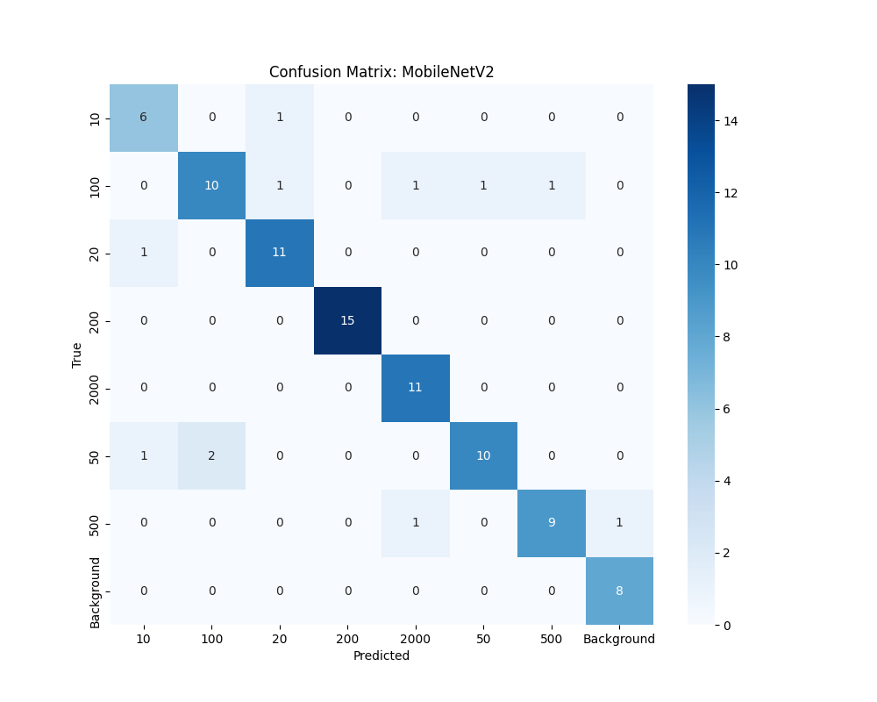

4. ResNet50 - Detailed Metrics

Classification Report (Precision, Recall, F1):
precision recall f1-score support
10 0.67 0.86 0.75 7
100 0.93 0.93 0.93 14
20 0.91 0.83 0.87 12
200 1.00 0.93 0.97 15
2000 1.00 1.00 1.00 11
50 0.80 0.92 0.86 13
500 1.00 0.73 0.84 11
Background 0.89 1.00 0.94 8
accuracy 0.90 91
macro avg 0.90 0.90 0.89 91
weighted avg 0.91 0.90 0.90 91

Confusion Matrix:
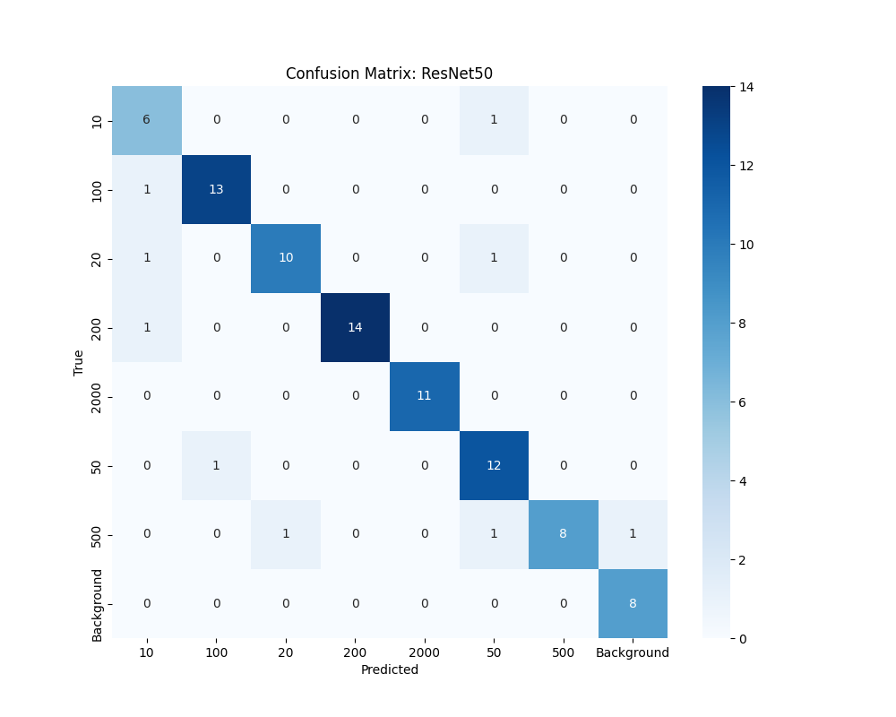

5. Conclusion
The results demonstrate that both models are highly effective for this task. ResNet50 provides deeper feature extraction, while MobileNetV2 remains a top choice for real-time applications on restricted hardware.

