|  |  |  |  |  |  |
| --- | --- | --- | --- | --- | --- |
| Opsin | Organism | About org | Structure (PDB/UniProt) | Properties |  |
| *Eubacteria* | | | | | |
| RyR | Rubrobacter xylanophilus | 2017, gram-positive thermophilic eubacterium, optimumpH 7.5–8.0 and 60 °C |  |  |  |
| PR  Proteorhodopsin | *Gamma-proteobacterium Hot 75m4* | 2000, eubacterial marine bacterioplankton |  |  |  |
| XR  Xanthorhodopsin | *Salinibacter ruber* | 2005, halophile eubacterial Salinibacter ruber | 3DDL |  |  |
| TR |  | 2000 |  |  |  |
| *Archaea* | | | | | |
| HsBR |  | 1971 |  |  |  |
| AR3 |  |  |  |  |  |
|  |  |  |  |  |  |
| SRI  sensory rhodopsin-I |  | Positive phototaxis | ??? |  |  |
| SRII  sensory rhodopsin-II | *Natronomonas pharaonis* | Negative phototaxis | 3QAP |  |  |
| cationchannelrhodopsins |  |  |  |  |  |
| anionchannelrhodopsins |  |  |  |  |  |
| ASR  Anabaena sensory rhodopsin |  | 2004 | 1XIO |  |  |
| HR  halorhodopsin | *Halobacterium salinarum* | 2015 | 1E12  5AHZ | Cl-  Br- |  |

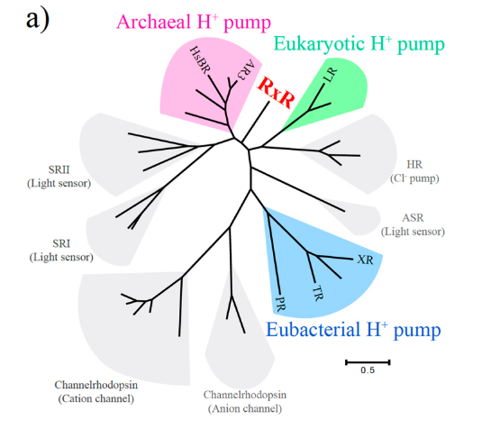

Arg71 (Arg82 in HsBR), Asp74 (Asp85 in HsBR), Thr78 (Thr89 in HsBR), Asp85 (Asp96 in HsBR), Glu187 (Glu194 in HsBR), Glu197 (Glu204 in HsBR), Asp205 (Asp212 in HsBR) and Lys209 (Lys216 in HsBR)

It was taken from <https://www.ncbi.nlm.nih.gov/pmc/articles/PMC5349596/> (very interesting conclusions).

Residues and their functions <https://www.ncbi.nlm.nih.gov/pmc/articles/PMC4915679/figure/pone.0156543.g003/>

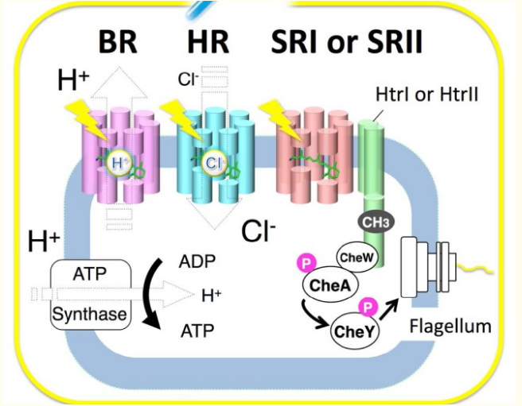

The classical four microbial rhodopsins from the archaeon Halobacterium salinarum. (<https://www.ncbi.nlm.nih.gov/pmc/articles/PMC4736836/>).

<https://www.ncbi.nlm.nih.gov/pmc/articles/PMC4736836/table/t1-12_121/?report=objectonly> – new types of rhodopsins.

<https://www.ncbi.nlm.nih.gov/pmc/articles/PMC4933271/> - about thermophilic stability