A. Linux processes
A process is a program that is currently running. For example, an SSH server, a web server, a terminal, or a monitoring agent can run as a process.
Every process typically has a Process ID (PID), an owner, resource usage, and a parent process.

Pid a unique number identifying a running process at a given time.
Process owner the account service running a process

Important: a process using high CPU or running as root is not automatically malicious. You need context.

B. Linux services
A service is a background component that provides a function, such as SSH access, DNS, web hosting, or time synchronization.
Many linuxes use systemd to manage process
Ssh or sshd:remote administration
Cron or crond:scheduled tasks

Important :To determine whether services are expected, whether they are running, and whether they expose network access.
C. Authentication logs
Authentication logs record security-related events, including:
- Successful and failed login attempts.
- SSH authentication activity.
- Account and authentication failures.
- sudo usage and privilege escalation events, depending on the system's logging configuration.
Important : A single failed login may be a typo. Many failures from the same source followed by a successful login may deserve investigation. Neither pattern alone proves an attack.

KALI LINUX VERSION

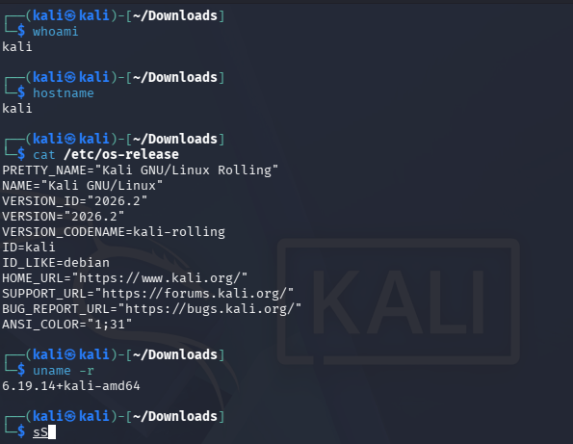

Process
$ Ps aux
lets you see all the processes
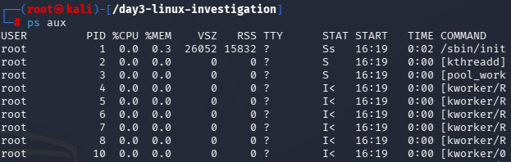

ps -eo pid,ppid,user,%cpu,%mem,stat,comm \
--sort=-%cpu | head -n 16

To see the 15 processes using the most CPU at the moment:

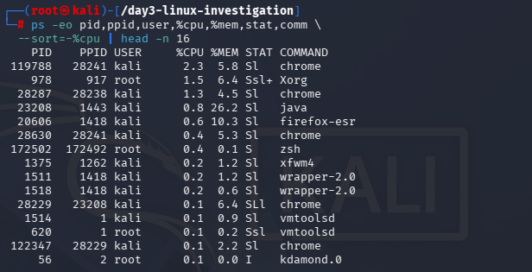
Security analyst's interpretation: To look for unfamiliar executables, unexpected users, strange command arguments, or resource usage that does not match the machine's purpose. Process names alone are not sufficient to determine legitimacy.

Pinpointing a process to get all the information :
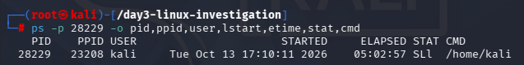
Real time processes
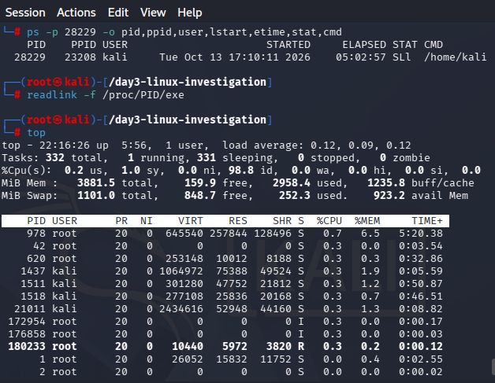

Process | Owner | Purpose | Observation
Example: systemd | root | System and service management | Expected on a systemd-based host
chrome | kali | Web browsing | No sus activity .moderaate cpu use
Xorg | Root | Graphical display and user interface | Runs with root privilege. Just verify
Chrome | Kali | Web browsing | Another separate chrome .
Java | Kali | Executes java based applications | High memory use . identification needed .
Firefox-esr | kali | Web browsing | No clear malicious activity . moderate memory and cpu usage.

Services
This lists services currently running under system.
systemctl list-units --type=service --state=running
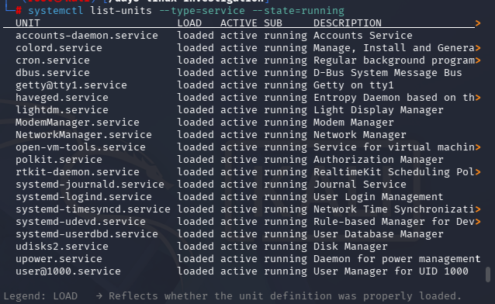

systemctl status ssh.service --no-pager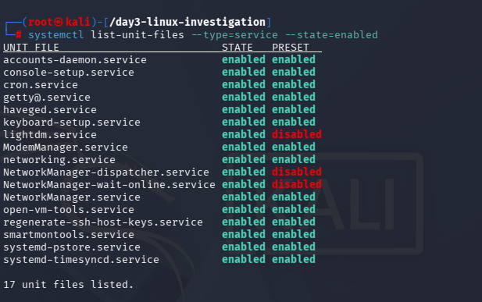

Step 1 : inspecting a specific service
So in this case we are inspecting a specific service.
We are investigating the sshd.service
systemctl status ssh.service --no-pager
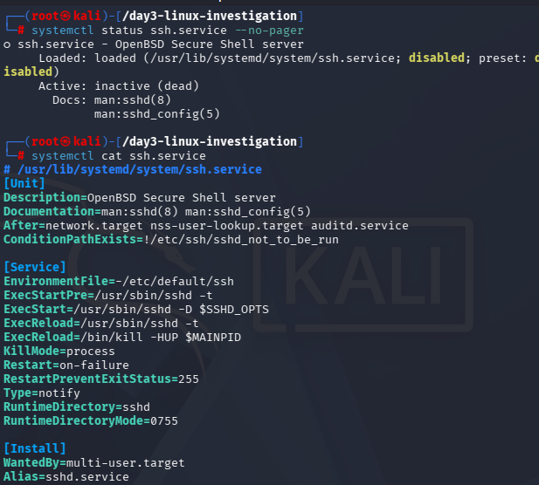
systemctl cat ssh.service

Step 2: inspecting listening network ports
ss -lntup
l is a listening socket, n is a numeric adresss or port, t is for tcp sockets, u is for udp sockets, and p is for process info.

A listening port indicates that an application is accepting or waiting for network traffic on that socket. It does not automatically mean the port is reachable from the internet.
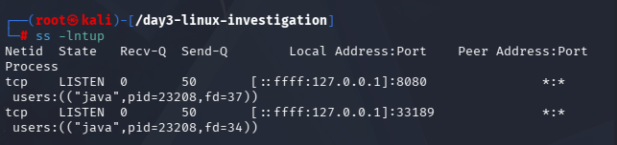

Step 3 :
Yes ssh is expect on this machine

Service investigation table
Field | Service 1: SSH | Service 2: Cron | Service 3: NetworkManager
Service name | ssh.service | cron.service | NetworkManager.service
Status | Inactive (dead) | Verify on system | Verify on system
Purpose | Provides secure remote login and command execution | Runs scheduled tasks | Manages network connections
Privileges | SSH daemon normally starts with root privileges; authenticated sessions use the relevant user account | Typically runs with root privileges to execute scheduled system tasks | Typically runs with root privileges
Network exposure | No SSH listener identified in the supplied screenshot | Usually no listening port; verify locally | May use local IPC or D-Bus; verify listening sockets
Assessment | Expected if remote access is not required; follow up if SSH is needed | Expected on many Linux systems; confirm status and need | Expected on a typical Kali desktop or networked system; confirm status and need

Authentication logs
CHECKING ON WHICH SYSTEM DOES OUR LOG RUN ON
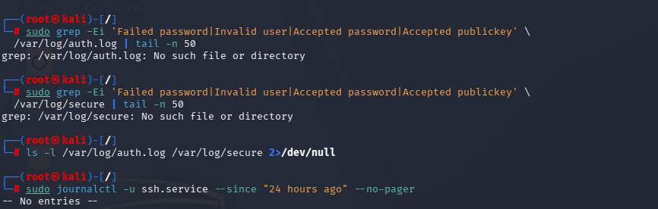

CHECKING WHETHER IT IS HAS ANY SSH SERVIVE LOGIN ENTRIES SINCE 24 HRS AGO

This is a quick keyword filter, not a complete or authoritative audit. It can miss differently worded events, and it may include lines that need context.

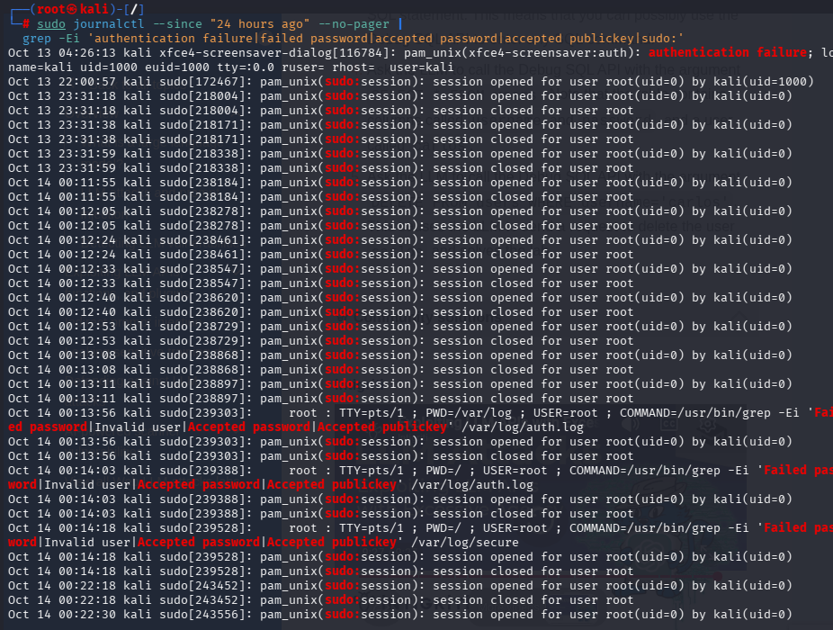

To examine an authentication log file if it exists, for example on Ubuntu:
sudo tail -n 100 /var/log/auth.log

Privacy reminder: Authentication logs can contain usernames, IP addresses, internal hostnames, and other sensitive metadata. Keep evidence in approved storage and redact details before sharing it externally.

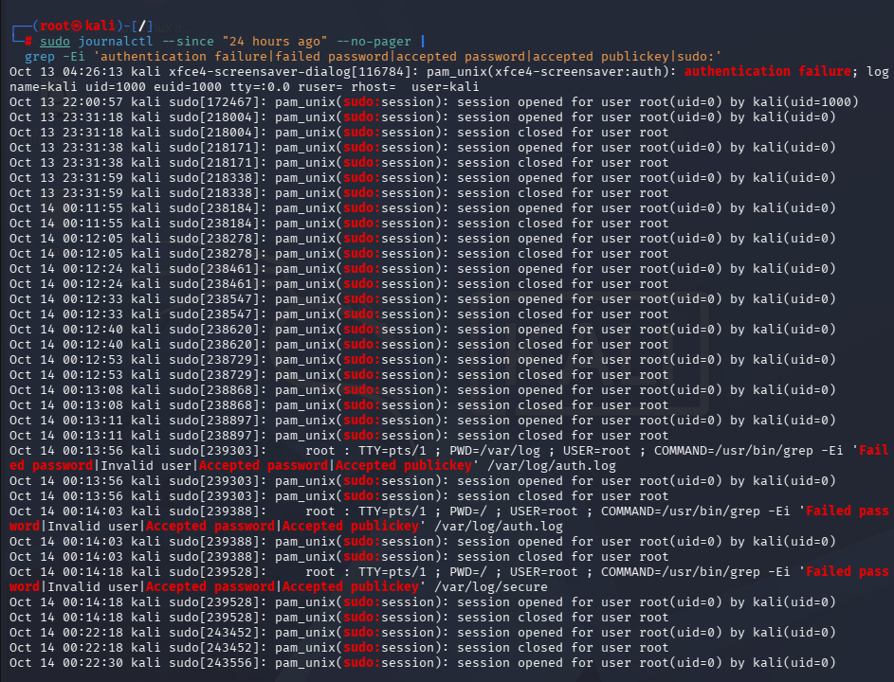

Authentication failure

Privilege escalation
Failed login attempts

Actual evidence | Correct observation | Appropriate conclusion
ssh.service shows inactive | The SSH service was inactive when checked. | Verify whether remote SSH access is required for this host.
No SSH listener appears in ss output | No SSH listening socket was identified in the captured output. | No listener was observed at that time; verify the intended configuration.
Java uses high memory | The Java process showed high memory use at the time of inspection. | Identify the application and determine whether its resource usage is expected.
Several failed logins appear | Multiple failed authentication events were recorded in the selected period. | Investigate the pattern and correlate it with other evidence.
No matching log entries appear | The search returned no matching events. | Verify logging coverage before concluding that no activity occurred.

OBSERVATIONS
PROCESS INVESTIGATION
I USED LINUX PROCESS-INSPECTION COMMANDS TO REVIEW RUNNING PROCESSES, OWNERS AND RESOURCE UTILIZATION. THE PROCESSES DOCUMENTED INCLUDED SYSTMD, CHROME XORG JAVA AND FIREFOX ESR
WHILE CHROME AND FIREFOX ARE USED FOR BROWSING WEB XORG IS ASSOCIATED WITH GRAPHICAL DISPLAY ENVIRONMENT. THE JAVA PROCESS SHOWED HIGH MEMORY USAGE IN MY OBSERVATIONS SO IT REQUIRES FURTHER ANALYSIS.
SERVICE AND NETWORK INVESTIGATION
I INSPECTED A SSH SERVICE USING SYSTEMCTL AND REVIEWED LISTENING NETWORK SOCKETS USING SS. SSH SERVICE WAS INACTIVE AND NO SSH LISTENER WAS IDENTIFIED.
I IDENTIFIED CRON AND NETWORK MANAGERS AS SERVICES TO REVIEW.THE ABSENCE OF ANY SSH LISTENER IN THE CAPTURED RESULT DOESN’T INDICATE A SECURITY INCIDENT BY ITSELF.
AUTHENTICATION LOG INVESTIGATION
I EXAMINE THE AVAILABLE AUTHENTICATION LOGGING SOURCES TO LOOK FOR ANYT SSH LOGIN ACTIVITY AUTHENTICATION FALIURES PRIVILIGE ACCESS AND SUCCESFUL LOGIN ATTEMPTS.
I HAVE LISTED UP ABOUT THE EVENTS

LIMITATIONS
THE RESULT DEPEND ON AVALIABLE LOGS, RETENTION PERIOD PERMISSIONS AND LOGGING CONFIGURATION.
WE ARE JUST SEEING A NORMAL LINUX BEING RUN IN A VIRTUAL MACHINE ASSESSING ITS PROCESSES, SERVICES AND LOGS.
GETTING USED TO THE BASH COMMANDS AND COLLECTING THEM ALL IN A Folder
Conclusion
THE PRACTICAL SESSION IMPROVED MY UNDERSTANDING OF LINUX PROCESS MANAGEMENT, SYSTEM SERVICES, NETWORK LISTENING SOCKETS, AND AUTHENTICATION LOGGING.
THE PROCESS INVESTIGATION DEMONSTRATED THE IMPORTANCE OF EXAMINING PROCESS OWNERSHIP, RESOURCE USAGE, AND APPLICATION PURPOSE BEFORE DECIDING WHETHER BEHAVIOR IS SUSPICIOUS. THE SERVICE INVESTIGATION SHOWED HOW SERVICE STATUS AND LISTENING PORTS CAN BE USED TO ASSESS WHETHER NETWORK ACCESS APPEARS CONSISTENT WITH THE SYSTEM'S INTENDED ROLE.

