**Report 3**

**Project Title:** Create data-driven strategies to help Conagra unlock future growth potential in the Meat Substitutes category

**Report Date:** 05/01/2024

**THE UNIVERSITY OF TEXAS AT DALLAS**

**GROUP 11 Members:**

Azime Gulin Divarci - AGD220003

Bhavana Balagopal – BXB220057

Priyanka Das - [PXD230010](mailto:pxd230010@utdallas.edu)

Suman Anand – SXA230187

Albin Poulose – AXP220239

Ashiq Mohammed Al Ameen - AXA220171

Srivani Kakumani - SXK230164

**INTRODUCTION**

In today's competitive marketplace, precision in marketing strategies is crucial for sustaining growth and profitability, particularly in specialized sectors such as meat substitutes. Conagra Brands, a leader in this industry, recognizes the importance of effectively leveraging discounts and merchandising to optimize sales outcomes. This analysis is centered around two fundamental questions that are vital for refining marketing tactics and enhancing product performance:

**Discount Effectiveness Across Product Segments:** Does the discount impact the sales of high-performing products and low-performing products?

**Influence of Merchandising on Sales Volume:** Does the volume sales with respect to merchandise versus no merchandise will impact sales?

To provide Conagra Brands with strategic insights, this report will meticulously analyze sales data to determine the impact of these variables. By employing advanced statistical analyses, we aim to identify clear patterns that could inform future marketing and pricing strategies. The outcome will enable Conagra Brands to tailor their approaches more effectively, ensuring optimal positioning of both high and low-performing products in the market, ultimately leading to improved market penetration and increased profitability. Through this targeted analysis, we will empower Conagra Brands to make data-driven decisions that enhance customer engagement and boost sales performance across their product portfolio.Top of Form

Bottom of Form

**DATA DESCRIPTION**

In the Conagra dataset, there are several distinct types of datasets:

**FZ Meat_POS, FZ Seafood_POS, FZ_RFG Poultry_POS, FZ_RFG Processed, Poultry_POS, FZ_RFG Substitute Meat_POS, RFG Bkfst Meats_POS, RFG, Dinner SSG_POS, RFG Frankfurters_POS, RFG Ham_POS, RFG Lunch, Meats_POS, RFG Meat_POS, RFG Seafood_POS.**

**FZ Meat_POS:** This dataset likely contains information about frozen meat products, and "_POS" suggests it includes point-of-sale data, such as sales quantity, revenue, and possibly customer demographics.

**FZ Seafood_POS:** Like FZ Meat_POS, this dataset likely focuses on frozen seafood products and their sales at the point of sale.

**FZ_RFG Poultry_POS**: This dataset probably includes data on ready-to-eat (RFG) frozen poultry products, with POS showing it has point-of-sale information.

**FZ_RFG Processed Poultry_POS:** Like the earlier dataset, this one likely focuses on ready-to-eat processed poultry products that are frozen, with point-of-sale data included.

**FZ_RFG Substitute Meat_POS:** This dataset may have information about frozen ready-to-eat substitute meat products, possibly including plant-based meat alternatives, with point-of-sale data included.

**RFG Bkfst Meats_POS:** This dataset may have information about ready-to-eat breakfast meat products, such as bacon or sausage, with point-of-sale data included.

**RFG Dinner SSG_POS:** This dataset likely focuses on ready-to-eat dinner sausage products, with POS showing it has point-of-sale information.

**RFG Frankfurters_POS:** This dataset probably includes data specifically related to ready-to-eat frankfurter products, with point-of-sale data included.

**RFG Ham_POS:** This dataset may have information about ready-to-eat ham products, with point-of-sale data included. GROUP-11

**RFG Lunch Meats_POS:** This dataset likely contains data on ready-to-eat lunch meat products, such as deli meats, with point-of-sale information included.

**RFG Meat_POS:** This dataset may focus on other types of ready-to-eat meat products not covered by the earlier categories, with point-of-sale data included.

**RFG Seafood_POS:** Like the earlier dataset, this one likely focuses on ready-to-eat seafood products, such as canned tuna or shrimp, with point-of-sale data included.

For each dataset available from 2020 to 2024, there are various variables and attributes. Here's a rewritten description of the data:

**Explanation of Variables:**

**Geography:** This refers to the geographical location where the sales data was collected, typically categorized by regions, states, cities, or specific store locations.

**Product:** This variable finds the specific product being sold, often categorized by product type, brand, flavor, or variant.

**Time:** This variable shows the time in which the sales data was recorded, typically segmented by date, week, month, quarter, or year.

**UPC (Universal Product Code) 13 digit**: The UPC is a unique 13-digit code assigned to each product for identification purposes. It's commonly used in retail and allows for right tracking of product sales.

**ACV (All Commodity Volume) Weighted Distribution: ACV** Weighted Distribution measures the availability of the product across different retail outlets, weighted by the size of each outlet. It shows the product's distribution reach in the market.

**Base Dollar Sales**: This stands for the total dollar amount of sales generated by a product during a specified period, excluding any promotional or incremental sales.

**Base Unit Sales:** Like Base Dollar Sales, this variable is the total number of units sold for a product during a specified period, excluding any promotional or incremental sales. GROUP-11

**Base Volume Sales:** This refers to the total volume of product sold (e.g., in Liters or gallons) during a specified period, excluding any promotional or incremental sales.

**Dollar Sales:** Total dollar amount of sales generated by a product during a specified time, including both base sales and any incremental sales resulting from promotions or other factors.

**Incremental Dollars:** The added dollar sales generated by a product due to promotional activities or other factors beyond the base sales.

**Incremental Units:** The added units sold for a product due to promotional activities or other factors beyond the base sales.

**Incremental Volume:** The added volume of product sold (e.g., in Liters or gallons) due to promotional activities or other factors beyond the base sales.

**Price per Unit:** The average price of the product per individual unit sold, calculated by dividing the total dollar sales by the total unit sales.

**Price per Volume:** The average price of the product per volume unit sold (e.g., per liter or gallon), calculated by dividing the total dollar sales by the total volume sales.

**Unit Sales**: Total number of units sold for a product during a specified time, including both base sales and any incremental sales.

**Volume Sales:** Total volume of product sold (e.g., in Liters or gallons) during a specified time, including both base sales and any incremental sales.

**Test (Count):** This variable likely represents the count of a particular test or experiment conducted within the dataset, providing information about the frequency or occurrence of a specific event or condition.

**Observations and Insights based on the analysis:**

**1. Does the discount impact the sales of high-performing products and low-performing products?**

Based on the detailed analysis of Conagra's discount strategies, we can derive the following insights and recommendations:

**Impact of Discounts on Product Performance:**

High Performers: High-performing products experience a decline in revenue when discounts are applied. This suggests that these products, which already have strong market acceptance, suffer in terms of profitability due to unnecessary discounting. It’s evident that discounts may reduce the perceived value of these high-quality items, leading to lower dollar sales despite an increase in unit sales.

Low Performers: For low-performing products, discounts do not significantly affect sales volumes or revenue. This indicates that these products may inherently lack consumer appeal or competitive strength, and discounts alone are insufficient to improve their market performance. However, discounts on these products do not lead to substantial revenue loss, making them less risky candidates for promotional pricing.

**Please find below the relevant visualizations of the outcome:**

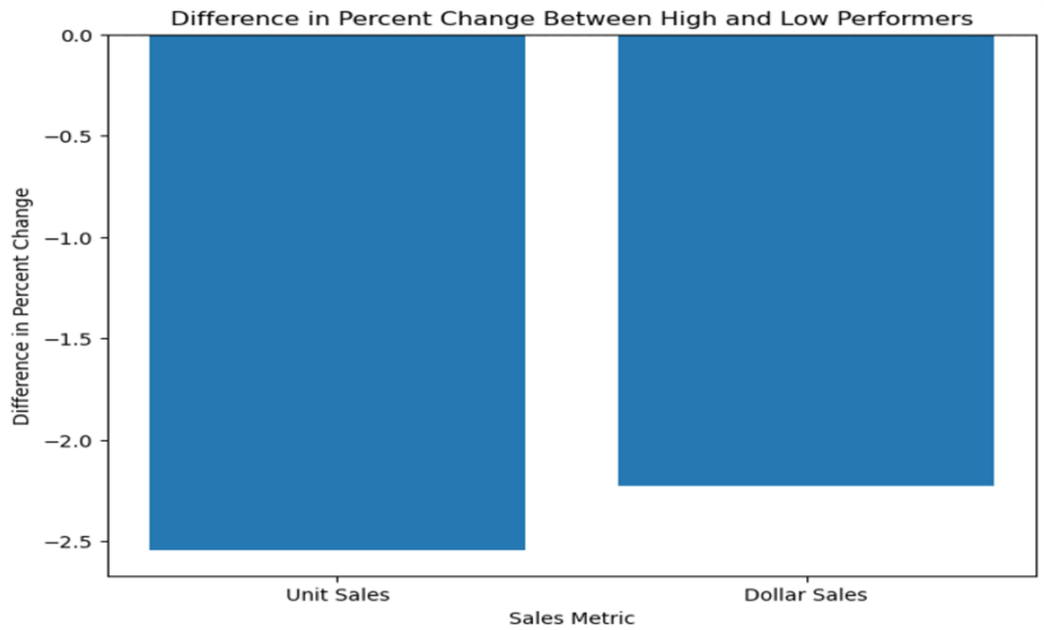

This chart displays the negative percent changes in unit and dollar sales between high and low performers when discounts are applied.

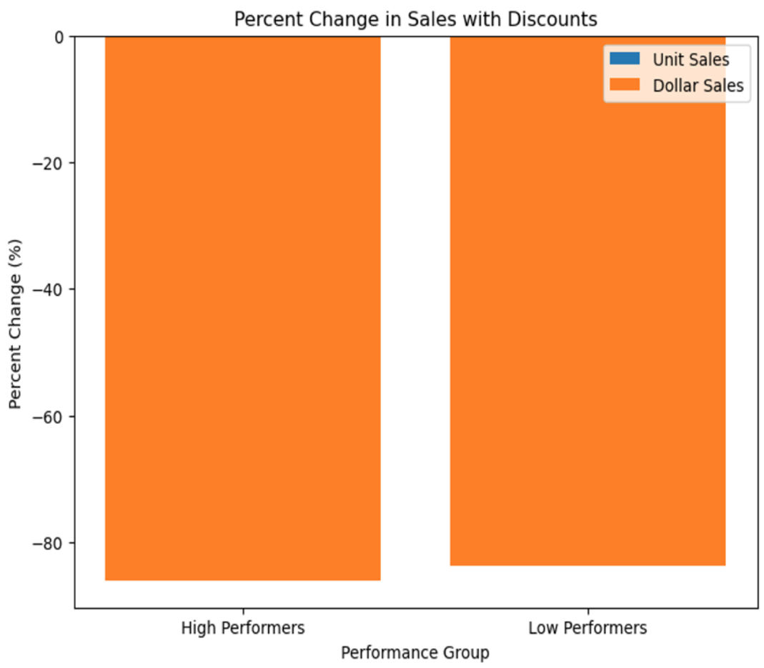

This visualization highlights the percent change in sales for high and low performers under discount conditions.

This chart shows that discounts cause significant revenue loss for high performers but have less impact on low performers, highlighting how discounts affect products differently based on their performance.

**Linear Regression**

The plot visualizing the relationship between discounted prices and unit sales **reveals a weak or non-existent impact** of discounted pricing on sales volumes, as indicated by a nearly flat regression line. Most sales activity is concentrated at lower price points, suggesting that while lower prices see higher volumes, the overall effect of varying discount levels across all price ranges is minimal. This implies that factors other than price might be more influential in driving sales. To better understand and leverage pricing strategies, further analysis using non-linear models, segmentation, or consideration of additional variables such as marketing activities and consumer preferences could provide deeper insights into the dynamics affecting sales performance**.**

It shows that while most products do not show a strong positive correlation between discounted prices and sales increases, there are specific products that significantly benefit from discounts. For example, items like "GARDENBURGER FROZEN ORIGINAL MEAT SUBSTITUTE BURGER" display a massive increase in sales when discounted, demonstrating that strategic discounts on select products can effectively boost sales. This suggests that targeted discount strategies could be valuable for certain products that are particularly responsive to price changes.

**Strategic Recommendations for Discount Implementation:**

Selective Application: Based on our analysis, Conagra should strategically apply discounts. High-performing products should maintain their premium pricing to protect revenue margins, whereas discounts might be more beneficial for boosting the visibility and sales of low-performing products without significant financial risks.

Promotional Diversification: For high performers, Conagra should consider promotional alternatives to direct price reductions, such as cross-promotions, loyalty programs, or adding value through bundled offers, which can sustain consumer interest and value perception without eroding profitability.

Detailed Market Analysis: It is crucial for Conagra to continuously analyze consumer responses and market trends related to discounts. This will enable the company to adjust promotional strategies effectively, ensuring they are timely, appropriate, and maximally impactful in the competitive meat substitute market.

Our analysis underscores the importance of a nuanced approach to discounts, highlighting the need to match promotional strategies with product performance and market conditions. This targeted approach will help Conagra maximize profitability while effectively managing its diverse product portfolio in the competitive meat substitute market.

**2. Does the volume sales with respect to merchandise versus no merchandise impact sales?**

**Sales Performance Analysis**:

-The average unit sales with merchandise are 763.63, significantly lower than the average unit sales without merchandise, which are 1138.82. Similarly, the average dollar sales with merchandise are 3867.53, lower than the average dollar sales without merchandise, which are 6806.06. This suggests that merchandise offerings may not be as effective in driving sales as initially thought.

-The average volume sales with merchandise are 527.94, also lower than the average volume sales without merchandise, which are 800.72. This indicates that customers tend to purchase more volume when merchandise is not available.

**Profitability Assessment**:

-Despite the lower unit and dollar sales with merchandise, the average dollar sales without merchandise are considerably higher. Specifically, the average dollar sales with merchandise are 3867.53, compared to 6806.06 without merchandise. This could indicate that the profit margins on main products are higher compared to merchandise items.

-Businesses should assess the profitability of their merchandise offerings and consider reallocating resources to focus on high-margin products.

In our regression analysis, we encountered challenges stemming from high correlation among predictor variables, leading to overfitting of the model. Upon removing the highly correlated fields, the adjusted R-squared value noticeably decreased, indicating a poorer fit of the model to the data. Consequently, the model's predictive performance suffered, failing to accurately predict values aligned with the actual observations.

This highlights the complexity of our dataset and underscores the need for further refinement in our modeling approach to improve predictive accuracy while mitigating overfitting concerns. Moving forward, we plan to explore alternative regression techniques and feature selection methods to address these challenges and enhance the robustness of our predictive models.

**Please find below the relevant visualizations of the outcome:**

**First Ridge Regression Model and its results:**

Ridge Regression Mean Squared Error: 3725269.22577414

Ridge Regression R-squared: 0.9964240424752682

Adjusted R-squared: 0.9964231999145

Recognizing the issue of heavy overfitting indicated by the R-squared value, we attempted to alleviate it by removing fields with correlation values exceeding 0.7. However, this strategy proved counterproductive as it resulted in a significant drop in the R-squared value and rendered the model's predictions divergent from the actual values.

New Model’s results and screenshots:

Mean Squared Error: 1018792514.3919865

R-squared: 0.022041485545673423

Adjusted R-squared: 0.02193514910583505

**Strategic Recommendations**

Merchandise Strategy:

Given the lower sales performance with merchandise, businesses should reassess their merchandise strategy. The average unit sales and dollar sales without merchandise are significantly higher, indicating potential misalignment with customer preferences.

Conducting market research or customer surveys can provide insights into the types of merchandise items that resonate with customers.

Promotional Strategies:

Implementing targeted promotions or discounts on merchandise items may help stimulate demand and encourage customers to make additional purchases.

Businesses should experiment with different promotional strategies and monitor their impact on sales performance to determine the most effective approach.

Inventory Management:

With lower sales performance with merchandise, businesses should carefully manage inventory levels to avoid overstocking and minimize carrying costs.

Adopting inventory optimization techniques, such as demand forecasting and inventory turnover analysis, can help businesses maintain lean inventory levels while ensuring product availability.

Customer Experience Enhancement:

Despite lower sales with merchandise, businesses can still enhance the overall shopping experience by focusing on other aspects such as customer service, product quality, and store ambiance.

Investing in staff training, product presentation, and store layout can create a positive shopping environment that encourages customer loyalty and repeat purchases

**Conclusion:**

In the end, our detailed review of Conagra's discount and merchandising tactics provides important insights for improving sales in the competitive market for meat substitutes. Our findings show that while discounts help increase the number of units sold for less popular products, they can lower profits for bestsellers. This suggests that random discounts might lower the value of high-quality products, harming profits. Therefore, we recommend a more thoughtful approach to discounting, keeping prices high for top products while using discounts to boost the visibility and sales of less popular items.

Our analysis also reveals that merchandise doesn't consistently lead to higher sales, with products generally performing better without it. This indicates that Conagra should refine its merchandise approach, focusing on high-profit items and improving the shopping experience with better customer service, product displays, and store environments instead of relying too much on merchandise to increase sales.

To further refine its market strategy, Conagra should conduct detailed market research to align its products and promotions with what consumers want. Using specific promotions, better managing inventory, and regularly reviewing the impact of sales strategies are key for staying competitive and growing.

Looking ahead, Conagra needs to stay flexible, using data to continuously improve its promotions and product lineup to meet the changing preferences of consumers. By taking these steps, Conagra can not only maintain but also grow its position in the expanding market for meat substitutes.

**References:**

[*https://www.datanovia.com/en/blog/types-of-clustering-methods-overview-and-quickstart-r-code/*](https://www.datanovia.com/en/blog/types-of-clustering-methods-overview-and-quickstart-r-code/)

[*https://www.scribbr.com/statistics/simple-linear-regression/*](https://www.scribbr.com/statistics/simple-linear-regression/)

[*https://www.conagrabrands.com*](https://www.conagrabrands.com/)

[*https://www.marketsandmarkets.com/Market-Reports/meat-substitutes-market-979.html*](https://www.marketsandmarkets.com/Market-Reports/meat-substitutes-market-979.html)

[*https://en.wikipedia.org/wiki/List_of_Conagra_brands*](https://en.wikipedia.org/wiki/List_of_Conagra_brands)