First Month Comprehensive Implementation Report
Quality Sweets — Local SEO, E-Commerce Infrastructure & Market Launch | September 2026
During this first month, our primary objective was establishing an unshakeable digital foundation for Quality Sweets. Rather than simple surface-level tweaks, we executed a complete architectural, technical, and operational overhaul across BigCommerce, Google Business Profile, Google Analytics 4, and Google Search Console. Extensive work was completed to clean up legacy technical debt, align online ordering paths, build out high-intent local and catering pages, and wire accurate conversion tracking so that every subsequent month can be measured with statistical certainty.
8  New & Revamped Pages  Homepage, /menu/ + 3 subpages, /catering/ + 3 subpages, /locations/iselin-nj/ | 8  Pickup Slugs Sanitized  Eliminated duplicate URLs & 404 risks for delicate sweets | 8  Baseline Geo-Grids  8 local Google Maps geo-grids across core tracked keywords
Key Strategic Pillars Put in Place
1. Architecture & Triage Journey  Transformed the website from a confusing single-flow catalogue into a 3-way triage hub: (1) Nationwide Sweets Shipping, (2) Fast In-Store & Takeout Pickup, and (3) Large-Scale Corporate & Wedding Catering. | 2. Forensic URL & Catalogue Cleanup  Sanitized root URLs to canonical 'Short SEO' structure, removed legacy theme redirects, and fixed 8 duplicate/in-store pickup product titles to eliminate crawl bloat and preserve link equity.
3. Google Business Profile Dominance  Sanitized exact NAP address, set primary category to 'Indian sweets shop', updated attributes (Dine-in: NO, Takeout: YES), and populated 10 service categories, active product catalogue, and to-go menu. | 4. Dual Schema & Action Measurement  Deployed advanced LocalBusiness + OnlineStore JSON-LD schema, submitted clean XML sitemaps, and configured GA4/GSC tracking for calls, directions, online orders, and catering leads.
Detailed breakdown of all completed operational phases and technical deliverables follows on subsequent pages.

1. Forensic Technical Audit & Catalogue Sanitization (Phase 1)
Quality Sweets had inherited significant technical legacy debt from older themes (Megnor) and default BigCommerce URL parameters. We conducted a forensic cleanup to eliminate 404 errors, consolidate redirect chains, and sanitize product naming conventions.
Workstream | Specific Tasks & Technical Actions Completed | Status
URL Structure & Canonicalization | Configured 'SEO Optimized (Short)' in BigCommerce Store Setup. Renamed categories and slugs via REST API (IDs 3, 8, 22, 2, 1, 14, 21) into clean root paths, eliminating duplicate folder levels. | DONE
Forensic 301 Redirects | Audited HTTP responses across core routes. Removed legacy Megnor demo redirect clutter and injected permanent 301 redirects mapping legacy paths (e.g., /bulk-corporate-orders/ to /catering/) to protect domain equity. | DONE
8 In-Store Pickup Slugs Sanitized | Updated Product IDs 120 (Channa Mango Malai), 83 (Palki), 88 (Rose Chum Chum), 87 (Pineapple Chum Chum), 84 (Malai Chum Chum), 133 (Cherry Chum Chum), 78 (Manpasand), and 80 (Anarkali) with clean slugs. | DONE
Fulfillment & Pickup Rules | Created dedicated 'Local Store Pickup Zone' (Free pickup at 1384 Oak Tree Rd, Iselin). Flagged delicate items (chaats, fresh chum chums) as 'In-Store Pickup Only' with clear frontend badges to prevent out-of-state shipping issues. | DONE
Robots.txt & XML Sitemap | Injected canonical sitemap declaration in robots.txt. Created and submitted clean XML sitemap to Google Search Console with 0 errors, validating crawl paths for search engine spiders. | DONE
2. Conversion Architecture & Content Implementation (Phase 2)
We built out high-converting dedicated pages to capture different customer intents: nationwide gift buyers, local takeout diners, and corporate/wedding event planners.
Target Page / Asset | Implementation & SEO Strategy Delivered | Status
Homepage (Master Hub) | Optimized Title, Meta Description & H1. Implemented 3-way triage CTAs (Shipping, Takeout, Catering), trust badges, dual store telephone click-to-call, and direct pickup ordering CTAs. | DONE
Takeout Digital Menu (/menu/) | Launched official takeout menu hub with prominent 'Counter Pickup Only - No Dine-In' disclaimer. Created 3 dedicated sub-pages: /menu/chaats/ ('chaat near me'), /menu/street-food-snacks/ ('samosa near me', 'pani puri near me'), and /menu/drinks/. | DONE
Iselin Local Store Page (/locations/iselin-nj/) | Published hyper-local landing page with verified NAP (1384 Oak Tree Rd), 7-day operating hours (10am-8pm), MetroPark NYC transit directions, parking guide, and fresh storefront photography. | DONE
B2B Catering Hub (/catering/) | Migrated legacy /pages.php?pageid=4 to modern /catering/ hub. Integrated corporate inquiry form and Wedding Tasting Box selector. Deployed 3 specialized sub-landings: /wedding-catering-tri-state/, /temple-mandir-bulk-prasad/, and /bulk-samosa-orders/. | DONE
6 E-Commerce Categories Copywriting | Wrote 400+ words of keyword-targeted copy and structured FAQs for top retail categories: /indian-sweets/, /bengali-sweets/, /barfi/, /traditional-mithai/, /indian-snacks/, and /mithai-box/. | DONE

3. Structured Data, Google Profile & Analytics Setup (Phases 3 & 4)
Area | Configuration & Optimization Delivered | Status
Dual JSON-LD Schema | Implemented LocalBusiness & Bakery schema (geo-coordinates, official menu link, acceptsReservations: false), OnlineStore & Product schema (prices, stock, shipping), and BreadcrumbList across all pages. | DONE
Google Business Profile (GBP) | Sanitized NAP address (1384 Oak Tree Rd). Set primary category to 'Indian sweets shop' and secondaries (Indian takeaway, Vegetarian restaurant, Caterer). Crafted 750-char SEO description. Set Dine-in to NO and Takeout to YES. | DONE
GBP Catalogue & Menu Items | Configured 10 distinct GBP service categories. Uploaded active product catalogue with high-res photos and direct links. Embedded to-go takeout items directly into Google's native menu interface. | DONE
Google Shopping Free Listings | Connected store product feed to Google Merchant Center, activating eligible retail sweets, snacks, and festive gift boxes for organic Google Shopping discovery. | DONE
GA4 & Conversion Tracking | Configured custom conversion events in Google Analytics 4 and GSC for primary commercial actions: phone calls, direction requests, online orders, catering lead submissions, and checkouts. | DONE
Keyword Tracking Project | Configured Ubersuggest tracking project monitoring top 15-20 core keywords (mithai, chaat, samosas, catering) to capture accurate month-over-month position shifts. | DONE
Why Commercial Data Starts in Month 2 & Strategic Roadmap
Sales, revenue, and lead percentage changes are intentionally not included in this first report. Month 1 was dedicated entirely to building and deploying the technical architecture, indexing the new pages, and establishing clean tracking. Google requires a full 30-day reporting cycle to crawl, index, and re-rank the sanitized URLs. Comparing Month 1 against past untracked periods would be statistically misleading; our next report (around November 1, 2026) will provide the first true comparable performance cycle.
Month 2 Strategic Roadmap (Upcoming Initiatives):
- Phase 4.4 — Visual Assets & GBP Posts: Deploy weekly high-resolution photography of fresh sweets, store displays, and regular Google Business Posts to drive engagement and local relevance.
- Phase 4.5 — Ethical Review Engine: Implement in-store physical review acceleration (counter QR code cards and packaging inserts) to increase Google review velocity from genuine store visitors.
- Phase 4.6 — Local Citation Authority: Audit and align NAP consistency across the top 40 local business directories (Yelp, Apple Maps, Bing Places, YellowPages, etc.).
- Phase 5.1 & 5.2 — Seasonal Landings & GEO: Deploy evergreen festive campaign landings (Diwali, Holi, Wedding Season) and optimize content for Generative Engine Optimization (ChatGPT, Perplexity, Google AI Overviews).

Indian sweets shop near me
Google Maps Local Grid Scan (Middlesex County)
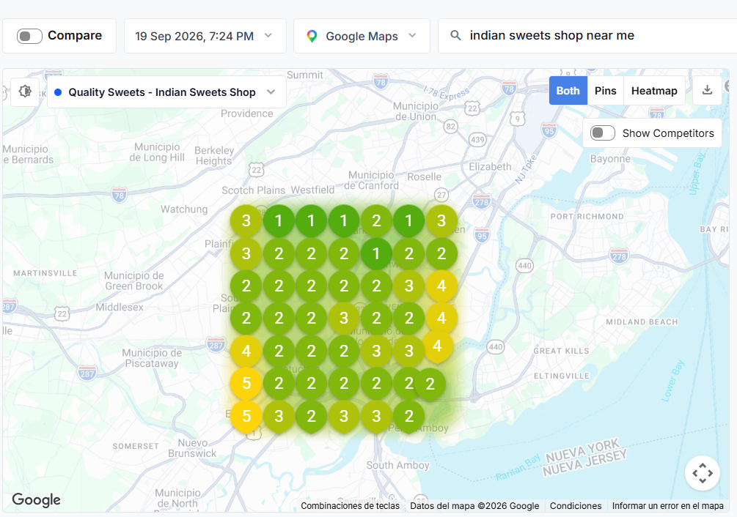
Strategic Analysis & Baseline Context: Baseline Scan: Tracks local visibility for core high-intent search. Shows strong top-3 positioning immediately around Oak Tree Road with clear expansion opportunities into Edison and Woodbridge.

Indian sweets near me
Google Maps Local Grid Scan (Middlesex County)
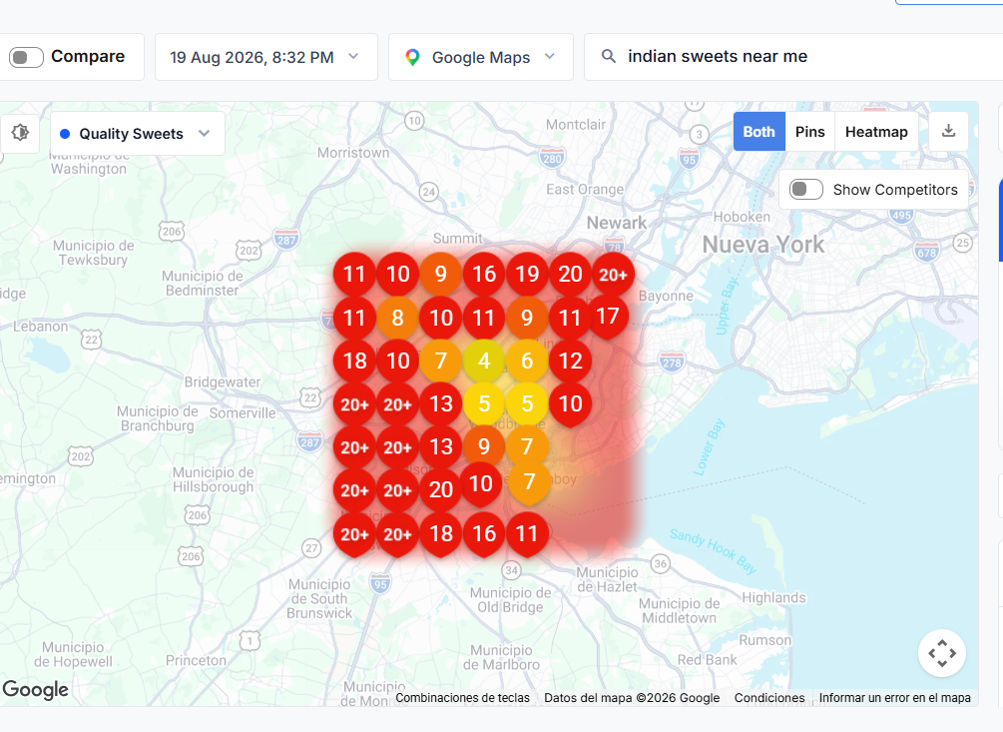
Strategic Analysis & Baseline Context: Baseline Scan: Broad regional search for Indian sweets. Serves as our primary benchmark for local ranking gains following the GBP category sanitization.

Samosas near me
Google Maps Local Grid Scan (Middlesex County)
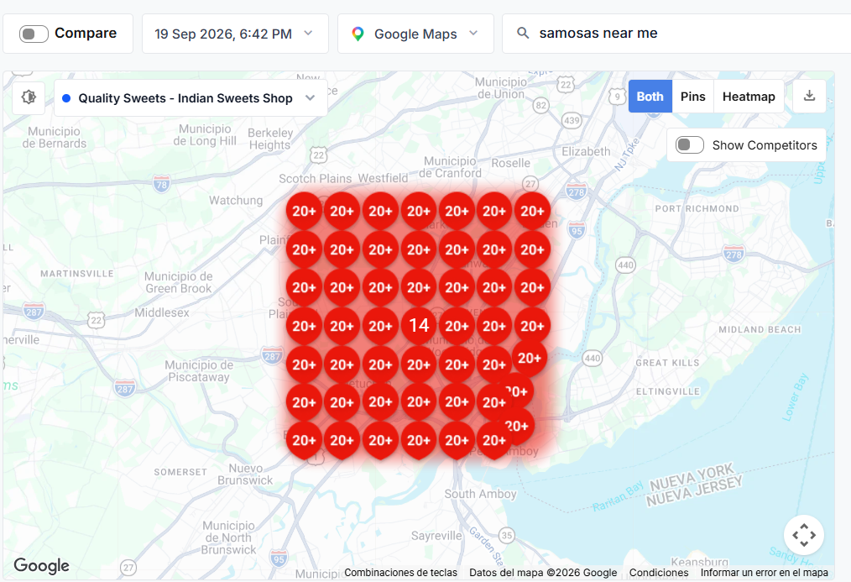
Strategic Analysis & Baseline Context: Baseline Scan: High-volume daily snack query. Supported by the newly deployed /menu/street-food-snacks/ page and to-go menu items added to Google.

Samosa chaat near me
Google Maps Local Grid Scan (Middlesex County)
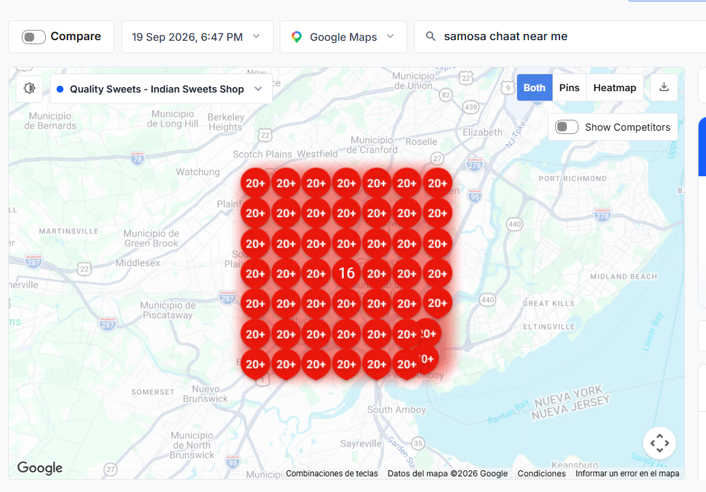
Strategic Analysis & Baseline Context: Baseline Scan: Niche chaat query. Directly aligned with our new /menu/chaats/ sub-page to drive foot traffic for afternoon and evening snack runs.

Chaat near me
Google Maps Local Grid Scan (Middlesex County)
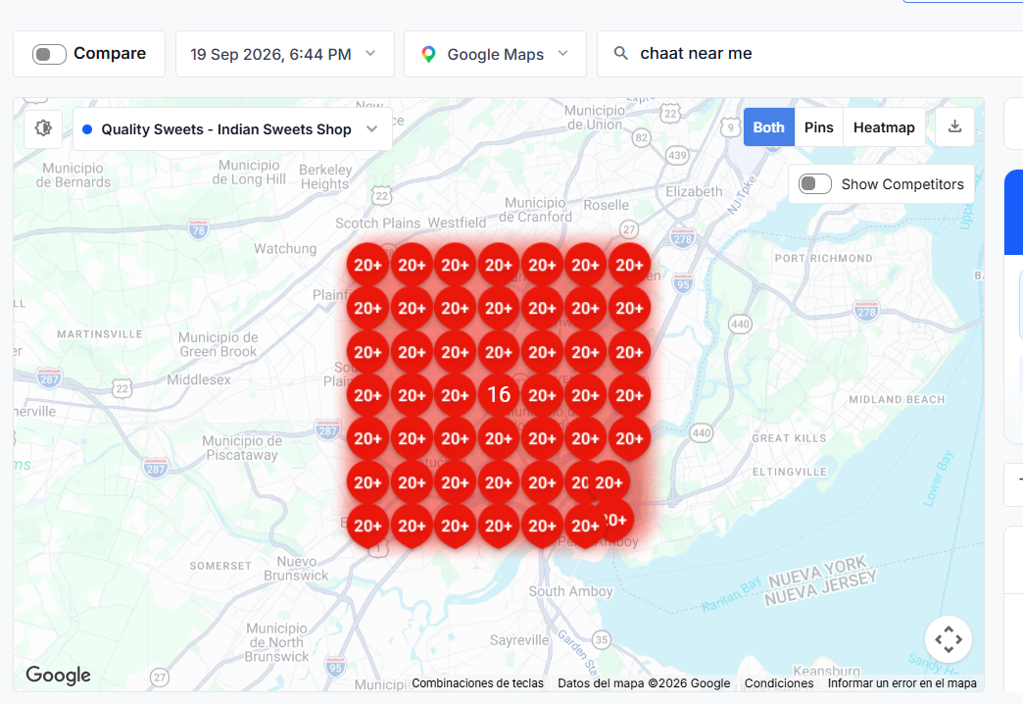
Strategic Analysis & Baseline Context: Baseline Scan: High-competition local search across Central NJ. Targeted via takeout menu architecture and GBP 'Vegetarian restaurant / Indian takeaway' categories.

Bengali sweets
Google Maps Local Grid Scan (Middlesex County)
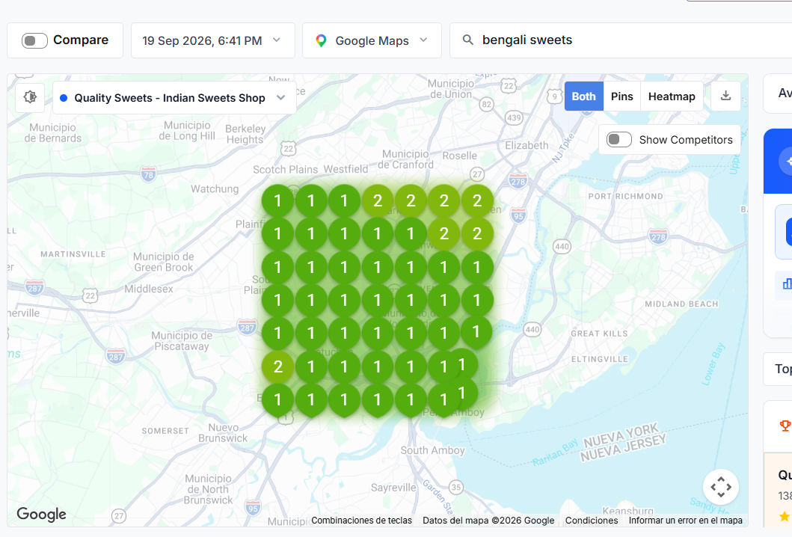
Strategic Analysis & Baseline Context: Baseline Scan: Specialty mithai search. Directly targeted through the sanitized Bengali sweet product slugs (chum chums, palki, anarkali) and the optimized /bengali-sweets/ category copy.

Pani puri near me
Google Maps Local Grid Scan (Middlesex County)
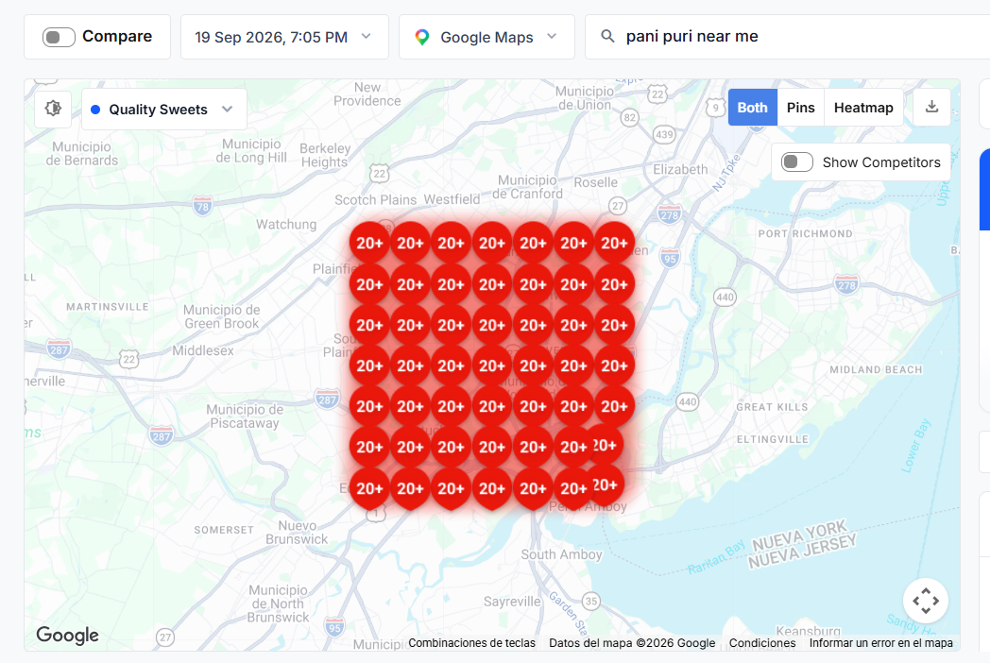
Strategic Analysis & Baseline Context: Baseline Scan: Popular street food snack search. Tracks conversion to store visits via the updated takeout menu and call-to-order CTAs.

Jalebi near me
Google Maps Local Grid Scan (Middlesex County)
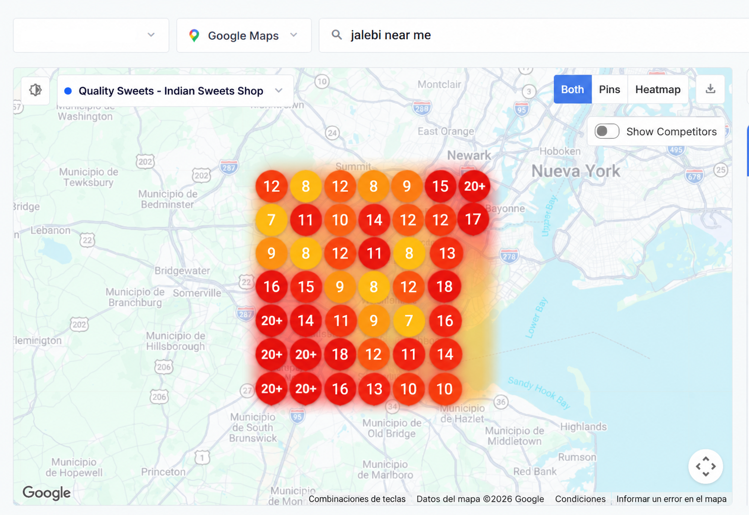
Strategic Analysis & Baseline Context: Baseline Scan: High-intent traditional mithai search. Tracks initial local rankings for Jalebi across the Iselin and Central Jersey corridor as a baseline for ongoing optimization.

