-> /etc =>is used to store the all file system are configured
-> /tmp => temporary files cleard on reboot
-> /usr => user application ,binaries ,libreries ,documentatioion
-> /lib => shared library
-> /

2 types of users

1. system user
2. manual users

cli command texture --> cli cmnd flag data

Terraform
----------

https://github.com/bhuvan-raj/Terraform-Zero-to-Hero

terraform file execution

1.terraform init -> initializing
2.terraform validate ->check the synaax and find the error
3.terraform fmt(format) -> find the unwanted space error only.this correct indentation erron only
4.terraform plan -> creates an execution plan what is created what is deleted
5.terraform apply -> just like terraform plan after that ask confirmation if give value yes then run
6.terraform destroy ->

directly execute

-> terraform apply --auto-approve

delete created infrastructure

-> terraform destroy

directly deleting

-> terraform destroy --auto-approve

---------------------------------------------------------

26/09/2025

-----------

terraform import (very very important)

lifecycle metaargument (important)

aws s3 permannt mounting

--------------------------------------------------------------------------------------------------

--------------------------------------------------------------------------------------------------

kubernetts

?? why k8s follows cluster architecture ??

-> kubernets is an open source sontainer orchestration platform that automates the deployment,scaling and mangement of containerized application

- > also known as k8s

- > kubernets follows cluster architecture

- > a kubernets cluster is madeup of two main parts

1.controll plane(master node)

-- > this is the brain of kuubernetes cluster,it manges everything

-- > scheduling workloads

-- > handling scaling and healing

2.Data plane (worker nodes)

-- > running application workloads (pods)

-- > handling networking between containers

--> repoding node and pod status

Kubernetes distributions

-> it is a packeged or customized version of k8s provided by a vendor or community

-> it includes k8s itself plus additional tools,configuation and integrations to make deployement, mangament and update eaasier

1.Cloud manged kubernets services (Kaas)

-> mater node is manged by vendors

-> A cloud manges kubenrnetes sevvice (kaas) is a kubernetes platform provided and manged by a cloud provider,meaning the controll plane are automatically manged by the cloud vendor

-> the user just focus on deploying and runnig the applications ,while the provider take care of hard parts like

1.cluster setup 2.scalling 3.upgrades 4.security patches ..

-> exapmple :Eks -aws,Aks-azure,gke(google k8s engine )-gcp,oke -oracle ,ibm cloud k8s service

2.On-premises k8s distribution

-> this distribution are design to run on your own data center or private infrastructre,instead of a public cloud

-> you have full controll over the cluster setup , networking ,security and scalling but also full responsibilty for manging and maintaing it

-> example :openshift -redhat,rancher kubernetes (rke) -rancher ,vmware tanzu -vmware,charmed k8s ,mirantais kubernetes

3.Local/study k8s distribution

-> local k8s distributions are lightweight version of k8s meant for learing ,testing on a persional computer or laptop -not for production

-> example :minikube,kind(kubernetes in docker ),micro k8s,k3s

28/10/2025

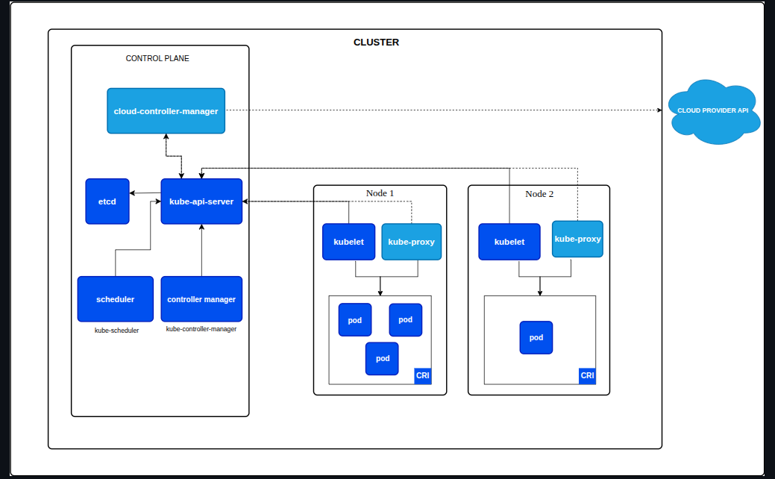
CRI-> container runtime interface

Control plane (Master Node) component

-------------------------------

kube-apiserver (API server)

-> it is act as front end for the kubernetes cluster .(beacuse when we give command it goes through the api server )

-> it is act as the central communication hub .(becuase if componetes want to communicate it goes through the api server )

-> All intractions go through the API server

etcd

->A highly availabe ,distributed ,consistent key -value store-- (basically a store location)

-> k8s uses etcd to store all cluster data,including the desired(the currently available state) state of your applications configuration, and actual(what we want) state

-> its the single source of thruth for the cluster

--pod->it is the smallest deployable unit in a k8s cluster and it actes as a wrapper around one or more containers.---

Kube scheduler(Scheduler)

-> it watches for newly created pods with no assigned node

-> duty of scheduler to check the worker nodes for resources

-> scheduler duty to assign pod to appropriate worker node

Kube controller manger

-> contiusly monitoring the desired stage and actual state

-> In Kubernetes, it is the duty of the Controller Manager to reconcile (tally) the actual state of the cluster with the desired state.

Cloud controller manager (optional)

-> only in cloud

Worker node components

-------------------------------

Kublet

-> it is act as a agent on each node in the cluster

-> check the status of container and node

-> ensures containers are run in a pod

->tells the status of pod (healthy or not) and to api server it is all saved in etcd

-> check the statues of node and go to api and saved in etcd and scheduler allows the pods

Kube-Proxy

-> it is the duty of kube proxy facilitate the networking in the cluster

-> maintains the

CRI(Container Runtime interface)

->b
-> pulls image from the registry

when execute kubectl api-version it will shows the list of resources that we can create in cluster

kubectl apply -f filename or kubectl create -f (only used for creating file first tym)

creating using command

kubectl run my-nginx-pod --image nginx

kubesctl get po/pod/pods ->list all pods

kubesctl get po/pod/pods -w -> watching the pods status

kubctl get replicaset/rs -> list all replicaset

kubectl delete po pod_name -> delete pods name

-> when we created just a pod and manually deleted ther is no self healing

-> replicaset -- it is an object we can create in k8s--another object it facilitate self healing – anreplicaset controller will be created---that cntroller look the desired number of pod is run or not

-> lables -- to iddentify the object uniquely (it should be a key value) or uniwue identifier –basically used to select pod --details fof pod

-> selector – when a we want label we want selector
fenebb

kubectl get po -o wide ->

It shows more detailed info about your pods, including:
- The Node each pod is running on
- The Pod IP address
- The Image used
- The Container status

kubectl exec -it pod -- /bin/sh -> inside the pod

Lifecycle of Pods (Pod Phases)

A Kubernetes Pod's status is a composite field that describes its current state in the cluster. It's represented primarily by two key fields: status.phase and status.conditions.
🚦 Pod Phase (status.phase)
The phase is a simple, high-level summary of where the Pod is in its lifecycle. It can be one of five values:

* Pending - The Pod has been accepted by the Kubernetes system but one or more of its containers hasn't been created or run yet. This includes time spent waiting for networking, scheduling, and image pull time. |
* Running - The Pod has been bound to a node, and all of the containers have been created. At least one container is still running, or is in the process of starting or restarting. |
* Succeeded - All containers in the Pod have terminated successfully and won't be restarted. This is common for Job Pods. |
* Failed - All containers in the Pod have terminated, and at least one container terminated in failure (i.e., it exited with a non-zero status code), and the Pod will not be restarted. |
* Unknown - For some reason, the state of the Pod could not be obtained (e.g., the communication with the host node failed). |

There are three primary Container States that define where a container is in its lifecycle:

🚦 Container States (Phases)
1. ⏳ Waiting
The container has been created by the Kubernetes system (Kubelet) but has not successfully started its main process yet. This is often a precursor to a problem.
- Common Reasons

- ContainerCreating - Resources are being set up on the node (a normal, temporary state). |
* ErrImagePull / ImagePullBackOff - The image could not be downloaded from the registry. |
* CrashLoopBackOff - The application in the container started but immediately crashed, and Kubernetes is waiting before retrying. |
* PodInitializing - The container is waiting for Init Containers in the Pod to complete their setup tasks. |
2. Running
The container's entry point command has executed successfully, and the container process is actively running.
* This state means the application's process is alive.
* However, a container in the Running state may still not be ready to serve traffic if its Readiness Probe is failing.
3. Terminated
The container has stopped running, either because it completed its task or because it failed.
Common Reasons
- Completed -The container exited successfully with an exit code of 0 (expected for Job or Init Containers). |
* Error -The container exited with a non-zero exit code (application failure). |
* OOMKilled - The container was forcibly stopped by the system because it exceeded its memory limit.
* Reason: - The container was terminated as part of a general Pod deletion, and no specific error reason was logged. |

Netwworkpolicy –act as a firewall b/w pod

1.first we stop communication between all pod using create a network policy
2. and we create the network policy
3.and the apply

get api version – kubectl api-resuources

probes

-> probes are dignostic check in container

-> importance of probes

-> automated healing
-> graceful gracing

diffrent typeof prob

1.Liveness prob

purpose: the liveness prob determine if your application is alive and healthy enough to continue running
->check container run or not

2.Readiness Probe
purpose:check if a container is ready to accept network

3.Startup Probe
purpose:it specifically designed for applications that have a long and potentially unpredictibble startup time

-> it used to stop liveness and readiness prob which means the startup prob is done then use liveness and readiness

-> only works in one time in container

---important---

stateless applications

-------------------------

-> not changing according to user just like static website or not store anything between user and request

-> we can only deploy statless appplication in deployment

Kubernetes deployement

--- to host statlesss application we use depolyemnet when apply deployement automaticallly deployement controller get activates

-- deployment are created for stateless application

- -- deployement dascilattes rollout and rollback

depolyement controller

functions

-> reconciling ddesired and actual state

-> creating and managing Replicasets

-> orcheshrating Rollouts

-> enabling rollbacks

-> self healing

-> scaling

rolback and rollout

revision means version

rollout undo

kubectl rollout -history deploy deployment_name(the name give to the metadata)-> to check revision

-> when we roll back to previous version it will disappear and a new revison will creeate

-> when we will create a 2 replicaset in veersion 1 and create replicaset to 4 in version and when we rolllback to version 1 it will be replicaset .when we change the revison the current revision replicaset will be grabage ccolledctor

-> when we apply kubectl rollout -history deploy deployment_name(the name give to the metadata) it will go back only one previous revision

->to specific revision rollback -->kubectl rollout undo deployment test-deployment --to-revision=1

-> revision is given to replicaset

kubectl rollout history deployment <deployment-name>

--------------------------------------------------------

Namespace

Service (svc)

-> it is an abstraction which is created to expose our applications the outside cluster

diffrent type of services

1.ClusterIP

-> default service in k8s
-> it axposses you application inside you cluster only,giving it a stable internal ip so other pods can talk to it

features
------------

->internal only access
->stable virtual ip(s
->load balancing
-> dns support – kubedns/core dns gives it a name like
my-service<namespace>.vc.cluster.load
------------------------------------------------
-> caanot access the outside we need to intgrate
-> only reachable from within the k8s cluster
-> clusterip is a static virtual ip address
->DNS resolution -convering domain name into a ip address
-> clusterip also do internel loadbalacing

ClusterIpservice
-> static ip address
-> tracking pods using the label

