JUST TRASH IT

GOTHAM CITY

SWAG (SOLID WASTE AGENCY of GOTHAM)

CHANGE MANAGEMENT PROJECT

**INTRODUCTION**

The authorities of Gotham city have decided to implement a change management plan regarding the system of garbage collection of the city through renovation of the whole system by using new tech tools at hand and also by digitisation of the processes.

**Objectives of Gotham city change management :**

1. Time manager, a time managing application
2. Vehicles are equipped with gps tracking devices
3. Employees equipment is renewed to gain efficiency and productivity
4. Drones
5. Intelligent Trash cans
6. Report it : Application for public for the alerts
7. Monthly reports

One of the obstacles to successful change management is employee resistance to change. This may be caused by a misunderstanding of the change.

To prevent the SWAG structure from being resistant to change, our first mission will be to present the health problems that the city of Gotham encounters, analyze the weaknesses of our organization and propose a plan to improve these weaknesses.

The following presentation is divided into three main building blocks :

1 - Before change: Preventive approach

### Recognize the need for change through SWOT analysis

The SWOT analysis of the acronym Strengths, Weaknesses, Opportunities and Threats, will allow us to identify the strengths, weaknesses, opportunities and threats of the Gotham project or the business plan as a whole. This tool will lead us to design a strategic plan.

In the case of the Gotham project, we know that the city is infested with rats and this is due to the many trash cans that pile up in the neighborhoods. The company SWAG, in charge of waste collection, is obliged to review its collection and logistics policy.

#### Need

* + Acknowledge the need for change

#### Identify

* + Stakeholders: analysis, grid, map...

#### Design

* + Strategy plan
  + ISC stages

#### Coach

* + Coaching plan
    - Sponsors for changes
    - Role of management

2 - During change: Pro-active approach

* Train
  + Training plan
* Communicate
  + Communication plan

3 - ​​After change: Reactive approach

* Measure
  + Metrics
  + How and Why
* Mitigate
  + Feedback
* Celebrate
  + Celebrate success

### 

### 

### Need

Since the cleaning process is unclear and the organization is below the expectations of the citizens of Gotham. Therefore it’s necessary to simplify the process by making it clear for every SWAG employee.

#### Our goals

* Make communication more effective between the field and headquarters teams
* Prepare the fields so that changes can be implemented smoothly
* Integrate and work with employees so that they feel concerned by the need for change
* Help the stakeholders with the changes
* Accompany changes resistance once the changes are in place
* Collect more data in the city, so we can react in real time
* Make better decisions with the data collection

#### The benefits of this change

* Increase speed of execution
* Using more data to make relevant choice
* More efficient waste collection system
* Keep the city clean

##### Strengths:

* Management motivated by making needed changes.
* Management is prepared to invest the funds needed
* (Moyen mis à disposition mis par…)

##### Weakness:

* Unclear work process for the employees
* Bad performance on the field
* Struggle with adapting to the new setup
* Trucks are not well equipped (fleet devices)

##### Opportunities:

* Better efficiency through the work process
* Recover Gotham city’s confidence and pride
* Eco friendly by rendering recycling possible

##### Threats:

* Employees strike (employees are not open to change : fear/old habits die hard)
* Workload and adaptation more important than expected (time consumption and more training sessions meaning more expenses)
* Culture and organizational culture resistant to change

#### SWOT company weakness analysis

Which initiatives are underperforming and why ?

* Where to improve ?
* What resources for better results ?

### Identify

Project stakeholders are probably the most critical people who play a role in the success of your project. For the smooth running of the project, it is important to communicate effectively with them, obtain their feedback and ensure that they are satisfied with the outcome of the project.

To identify all project stakeholders, a stakeholder map was used. The map provides the ability to bring together all the parties involved in the change and see their relationships.

##### Stakeholder categorisation map:

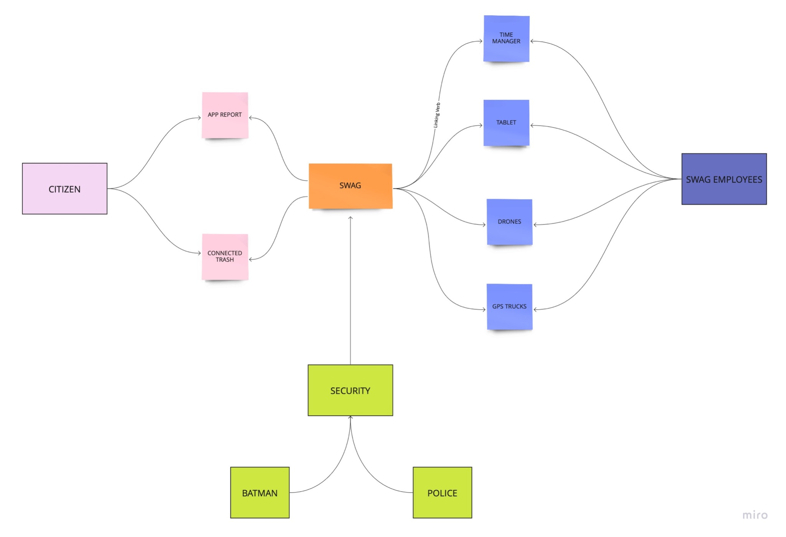

To create a communication plan, we had to prioritize key stakeholders and make sure we started talking to them early in the project.

### Design:

**Methodology** : Prosci is a Change Management Program

Why PROSCI CHANGE MANAGEMENT?

organizations are facing faster and more complex changes than ever before, change management prepares, equips and supports employees, so they can engage, adopt and use the change successfully.

The Prosci Methodology enables organizations to manage change wisely. By doing so, it helps employees thrive through the changes they’re faced with and increases the returns on project investments.

**Better percentage of :**

* achieving goals
* stay on schedule
* stay on budget

employees embrace and adopt change

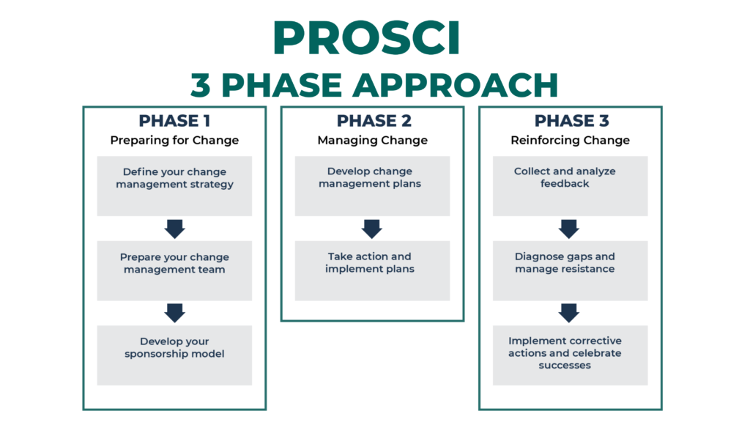

The Prosci ADKAR® Model is one of the two foundational models of the Prosciand a results-oriented approach to managing change based on a simple truth: *company-wide change happens one person at a time.*

While the ADKAR Model enables successful change at the individual level, the Prosci 3-Phase Process provides a framework for achieving change at the organizational level.

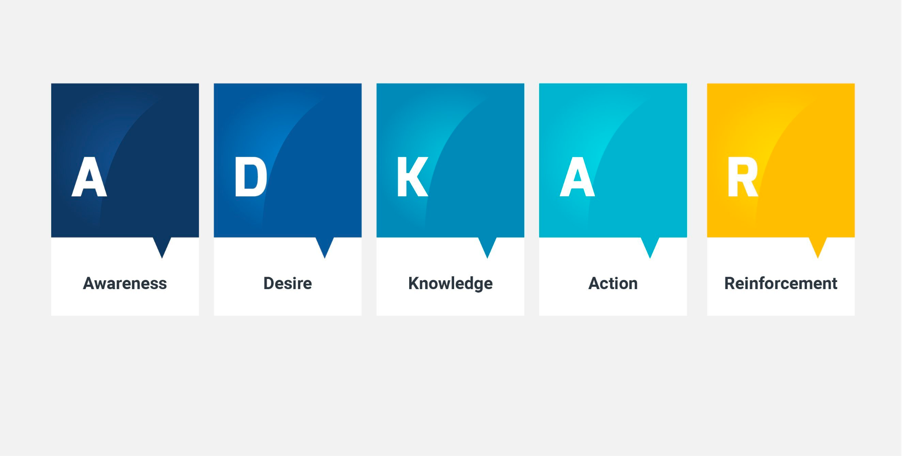

Steps of ADKAR change :

**A**wareness :

Aware and understand why the change is necessary

**D**esire :

Feel dissatisfied with the current state

Understand the negative consequences of not changing

Want to participate in the change

**K**nowledge :

Having the knowledge of how to change

**A**bility :

New skills and behaviors to make the change happen

**R**einforcement :

The change is reinforced within each individual. (rewards)

## 

## **PCT Model:** A framework that shows the four critical aspects of any successful change effort and how they are interrelated: namely, a shared definition of success with leadership/sponsorship, project management and change management.

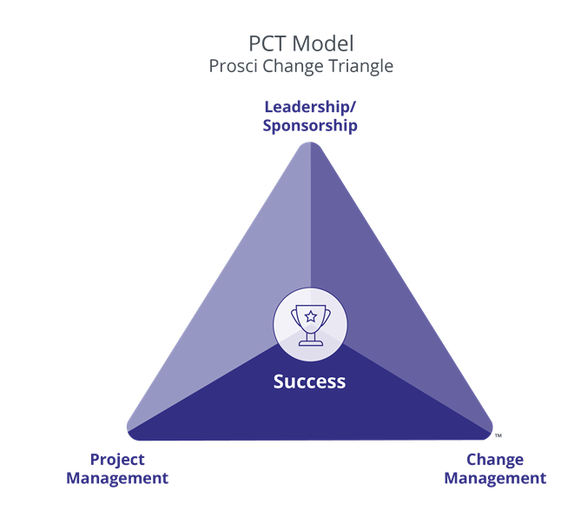

[Prosci 3-Phase Process](https://www.prosci.com/methodology/3-phase-process) – a structured, flexible framework for driving change at the organizational level:

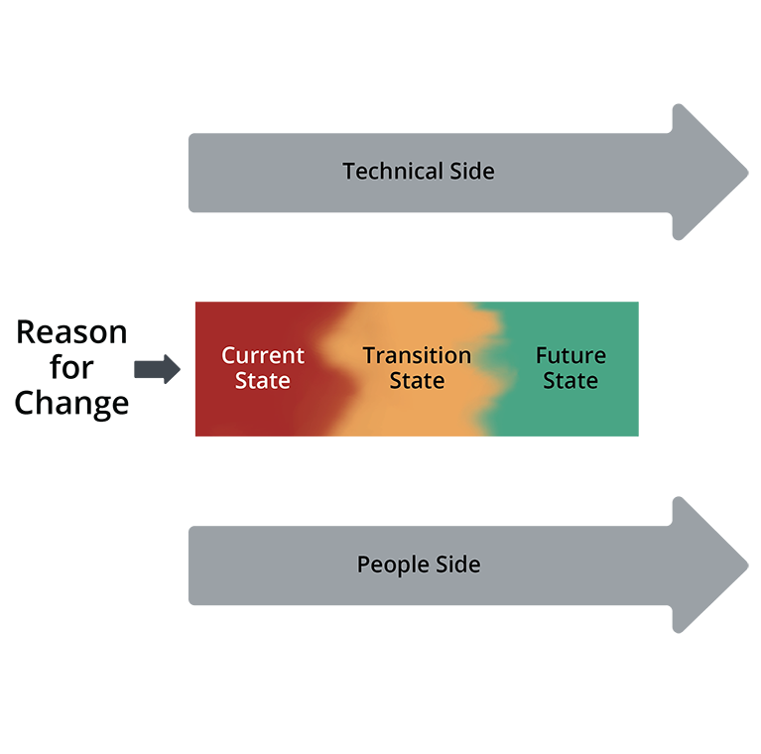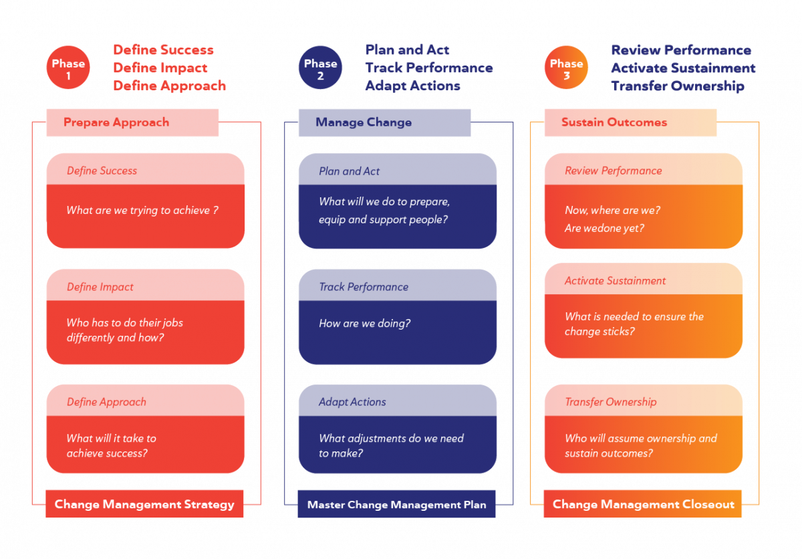

## Phase 1 – Prepare Approach - equivalent to before change

Purpose: To position the change for success by developing a customized and scaled change management strategy with the necessary sponsorship and commitment.

**Define Success : What are we trying to achieve?**

1. Make the city clean again
2. Improve collecting garbages efficiently
3. Manage garage for recycling
4. Optimize work time
5. Facilitate work conditions
6. Manage productivity

**Define Impact : Who has to do their jobs differently and how?**

1. SWAG team by using new equipments and methods
2. Citizens who need to learn and adopt to new routine and have access to the application
3. Gotham city hall to manage the new system

**Define Approach : What will it take to achieve success?**

1. Communication : inform the stakeholders of the transformation
2. Convince people why the change is needed and how it is useful
3. Train person that are engaged (SWAG employees, police and citizens)

## Phase 2 – Manage Change - equivalent to during change

Purpose: To achieve adoption and usage of the change by creating, implementing and adapting plan(s) that will move individuals and the organization through ADKAR transitions.

**Plan and Act : What will we do to prepare, equip and support people?**

1. By showing people why the current system isn’t working and that change is required
2. By providing new tools such as tablets, drones, connected trash cans and applications
3. By upgrading equipments like louse trucks
4. By creating a system to teach on and off field employees as well as citizens how to use the applications
5. By training management team
6. By defining a timeline

**Track Performance : How are we doing?**

1. By checking if the training is good enough for people to understand ?
2. By comparing the current efficiency with the previous system

**Adapt Actions : What adjustments do we have to make?**

1. By providing individual training to those in need.
2. Manage the transformation and seek out the outcome in order to overcome any difficulties

Phase 3 – Sustain Outcomes - equivalent to after change

Purpose: To realize the value of the change by ensuring the change is adopted and the organization is committed and prepared to sustain the change.

**Review Performance : Now, where are we? Are we done yet?**

1. Is the equipment sufficient ?
2. Are the results what was expected ?
3. Is there something left to do ?
4. Find out if and why the current system isn’t working up to its full potential.

**Activate Sustainment : What do we need to ensure the change sticks?**

1. By getting feedback of those who are involved specially the citizens
2. Keep the simulations and training ongoing for all employees
3. Have a developer team in hand to maintain and modify applications when needed
4. Maintain trucks, drones and replace any damaged equipment

**Transfer Ownership : Who will assume ownership and sustain outcomes?**

1. Keep the development team to save external dependency
2. Keep the project in house to remain close to the Gotham’s officials

**Coach , training and communication:**

Before developing any specific change management plan, change practitioners create an ADKAR Blueprint to set the direction for a change initiative. The ADKAR Blueprint is a simple and scalable guide, oriented toward people, which enables the practitioner to identify at a high level the milestone dates, expected gaps and initial ideas for each ADKAR element.

ADKAR blueprint is in Phase 2

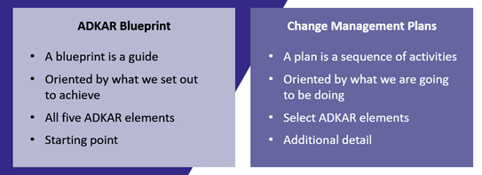

#### **ROLE PLANS**

* Sponsor Plan
* People Manager Plan

#### **ACTIVITY PLANS**

* Communications Plan
* Training Plan

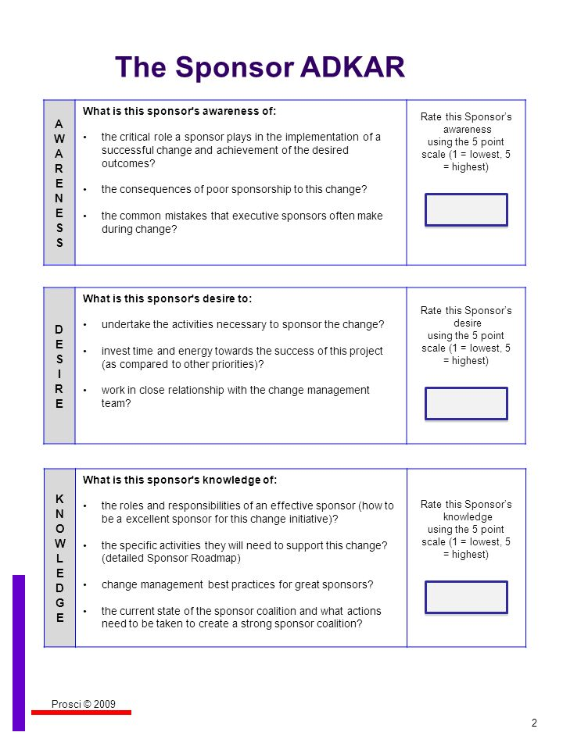

A primary sponsor is the leader who authorizes the change within an organization and is ultimately responsible for ensuring that the change realizes intended benefits.

Employees impacted by change need to understand why changement is needed, for that as a sponsor we have to justify the changes for the employees.

Arguments for why change is needed:

* Simplify the life of the citizens and the employees. They don’t need to worry anymore about the appointment. This should result, if used properly, in a fairer schedule for those who work night shifts.
* The citizens can easily signal a problem with the application
* The trucks will be equipped with GPS tracers, in order to be able to live-map their presence on the city map: thus, the managers can send the adequate team when there is an emergency.
* The employees will be able to see their working time to see the balance of their vacation.
* The manager can improve the working time of the employees and help the city save money.

We need to focus on the advantages of the changement to convince the employees and the citizens to accept the changes.

**Communication plan**

There are Two different audiences :

* **Staff members**
* **General population**

In the beginning, we start with an in house seminar.

The goal is to not only provide information(**awareness**) about **why we need to make changes** which are about to be implemented but also to explicitly provide objectives of the plan and show them the major axes and priorities and also to explain **why now** alongside **what happens if we don’t**.

We will address the subject of **why everyone should** **embrace the change** and explain **how we are implementing these changes** and **what will bring for them**.

A **support service** is created. They are available to the staff members who might have any question or need clarification about the process. They also have the possibility to use this service as a **platform for their demands/needs** revolving around change. For those who have difficulties or have issues, they have access to an easy to use ticketing solution.

The service information is communicated throughout the SWAG internal communication channels such as **mails**, video **tutorials** on how to use new devices and **documentation**. A regular mandatory **feedback** is also in place. There is another goal which is to gather all the important information regarding the change so that the **statistics** collected can be used to **better understand the staff** their **needs** and **reaction** to the change in order to implement changes when needed.

Then comes outside communication where we target the citizens.

Through usual communication channels we provide the **simplest way possible** the **key information** about the change and this on a regular basis such as publicities on TV channels, radio stations or even by flyers in letterboxes and posters in public transportation so that everyone is informed and kept updated. This should include **why they should comply** doing this and **what’s in it for them**. A rewarding program has been undertaken in which compliance is rewarded through bonus points lowering taxes.

**Training plan**

The Training plan is based on 3 main building blocks :

1. Preparation
2. Implementation
3. Reinforcement

In order to successfully implement a training plan we need to identify the different audiences that need training, conducting a needs assessment and gap analysis, and documenting requirements for the training organization. There could be several phases to this :

* **Structured timeline:**

within a month we should have finished training

* **Management training:**

management staff should learn within 2 weeks tops

* **Workshops with real-life situations:**

A general Workshop in which all the on field employees are trained through the real-life situations

* **Group training:**

young, easy to train to the new techs could be trained in groups

* **Individual training:**

by gathering individual info and capacity of learning and gap analysis individual training for the most difficult audience is needed.

It’s important to take into account the urgent and important needs of the employees in order to improve the performance and productivity.

By using Support service’s statistics and staff’s demands, we can rearrange and adjust the training sessions or make them more personalized to boost the implementation success level.

A separate training program has been defined for those who are going to control drones. There are multiple parameters to be taken into consideration about rules and regulations since it touches a sensitive subject of privacy which got the general public already worried. This specific training contains a set of skills others jobs don’t require thus upgrading trainable internal staff having related background or ability to adapt but at the end we had to hire mostly to get it going. This required budget adjustments that weren't on the plan before.

**Resistance Management Plan**

Prosci's Resistance Management Plan is a framework that helps organizations manage and overcome resistance to change. It includes several key components :

1. **Identify and assess resistance** : Understand who is likely to resist the change, why they might do so, and the potential impact of their resistance.

There is always resistance towards change, humans love their habits and routine. There are those who resist naturally without any specific cause and then there are those who even with their good will need assistance to be able to adjust to the new setup since they have been working in a different environment for years thus making it hard for them to develop new skills specially with new tools they never used before. The privacy concerns are the most difficult ones to overcome, citizens got worried about drones equipped with cameras as they are here to be used as a tool to keep an eye on everyone’s move in public areas alongside the fixed street cameras that are already in place now they got a mobile device that can not only locate anyone anywhere but can also follow them throughout their route.

These concerns will be a hurdle in the implementation of this change. At first it will slow down productivity for sure.

1. **Develop a resistance management strategy** : Use this information to develop a plan for addressing resistance, which may include tactics such as communication, education, and addressing concerns.

The plan consists of two parts. First is to maintain the resistance’s impact on productivity at a minimum level by using better communication then secondly make sure to fight the resistance by helping those in need to adjust and learn new ways by personally addressing their issues. Usually they are the aged ones and the ones working in the old systems for years.

1. **Implement the plan** : Put the resistance management strategy into action.

In this phase we get outside help from specialized trainers with such experiences to help manage the resistance efficiently.

1. **Monitor progress** : Track progress and make adjustments as needed.
2. **Sustain the change** : Ensure that the change is fully adopted and embedded into the culture of the organization.

Overall, the plan emphasizes the importance of proactively addressing resistance, rather than simply reacting to it, and recognizing that resistance is a normal part of the change process.

Phase 3 :

Mesure :

a measurement strategy into the standard change management framework.

**measurement categories:**

* **start with Change Management Performance and move up to Organizational Performance**

1. **organisational performance:** outcomes

Big Question:Did the initiative deliver what was expected?

-are associated with the project achieving the desired outcomes for the organization

-should answer the questions

Early:

* Objectives set
* Readiness (inhouse developer team and support team)

During:

* Progress to plan
* Deliverables met
* Schedule adherence
* KPIs(Key performance indicators )

Late:

* Benefit realization
* Project success
* Objectives met
* Performance improvement

1. **individual performance**: outcomes

Big Question:How effectively did impacted individuals (citizens, employees) adopt and use the change?

**methods** : surveys, tests, assessments, observation, and performance evaluations

Early:

* Buy-in and commitment
* Awareness Readiness

During:

* Understanding
* Engagement
* Participation

Late:

* Usage
* Compliance
* Adoption
* Proficiency

1. **change management performance**: activities

Big Question:How well did we “do” management?

Early:

* Approach
* Resources
* Scaling and customizing

During:

* Activity completion
* Comm. completion
* Training completion

Late:

* Activity effectiveness
* Compliance/usage audits
* Collection of feedback
* Sustainment activities

**Organizational KPI**    
Monthly Report => Performance Analysis  
 - Tons of waste collected  
 - Number of garbage cans installed and operational  
 - Number of missions completed per day  
 - Reaction time to an emergency  
 - Number of reports/requests made on the app (tablet)  
 - Rate of coverage of the drones  
 - Incident reporting by citizens and requests for internship of garbage collectors  
 **Individual KPI** - Notifications used on the notification site  
 - Incident reporting by citizens  
 - Number of reports/requests made on the applications  
 - Number of calls to the help desk

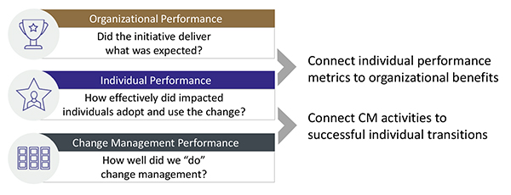

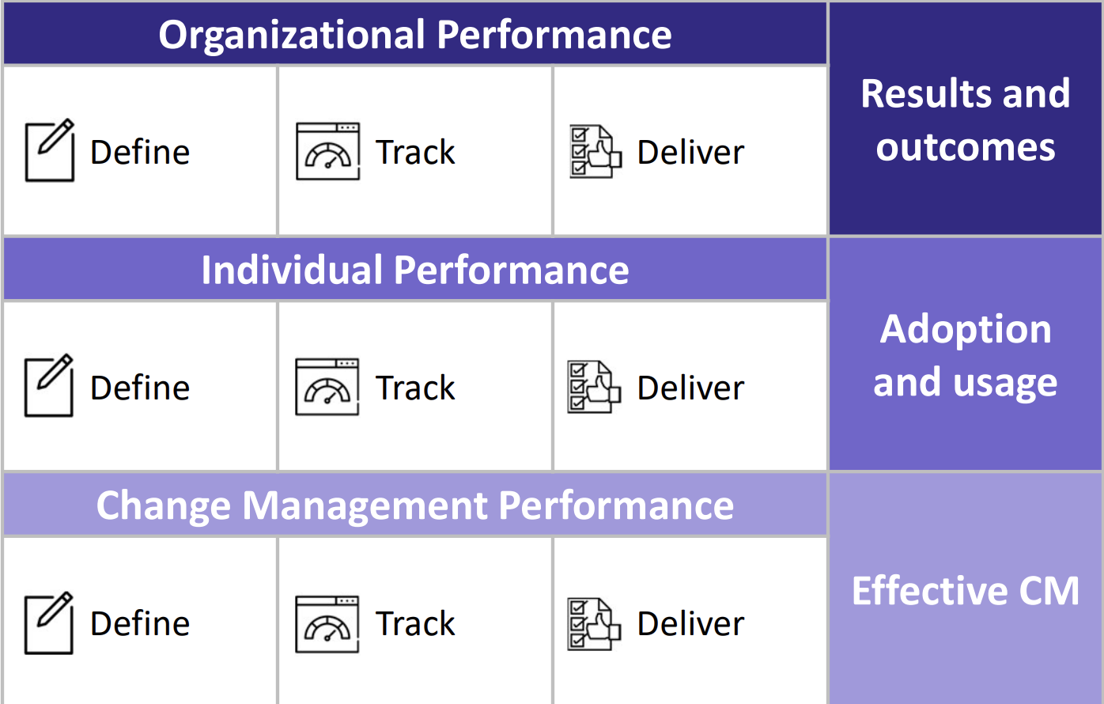 lifecycle

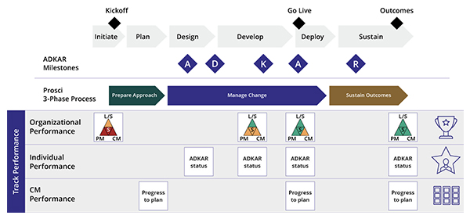

Feedbacks

To assess the progress of change we need to gather feedback from employees of SWAG company, the data collected will help us understand better the needs in terms of change allowing us to adapt and focus on key points :

To get feedback that has the key information regarding the methodology applied to this project we will have to ask specific questions on which we would need to work on. Thus we applied the “employee feedback template” provided by Prosci ADKAR model :

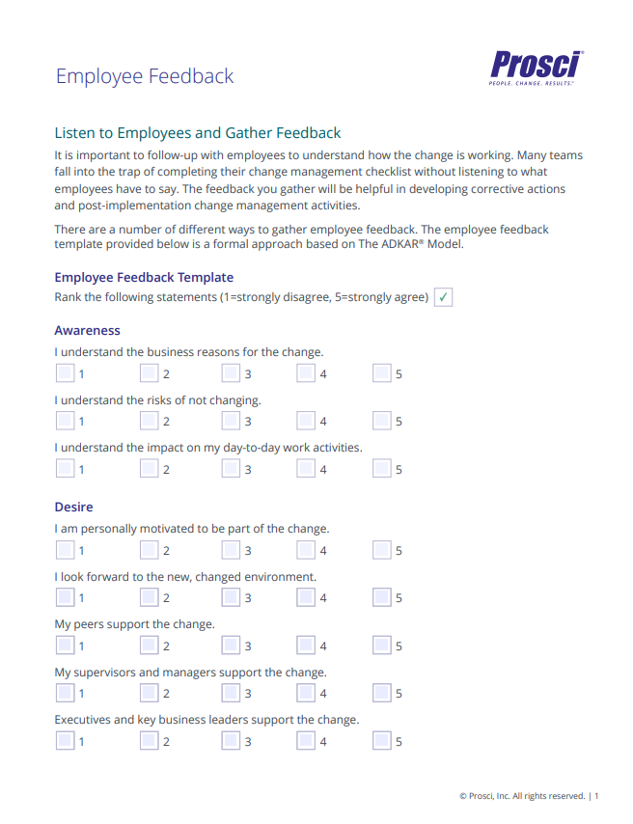

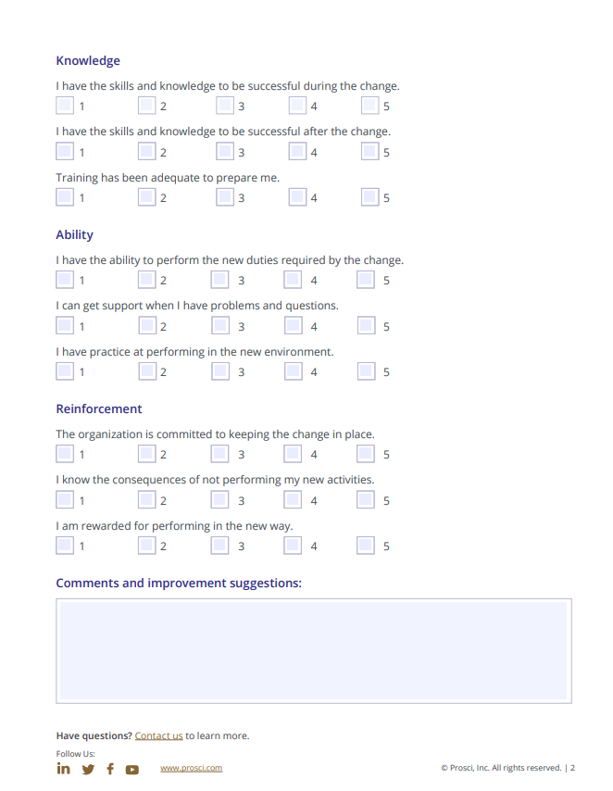By following the PROSCI method, the SWAG company can gather feedback from employees, identify areas for improvement, and implement changes that will benefit both the company and the employees.

Diagnose gaps

The PROSCI method can be used to diagnose gaps and manage resistance in SWAG company. Here are some steps that can be followed to diagnose gaps and manage resistance using the PROSCI method:

1. Using feedback: Assess the current state of the company by using the interviews and surveys collected to understand their current experience, their perception of the company and identify any gaps in the process or resistance to change.
2. Analyze gaps: Analyze the gaps between the current and desired state and identify the root causes of any resistance to change.
3. Develop a plan: Develop a plan to address the gaps and manage resistance, including specific goals, timelines, and resources required.
4. Communicate the plan: Communicate the plan to employees, and explain the rationale behind the changes and how they will benefit the company and the employees.
5. Provide training: Provide training to employees on the new processes, procedures, and technologies that will be implemented, so they can be successful in their new roles.
6. Implement the plan: Implement the plan, and monitor progress to ensure that the desired changes are being met.
7. Address resistance: Address the root causes of resistance and implement specific strategies to manage it, such as involving employees in the change process, providing support and resources, and communicating the benefits of the change.

Celebrating and corrective actions are both important steps :

Implementing correctives:

If the success level is not as high as expected, we have to identify issues by using all the tools, feedback and statistics in hand.

Then make a plan which is clear, actionable, and has a specific timeline before implementing those corrective measures (reinforcement) and also we have to keep an eye by monitoring progress, assigning responsibilities and communicating as many times as possible until we have reached our objective.

Celebrate :

Once we have achieved the initial objective, it’s important to celebrate as every victory should, by helding a celebrating event in which we can have a lunch or a cocktail party of sorts.

Acknowledge the individual/team contributions who played a key role in the success.

The results are also shown to boost the workers motivation or of the stakeholders.

Reflect on the journey to show how far we have come from the start to emphasize on a new way of working to encourage people to fully embrace the change.