Vision AI for Defense
From camera views to useful insights
Use Isaac Sim to create realistic environments with drone, fixed and vehicle-mounted cameras. Bring the camera views into VSS to show what edge AI can help an operator see, understand and review.

01 Drone inspection and search
Find something. Take a closer look. Record the finding.
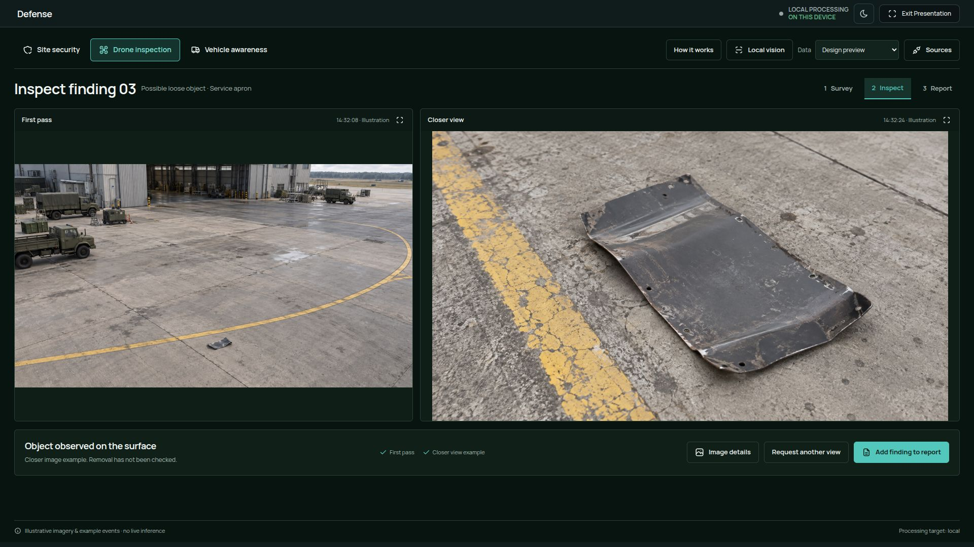
Actual VSS Defense screen, in Design preview: a first-pass observation beside a closer inspection image.
- Use Pegasus in Isaac Sim to create camera-equipped drones that fly through an airfield or facility.
- Find people, loose objects or surface issues. Select an object for the AI to describe or outline with segmentation.
- In VSS, move from a survey view to a closer image, then collect the findings in an inspection report.
Example: a drone spots a loose object on the apron. The operator opens a closer view and adds the finding to a report.

02 Site security
See activity across cameras. Bring the relevant event forward.
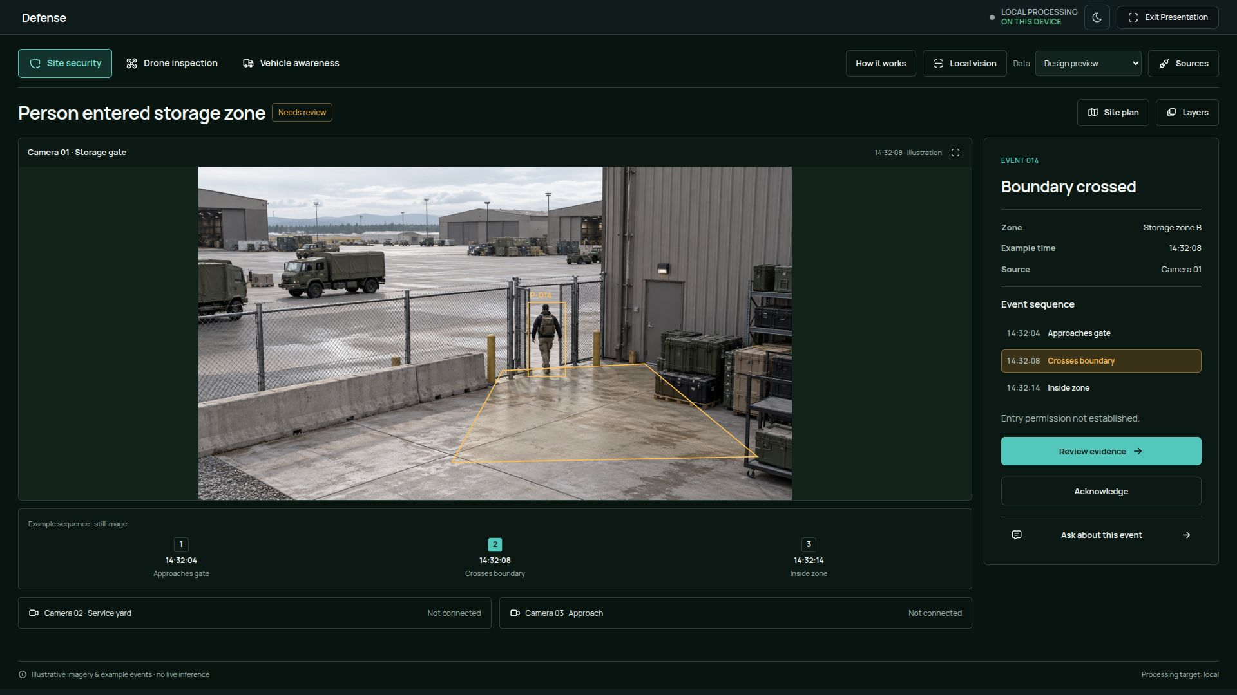
Actual VSS Defense screen, in Design preview: a person crosses a storage-area boundary and the event is ready for review.
- Place cameras around an air base, including hangars, gates and storage areas.
- Detect and track people across camera views. Define areas that trigger an alert when someone enters, crosses a boundary or stays too long.
- In VSS, open the alert, follow the event sequence and review the supporting images or video.
Example: a person enters a defined storage zone. VSS shows the camera, the boundary and the sequence of events.

03 Vehicle awareness
Bring the views around a vehicle into one clear display.
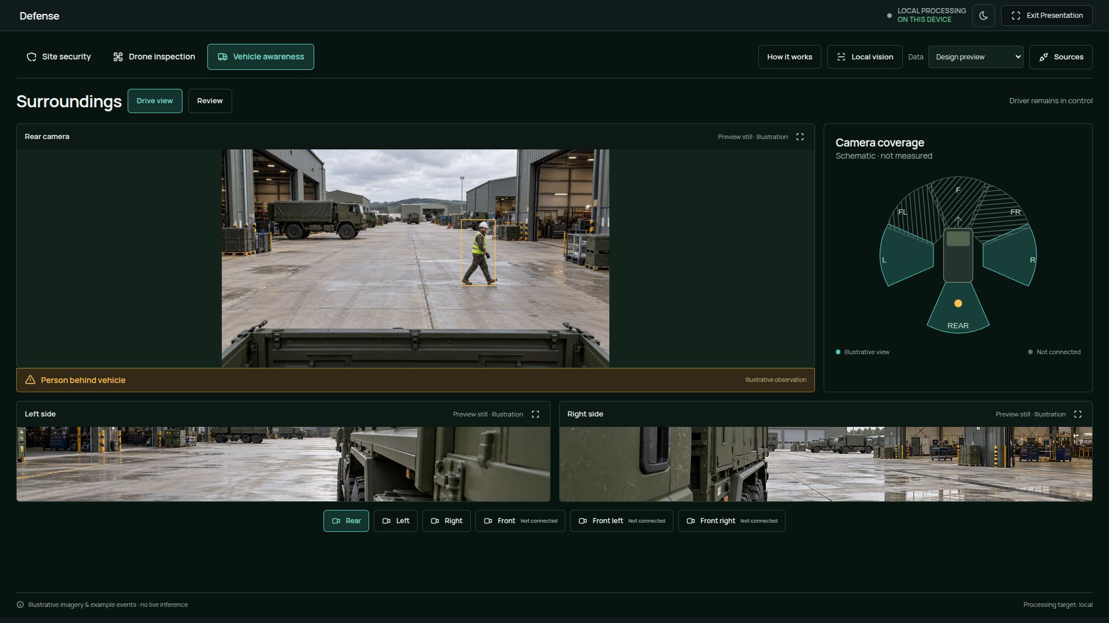
Actual VSS Defense screen, in Design preview: rear and side views beside a camera-position diagram.
- Attach front, rear and side cameras to a vehicle in Isaac Sim.
- Detect people, vehicles and obstacles around it. Bring the relevant camera view forward when something needs attention.
- In VSS, show the surrounding camera views together, with visual cues that help the driver understand where to look.

How this fits into VSS
VSS — Video Search and Summarization — brings the camera views and AI results into one operator workspace.
- Watch the views and see detections, tracks and area alerts.
- Select a finding to inspect its image, description or segmentation outline.
- Ask about the footage and review an answer or summary with supporting images or clips.

Inspection and border security
See the activity. Bring the relevant images forward.

04 Aircraft exterior inspection
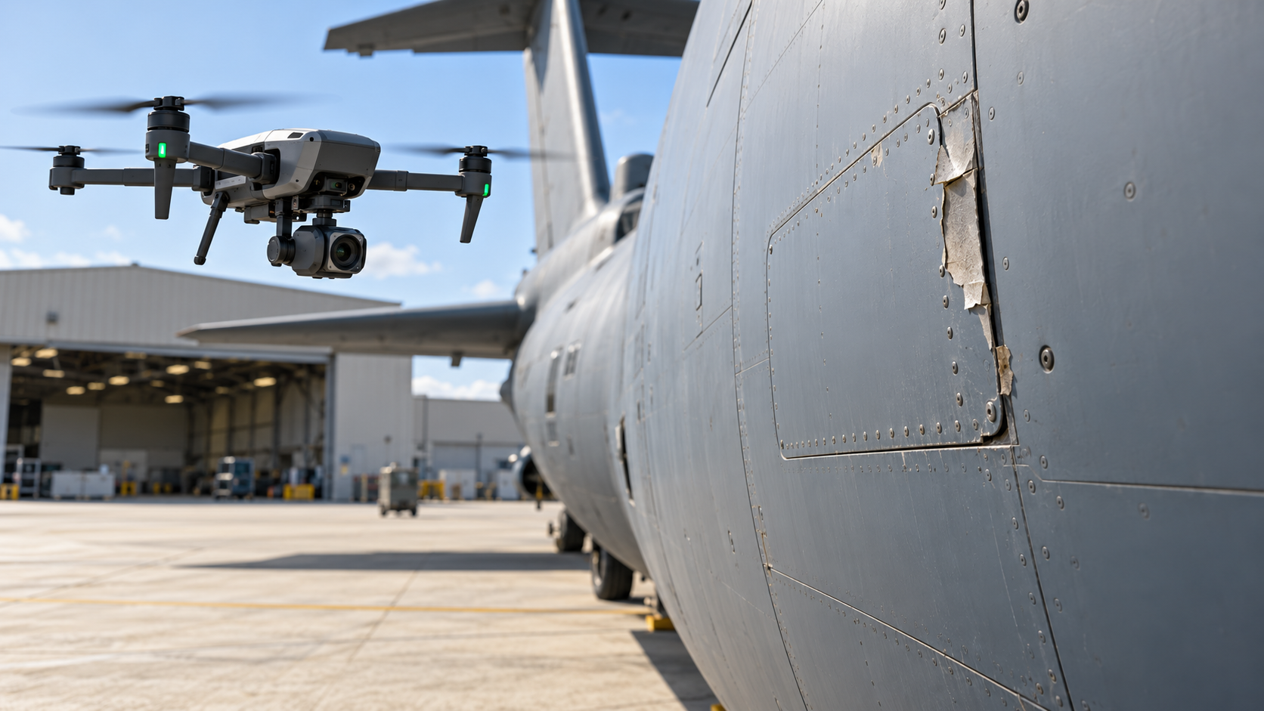  Scenario illustration: a drone camera inspects the aircraft exterior. | - Fly a camera around an aircraft and highlight visible panel, seal or coating issues for closer review.  - In VSS, browse the inspection images and open each highlighted area for the maintenance team.

05 Border security
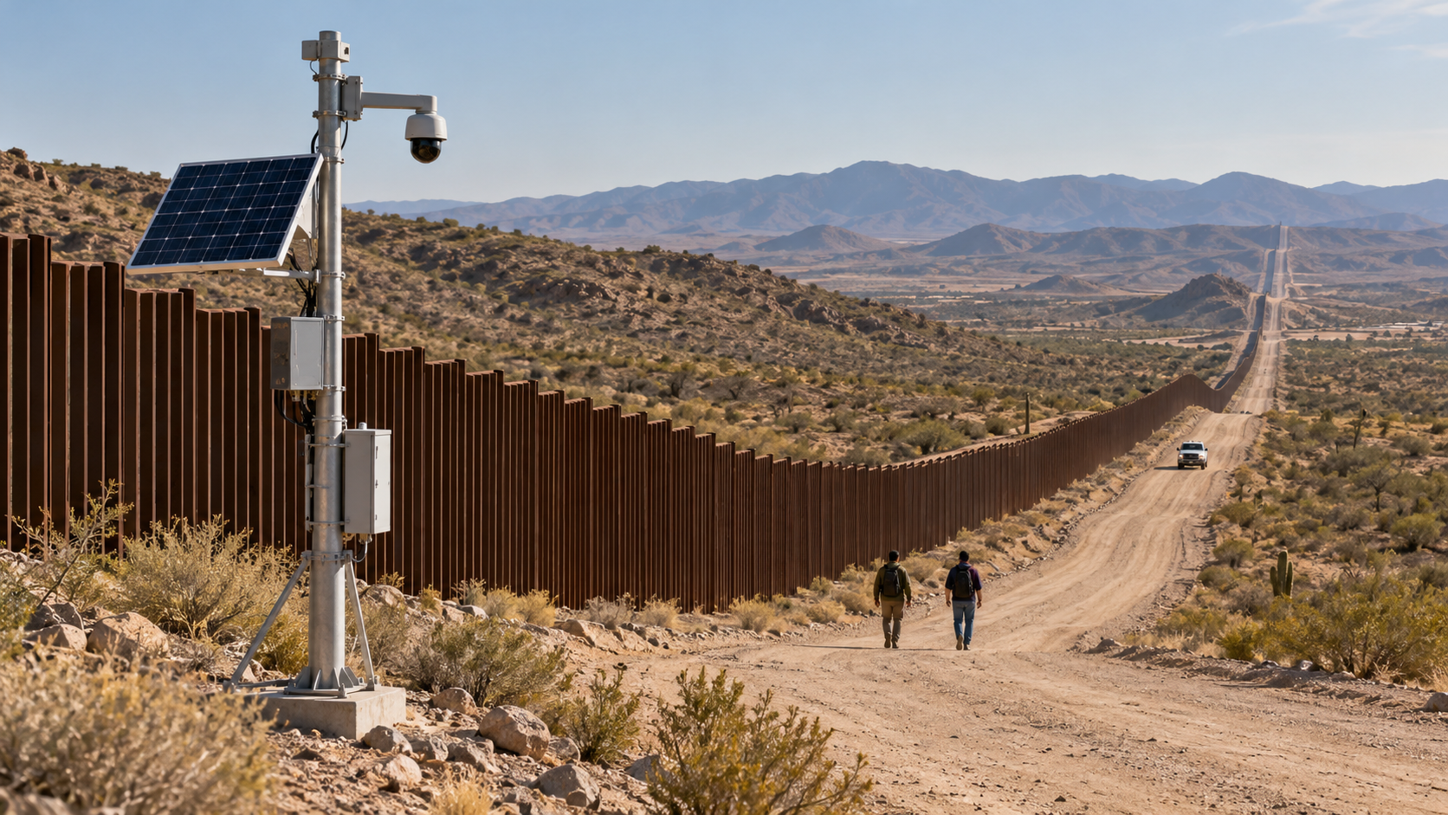  Scenario illustration: a camera monitors people and vehicle activity along a remote border access road. | - Use fixed or drone cameras to monitor remote border areas and access roads. Detect people and vehicles, track movement and flag crossings of a defined boundary.  - In VSS, bring the relevant camera view and alert forward, then show the event sequence and supporting images for operator review.

