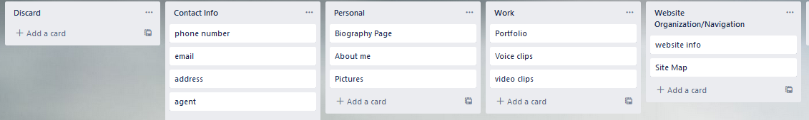  
Card Sort 1 ***closed card-sort***   
20 years old, is currently in college, uses the internet for education, and entertainment (target user)  
  
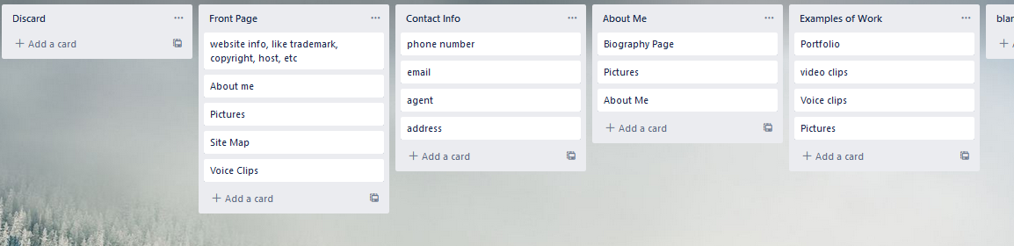  
Card Sort 2 ***open card-sort***  
20 years old, not currently in school, currently working, primarily uses the internet for entertainment. (target user)  
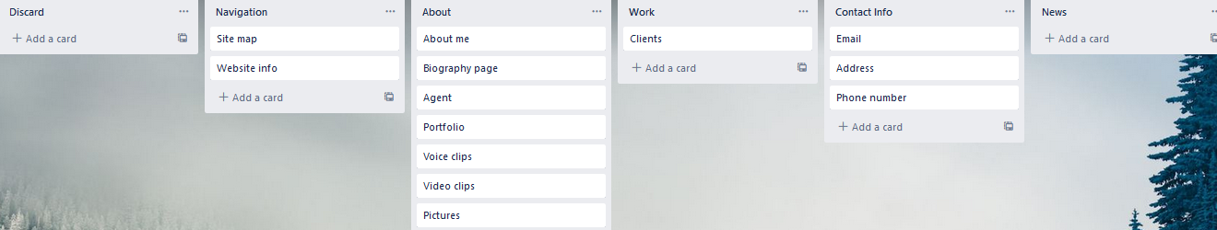  
Card Sort 3 ***closed card-sort***   
53 years old, working in electrical engineering, primary uses of the internet are entertainment and work