**Group A Site Layout Analysis**

Site Color Scheme: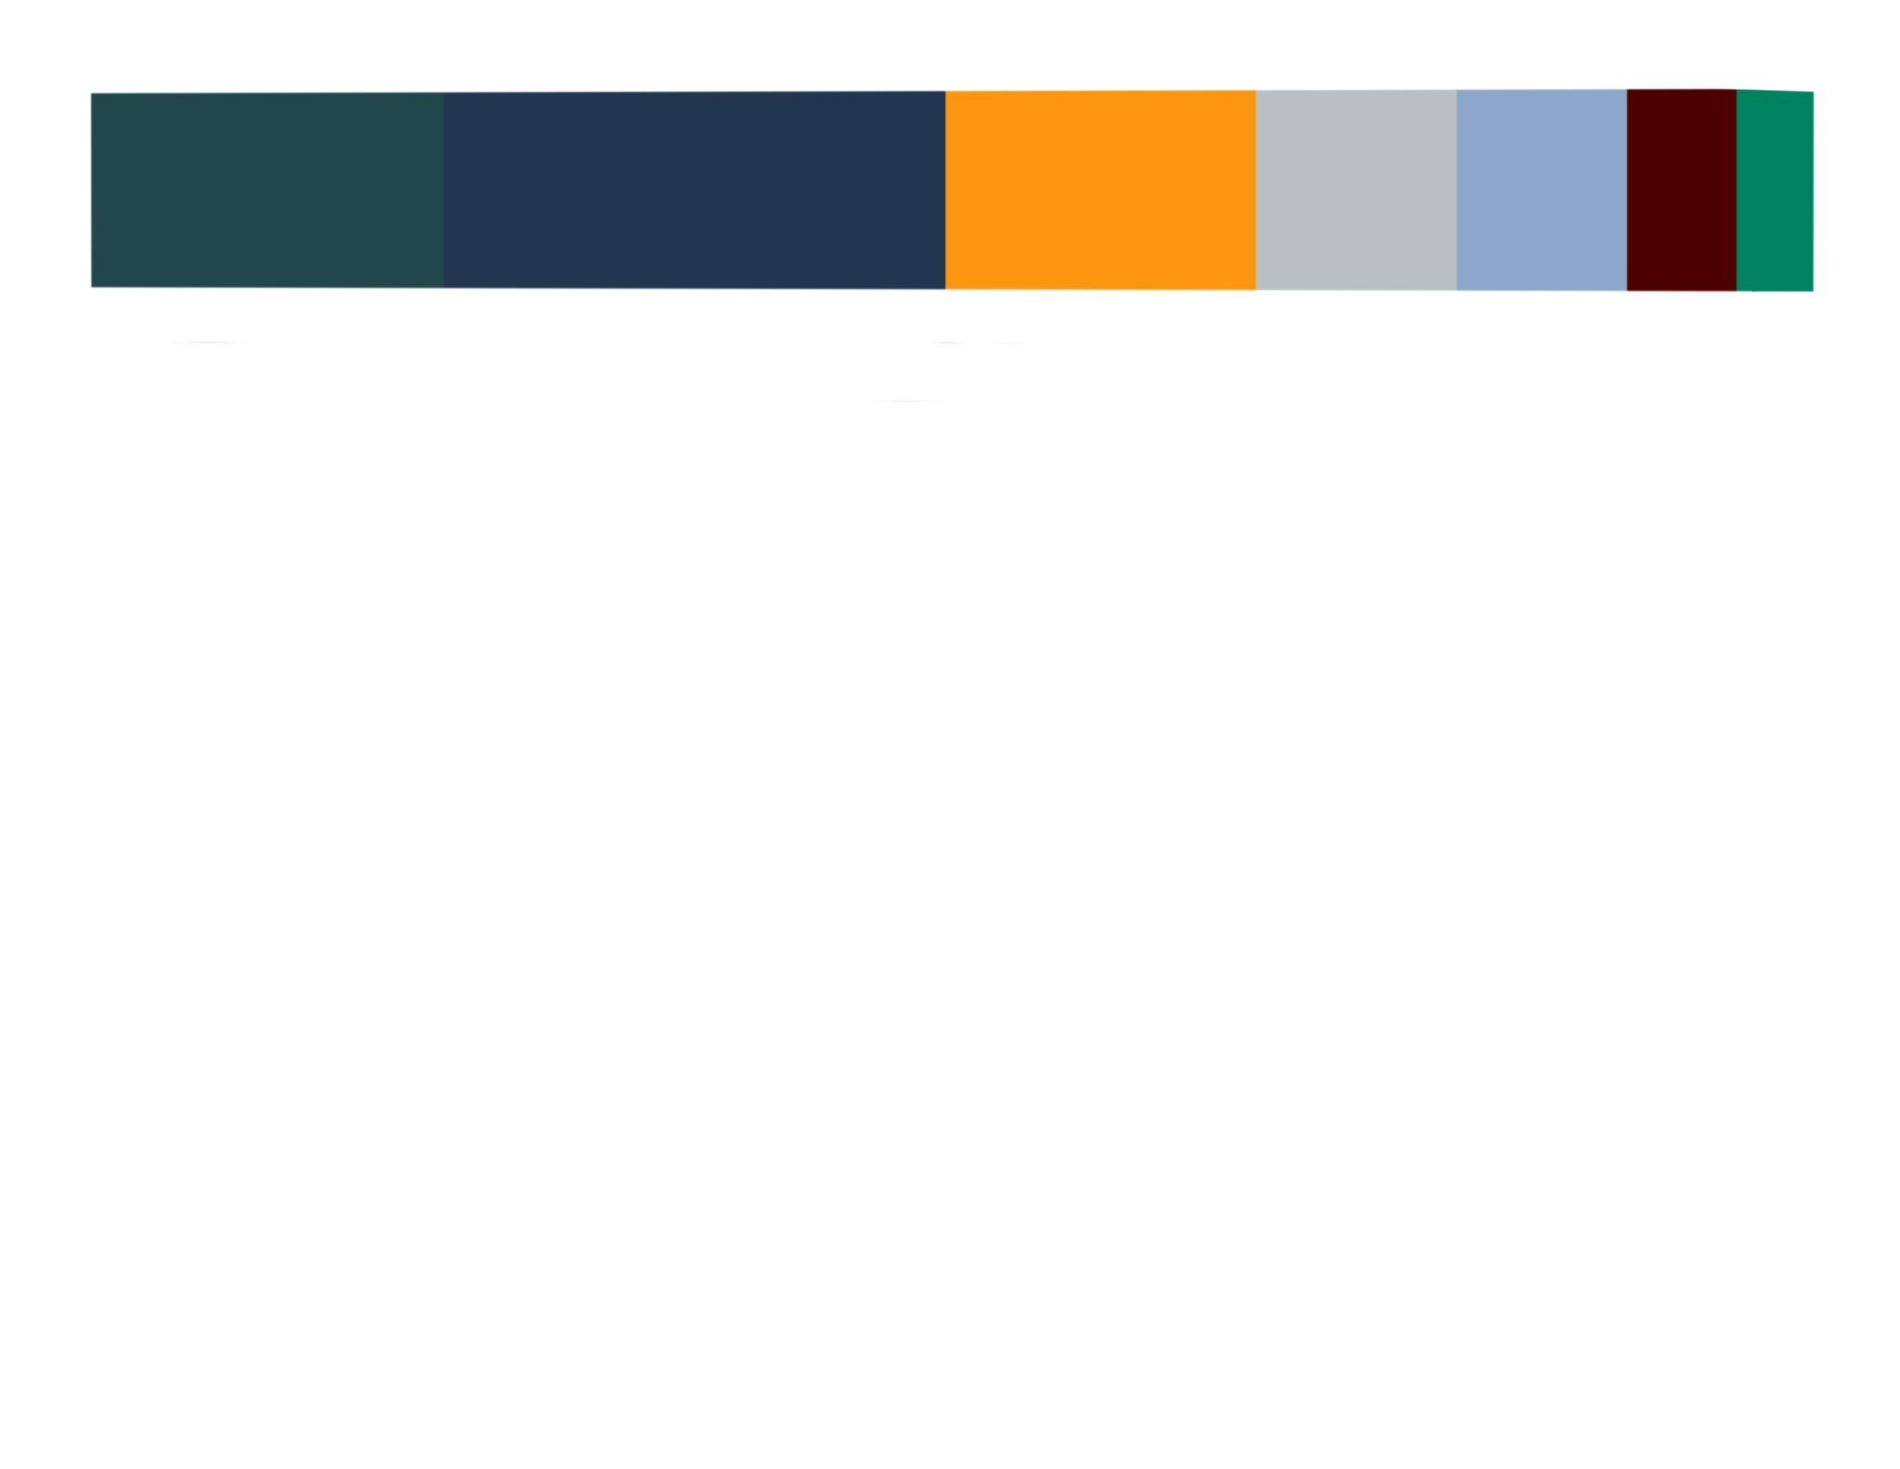

We chose this color scheme because it is accommodating to the client’s requests, while being professional, colorful, and gender neutral. The client wanted the site to read as minimalistic, yet still interesting to look at. The gold (at the request of the client) adds a pop of color that unifies the composition of the site. The blues and grays provide a neutral background to build upon, while the greens compliment the color scheme and deepen the sense of variety across the composition. We chose gender neutral colors to appeal to every audience that may be interested in our client’s work.

Site Layout (Attached in Github):

This layout is fully adapted to best fit the client’s requests. There are ways for users to contact the client (achieving the goal of increasing networking). The site displays all of the clients most notable works, acting as a working portfolio for prospective employers. Additionally, the site draws inspiration from example sites the client has cited. This site, once completed will allow our client to meet people interested in his work, which is our most important site objective.