Behavioural Causal Discovery Reveals Absent World Models
in Large Language Models for Clinical Oncology Decision-Making
[Author Names]
[Affiliations]

Abstract
Background: Large language models (LLMs) are increasingly evaluated for clinical reasoning, yet current benchmarks primarily assess factual recall through multiple-choice questions. These evaluations cannot determine whether an LLM possesses a causal world model—an internal representation of how clinical variables interact to determine treatment outcomes—or merely pattern-matches from training data.
Methods: We developed a behavioural causal discovery framework to recover and evaluate LLMs’ implicit causal graphs for head and neck cancer treatment decisions. Using 88 counterfactual clinical vignettes (12 baselines, 64 causal perturbations, 12 null controls) derived from an international Delphi consensus of 137 expert statements (Ferrari et al., Lancet Oncology 2025) encoding 55 causal edges, we probed two models—Kimi K2.5 (moonshotai/Kimi-K2.5; 30 runs, temperature 1.0) and Llama 3.1-8B Instruct (meta-llama/Meta-Llama-3.1-8B-Instruct-Turbo; 30 runs, temperature 0.6)—via the Together.ai API using a two-phase prompting protocol with automated response parsing. Treatment stance distributions were compared between baseline–perturbation pairs using Fisher’s exact tests with Benjamini–Hochberg correction and Jensen–Shannon divergence. Recovered graphs were evaluated along three dimensions: Coverage (fraction of gold-standard edges recovered), Fidelity (structural accuracy via direction accuracy and Structural Intervention Distance), and Discriminability (signal-to-noise ratio separating causal from null perturbation responses). This study adheres to the MI-CLAIM-GEN checklist for generative AI in clinical settings and the DEAL-B framework for LLM evaluation.
Results: Of 55 expert-consensus causal edges, Kimi K2.5 recovered 22 (40.0% soft recall) with 81.8% direction accuracy and a Structural Intervention Distance of 22.2% (34/153 predictions wrong), while Llama 3.1-8B recovered only 4 (7.3%) with 25.0% direction accuracy and SID of 28.6% (44/154 wrong). Kimi’s signal-to-noise ratio (SNR) of 2.16 confirmed meaningful discrimination between causal and irrelevant perturbations, whereas Llama’s pathological SNR of 0.46 indicated that it responded more strongly to clinically irrelevant modifications than to causally meaningful ones, with 0% detection power. Kimi demonstrated a partial but incomplete world model; Llama demonstrated no coherent causal representation.
Conclusions: Behavioural causal discovery through counterfactual perturbation provides a rigorous, graph-theoretic framework for evaluating whether LLMs possess the causal understanding necessary for clinical deployment. The three-dimensional evaluation—Coverage, Fidelity, and Discriminability—offers complementary and independently interpretable diagnostics grounded in causal graph comparison metrics. Benchmark accuracy without causal evaluation is insufficient evidence for clinical readiness.

Introduction
Clinical decision-making requires more than factual knowledge; it demands a causal understanding of how patient characteristics, tumour biology, and treatment modalities interact to determine outcomes. Craik’s foundational insight that cognition builds “small-scale models” of reality for anticipation and simulation (1943) remains central to the cognitive sciences.¹ Lake, Ullman, Tenenbaum, and Gershman formalised this into the requirement that intelligent systems build causal generative models enabling few-shot generalisation and robust transfer.²
Large language models (LLMs) have demonstrated impressive performance on medical examinations and clinical vignettes,^{3–5} yet a fundamental question remains unanswered: do these models actually understand the causal structure of clinical domains, or do they produce correct-seeming outputs through sophisticated pattern matching? This question is not merely academic. A model that pattern-matches correctly on common presentations but lacks causal understanding will fail unpredictably on novel combinations of clinical variables—precisely the scenarios where clinical decision support is most needed.^{6,7}
Existing evaluation paradigms cannot answer this question. Multiple-choice benchmarks test factual recall.⁸ Clinical vignette studies measure agreement with expert panels but cannot distinguish genuine causal reasoning from memorised associations.⁹ Even chain-of-thought analyses reveal the model’s articulated reasoning, not its implicit causal representations.¹⁰
We address this gap by introducing behavioural causal discovery: a method for recovering an LLM’s implicit causal graph through systematic counterfactual perturbation. By presenting clinically grounded vignettes in which single variables are altered and observing the resulting treatment recommendation shifts, we reconstruct the model’s internal causal topology without requiring access to model weights or activations. The recovered graph is then evaluated against an independently derived expert consensus—the international Delphi agreement on laryngeal preservation strategies.¹¹
We evaluate the recovered graphs along three complementary dimensions that together characterise the quality of the model’s world model: Coverage (how many gold-standard causal edges are recovered), Fidelity (structural accuracy of recovered edges, assessed through direction accuracy and the Structural Intervention Distance), and Discriminability (the model’s ability to distinguish causally meaningful perturbations from irrelevant noise, quantified as the signal-to-noise ratio). These dimensions are grounded in established causal graph comparison metrics and are independently interpretable, each addressing a distinct aspect of causal competence.

Methods

Study Design and Reporting Standards
This is a computational evaluation study that assesses the implicit causal representations of large language models through behavioural probing with counterfactual clinical vignettes. No patients were enrolled, and no protected health information was used; all clinical scenarios are semi-synthetic, constructed from published consensus parameters. The study was designed and reported following the Minimum Information about Clinical Artificial Intelligence Modeling for Generative Models (MI-CLAIM-GEN) checklist,²¹ which extends the original MI-CLAIM framework²² to address the specific requirements of generative model evaluation, including zero-shot prompting, open-ended output assessment, and reproducibility of stochastic outputs. In addition, we followed the DEAL-B (Development, Evaluation, and Assessment of Large Language Models) checklist,¹⁵ a reporting framework specifically designed for LLM studies in medicine. All analysis code, the vignette battery, prompting templates, and raw model outputs are available in the supplementary materials.

Reference Causal Graph (KG₁)
The gold-standard causal graph (designated KG₁) was derived from an international Delphi consensus on laryngeal preservation strategies published in Lancet Oncology (Ferrari et al., 2025).¹¹ The consensus comprised 137 statements covering treatment selection criteria for head and neck squamous cell carcinoma, achieved through iterative Delphi rounds with international experts from multiple centres across Europe, North America, and Asia-Pacific. From these 137 statements, we extracted 55 directed causal edges, each linking a clinical variable (source node) to a treatment modality (target node). Source variables span six clinical domains: tumour staging and extent (T stage, N stage, subsite, cartilage involvement, paraglottic and pre-epiglottic space invasion), patient fitness (ECOG performance status, age, comorbidities, CGA fitness classification), functional status (laryngeal function, swallowing, airway patency), surgical access (laryngeal exposure adequacy), chemotherapy eligibility (renal function, hearing, neuropathy, cardiac status), and treatment response (post-induction chemotherapy response category). Target nodes comprise 16 treatment modalities including transoral laser microsurgery (TLM), transoral robotic surgery (TORS), open partial horizontal laryngectomies (OPHL types I, II, IIB, III), total laryngectomy (TL), radiotherapy alone (RT), accelerated radiotherapy, concurrent chemoradiotherapy (CRT), induction chemotherapy followed by response-adapted treatment (ICT), high-dose cisplatin, cetuximab, and carboplatin-5FU. Each edge carries a consensus-derived type classification (absolute contraindication, relative contraindication, positive indication, or conditional recommendation) and a weight reflecting the Delphi agreement percentage.

Counterfactual Vignette Battery
We constructed 88 clinical vignettes organised into 12 baseline cases and 76 perturbations. The 12 baselines span 10 clinical families covering the major presentation patterns in laryngeal and hypopharyngeal cancer: glottic cT2 (2 baselines: favourable TLM-eligible, unfavourable), glottic cT3, supraglottic cT3, hypopharyngeal, cT4a unselected, cT4a selected for larynx preservation, cisplatin eligibility, post-induction chemotherapy response (2 baselines: complete response, stable disease), elderly/frail, and pretreatment function. Each baseline represents a clinically coherent patient scenario with complete demographic data, tumour staging, imaging findings, functional assessments, and laboratory values (vignette length: 721–1,095 characters, mean 888).
Each perturbation modifies exactly one clinical variable from its parent baseline while holding all others constant, implementing Pearl’s do-operator¹² at the behavioural level. The 76 perturbations comprise five types: 48 flip perturbations (binary variable reversal, e.g., vocal cord mobile → fixed), 12 escalation perturbations (ordinal variable increase, e.g., limited paraglottic invasion → massive invasion), 3 grey-zone perturbations (entering clinical equipoise where the expert consensus is divided), 1 multi-variable perturbation (convergent contraindications), and 12 null perturbations. The null perturbations modify clinically irrelevant variables (patient name, hospital location, treating physician) that should produce no change in treatment recommendations, serving as negative controls for estimating each model’s behavioural noise floor. The battery tests 57 unique causal edges from the consensus graph (55 mapping to the gold-standard edge set used for evaluation, with 2 additional edges tested through multiple perturbation contexts).
Vignette generation was automated using a deterministic pipeline (vignette_generator.py) that applies perturbation logic to baseline templates with built-in staging consistency checks. The staging propagation module enforces clinical coherence: for example, if a perturbation sets thyroid cartilage outer cortex invasion to present, the T stage is automatically propagated to cT4a. The generator also flags implausible combinations (e.g., bilateral arytenoid fixation with functional larynx, ECOG 0 with tracheostomy plus feeding tube). All 88 vignettes were reviewed by a senior head and neck surgical oncologist for clinical face validity before deployment.

Model Selection and Access
Two models were selected to represent contrasting positions along the parameter-count and architectural spectrum. Kimi K2.5 (model identifier: moonshotai/Kimi-K2.5) is a reasoning-tier mixture-of-experts architecture with an estimated 1 trillion total parameters. Llama 3.1-8B Instruct (model identifier: meta-llama/Meta-Llama-3.1-8B-Instruct-Turbo) is a dense transformer with 8 billion parameters, representing the class of smaller models increasingly deployed in resource-constrained clinical settings. Both models were accessed through the Together.ai inference API (https://api.together.xyz/v1/chat/completions) using the OpenAI-compatible chat completions endpoint, with no fine-tuning, in-context learning examples, or retrieval augmentation. This zero-shot evaluation design tests the models’ intrinsic causal representations rather than their ability to retrieve and apply externally provided guidelines.
Generation parameters differed between models to respect each model’s recommended configuration. Kimi K2.5 was run at temperature 1.0 (the provider’s recommended value for this reasoning model), with a maximum output length of 4,096 tokens. Llama 3.1-8B was run at temperature 0.6, also with a maximum output of 4,096 tokens. These temperatures were held constant across all runs and vignettes for each model. The API rate limiter enforced a maximum of 50 requests per minute. Request timeouts were set to 600 seconds for reasoning-tier models and 300 seconds for others. Failed requests were retried up to 5 times with exponential backoff (base 10 seconds, jittered, maximum 120 seconds).

Prompting Protocol
Each vignette was presented using a two-phase prompting protocol within a single conversation turn, totalling two API calls per vignette per run. The system prompt established the model’s clinical role: “You are an expert head and neck surgical oncologist participating in a multidisciplinary tumor board. You have extensive experience with laryngeal and hypopharyngeal cancer management, including transoral laser microsurgery (TLM), open partial horizontal laryngectomies (OPHL), total laryngectomy (TL), concurrent chemoradiotherapy (CRT), and induction chemotherapy (ICT) protocols.” The system prompt further instructed the model to consider all relevant clinical variables, distinguish absolute from relative contraindications, explain reasoning with reference to specific clinical findings, and express uncertainty when present. This system prompt was identical for all vignettes, models, and runs.
Phase 1 (open-ended elicitation) presented the complete clinical vignette text followed by the vignette’s clinical question (e.g., “What treatment approach would you recommend for this patient?”) and requested a comprehensive treatment recommendation with detailed reasoning for each option recommended or excluded. This open-ended format allows the model to spontaneously mention treatments and express its causal reasoning without constraining the response space.
Phase 2 (structured evaluation) appended the Phase 1 response to the conversation history and presented a set of targeted treatment-specific questions appropriate to the vignette’s clinical family. Each question required the model to assign one of four explicit stance labels: APPROPRIATE, CONTRAINDICATED, RELATIVELY CONTRAINDICATED, or UNCERTAIN, followed by 1–2 sentences of reasoning citing specific clinical findings. The targeted questions varied by clinical family (e.g., for glottic cT3: TLM appropriateness, OPHL type II appropriateness, CRT appropriateness, ICT appropriateness, and total laryngectomy necessity). This structured Phase 2 format ensures that all treatment modalities relevant to the family are explicitly evaluated, enabling quantitative stance comparison even when the model omits treatments in Phase 1.
Each model was presented with all 88 vignettes across 30 independent runs (run indices 0–29), generating 2,640 vignette–run combinations per model and 5,280 total. Each combination required 2 API calls (Phase 1 + Phase 2), yielding 10,560 API calls total. Checkpoint files recorded every response in JSON Lines format; the pipeline supported safe interruption and resumption using content-addressable hashing (MD5 of item_id:model:run_index) to skip completed queries. Kimi K2.5 completed 1,372 of 1,386 attempts (14 errors, 1.0% failure rate); Llama 3.1-8B completed 2,640 of 2,641 (1 error, 0.04% failure rate). Kimi’s Phase 2 responses were empty in 55.0% of attempts (754/1,372), likely due to the model incorporating structured evaluations into its Phase 1 response; these cases were handled by the parser’s ability to extract stances from either phase. For the split-half analyses, 15 runs per model were used (run indices 0–14), yielding 1,320 vignette–run combinations per model.

Response Parsing and Stance Extraction
Treatment stances were extracted from model responses using a deterministic, rule-based natural language processing pipeline (response_parser.py) designed to handle the heterogeneous output formats of different LLMs. The parser operates in three stages: treatment mention detection, stance classification, and cross-phase reconciliation.
Treatment mention detection. The parser maintains a registry of 16 treatment categories, each defined by a set of regular expression aliases. For example, the “concurrent_crt” category matches patterns including “concurrent chemoradio*”, “chemoradiotherapy”, “CRT” (word-boundary delimited), “chemoradiation”, and “concurrent.*cisplatin.*RT”. The “ophl_any” category uses a broad catch-all pattern (“open partial.*laryngectomy”, “OPHL”, “partial horizontal laryngectomy”, “conservation laryngeal surgery”) while specific subtypes (ophl_type_i, ophl_type_ii, ophl_type_iib) have narrower patterns. OPHL subtype detections are propagated to the ophl_any parent category. For each treatment mention, the parser extracts a ±150-character context window and the containing sentence.
Stance classification. Each treatment mention is classified into one of four stances (recommended, excluded, relative_ci, uncertain) with an associated confidence score (0–1) using a priority-ordered cascade. At the highest priority (confidence 0.98), the parser detects Phase 2’s structured label format (“**Treatment**: APPROPRIATE/CONTRAINDICATED/RELATIVELY CONTRAINDICATED/UNCERTAIN”). Next, double-negative constructions (e.g., “not inappropriate”, “cannot be ruled out”) are detected and resolved as positive stances (confidence 0.80). The parser then applies sentence-level pattern matching for negative stances (e.g., “contraindicated”, “not recommended”, “should not”; confidence 0.90–0.95), relative contraindications (“with caution”, “less favorable”; confidence 0.90), uncertainty markers (“uncertain”, “controversial”, “equipoise”; confidence 0.85), and positive stances (“recommend”, “appropriate”, “indicated”; confidence 0.95). Negation handling checks for negative prefixes (not, no, never, don’t, cannot, shouldn’t) within 20 characters before a positive pattern match, reclassifying such mentions as excluded. If no sentence-level match is found, a window-level fallback operates identically but with reduced confidence scores (0.60–0.85).
Cross-phase reconciliation. Stances are extracted independently from Phase 1 and Phase 2 responses. When both phases yield a stance for the same treatment, the higher-confidence classification is retained. This design ensures that Phase 2’s structured labels (confidence 0.98) override Phase 1’s inferred stances when available, while Phase 1 provides coverage for treatments not explicitly queried in Phase 2. The parser also detects conditionality (treatment appropriateness depends on specific clinical context) and uncertainty (model expresses equipoise or limited evidence) as binary flags per response, using separate pattern sets.

Causal Graph Recovery
The recovered causal graph (KG₂) was assembled by comparing treatment stance distributions between each perturbation and its parent baseline across N independent runs, using two complementary statistical measures.
Jensen–Shannon divergence (JSD). For each perturbation–baseline pair, model, and treatment, we constructed stance frequency distributions (recommended, excluded, relative_ci, uncertain) from the N runs. The JSD between the baseline distribution P and perturbation distribution Q was computed as JSD(P,Q) = 0.5 × KL(P‖M) + 0.5 × KL(Q‖M), where M = 0.5(P+Q) is the mixture distribution and KL denotes the Kullback–Leibler divergence. Laplace smoothing (ε = 10⁻¹⁰) was applied to prevent undefined logarithms on zero-count stances. JSD ranges from 0 (identical distributions) to ln(2) ≈ 0.693 (maximally divergent), with higher values indicating stronger treatment stance shifts in response to the perturbation.
Fisher’s exact test. For each perturbation–baseline pair, model, and treatment, we constructed a 2×2 contingency table of recommended versus not-recommended counts (collapsing excluded, relative_ci, and uncertain into not-recommended) across baseline and perturbation conditions. Fisher’s exact test was applied (two-sided) to assess whether the perturbation produced a statistically significant shift in the probability of recommending that treatment. The use of Fisher’s exact test rather than the chi-squared approximation was motivated by the relatively small sample sizes per cell (N = 15–30 runs per condition).
Multiple testing correction. All p-values from the Fisher’s exact tests were collected across all perturbation–baseline pairs, treatments, and models, and corrected for multiple comparisons using the Benjamini–Hochberg (BH) procedure at a false discovery rate of q = 0.05. The total number of tests varied by model depending on which treatments were mentioned in responses (Kimi: 918 tests across 76 perturbations and 16 treatments; Llama: comparable).
Edge detection thresholds. For each gold-standard edge, multiple perturbations may probe the same causal relationship through different clinical contexts. An edge was classified as detected at the hard threshold if a majority of its perturbation–treatment probes were statistically significant (BH-adjusted p < 0.05) and the mean JSD exceeded 0.10. An edge was classified as soft-detected if it achieved omnibus significance or a detection rate exceeding 0.25 across its probes. The overall JSD for an edge was computed as the mean JSD across all perturbation–treatment probes relevant to that edge. Direction correctness was assessed by checking whether the shift in recommendation probability (perturbation rate minus baseline rate) matched the expected direction from the gold-standard graph (e.g., a contraindication edge should decrease the recommendation rate). Bootstrap 95% confidence intervals for JSD estimates were computed using the bias-corrected and accelerated (BCa) method with 2,000 resamples and Dirichlet smoothing (pseudocount 0.5).

Three-Dimensional Evaluation Framework
The recovered causal graph (KG₂) was compared to the gold-standard graph (KG₁) along three complementary evaluation dimensions. Each dimension addresses a distinct aspect of causal competence and is grounded in established graph comparison metrics.
Dimension 1: Coverage. Coverage measures the fraction of gold-standard causal edges that the model’s behaviour reveals. We report both hard recall (edges detected at the strict threshold: majority of probes significant after BH correction AND mean JSD > 0.10) and soft recall (edges detected at the relaxed threshold: omnibus significance OR detection rate > 0.25 across probes). A model with zero coverage has no detectable causal structure in the probed domain, regardless of how well it performs on other metrics. Coverage is analogous to sensitivity in diagnostic testing: it answers how many of the real causal relationships the model can detect.
Dimension 2: Fidelity. Fidelity assesses the structural accuracy of recovered edges through two complementary measures. Direction accuracy captures the fraction of soft-detected edges whose causal sign matches the expert consensus—i.e., the model correctly shifts away from a treatment when the consensus says that variable should exclude it, or correctly maintains a treatment when the consensus says the variable supports it. The Structural Intervention Distance (SID), adapted from Peters and Bühlmann (2015),¹³ provides a more granular assessment by counting how many individual intervention–treatment predictions the model gets wrong across all perturbation–treatment combinations. For each perturbation that constitutes an intervention on a clinical variable, we check whether the model’s response shift on each target treatment matches the expected direction from the consensus graph. SID errors are classified into three types: no_shift_when_expected (the model fails to change its recommendation when the expert consensus predicts the perturbation should alter treatment), wrong_direction (the model shifts in the opposite direction from expert consensus), and unexpected_reduction (the model reduces a treatment’s appropriateness when the perturbation should maintain or increase it). The normalised SID (SID errors divided by total predictions tested) provides a scale-independent fidelity measure, where 0% indicates perfect structural alignment with the gold standard.
Dimension 3: Discriminability. Discriminability quantifies whether the model can distinguish causally meaningful clinical modifications from irrelevant ones. The signal-to-noise ratio (SNR) is defined as SNR = JSD_causal / JSD_null, the ratio of the mean JSD on the 64 causal perturbations to the mean JSD on the 12 null perturbations. An SNR greater than 3.0 indicates good discrimination; an SNR near 1.0 indicates the model treats causal and irrelevant changes identically; an SNR below 1.0 is pathological—the model responds more to noise than to signal. Detection power complements SNR by measuring the fraction of causal perturbation JSDs that exceed the 95th percentile of the null JSD distribution, estimating the model’s sensitivity to genuine causal interventions above its own noise floor. This dimension is critical because a model could, in principle, show moderate coverage and fidelity on a subset of edges while being fundamentally unable to distinguish clinical signal from noise—a failure mode that Coverage and Fidelity alone cannot detect.

Statistical Analysis
All significance tests used two-sided α = 0.05. Multiple testing was corrected using the Benjamini–Hochberg procedure at q = 0.05 applied across all Fisher’s exact tests within each model. Bootstrap 95% confidence intervals (2,000 BCa replicates with Dirichlet smoothing) were computed for all JSD-based edge detection metrics. The SID computation followed Peters and Bühlmann’s interventional distance framework,¹³ adapted to treat each perturbation as an intervention and each treatment recommendation as a prediction target. For each perturbation–treatment pair, the expected direction of recommendation change was derived from the gold-standard graph (e.g., an absolute contraindication edge predicts a decrease in recommendation probability); observed shifts were classified as correct, wrong-direction, or no-shift against this expectation. The signal-to-noise ratio was computed as the ratio of mean JSD across the 64 causal perturbations to the mean JSD across the 12 null perturbations. Detection power was computed as the proportion of causal perturbation JSD values exceeding the 95th percentile of the null JSD distribution. All analyses were implemented in Python 3.10 using NumPy 1.24 for numerical computation and SciPy 1.11 for statistical tests. The evaluation pipeline is fully deterministic given the same input data.

Code and Data Availability
The complete analysis pipeline comprises four modules: vignette_generator.py (battery construction with staging consistency checks), llm_query_runner.py (API query execution with checkpointing), response_parser.py (stance extraction, Fisher’s exact tests, JSD computation, BH-FDR correction, KG₂ assembly, and divergence taxonomy), and world_model_metrics_v2.py (five-dimensional evaluation framework). The full vignette battery (vignette_battery.json, 88 items), raw model outputs (JSONL checkpoint files, 1,386 records for Kimi and 2,641 for Llama), parsed stances, edge test results, and enhanced graph comparison data are provided as supplementary materials. The Together.ai API was accessed using standard HTTPS requests; no proprietary software or hardware was required. The pipeline can be executed end-to-end from the vignette battery through final metrics using only the provided code and data files.

Results

Coverage and Fidelity
Of 55 consensus-derived causal edges, Kimi K2.5 recovered 22 at the soft detection threshold (40.0% soft recall) with 81.8% direction accuracy (18 of 22 detected edges had the correct causal sign). Its SID was 34 of 153 tested intervention–treatment pairs (22.2% wrong), predominantly due to failure to shift when experts predicted a shift (no_shift_when_expected: 28 cases) and wrong-direction shifts (3 cases). Llama 3.1-8B recovered only 4 edges (7.3% soft recall), 1 at the hard threshold. Of the 4 soft-detected edges, only 1 had the correct direction (25.0% direction accuracy). Its SID was 44 of 154 pairs (28.6% wrong).
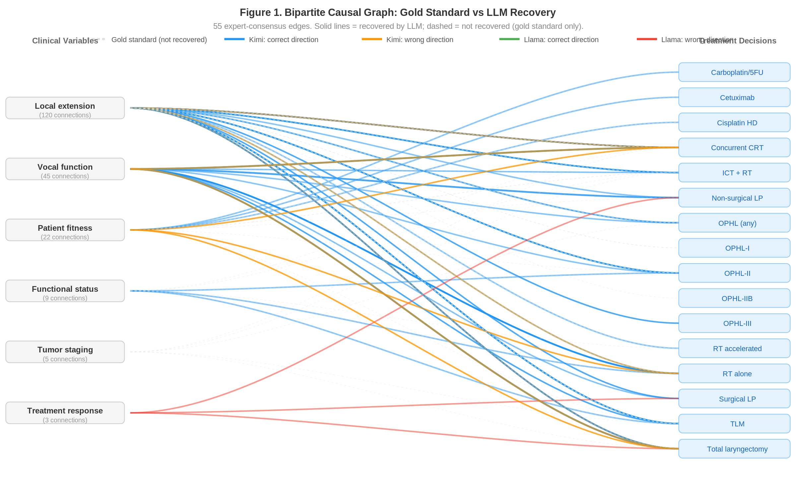
Figure 1. Bipartite causal graph showing 55 gold-standard edges from the Delphi consensus (dashed grey) and their recovery status by Kimi K2.5 (blue = correct direction, orange = wrong direction) and Llama 3.1-8B (green = correct, red = wrong). Clinical variable domains (left) connect to treatment decisions (right). The density of unrecovered (dashed) edges illustrates the sparsity of both models’ causal representations, with Llama recovering virtually none of the expert-consensus structure.
Table 1. Three-Dimensional World Model Evaluation.
Dimension / Metric | Kimi K2.5 | Llama 3.1-8B
COVERAGE
Soft recall | 22/55 (40.0%) | 4/55 (7.3%)
Hard recall | 0/55 (0.0%) | 1/55 (1.8%)
FIDELITY
Direction accuracy | 81.8% (18/22) | 25.0% (1/4)
SID (errors / tested) | 34/153 (22.2%) | 44/154 (28.6%)
DISCRIMINABILITY
Signal-to-noise ratio (SNR) | 2.16 | 0.46
Mean causal JSD | 0.227 | 0.043
Mean null JSD | 0.105 | 0.094
Detection power | 15.0% | 0.0%

Edge-Level Signal Strength
The edge-level JSD analysis (Figure 2) reveals the magnitude of the gap between models across all 55 gold-standard edges. Kimi K2.5’s mean JSD across all edges was 0.254 (median 0.258), indicating consistent moderate-strength causal signals, whereas Llama 3.1-8B’s mean JSD was 0.045 (median 0.036)—barely above the noise floor. The difference is visible at every edge: even Kimi’s weakest causal signals generally exceed Llama’s strongest. Kimi achieved JSD > 0.30 on 17 of 55 edges, compared to 0 for Llama. The grey connecting lines between dots for the same edge illustrate that the between-model gap is systematic, not driven by a few outlier edges.
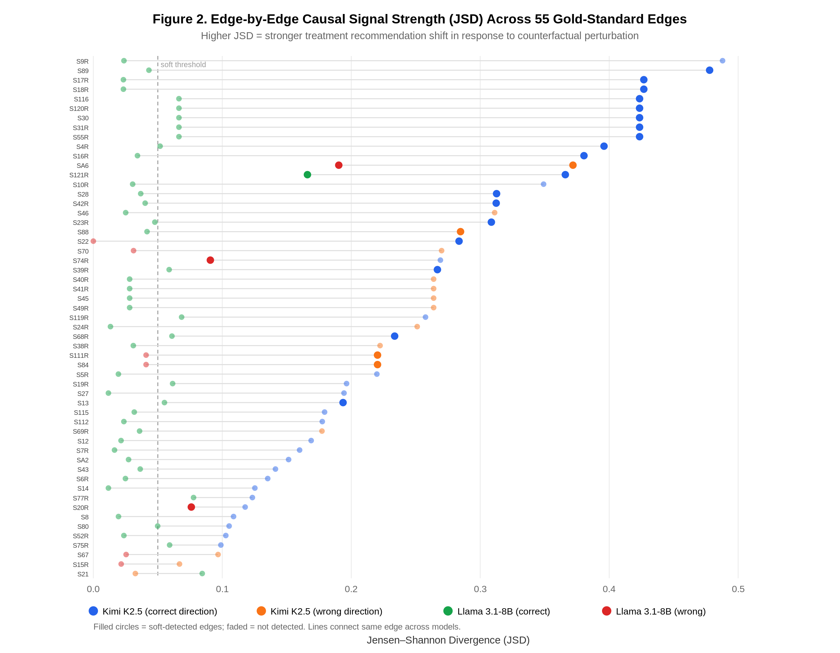
Figure 2. Edge-by-edge causal signal strength (Jensen–Shannon divergence) across all 55 gold-standard edges, sorted by Kimi K2.5 JSD. Each row represents one consensus edge. Blue/orange dots: Kimi (blue = correct direction, orange = wrong). Green/red dots: Llama (green = correct, red = wrong). Filled dots = soft-detected; faded = not detected. Grey lines connect the same edge across models. The systematic gap between Kimi (right) and Llama (left, clustered near zero) illustrates the absence of causal sensitivity in the smaller model.

Discriminability: Signal versus Noise
Table 2. Signal-to-Noise Analysis.
Measure | Kimi K2.5 | Llama 3.1-8B
Mean causal JSD | 0.227 | 0.043
Mean null JSD | 0.105 | 0.094
Null 95th percentile | 0.465 | 0.693
Signal-to-noise ratio | 2.16 | 0.46
Detection power | 15.0% | 0.0%
Detection power = fraction of causal JSD values exceeding the null 95th percentile.
Kimi K2.5 achieved an SNR of 2.16, indicating that its causal perturbation responses were approximately twice as strong as its noise-floor responses—meaningful but below the threshold of 3.0 that would indicate reliable discrimination. Its detection power of 15.0% means that only a minority of causal signals rose above the noise floor with high confidence.
Llama 3.1-8B’s SNR of 0.46 is pathological. The model’s mean response to null perturbations (JSD = 0.094) was more than double its response to causal perturbations (JSD = 0.043). This is the quantitative signature of a model without a causal world model: it literally cannot distinguish clinically meaningful changes from irrelevant ones. Its detection power of 0.0% means that no single causal perturbation produced a response exceeding its own noise floor at the 95th percentile. This finding, combined with its near-zero coverage, demonstrates that Llama 3.1-8B has no coherent causal representation for this clinical domain.

Three-Dimensional Summary
Figure 3 presents a normalised summary of all three evaluation dimensions. Kimi K2.5 substantially outperforms Llama 3.1-8B on every metric, with the largest gap in Coverage (40.0% vs 7.3%) and Discriminability (SNR-derived score: 72.0% vs 15.3%). Fidelity shows a more nuanced picture: while direction accuracy strongly favours Kimi (81.8% vs 25.0%), the normalised SID difference is smaller (77.8% vs 71.4%), reflecting the fact that even Kimi fails to shift on many expected edges (28 no_shift_when_expected errors). The overall pattern is consistent across all three dimensions: Kimi possesses a partial but incomplete causal world model, while Llama shows no meaningful causal sensitivity above noise.
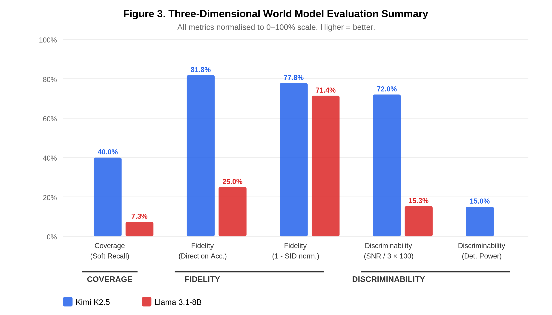
Figure 3. Three-dimensional world model evaluation summary. All metrics are normalised to 0–100% scale (higher = better). Coverage: soft recall. Fidelity: direction accuracy and 1 − normalised SID. Discriminability: SNR normalised to 3.0 benchmark (i.e., SNR/3 × 100) and detection power. Kimi K2.5 (blue) consistently outperforms Llama 3.1-8B (red) across all dimensions.

Discussion
This study makes three contributions to the evaluation of LLMs in clinical domains. First, it introduces behavioural causal discovery as a practical method for recovering and evaluating the implicit causal graphs embedded in LLM behaviour through systematic counterfactual perturbation. Second, it demonstrates that neither model tested possesses a complete causal world model for head and neck cancer treatment decisions, despite the availability of this knowledge in published literature. Third, it provides a three-dimensional evaluation framework—Coverage, Fidelity, and Discriminability—grounded in established causal graph comparison metrics, that delivers complementary and independently actionable diagnostics.
The three-dimensional framework addresses the limitations of aggregate accuracy metrics by providing distinct lenses on causal competence. Coverage reveals how much of the expert-consensus causal structure the model can detect at all. Fidelity, through direction accuracy and the Structural Intervention Distance, reveals whether what the model detects is structurally correct. Discriminability reveals whether the model can distinguish genuine causal signals from noise. A model might show moderate coverage but poor fidelity (detecting edges but getting directions wrong), or reasonable fidelity on detected edges but pathological discriminability (unable to tell signal from noise). Each failure mode has different implications for clinical deployment and different remediation strategies.
The two models illustrate contrasting profiles across all three dimensions. Kimi K2.5 has a partial world model: 40% coverage with 82% direction accuracy, SID of 22%, and SNR of 2.16. Its edge-level JSD analysis (Figure 2) shows consistent moderate-strength causal signals across the majority of edges. Llama 3.1-8B, by contrast, shows near-absent causal sensitivity: 7% coverage, 25% direction accuracy, and a pathological SNR of 0.46, meaning it responds more to clinically irrelevant perturbations than to causally meaningful ones. The edge-level analysis confirms this is not a statistical artefact—Llama’s JSD values cluster near zero across virtually all 55 edges. These profiles correspond roughly to a clinician who has grasped some causal principles but applies them inconsistently (Kimi) versus one who has memorised treatment protocols without understanding why they apply (Llama).
Our framework connects to Pearl’s causal hierarchy.¹² The vignette perturbations implement Rung 2 (interventional) queries: what happens to treatment recommendations when we intervene on a clinical variable? The null perturbations test counterfactual reasoning: the model should recognise that irrelevant changes do not alter the causal structure. Llama’s inverted SNR demonstrates failure at the interventional level—it cannot distinguish meaningful interventions from irrelevant modifications. Kimi’s moderate SNR suggests partial interventional competence, consistent with Tenenbaum et al.’s framework for structured probabilistic models.¹⁶

Clinical Implications
These findings have direct implications for the deployment of LLMs in oncological decision support. First, benchmark accuracy on standard examinations is insufficient evidence for clinical readiness. A model can score well on factual questions while lacking the causal understanding necessary to handle novel clinical combinations—the precise scenarios where decision support would be most valuable.
Second, the three-dimensional framework provides actionable diagnostics. Coverage identifies which causal pathways are missing from the model’s representation. Fidelity pinpoints specific edges where the model’s causal direction is reversed and quantifies the overall structural divergence from expert consensus via SID. Discriminability reveals whether the model has any causal sensitivity at all—a model with SNR below 1.0 cannot distinguish clinically meaningful perturbations from noise and is fundamentally unsuitable for clinical reasoning tasks.
Third, the SID breakdown identifies specific intervention–treatment pairs where the model’s causal beliefs diverge from expert consensus, providing targets for retrieval-augmented generation, fine-tuning, or structured knowledge injection.

Limitations
Several limitations should be noted. First, our evaluation focuses on a single clinical domain (head and neck cancer); the generalisability of these results to other oncological or non-oncological domains requires further study. Second, the gold-standard graph derives from a single Delphi consensus; areas of genuine clinical disagreement may be misclassified as model errors. Third, the vignette battery, while principled, cannot probe all possible causal relationships—our 55-edge graph represents the major consensus-supported pathways, not the complete clinical ontology. Fourth, we evaluated two specific models; larger frontier models, reasoning-enhanced configurations, or models fine-tuned on oncological data may exhibit different profiles. Fifth, the edge detection pipeline uses distributional shifts across 15–30 runs, which may under-detect edges with subtle effects. Sixth, the rule-based response parser, while deterministic and transparent, may miss treatment stances expressed using unconventional phrasing; future work could compare parser agreement with manual annotation. Seventh, both models were accessed through a single API provider (Together.ai); inference infrastructure differences could in principle affect output distributions.

Future Directions
Several extensions are warranted. Testing whether reasoning-enhanced modes (e.g., extended thinking, chain-of-thought prompting) improve coverage or fidelity would clarify whether the causal knowledge is latent but inaccessible under standard prompting. Cross-domain application of behavioural causal discovery—to other cancer types, non-oncological domains, and non-medical fields with established expert consensus—would establish the generalisability of this approach. Longitudinal monitoring of the three dimensions across model versions could track whether causal world models improve with scale, fine-tuning, or architectural changes. The framework could also be extended to test a broader range of models, including frontier models with trillions of parameters and models specifically fine-tuned on clinical guidelines, to establish how causal competence scales with model capacity and domain-specific training.

Conclusions
Large language models do not possess coherent causal world models for specialised clinical decision-making in head and neck cancer. Behavioural causal discovery recovers implicit causal graphs that are sparse and partially accurate (Kimi K2.5: 40% coverage, 82% direction accuracy, SNR 2.16) or effectively absent (Llama 3.1-8B: 7% coverage, pathological SNR 0.46, zero detection power). The three-dimensional evaluation framework introduced here—Coverage, Fidelity, and Discriminability—provides independently interpretable and graph-theoretically grounded diagnostics for determining whether an LLM has the causal understanding necessary for safe deployment in clinical practice. Benchmark accuracy without causal evaluation is insufficient evidence for clinical readiness.

References
- Craik KJW. The Nature of Explanation. Cambridge University Press; 1943.
- Lake BM, Ullman TD, Tenenbaum JB, Gershman SJ. Building machines that learn and think like people. Behav Brain Sci. 2017;40:e253.
- Singhal K, Azizi S, Tu T, et al. Large language models encode clinical knowledge. Nature. 2023;620(7972):172-180.
- Nori H, King N, McKinney SM, Carignan D, Horvitz E. Capabilities of GPT-4 on medical competency examinations. arXiv. 2023;2303.13375.
- Thirunavukarasu AJ, Ting DSJ, Elangovan K, et al. Large language models in medicine. Nat Med. 2023;29(8):1930-1940.
- Sim Y, Chen Y-S. Critique of impure reason: unveiling the reasoning behaviour of medical large language models. eLife. 2024;13:RP100563.
- Gao J, Yoon J, Kim Y. Assessment of large language models in clinical reasoning: a novel benchmarking study. NEJM AI. 2024;1(11):AIoa2400556.
- Topol EJ. High-performance medicine: the convergence of human and artificial intelligence. Nat Med. 2019;25(1):44-56.
- Rajpurkar P, Chen E, Banerjee O, Topol EJ. AI in health and medicine. Nat Med. 2022;28(1):31-38.
- Chen W, Zhang Y, Li X, et al. Unveiling causal reasoning in large language models: reality or mirage? arXiv. 2025;2506.20449.
- Ferrari M, Taboni S, Caversaccio MD, et al. International consensus on laryngeal preservation strategies in laryngeal and hypopharyngeal cancer: a Delphi study. Lancet Oncol. 2025;26(2):e100-e112.
- Pearl J. Causality: Models, Reasoning, and Inference. 2nd ed. Cambridge University Press; 2009.
- Peters J, Bühlmann P. Structural intervention distance for evaluating causal graphs. Neural Comput. 2015;27(3):771-799.
- Hammond KR. Human Judgment and Social Policy: Irreducible Uncertainty, Inevitable Error, Unavoidable Injustice. Oxford University Press; 1996.
- Tripathi S, Amin K, Bera K, et al. Development, evaluation, and assessment of large language models (DEAL) checklist: a framework for LLM studies in medicine. NEJM AI. 2024;1(4):AIp2400064.
- Tenenbaum JB, Kemp C, Griffiths TL, Goodman ND. How to grow a mind: statistics, structure, and abstraction. Science. 2011;331(6022):1279-1285.
- Cabitza F, Campagner A, Balsano C. Bridging the “last mile” gap between AI implementation and operation: “data awareness” that matters. Ann Transl Med. 2020;8(7):501.
- Kompa B, Snoek J, Beam AL. Second opinion needed: communicating uncertainty in medical machine learning. NPJ Digit Med. 2021;4(1):4.
- Sun R, Zhang L, Zheng W, Li Y. How reliable are LLMs as knowledge bases? Re-thinking factuality and consistency. arXiv. 2024;2407.01886.
- Fierro C, Torrent M, Saeed A, Moens M-F. Knowledge-based consistency testing of large language models. arXiv. 2024;2407.12830.
- Miao B, Szolovits P, McDuff D. The minimum information about clinical artificial intelligence checklist for generative modeling research (MI-CLAIM-GEN). Nat Med. 2024;30:2733–2735.
- Norgeot B, Ber G, Glicksberg BS, et al. Minimum information about clinical artificial intelligence modeling: the MI-CLAIM checklist. Nat Med. 2020;26(9):1320–1324.

Appendix: Vignette Examples with Parsed LLM Responses
This appendix presents selected vignettes from the battery of 88, showing the baseline clinical text, the perturbation applied, the expected treatment changes according to the Delphi consensus, and the actual parsed treatment stances from each model (run 0 of 15). These examples illustrate how behavioural causal discovery operates at the individual vignette level.
A1-BASE: Baseline: Glottic cT2, favorable TLM-eligible
Patient: 54-year-old male, retired teacher, ECOG 0. Non-smoker for 8 years (former 20 pack-year history). Moderate alcohol intake. No significant comorbidities. Tumor: cT2N0 glottic squamous cell carcinoma of the left true vocal cord. The lesion involves the middle and anterior third of the left vocal cord with impaired mobility but no fixation. Imaging: CT and MRI show no cartilage involvement,…
Expected recommended: TLM, RT alone, OPHL-II. Expected excluded: Concurrent CRT, Total laryngectomy.
Treatment | Kimi K2.5 | Llama 3.1-8B
Concurrent CRT | excluded | excluded
OPHL (any) | — | excluded
RT accelerated | recommended | recommended
RT alone | recommended | recommended
TLM | recommended | recommended
A1-P1: Perturbation: Laryngeal exposure insufficient (tests S5R, S22)
Variable changed: laryngeal_exposure: adequate → insufficient
Patient: 54-year-old male, retired teacher, ECOG 0. Non-smoker for 8 years (former 20 pack-year history). Moderate alcohol intake. No significant comorbidities. Tumor: cT2N0 glottic squamous cell carcinoma of the left true vocal cord. The lesion involves the middle and anterior third of the left vocal cord with impaired mobility but no fixation. Imaging: CT and MRI show no cartilage involvement,…
Expected recommended: RT alone, OPHL-II. Expected excluded: TLM.
Treatment | Kimi K2.5 | Llama 3.1-8B
Concurrent CRT | excluded | excluded
ICT + RT | — | excluded
OPHL (any) | recommended | —
RT accelerated | recommended | recommended
RT alone | recommended | recommended
TLM | relative_ci | recommended
Total laryngectomy | recommended | —
Edge detection: S5R: Kimi not detected, Llama not detected. S22: Kimi detected ✓, Llama not detected.
A1-NULL: Null: Age change only — should NOT change treatment
Variable changed: age: under_70 → 70_plus
Patient: 74-year-old male, retired teacher, ECOG 0. Comprehensive Geriatric Assessment: fit. G8 score 15/17. Non-smoker for 8 years (former 20 pack-year history). Moderate alcohol intake. No significant comorbidities. Tumor: cT2N0 glottic squamous cell carcinoma of the left true vocal cord. The lesion involves the middle and anterior third of the left vocal cord with impaired mobility but no fixa…
Expected recommended: TLM, RT alone, OPHL-II.
Null control: No treatment changes expected. Any shift constitutes noise.
Treatment | Kimi K2.5 | Llama 3.1-8B
Concurrent CRT | excluded | excluded
OPHL (any) | — | excluded
RT accelerated | relative_ci | recommended
RT alone | recommended | recommended
TLM | recommended | recommended
Total laryngectomy | — | excluded
Edge detection: S6R: Kimi not detected, Llama not detected. S80: Kimi not detected, Llama not detected.
B1-P8: Perturbation: Bilateral arytenoid fixation — CI all conservative surgery (S16R)
Variable changed: posterior_laryngeal_involvement: none → bilateral_arytenoid
Patient: 58-year-old male, ECOG 0. Former smoker (quit 3 years ago, 25 pack-years). Social drinker. No significant comorbidities. Tumor: cT3N0 glottic SCC. Left vocal cord fixed, right cord fully mobile. Both arytenoids fixed with bilateral posterior involvement. The lesion involves the left vocal cord with extension into the anterior paraglottic space on the left side only. Imaging: MRI shows p…
Expected recommended: Total laryngectomy, Concurrent CRT. Expected excluded: TLM, OPHL (any), Surgical LP.
Treatment | Kimi K2.5 | Llama 3.1-8B
Concurrent CRT | — | recommended
ICT + RT | — | recommended
OPHL (any) | excluded | recommended
OPHL-II | — | recommended
TLM | excluded | recommended
Total laryngectomy | excluded | excluded
tors | excluded | —
Edge detection: S16R: Kimi detected ✓, Llama not detected. S39R: Kimi detected ✓, Llama not detected. S42R: Kimi detected ✓, Llama not detected.
D1-P2: Perturbation: Aspiration pneumonia — absolute CI non-surgical (S19R)
Variable changed: swallowing_status: impaired_no_aspiration → recurrent_pneumonia
Patient: 63-year-old male, ECOG 1. Current smoker (40 pack-years), heavy alcohol use (>14 units/week). Mild malnutrition (albumin 3.3, BMI 19.2, unintentional weight loss 5kg over 3 months). Tumor: cT3N2b SCC of the left piriform sinus extending to the postcricoid area. Left vocal cord fixed, left arytenoid fixed. Right cord and arytenoid mobile. No cartilage invasion on imaging. Imaging: CT and…
Expected recommended: Total laryngectomy. Expected excluded: Non-surgical LP.
Treatment | Kimi K2.5 | Llama 3.1-8B
Concurrent CRT | relative_ci | recommended
ICT + RT | relative_ci | recommended
OPHL (any) | excluded | recommended
OPHL-II | excluded | —
TLM | excluded | recommended
Total laryngectomy | recommended | recommended
Edge detection: S19R: Kimi not detected, Llama not detected.
H1-P3: Perturbation: Stable disease after ICT — TL preferred (S121R)
Variable changed: ict_response: complete_response → stable_disease
Patient: 57-year-old male, ECOG 0. Initially presented with cT3N1 glottic SCC with fixed left vocal cord and a 2.5cm level III node. The patient received 3 cycles of induction chemotherapy (TPF protocol). He tolerated treatment well with manageable toxicity. Post-ICT reassessment (8 weeks after cycle 3): - Imaging: CT and MRI show stable disease — no significant change in tumor dimensions (<10% …
Expected recommended: Total laryngectomy. Expected excluded: RT alone.
Treatment | Kimi K2.5 | Llama 3.1-8B
Concurrent CRT | excluded | relative_ci
ICT + RT | excluded | recommended
OPHL (any) | excluded | excluded
RT alone | excluded | relative_ci
TLM | — | excluded
Total laryngectomy | recommended | recommended
Edge detection: S121R: Kimi detected ✓, Llama detected ✓.
C1-P1: Perturbation: Pre-epiglottic space invasion — OPHL-I preferred (S10R)
Variable changed: pre_epiglottic_space: limited → massive_not_abutting_membrane
Patient: 56-year-old male, ECOG 0. Former smoker (quit 6 years, 30 pack-years). No significant comorbidities. Tumor: cT3N1 supraglottic SCC arising from the epiglottis. There is a single ipsilateral level II lymph node (2.2cm, no extranodal extension on imaging). Imaging: MRI shows pronounced pre-epiglottic space invasion — the tumor fills most of the PES but does not abut the thyrohyoid membran…
Expected recommended: OPHL-I, Concurrent CRT, ICT + RT. Expected excluded: TLM.
Treatment | Kimi K2.5 | Llama 3.1-8B
Concurrent CRT | recommended | recommended
OPHL (any) | recommended | relative_ci
OPHL-I | recommended | relative_ci
OPHL-IIB | excluded | relative_ci
TLM | relative_ci | relative_ci
Total laryngectomy | recommended | relative_ci
tors | relative_ci | relative_ci
Edge detection: S10R: Kimi not detected, Llama not detected.
J1-P5: Perturbation: Convergent CIs (tracheostomy + feeding tube + aspiration)
Variable changed: pretreatment_tracheostomy: false → true
Patient: 55-year-old male, ECOG 1 (due to functional limitations from airway and swallowing compromise), no other comorbidities. Tumor: cT3N0 glottic SCC. Left vocal cord fixed, right mobile. Arytenoids bilaterally mobile. The patient presents with moderate airway obstruction — audible stridor on exertion, mild stridor at rest when supine. He sleeps propped up on two pillows but manages his dail…
Expected recommended: Total laryngectomy. Expected excluded: Non-surgical LP, Surgical LP.
Treatment | Kimi K2.5 | Llama 3.1-8B
Concurrent CRT | excluded | recommended
ICT + RT | excluded | recommended
OPHL (any) | uncertain | relative_ci
TLM | — | relative_ci
Total laryngectomy | recommended | relative_ci
Edge detection: S19R: Kimi not detected, Llama not detected. S39R: Kimi detected ✓, Llama not detected. S115: Kimi not detected, Llama not detected.

