INSTALLATION MANUAL

Table of Contents
Client setup 2
Server setup 2
Software compilation 3
Sensors 5
Circuit diagram 6
Breadboard schematic 8

Client setup
To setup the device, place it at the desired location.
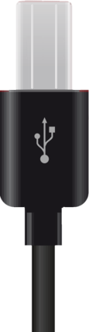
Plug in the USB cable into the device as pictured below:
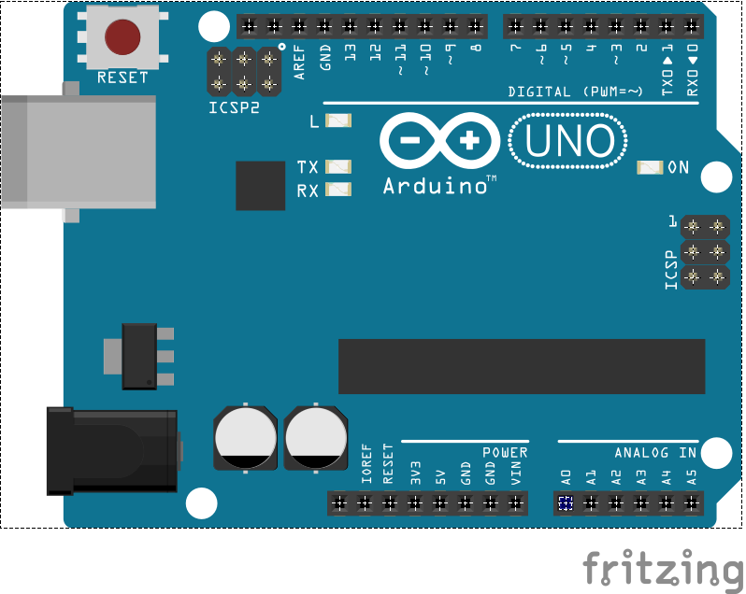


Server setup
Plug in the other end of the USB cable into the device that should run the server:
Test and make sure the server device is connected to the internet.




Software compilation
- To compile the software, you will need the following tools:
- Terminal/command prompt – Operating systems usually have this pre-installed
- GNU make/MinGW - https://sourceforge.net/projects/mingw/
- Arduino IDE - https://www.arduino.cc/en/main/software

Once downloaded and installed, run Arduino IDE and open client.ino inside the client subdirectory from the source code’s root directory. Make sure “Arduino/Genuino Uno” is selected in Tools > Board and Tools > Port has the correct port selected in which the client device is connected:
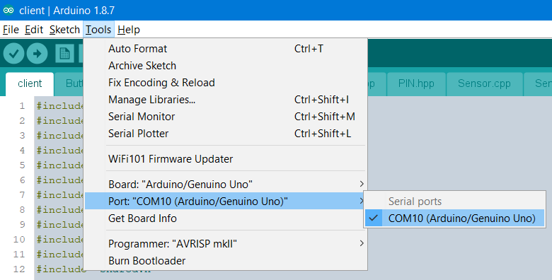

Now press upload:
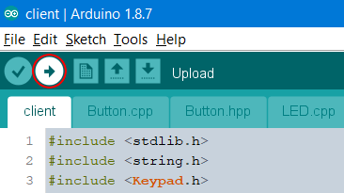

When the client has uploaded successfully, open a terminal/command prompt and navigate to the source code’s root directory.
From here navigate to the server subdirectory.
Run make command:
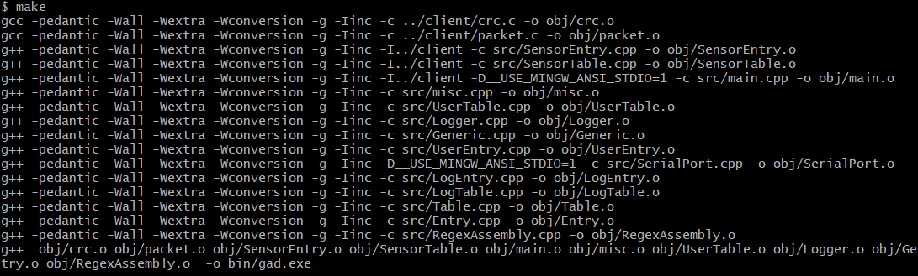
Once completed, you can now start the server by either using make run command:
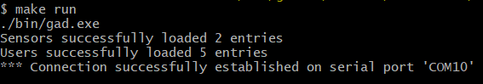

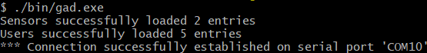
Or just run it directly: ./bin/gad.exe:

Sensors
There’s two types of sensors: Magnetic switches and sonic motion sensor.
Magentic switches should, for example be installed on doors and windows or any other opeanable/breakable entry point to the protected area. They should be placed close enough to each other to make contact. When the sensors are active and lose contact with one another, the alarm will trigger.
Motion sensors should preferably be placed aloft, facing a plain surface, wall or door of what would be a possible entry point for a trespasser. Having several object with different distances form each other in front of the sensor may trigger a false positive alarm. When motion sensor is activated, it scans the distance to the target surface and keeps that value for future comparisons. Whenever the distance is changed i.e. something has moved in-between the sensor and the surface, the alarm will trigger. Therefore, be cautious to have moving entities in the area as this sensor is activated. The motion sensor has a distance threshold of 0.5 meters (1.64 ft). If the motion sensor would break from a defect or a distance read failure due to getting the initial monitoring distance at activation process, the alarm will also trigger. This will happen if the duration of faulty readings reaches 1 second and above (5 seconds at the startup process).

Circuit diagram
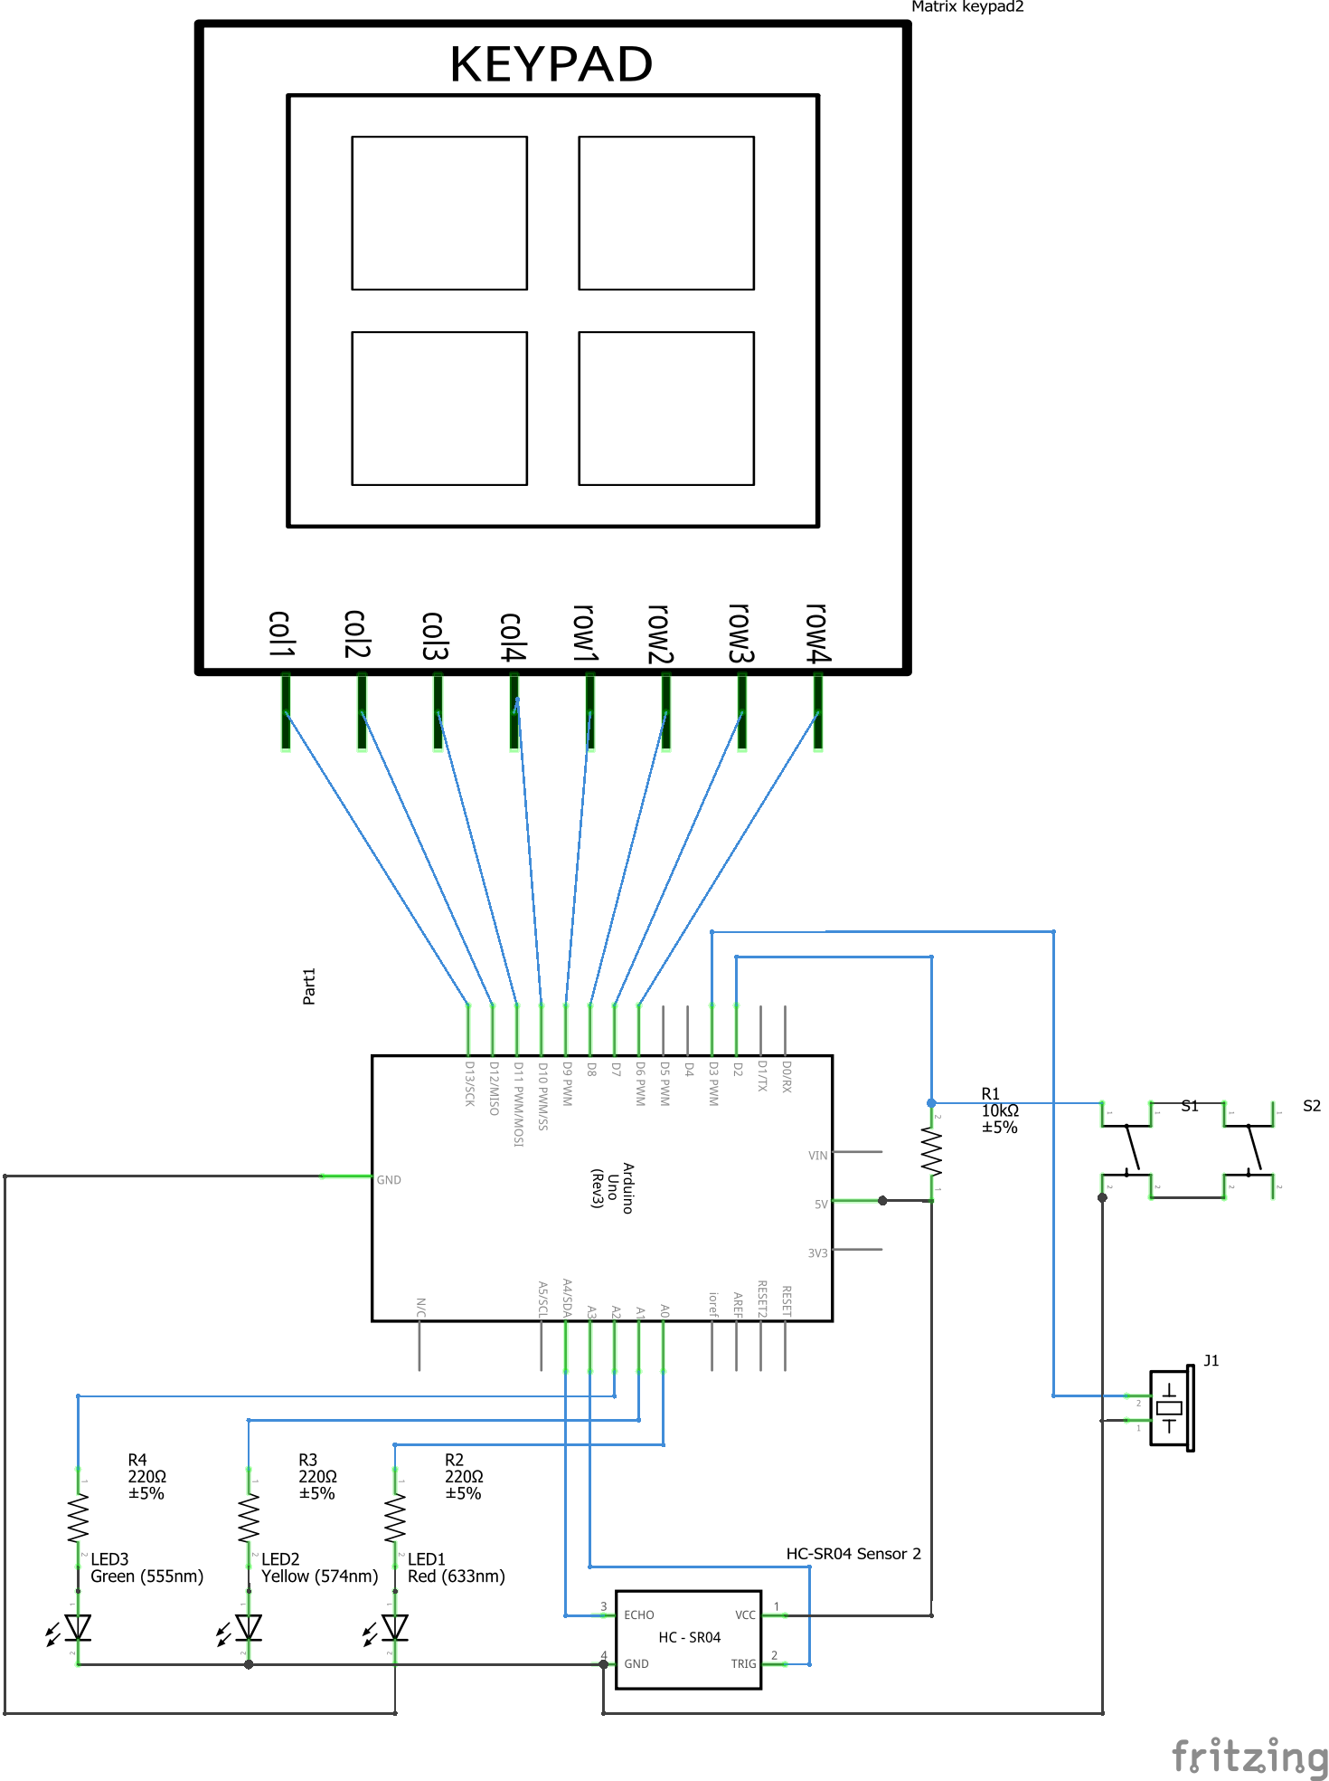

Breadboard schematic
