QUICKSTART MANUAL

- Client setup
To setup the device, place it at the desired location.
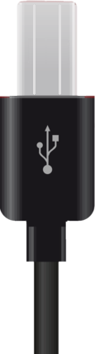
Plug in the USB cable into the device as pictured below:
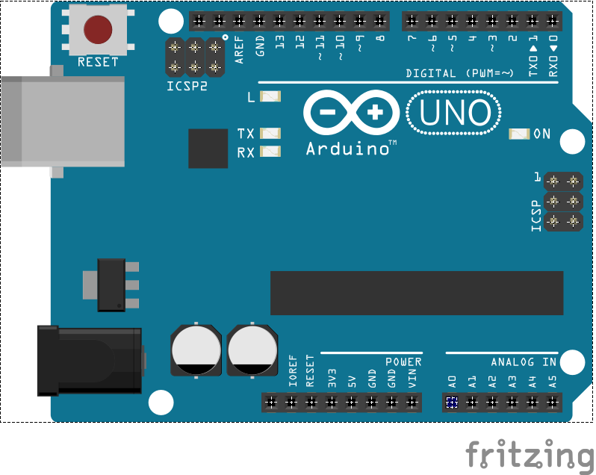


- Server setup
Plug in the other end of the USB cable into the device that should run the server:
Test and make sure the server device is connected to the internet.
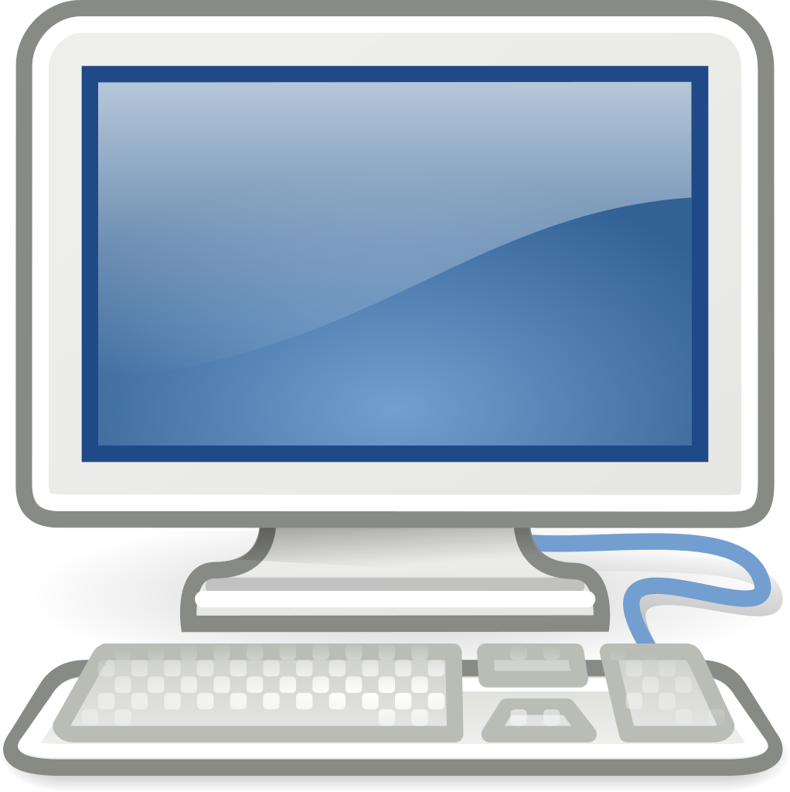

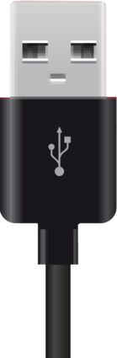

- Software compilation
- To compile the software, you will need the following tools:
- Terminal/command prompt – Operating systems usually have this pre-installed
- GNU make/MinGW - https://sourceforge.net/projects/mingw/
- Arduino IDE - https://www.arduino.cc/en/main/software

Once downloaded and installed, run Arduino IDE and open client.ino inside the client subdirectory from the source code’s root directory. Make sure “Arduino/Genuino Uno” is selected in Tools > Board and Tools > Port has the correct port selected in which the client device is connected:
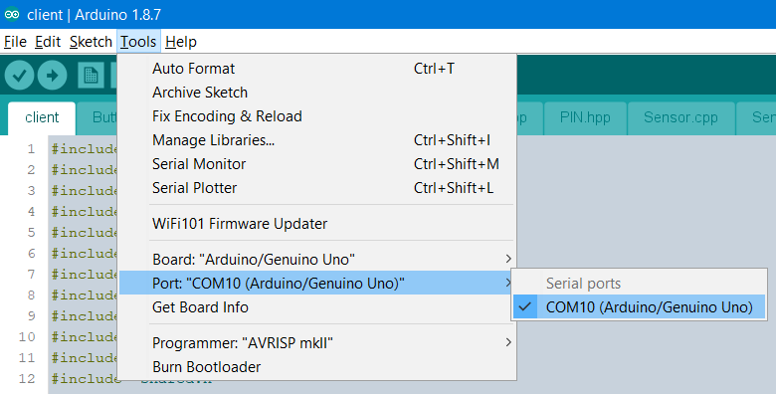

Now press upload:
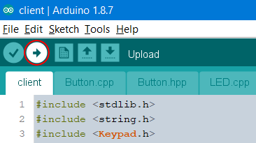

When the client has uploaded successfully, open a terminal/command prompt and navigate to the source code’s root directory.
From here navigate to the server subdirectory.
Run make command:
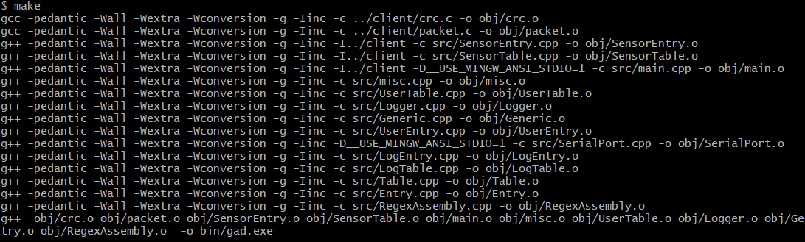
Once completed, you can now start the server by either using make run command:
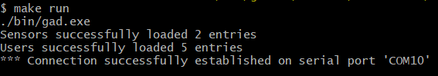

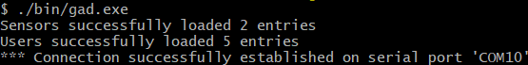
Or just run it directly: ./bin/gad.exe:

- Circuit diagram
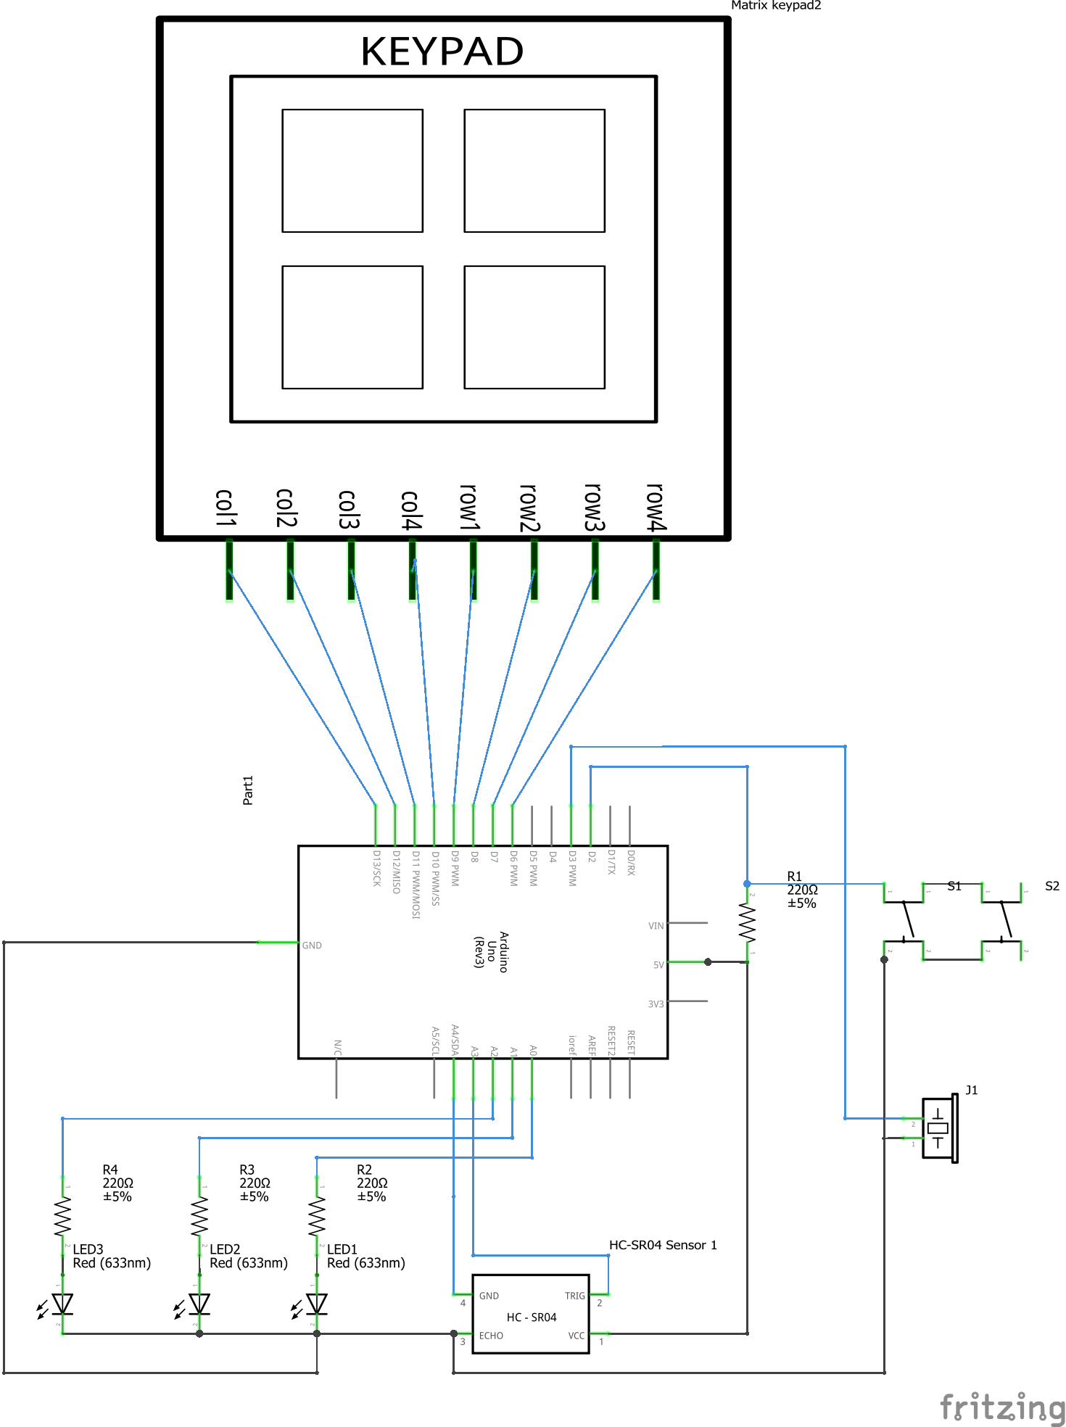

- Breadboard
