QUICKSTART MANUAL

- First time setup
To setup the device, place it at the desired location.
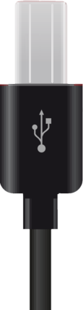
Plug in the USB cable into the device as pictured below:
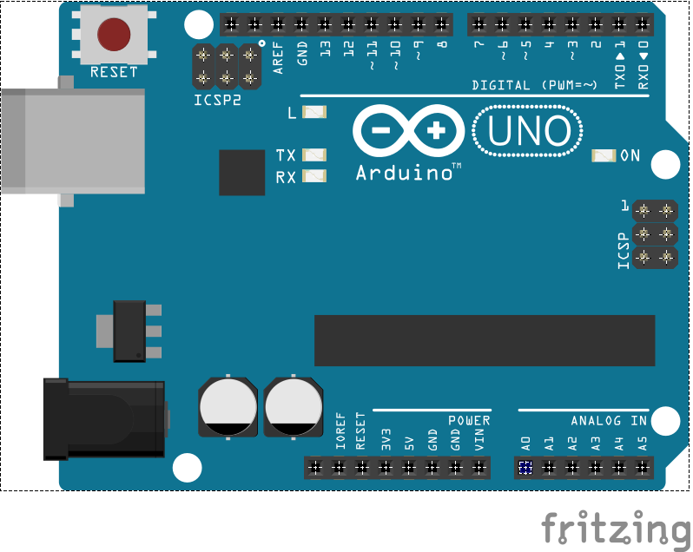


Plug in the other end of the USB cable into the device that should run the server:
Test and make sure the server device is connected to the internet.




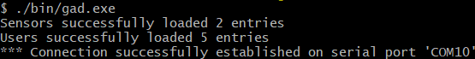
On the server device run gad.exe and check if the software connected successfully.

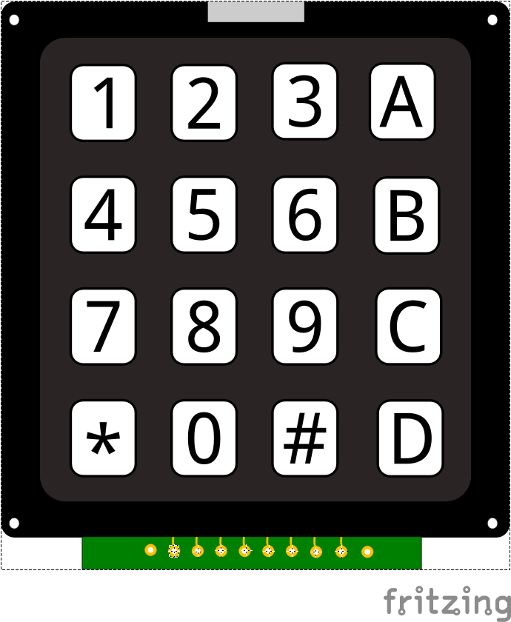
- Log in using the keypad
Type your PIN code (4-6 digits) followed by a #.
To clear the input press * and follow the previous step again.
If the authentication was successful, the alarm central will sound with 2 short beeps and if the alarm was previously active, all LEDs will turn off.
- Emergency code
The alarm contains an emergency code feature.
To use your emergency PIN code, type in all digits in your regular code except the last digit. Instead increment that very last digit by 1. For example: If your PIN code is 1234, type 1235. If your PIN code has a 9 as a last digit, replace it with 0. For example: 1239 becomes 1230. Do not forget to always end your PIN code with a final #.
If an emergency code is entered, the alarm will turn of as usual, not exposing, nor notifying in any way that an emergency code was entered. Instead, a silent emergency signal will be sent to the authorities.
NOTE: If the emergency code is accidentally entered, immediately notify the authorities as soon as possible.
- Activate all alarm sensors
To activate all the sensors (both outside AND inside), first follow instruction 2 to log in.
Now type A followed by your PIN code followed by a final #, for example: A1234#. On success, the alarm central will now sound with 3 long beeps and the green and yellow LED will emit a constant light.
WARNING: The alarm and ALL sensors are now active. Be cautious not to accidentally trigger any of them. Be aware also that animals or other moving elements in the area could trigger a sensor.
- Activate outer sensors
To only activate the outer sensors, first follow instruction 2 to log in.
Now type B followed by your PIN code followed by a final #, for example: B1234#. On success, the alarm central will now sound with 2 short beeps and the green LED will slowly blink and the yellow LED will emit a constant light.
WARNING: The alarm and the outer sensors are now active. Be cautious not to accidentally trigger any of them.
- Triggered alarm
If any active sensor is disturbed/triggered the alarm will sound like a siren and all LEDs will blink with a short interval. An emergency signal will be transmitted to the proper authorities via the server. There is no way for a user (or a possible trespasser) to disable a triggered alarm.
NOTE: If the alarm is accidentally triggered, immediately notify the authorities as soon as possible.

