Invoice project:

1. How to run the project
2. Before you can run the project, please move the whole project folder admin into your server folder or your xampp/htdocs/ folder if you use localhost.
3. Please change database information in admin/includes/config.php.

defined('DB_SERVER') ? null : define("DB_SERVER", "localhost"); // change localhost to your own db

defined('DB_USER') ? null : define("DB_USER", "root"); // change root to you own mysql username

defined('DB_PASS') ? null : define("DB_PASS", "13692"); // change 13692 to you own mysql password

defined('DB_NAME') ? null : define("DB_NAME", "admin"); // change admin if you want another database name.

1. If you run the project not under localhost, then please check scripts/admin.js line 67:

location.host part could be different, if the project admin is not on your server’s root path.

1. In project invoice’s root path find 127.0.0.1.sql to import into your mysyql.
2. Then you can type localhost/admin into your browser, and it should run now.

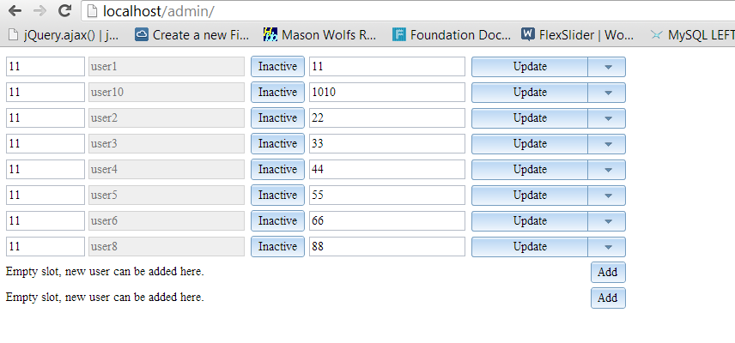

1. Sample data:

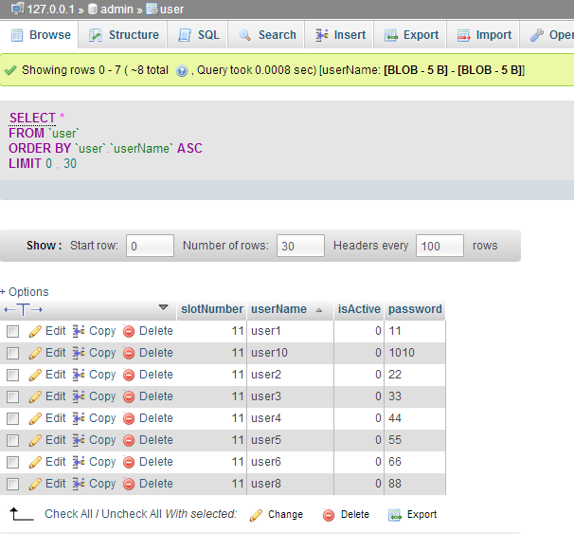

1. No Limitation found yet.
2. How to use this admin project:
3. Loading page

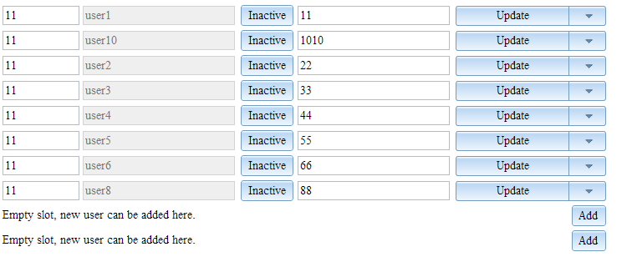

1. Add a new entry

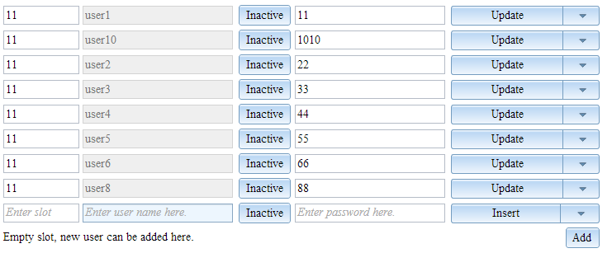

1. Insert

You can click Insert button only when you type slot number, user name and password.

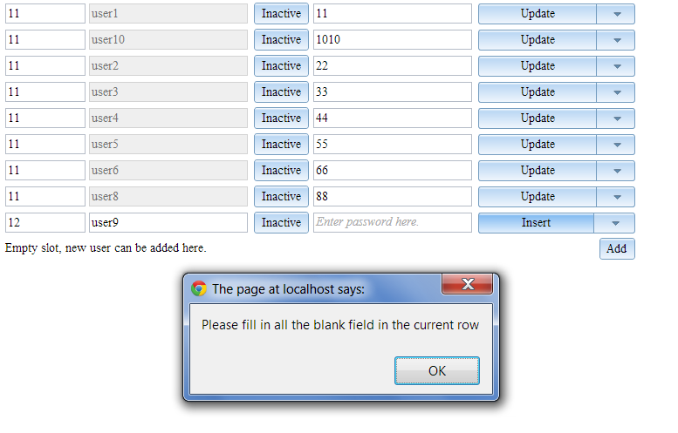

After filled out all three textboxes, click Insert

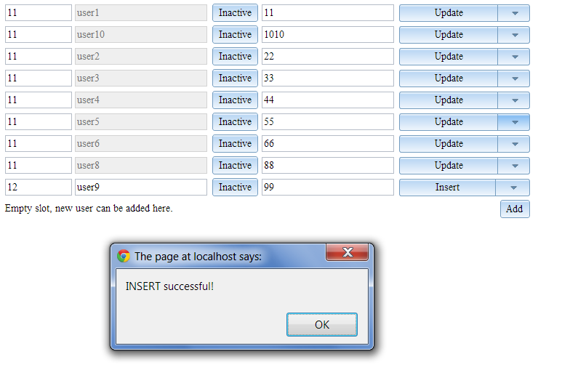

Now the data is stored in the db. User name cannot be edited after the new row is inserted. I disabled user name after insertion, because user name is the unique col.

1. Update

Select the second row, i.e. user 10, change slog number to 13 and password to “albrecht”. Then click update button on this row.

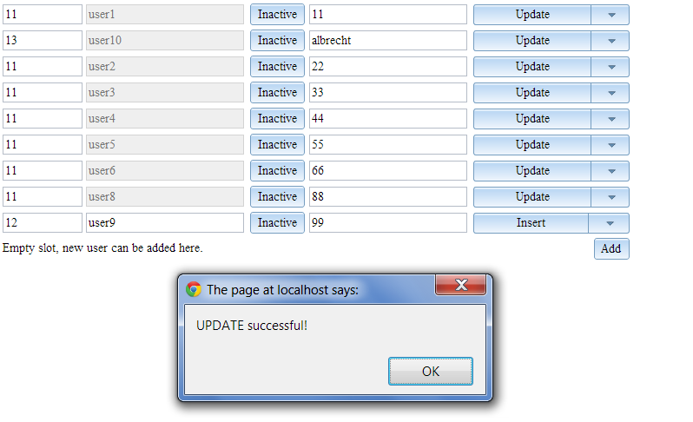

1. Delete

Select the fourth row, i.e. user3. Then click the dropdown triangle form button , select Delete.

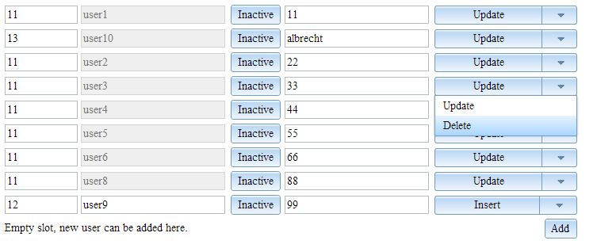

Click the combo button this row will be deleted.

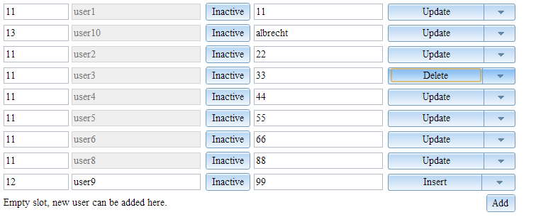

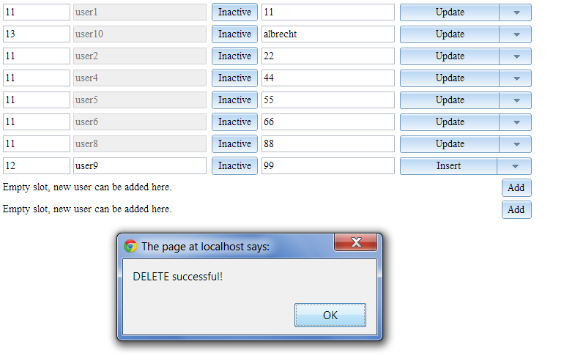

You will see that a new empty row is appended at the bottom.