Invoice project:

1. How to run the project
2. Before you can run the project, please move the whole project folder invoice into your server folder or your xampp/htdocs/ folder if you use localhost.
3. Please change database information in includes/config.php.

defined('DB_SERVER') ? null : define("DB_SERVER", "localhost"); // change localhost to your own db

defined('DB_USER') ? null : define("DB_USER", "root"); // change root to you own mysql username

defined('DB_PASS') ? null : define("DB_PASS", "13692"); // change 13692 to you own mysql password

defined('DB_NAME') ? null : define("DB_NAME", "invoice"); // change invoice if you want another database name.

1. If you run the project not under localhost, then please check scripts/loadData.js line 12:

location.host part could be different, if the project invoice is not on your server’s root path.

1. In project invoice’s root path find 127.0.0.1.sql to import into your mysyql.
2. Then you can type localhost/invoice into your browser, and it should run now.
3. Sample data:

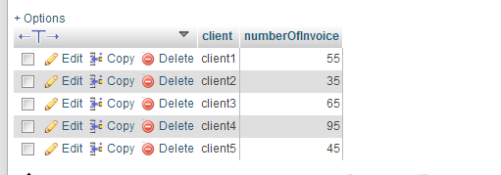

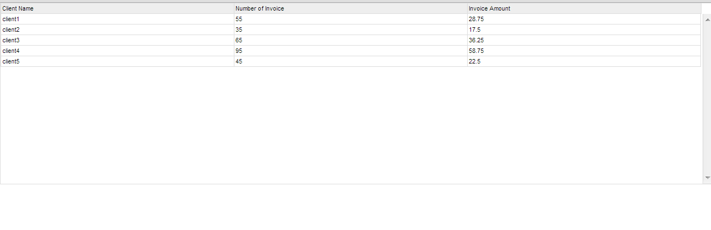

1. No Limitation found yet.