optimizando

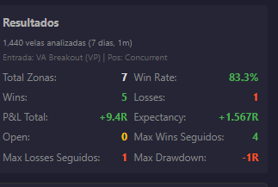

1 día
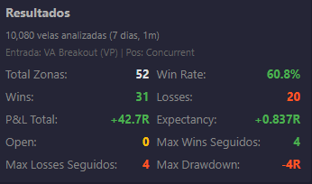
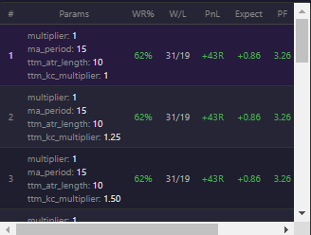

7 días

tabla simulaciones

# | Params | WR% | W/L | PnL | Expect | PF | DD
1 | multiplier: 1  ma_period: 15  ttm_atr_length: 10  ttm_kc_multiplier: 1 | 62% | 31/19 | +43R | +0.86 | 3.26 | -4R | Aplicar
2 | multiplier: 1  ma_period: 15  ttm_atr_length: 10  ttm_kc_multiplier: 1.25 | 62% | 31/19 | +43R | +0.86 | 3.26 | -4R | Aplicar
3 | multiplier: 1  ma_period: 15  ttm_atr_length: 10  ttm_kc_multiplier: 1.50 | 62% | 31/19 | +43R | +0.86 | 3.26 | -4R | Aplicar
4 | multiplier: 1  ma_period: 15  ttm_atr_length: 10  ttm_kc_multiplier: 1.75 | 62% | 31/19 | +43R | +0.86 | 3.26 | -4R | Aplicar
5 | multiplier: 1  ma_period: 15  ttm_atr_length: 10  ttm_kc_multiplier: 2 | 62% | 31/19 | +43R | +0.86 | 3.26 | -4R | Aplicar
6 | multiplier: 1  ma_period: 15  ttm_atr_length: 10  ttm_kc_multiplier: 2.25 | 62% | 31/19 | +43R | +0.86 | 3.26 | -4R | Aplicar
7 | multiplier: 1  ma_period: 15  ttm_atr_length: 10  ttm_kc_multiplier: 2.50 | 62% | 31/19 | +43R | +0.86 | 3.26 | -4R | Aplicar
8 | multiplier: 1  ma_period: 15  ttm_atr_length: 15  ttm_kc_multiplier: 1 | 62% | 31/19 | +43R | +0.86 | 3.26 | -4R | Aplicar
9 | multiplier: 1  ma_period: 15  ttm_atr_length: 15  ttm_kc_multiplier: 1.25 | 62% | 31/19 | +43R | +0.86 | 3.26 | -4R | Aplicar
10 | multiplier: 1  ma_period: 15  ttm_atr_length: 15  ttm_kc_multiplier: 1.50 | 62% | 31/19 | +43R | +0.86 | 3.26 | -4R | Aplicar
11 | multiplier: 1  ma_period: 15  ttm_atr_length: 15  ttm_kc_multiplier: 1.75 | 62% | 31/19 | +43R | +0.86 | 3.26 | -4R | Aplicar
12 | multiplier: 1  ma_period: 15  ttm_atr_length: 15  ttm_kc_multiplier: 2 | 62% | 31/19 | +43R | +0.86 | 3.26 | -4R | Aplicar
13 | multiplier: 1  ma_period: 15  ttm_atr_length: 15  ttm_kc_multiplier: 2.25 | 62% | 31/19 | +43R | +0.86 | 3.26 | -4R | Aplicar
14 | multiplier: 1  ma_period: 15  ttm_atr_length: 15  ttm_kc_multiplier: 2.50 | 62% | 31/19 | +43R | +0.86 | 3.26 | -4R | Aplicar
15 | multiplier: 1  ma_period: 15  ttm_atr_length: 20  ttm_kc_multiplier: 1 | 62% | 31/19 | +43R | +0.86 | 3.26 | -4R

===============
===============
===============

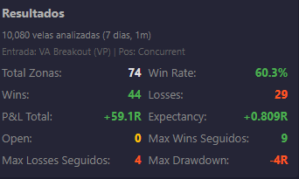

1 | max_range_pct: 6  period: 100  ttm_min_squeeze_bars: 5 | 60.3% | 44/29 | +59R | +0.808 | 3.03 | -4R | Aplicar
2 | max_range_pct: 6.50  period: 100  ttm_min_squeeze_bars: 5 | 60.3% | 44/29 | +59R | +0.808 | 3.03 | -4R | Aplicar
3 | max_range_pct: 7  period: 100  ttm_min_squeeze_bars: 5 | 60.3% | 44/29 | +59R | +0.808 | 3.03 | -4R | Aplicar
4 | max_range_pct: 7.50  period: 100  ttm_min_squeeze_bars: 5 | 60.3% | 44/29 | +59R | +0.808 | 3.03 | -4R | Aplicar
5 | max_range_pct: 8  period: 100  ttm_min_squeeze_bars: 5 | 60.3% | 44/29 | +59R | +0.808 | 3.03 | -4R | Aplicar
6 | max_range_pct: 8.50  period: 100  ttm_min_squeeze_bars: 5 | 60.3% | 44/29 | +59R | +0.808 | 3.03 | -4R | Aplicar
7 | max_range_pct: 9  period: 100  ttm_min_squeeze_bars: 5 | 60.3% | 44/29 | +59R | +0.808 | 3.03 | -4R | Aplicar
8 | max_range_pct: 1.50  period: 100  ttm_min_squeeze_bars: 5 | 63.1% | 41/24 | +58R | +0.892 | 3.42 | -3R | Aplicar
9 | max_range_pct: 6  period: 100  ttm_min_squeeze_bars: 3 | 59.5% | 44/30 | +58R | +0.784 | 2.93 | -4R | Aplicar
10 | max_range_pct: 6  period: 100  ttm_min_squeeze_bars: 4 | 59.5% | 44/30 | +58R | +0.784 | 2.93 | -4R | Aplicar
11 | max_range_pct: 6.50  period: 100  ttm_min_squeeze_bars: 3 | 59.5% | 44/30 | +58R | +0.784 | 2.93 | -4R | Aplicar
12 | max_range_pct: 6.50  period: 100  ttm_min_squeeze_bars: 4 | 59.5% | 44/30 | +58R | +0.784 | 2.93 | -4R | Aplicar
13 | max_range_pct: 7  period: 100  ttm_min_squeeze_bars: 3 | 59.5% | 44/30 | +58R | +0.784 | 2.93 | -4R | Aplicar
14 | max_range_pct: 7  period: 100  ttm_min_squeeze_bars: 4 | 59.5% | 44/30 | +58R | +0.784 | 2.93 | -4R | Aplicar
15 | max_range_pct: 7.50  period: 100  ttm_min_squeeze_bars: 3 | 59.5% | 44/30 | +58R | +0.784 | 2.93 | -4R
============================
============================
============================

# | Params | WR% | W/L | PnL | Expect | PF | DD
1 | multiplier: 1  ma_period: 15  min_score_filter: 0 | 62.7% | 42/25 | +59R | +0.881 | 3.36 | -4R | Aplicar
2 | multiplier: 1  ma_period: 15  min_score_filter: 10 | 62.7% | 42/25 | +59R | +0.881 | 3.36 | -4R | Aplicar
3 | multiplier: 1  ma_period: 15  min_score_filter: 20 | 62.7% | 42/25 | +59R | +0.881 | 3.36 | -4R | Aplicar
4 | multiplier: 1  ma_period: 15  min_score_filter: 30 | 62.7% | 42/25 | +59R | +0.881 | 3.36 | -4R | Aplicar
5 | multiplier: 1  ma_period: 15  min_score_filter: 40 | 62.9% | 39/23 | +55R | +0.887 | 3.39 | -4R | Aplicar
6 | multiplier: 0.75  ma_period: 10  min_score_filter: 0 | 57.5% | 42/31 | +53R | +0.726 | 2.71 | -6R | Aplicar
7 | multiplier: 0.75  ma_period: 10  min_score_filter: 10 | 57.5% | 42/31 | +53R | +0.726 | 2.71 | -6R | Aplicar
8 | multiplier: 0.75  ma_period: 10  min_score_filter: 20 | 57.5% | 42/31 | +53R | +0.726 | 2.71 | -6R | Aplicar
9 | multiplier: 0.75  ma_period: 10  min_score_filter: 30 | 57.5% | 42/31 | +53R | +0.726 | 2.71 | -6R | Aplicar
10 | multiplier: 1  ma_period: 15  min_score_filter: 50 | 64.3% | 36/20 | +52R | +0.929 | 3.6 | -4R | Aplicar
11 | multiplier: 1  ma_period: 20  min_score_filter: 0 | 67.3% | 33/16 | +50R | +1.02 | 4.12 | -3R | Aplicar
12 | multiplier: 1  ma_period: 20  min_score_filter: 10 | 67.3% | 33/16 | +50R | +1.02 | 4.12 | -3R | Aplicar
13 | multiplier: 1  ma_period: 20  min_score_filter: 20 | 67.3% | 33/16 | +50R | +1.02 | 4.12 | -3R | Aplicar
14 | multiplier: 1  ma_period: 20  min_score_filter: 30 | 67.3% | 33/16 | +50R | +1.02 | 4.12 | -3R | Aplicar
15 | multiplier: 1.25  ma_period: 25  min_score_filter: 0 | 67.3% | 33/16 | +50R | +1.02 | 4.12 | -3R | Aplicar

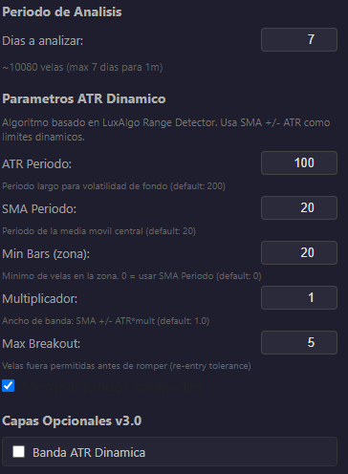
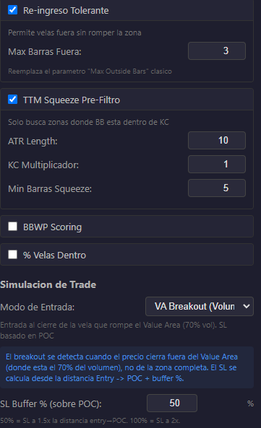
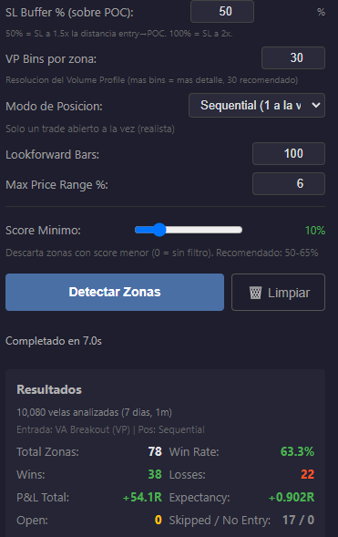
Preset: vp_4_score

=======================================================================
Preset: vp_4_score + R/R

# | Params | WR% | W/L | PnL | Expect | PF | DD
1 | multiplier: 1  min_score_filter: 0  tp_rr_ratio: 1 | 83% | 44/9 | +79R | +1.491 | 9.78 | -2R | Aplicar
2 | multiplier: 1  min_score_filter: 10  tp_rr_ratio: 1 | 83% | 44/9 | +79R | +1.491 | 9.78 | -2R | Aplicar
3 | multiplier: 1  min_score_filter: 20  tp_rr_ratio: 1 | 83% | 44/9 | +79R | +1.491 | 9.78 | -2R | Aplicar
4 | multiplier: 1  min_score_filter: 30  tp_rr_ratio: 1 | 83% | 44/9 | +79R | +1.491 | 9.78 | -2R | Aplicar
5 | multiplier: 1  min_score_filter: 40  tp_rr_ratio: 1 | 82.4% | 42/9 | +75R | +1.471 | 9.33 | -2R | Aplicar
6 | multiplier: 1.75  min_score_filter: 0  tp_rr_ratio: 1 | 82.1% | 55/12 | +98R | +1.463 | 9.17 | -2R | Aplicar
7 | multiplier: 1.75  min_score_filter: 10  tp_rr_ratio: 1 | 82.1% | 55/12 | +98R | +1.463 | 9.17 | -2R | Aplicar
8 | multiplier: 1.75  min_score_filter: 20  tp_rr_ratio: 1 | 82.1% | 55/12 | +98R | +1.463 | 9.17 | -2R | Aplicar
9 | multiplier: 1.75  min_score_filter: 30  tp_rr_ratio: 1 | 82.1% | 55/12 | +98R | +1.463 | 9.17 | -2R | Aplicar
10 | multiplier: 1  min_score_filter: 50  tp_rr_ratio: 1 | 81.8% | 36/8 | +64R | +1.455 | 9 | -2R | Aplicar
11 | multiplier: 1.75  min_score_filter: 60  tp_rr_ratio: 1 | 81.4% | 35/8 | +62R | +1.442 | 8.75 | -2R | Aplicar
12 | multiplier: 1.50  min_score_filter: 30  tp_rr_ratio: 1 | 81.3% | 61/14 | +108R | +1.44 | 8.71 | -2R | Aplicar
13 | multiplier: 1.75  min_score_filter: 40  tp_rr_ratio: 1 | 81.2% | 52/12 | +92R | +1.438 | 8.67 | -2R | Aplicar
14 | multiplier: 1  min_score_filter: 0  tp_rr_ratio: 1.25 | 81.1% | 43/10 | +76R | +1.434 | 8.6 | -2R | Aplicar
15 | multiplier: 1  min_score_filter: 10  tp_rr_ratio: 1.25 | 81.1% | 43/10 | +76R | +1.434 | 8.6 | -2R | Aplicar
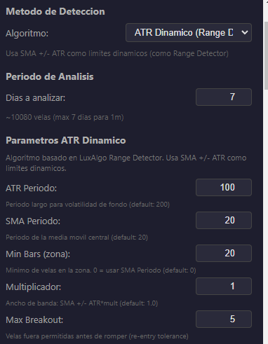
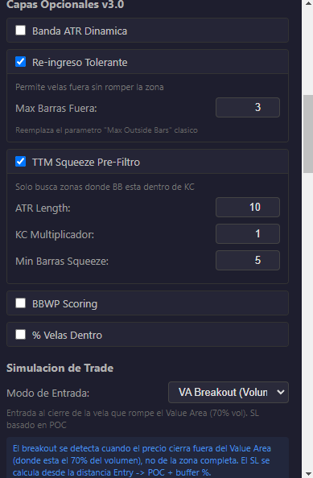


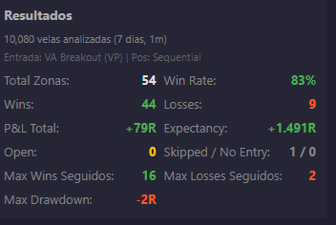

=======================================================================

# | Params | WR% | W/L | PnL | Expect | PF | DD
1 | ttm_atr_length: 10  ttm_kc_multiplier: 1.25  ttm_min_squeeze_bars: 5 | 79.5% | 66/17 | +115R | +1.386 | 7.76 | -2R | Aplicar
2 | ttm_atr_length: 30  ttm_kc_multiplier: 1  ttm_min_squeeze_bars: 10 | 87.3% | 62/9 | +115R | +1.62 | 13.78 | -2R | Aplicar
3 | ttm_atr_length: 10  ttm_kc_multiplier: 1.25  ttm_min_squeeze_bars: 3 | 78.6% | 66/18 | +114R | +1.357 | 7.33 | -2R | Aplicar
4 | ttm_atr_length: 10  ttm_kc_multiplier: 1.25  ttm_min_squeeze_bars: 4 | 78.6% | 66/18 | +114R | +1.357 | 7.33 | -2R | Aplicar
5 | ttm_atr_length: 10  ttm_kc_multiplier: 1.50  ttm_min_squeeze_bars: 3 | 78.6% | 66/18 | +114R | +1.357 | 7.33 | -2R | Aplicar
6 | ttm_atr_length: 10  ttm_kc_multiplier: 1.50  ttm_min_squeeze_bars: 4 | 78.6% | 66/18 | +114R | +1.357 | 7.33 | -2R | Aplicar
7 | ttm_atr_length: 10  ttm_kc_multiplier: 1.50  ttm_min_squeeze_bars: 5 | 78.6% | 66/18 | +114R | +1.357 | 7.33 | -2R | Aplicar
8 | ttm_atr_length: 10  ttm_kc_multiplier: 1.50  ttm_min_squeeze_bars: 6 | 78.6% | 66/18 | +114R | +1.357 | 7.33 | -2R | Aplicar
9 | ttm_atr_length: 10  ttm_kc_multiplier: 1.50  ttm_min_squeeze_bars: 7 | 78.6% | 66/18 | +114R | +1.357 | 7.33 | -2R | Aplicar
10 | ttm_atr_length: 10  ttm_kc_multiplier: 1.50  ttm_min_squeeze_bars: 8 | 78.6% | 66/18 | +114R | +1.357 | 7.33 | -2R | Aplicar
11 | ttm_atr_length: 10  ttm_kc_multiplier: 1.50  ttm_min_squeeze_bars: 9 | 78.6% | 66/18 | +114R | +1.357 | 7.33 | -2R | Aplicar
12 | ttm_atr_length: 10  ttm_kc_multiplier: 1.75  ttm_min_squeeze_bars: 3 | 78.6% | 66/18 | +114R | +1.357 | 7.33 | -2R | Aplicar
13 | ttm_atr_length: 10  ttm_kc_multiplier: 1.75  ttm_min_squeeze_bars: 4 | 78.6% | 66/18 | +114R | +1.357 | 7.33 | -2R | Aplicar
14 | ttm_atr_length: 10  ttm_kc_multiplier: 1.75  ttm_min_squeeze_bars: 5 | 78.6% | 66/18 | +114R | +1.357 | 7.33 | -2R | Aplicar
15 | ttm_atr_length: 10  ttm_kc_multiplier: 1.75  ttm_min_squeeze_bars: 6 | 78.6% | 66/18 | +114R | +1.357 | 7.33 | -2R | Aplicar

