CSC 174 Fall 2018
Homework 2
(Total 100 points)

This homework allows students to practice the development of a database using MySQL.

Section 1
Using SQL, create tables according to the given schema in Figure 1. The EER is shown in Figure 2. You must use the exact same attribute names in your tables as the relational schema (figure1), because you will use the views provided by the instructor.

Artist (name, date_born, date_died, description, country_of_origin)

Art_object( id_no, year, title, description, artist_name) foreign key (artist_name) references to Artist(name)

Others( id_no, type, style) foreign key (id_no) references to Art_object(id_no)

Painting(id_no, type, style, drawn_on) foreign key(id_no) references to Art_object(id_no)

Sculpture(id_no, material, weight, height) foreign key(id_no) references to Art_object(id_no)

Exhibition( name, start_date, end_date) Note: please give the domain/type of “name” as VARCHAR (60)

Shown_at( art, exhibition_name) foreign key(art) references to Art_object(id_no), foreign key (exhibition_name) references to Exhibition(name)

Figure 1. Relational Schema
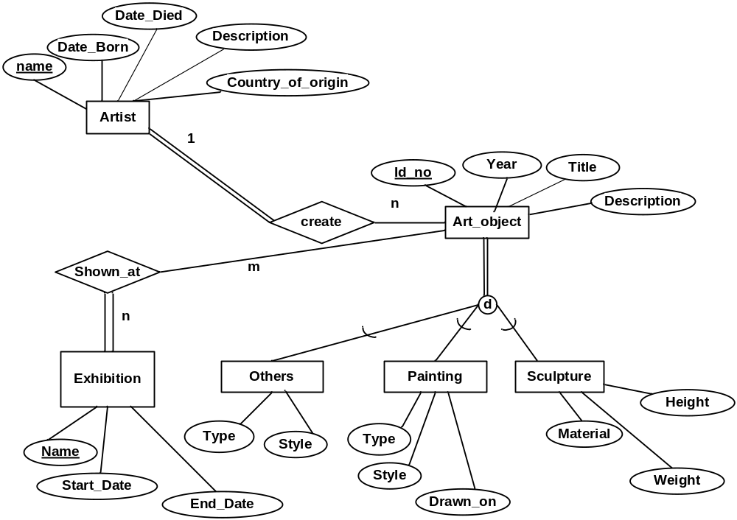

Figure 2. EER

Views related to the specialization are defined as follows.

Create view Others_view as
Select a.id_no, a.year, a.title, a.description, o.type, o.style, a.artist_name
From Art_object a, Others o
Where a.id_no = o.id_no;

Create view Painting_view as
Select a.id_no, a.year, a.title, a.description, p.type, p.style, p.drawn_on, a.artist_name
From Art_object a, Painting p
Where a.id_no=p.id_no;

Create view Sculpture_view as
Select a.id_no, a.year, a.title, a.description, s.material, s.weight, s.height, a.artist_name
From Art_object a, Sculpture s
Where a.id_no = s.id_no;

Section 2
Populate the database. Please check sections 3, 4, and 5 for details.

Section 3
Create the following view. Display the results of selecting all tuples from the view. When you populate the database, insert data such that at least one tuple will display as the result of querying the view (select all tuples from the views).

Listing artist names and total number of sculpture created by each artist, if the artist created more than 2 sculptures.
View name: artist_no_of_sculpture
View parameters: artist_name, no_of_sculpture

Section 4
Create a function to implement the following requirements:
Retrieve the number of paintings exhibited in a particular exhibition.
Function name: No_of_painting_exhibited
Input parameter: exhibition_name
Return: no_of_paintings

Functions are allowed to used in the SELECT clause of a SQL query. Using this function (No_Of_painting_exhibited), specify a SQL query to retrieve the exhibition name, exhibition start date, exhibition end date, and number of paintings exhibited by exhibition “E1”.

Section 5
Specify the statements to drop all the tables, views, functions, and triggers. Pay attention to the order of the drop statements in order to drop everything successfully.

Submission
1) What you need to do:
- Section 1: Create table statements.
Create view statements that are given by the instructor.
- Section 2: Insert statements to populate database
- Section 3: View definition for “artist_no_of_sculpture”. Print the results of selecting all tuples from the views.
- Section 4: definition of the function. Print how to call the function to generate a result, as well as the result of calling the function.
- Section 5: Statements to drop tables, views, and functions.

2) What you need to submit:
Submit the following files.
  - Create table statements, as well as all the views defined by the instructor.
(1_create_table.sql)
  - Insert statements to populate database (2_populate_db.sql)
  - Create view statement (View named “artist_no_of_sculpture”) (3_create_view.sql)
  - View definition (same as c). As well as the results of selecting all tuples from the view. (3_view_all. pdf)
  - Definition of the function. (4_func.sql)
  - Definition of the function (same as e.). Print how to call the function to generate a result, as well as the result of calling the function. (4_func_all.pdf)
  - Statements to drop all tables, views, and functions (6_drop_all.sql)

