

**CSE303: Statistics for Data Science**

**[SUMMER 2025]**

**Term Project Report**

**Modelling the Relationship Between Workload and Mental**

**Health in University Students**

**Submitted by:**

| **Student ID** | **Student Name** | **Contribution Percentage** |
| --- | --- | --- |
| **2023-1-60-097** | **Hassan Ahmed Shawon** | **45%** |
| **2023-1-60-212** | **Albin Israt Siddique** | **35%** |
| **2023-1-60-236** | **Yeamin Sultana** | **20%** |
| **2023-1-60-215** | **Abdullah Saleh Mahmud** | **0%** |

# Introduction

In this project, We collected data from over 200+ students and prepared many simple linear and multiple linear regression model. Our goal was to find some relations between the features of our servey and visualizing them. Simple and Multiple linear regression models were created based on the correlation between the features which we found through heatmap. 4-types of Hypothesis Testing were also added here(eg: Independent t-test, One-way ANOVA, Correlation test,Proportion test (Chi-square).

We collected our dataset from conducting a severy among university students from different institutions of BD using Google-Forms. Integrity of data was our main priority, we tried to ensure all data’s are filled by different students to get dynamic and real data. Overall, this project is capable of showing relationship between workload and mental health in university students by analysis different aspects.

# 2. Data Preprocessing

Filling up missing values was a quite challenging part; we first analyzed the particular feature distribution type and what does the missing value indicates. based on that result, we fulfilled CGPA column empty values with the mean of CGPA column as the distribution is symmetric. PartTime_Job_Hours, Extracurricular_Hours column empty values were filled with 0 as the empty value indicates that they donot work or participate in extracurricular activities so their invested hours is empty. Categorical values were encoded with numerical values(ex: Years_of_Study→{"1st":1,"2nd":2,"3rd":3,"4th":4},Gender→{"Male":1,”Female":0},Extracurricular_pariticipation→{"Yes":1,"No":0},PartTime_Job_Status→{"Yes":1, "No":0}. We also dropped the rows where Years_of_Study is null. Feature Scaling Strandardization process is used here for scaling the data.

# 3.Dataset Characteristics and Exploratory Data Analysis

Our Student_Servery dataset has (205,14) rows and columns and each rows are different.

In this section, introduce your dataset. Mention the number of rows, columns, and other characteristics. Provide the histograms of data distribution and correlations among the variable with a suitable discussion. Try to stand out and be creative in your presentation!

# Feature Engineering

In this project , Standardizatin of Feature Scaling is used to scale the all numeric data . It makes the data range between -1 to +1. It helped to obtain the correct r^2 value.

# Hypothesis Testing

**Indepndent t-test:** CGPA by Gender

H0: Mean CGPA of males = Mean CGPA of females

Ha : Mean CGPA of males != Mean CGPA of females  
t-statistic = -.25 , p-value= 0.803

p-value> 0.05 → **Fail to reject H0**  
Interpretation: There is no difference or mean CGPA of males is equal to females.

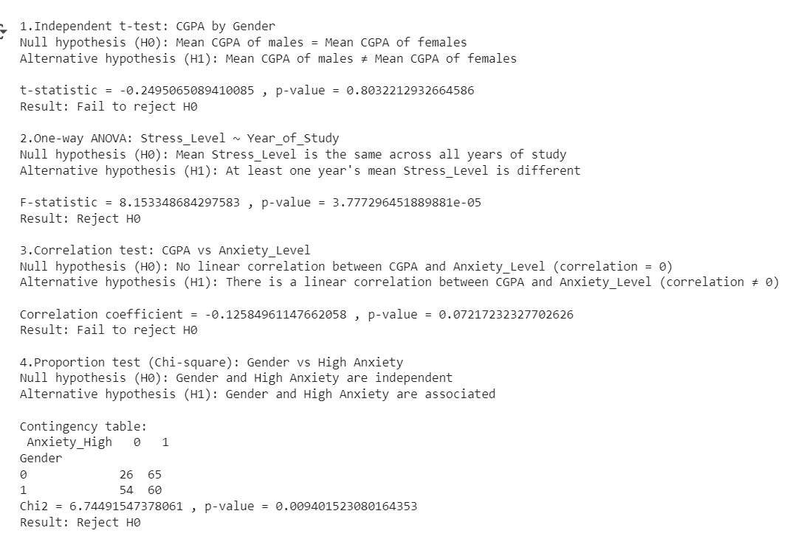

**One-way ANOVA:** Stress_Level by Year_of_Study

H0: Mean Stress_Level is same across all years of study  
Ha : At least one year’s mena Stress_Level is different  
F-statistic = 8.15 , p-value=3.78e^-05

p-value< 0.05 → **reject H0**  
Interpretation: At least one year’s mena Stress_Level is different

**Correlation Test:** CGPA by Anxiety_Level

H0: No linear correlation between CGPA and Anxiety_Level  
Ha : There is linear correlation between CGPA and Anxiety_Level  
Correlation coefficient= -0.126, p-value=0.072

p-value>0.05 → **fail to reject H0**  
Interpretation: There is no linear correlation between CGPA and Anxiety_Level

**Proportion Test(Chi-square):** Gender vs High Anxiety  
H0: Gender and High Anxiety are independent  
Ha : Gender and High Anxiety are associated  
Chi2 = 6.74, p-value = 0.009

p-value < 0.05 → **Reject H₀**  
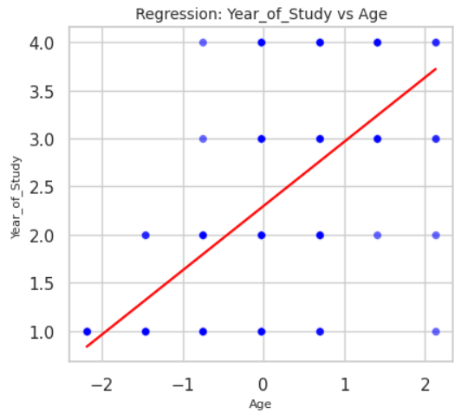Interpretation:

* Gender is significantly associated with anxiety level and Males are moore like to have high anxiety than female.
* Male has **65%** high anxiety vs **26%** low anxiety
* Female has **60%** high anxiety vs **54%** low anxiety

# Regression Model and Performance Evaluation

Here our top 5 best simple and multiple linear regression model is shown

## Simple Linear Regression Models **1. Years_of_Study ~ Age**

* **Intercept ≈ 0** ; when Age is zero, Year_of_Study is also zero means study is not started yet.
* **Age Coefficient ≈ 0.67** ; means for every 1   
  unit increase in age will increase the Year_of_Study by 0.67 on average
* **R2- Value ≈ 0.457**; about 45.7% f the variation in Year_of_Study can be explained by Age.

**2.Extracurricular_Hours~Extracurricular_pariticipation**

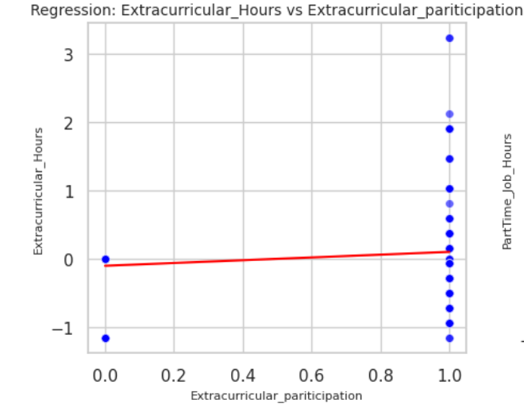

* **Intercept ≈ -0.64**; non-paritcipants do not have any hours dedicated for extracurricular activities.
* **Extracurricular_pariticipation ≈ 1.34**;

means for every 1 unit increase in Extracurricular_pariticipation will increase the Extracurricular_Hours by 1.34 on average.

* **R2- Value ≈ 0.447**; about 44.7% of the variation in Extracurricular_Hours can be explained by Extracurricular_pariticipation.

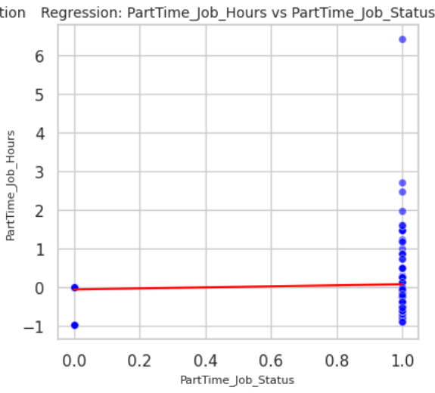

**3. PartTime_Job_Hours ~ PartTime_Job_Status**

* **Intercept ≈ -0.60** ; This means who doesn’t have partime job **≈** donot spent any job hours.
* **PartTime_Job_Status Coefficient ≈ 1.19** ; means for every 1 unit increase in partTime_Job_Status will increase the PartTime_Job_Hours by 1.19 on average .
* **R² ≈ 0.355**; about 45.7% f the variation in Year_of_Study can be explained by Age.

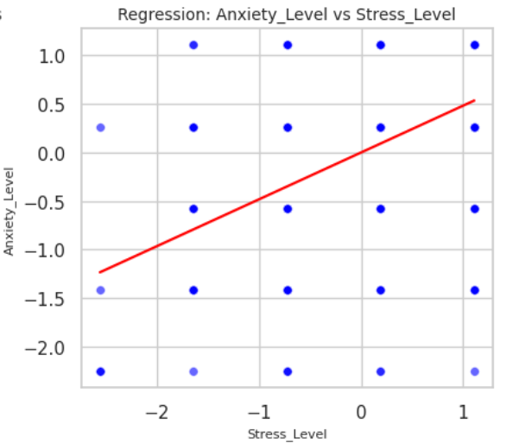

**4. Anxiety_Level~ Stress_Level**

* **Intercept ≈ 0** ; When Stress_Level = 0, Anxiety_Level **≈**  0.
* **Stress Coefficient ≈ 0.48** ; means for every 1   
  unit increase in Stress_Level will increase the Anxiety_Level by 0.48 on average
* **R² ≈ 0.233** ;About 23.3% of the variation in Anxiety_Level is explained by Stress_Level.

**5.Sleep_Quality ~ Sleep_Hours**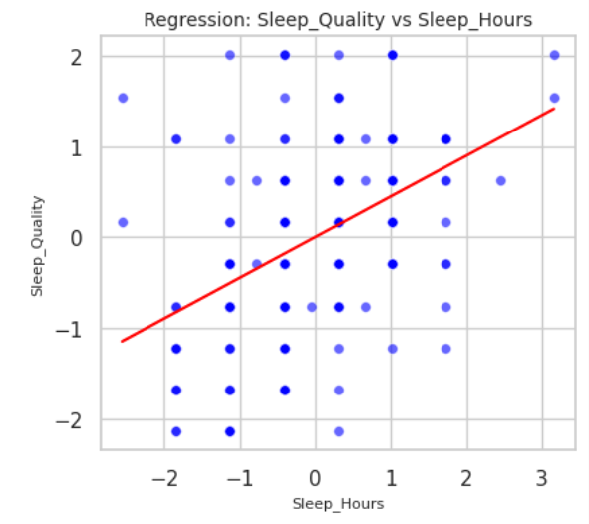

* **Intercept ≈ 0** ; when Age is zero, Year_of_Study is also zero means study is not started yet.
* **Sleep_Hours Coefficient ≈ 0.45**; means for every 1 unit increase in Sleep_Hours will increase the sleep_Quality by 0.45 on average
* **R² ≈ 0.200** ; About 20% of the variation in sleep_Quality is explained by Sleep_Hours .

## Multiple Linear Regression Models

1. **Stress_Level ~ Anxiety_Level + Year_of_Study + Sleep_Hours**

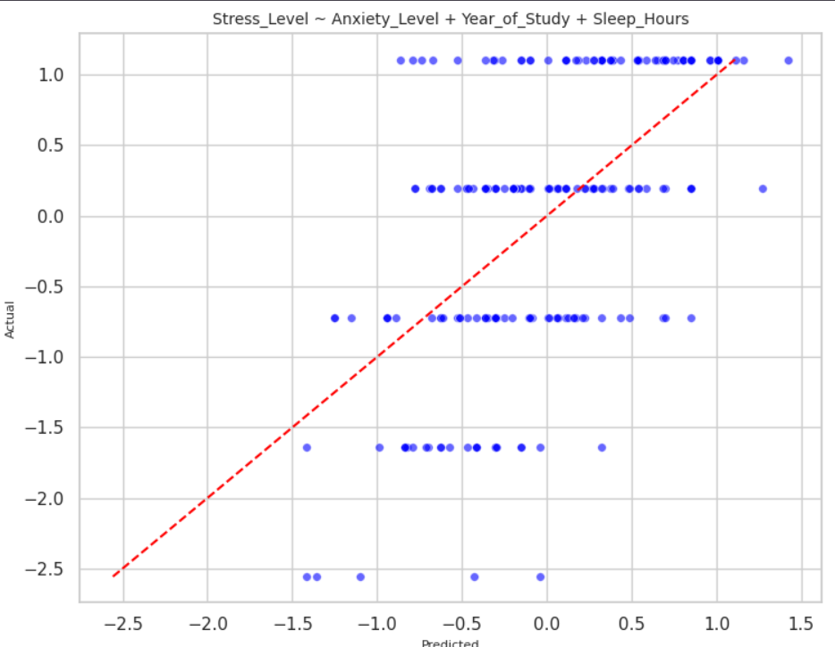

* **Intercept ≈ 0** ; When predictors are 0, stress is ~0 (not meaningful baseline).
* **Anxiety_Level Coefficient ≈ 0.38** ;Each 1-unit increase in anxiety increases stress by ~0.38.
* **Year_of_Study Coefficient ≈ 0.26** ; Each 1-year increase in study year increases stress by ~0.26.
* **Sleep_Hours Coefficient ≈ -0.22** ; Each extra hour of sleep decreases stress by ~0.22.
* **R² ≈ 0.345** ; About 34.5% of variation in stress is explained by anxiety, year of study, and sleep hours.

### Sleep_Quality ~ Sleep_Hours + Anxiety_Level + Stress_Level

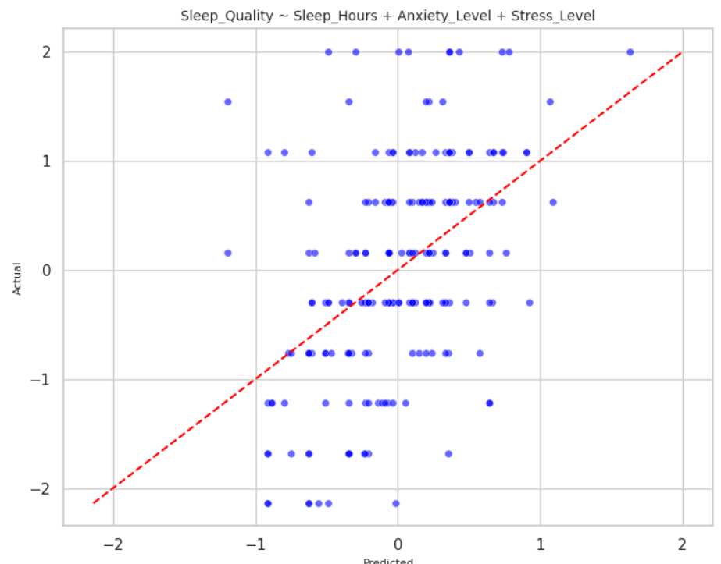

* **Intercept ≈ 0** ;When predictors are 0, sleep quality is ~0 (baseline).
* **Sleep_Hours Coefficient ≈ 0.40** ; Each extra hour of sleep improves sleep quality by ~0.40.
* **Anxiety_Level Coefficient ≈ -0.14** Higher anxiety tends to lower sleep quality (weak evidence).
* **Stress_Level Coefficient ≈ -0.02** ;Stress has almost no effect on sleep quality.
* **R² ≈ 0.221** ;About 22.1% of variation in sleep quality is explained by these predictors.

### Anxiety_Level ~ Stress_Level + Sleep_Hours + Gender

* **Intercept ≈ 0.23** ;Baseline anxiety level when predictors = 0.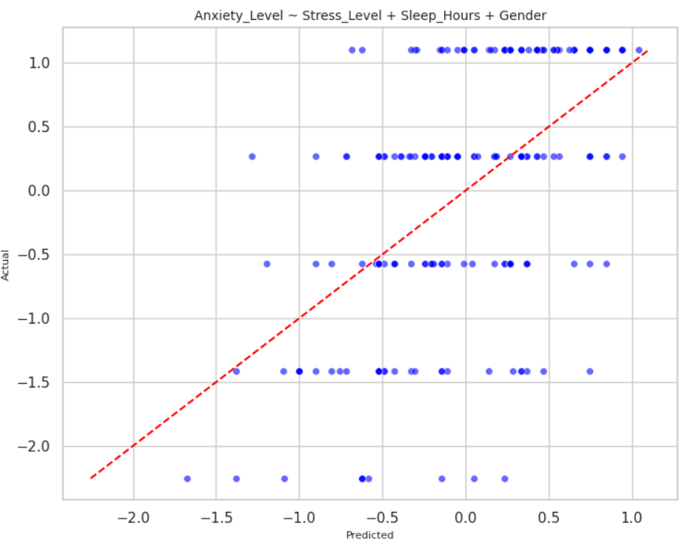
* **Stress_Level Coefficient ≈ 0.41** ; Each 1-unit increase in stress increases anxiety by ~0.41.
* **Sleep_Hours Coefficient ≈ -0.14** ;Each extra hour of sleep decreases anxiety by ~0.14.
* **Gender Coefficient ≈ -0.41** ;Gender difference: coded group (likely female vs male) has ~0.41 lower anxiety on average.
* **R² ≈ 0.295** ;About 29.5% of variation in anxiety is explained by stress, sleep, and gender.

### PartTime_Job_Hours ~ PartTime_Job_Status + Age + Sleep_Quality

* **Intercept ≈ -0.58** ;Baseline job hours when predictors = 0 (not realistic, just model baseline).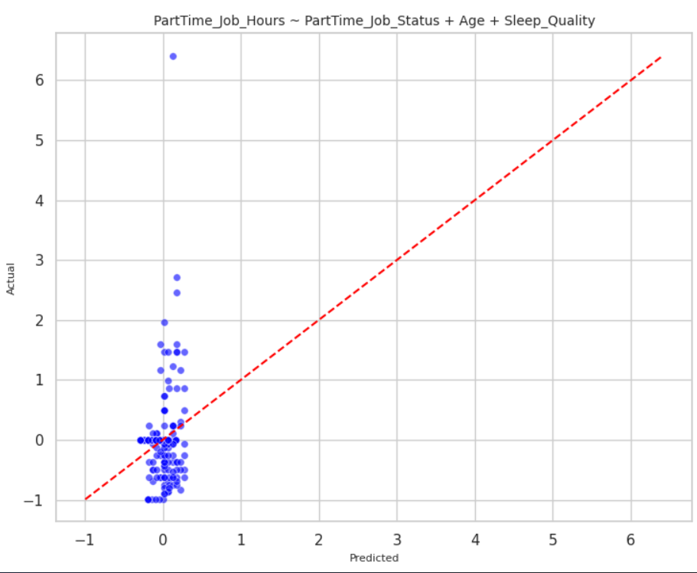
* **PartTime_Job_Status Coefficient ≈ 1.16** ;Students with a job work ~1.16 more hours than those without.
* **Age Coefficient ≈ 0.02 (ns)** ;Age has no meaningful effect on job hours.
* **Sleep_Quality Coefficient ≈ 0.10 ;**Higher sleep quality slightly increases job hours (weak evidence).
* **R² ≈ 0.366** ; About 36.6% of variation in job hours is explained by these predictors.

### Extracurricular_Hours ~ Extracurricular_participation + Year_of_Study + PartTime_Job_Status

* **Intercept ≈ -0.61**;Baseline extracurricular hours when predictors = 0.
* **Participation Coefficient ≈ 1.34**; Participants spend ~1.34 more hours in extracurriculars than non-participants.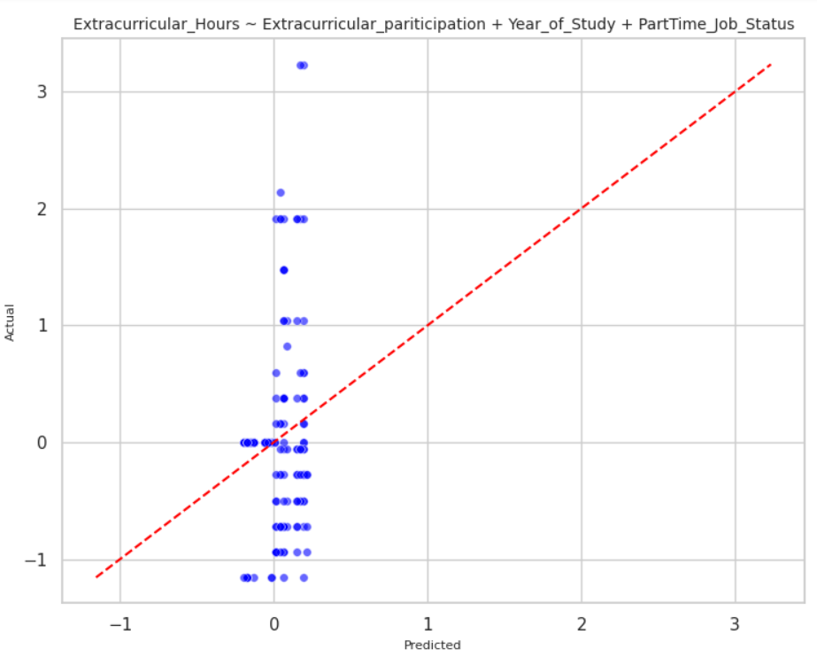
* **Year_of_Study Coefficient ≈ 0.01;**Year of study has no effect on extracurricular hours.
* **PartTime_Job_Status Coefficient ≈ -0.06 ;** Job status has no effect on extracurricular hours.
* **R² ≈ 0.447** ;About 44.7% of variation in extracurricular hours is explained by these predictors (but mostly participation).

# Discussion

Most important section!

Analyse the performance of your regression systems and provide the hypothesis behind their performance, e.g., why the model is performing in this way or why it is not performing better? Provide appropriate reasoning for your hypothesis.

# Dashboard

Provide a description of your dashboard using screenshots as necessary. Also, include the link to your code and dashboard.

# Conclusion

For collecting data, we had some debate whether to collect data offline or online as on online survey people don’t give actual data and offline data collection much more time consuming and hard working also costly. Finally, we decided to collect data using Google-Forms. Cleaning data and adjusting the R2  value was completely unknown to us , we had study a lot for this. EDA part was also challenging because dataset is not so organized. Lastly, building and running the application was quite frustrating and brainstorming for us.

In our project, regression models are underfitted and has low-r^2 value because of the dataset. For this reason , many potential important relationships were not found in our project. This project has some potential to predict and describe student’s mental health with respect to workload features only if the data are collected sincerely and accurately.   
  
This project might not be perfect but by building this project we got to understand statistics and its related topic, deeply which will help us to strengthen our knowledge in the Data Science filed in Future. Thanks to our Rezwan sir for his effort.