Q1.a Threshold like behaviour is observed when we vary m for a fixed n. In particular, size of largest connected component reaches n, indicating full connectivity, as m increases after a particular value. This is consistent with what we studied in the class that graph becomes fully connected at a threshold m\* = O( nlog(n) )

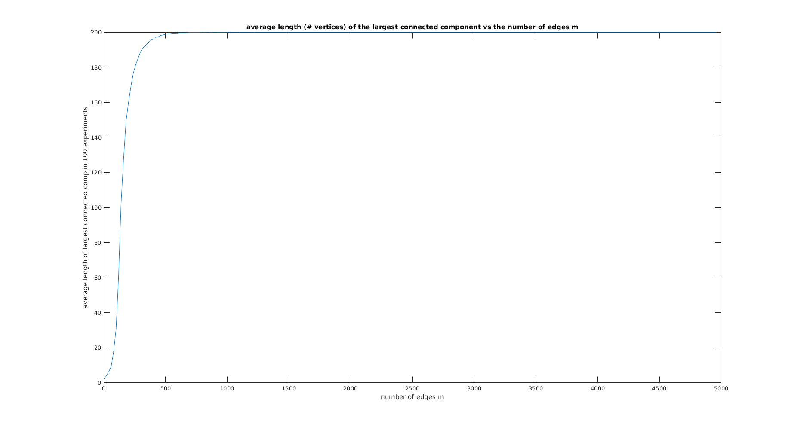

Q1.b Both the largest and the second largest components seem to have O( log(n) ) sizes. This is the case for m = 0.3n

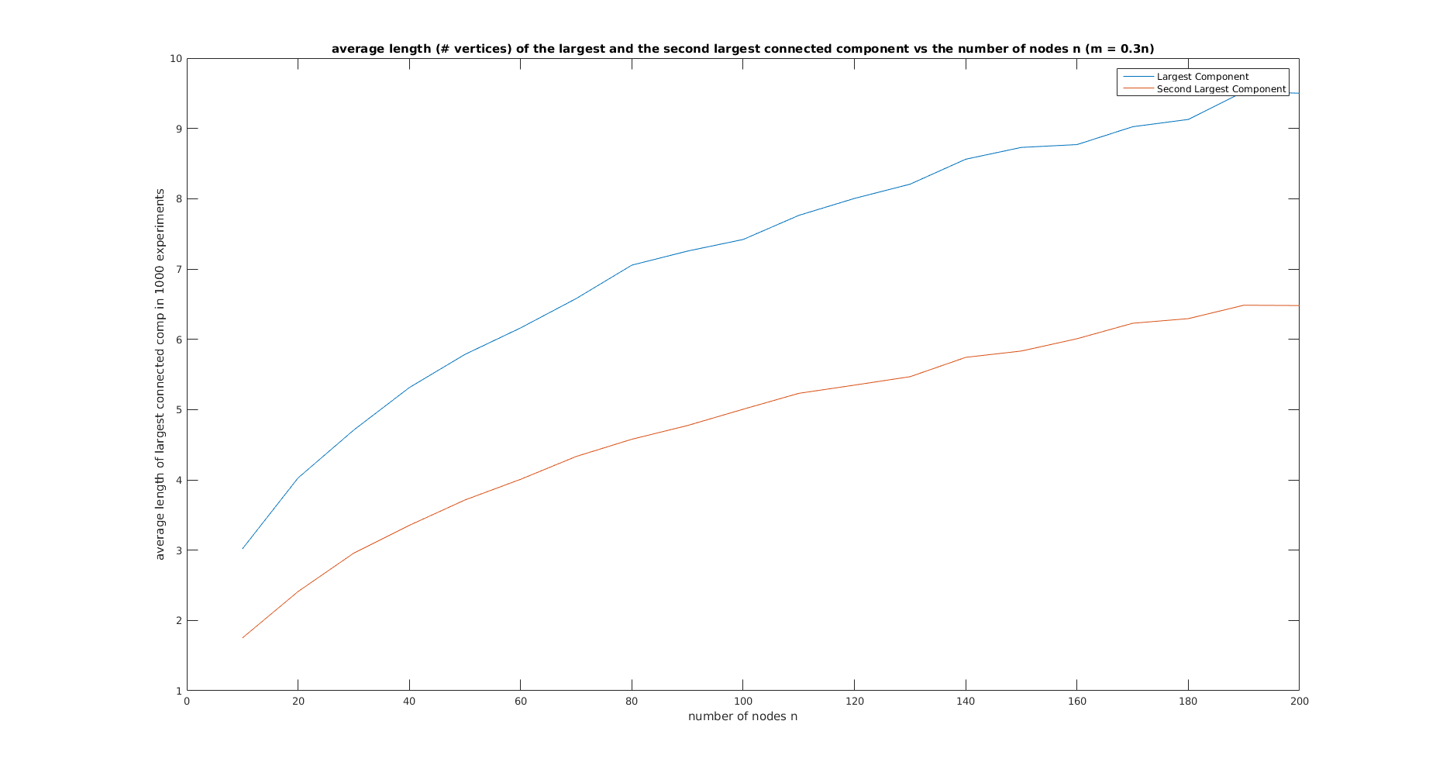

Q1.c Both the largest and the second largest components seem to have O( n ) sizes. This is the case for m = 0.6n

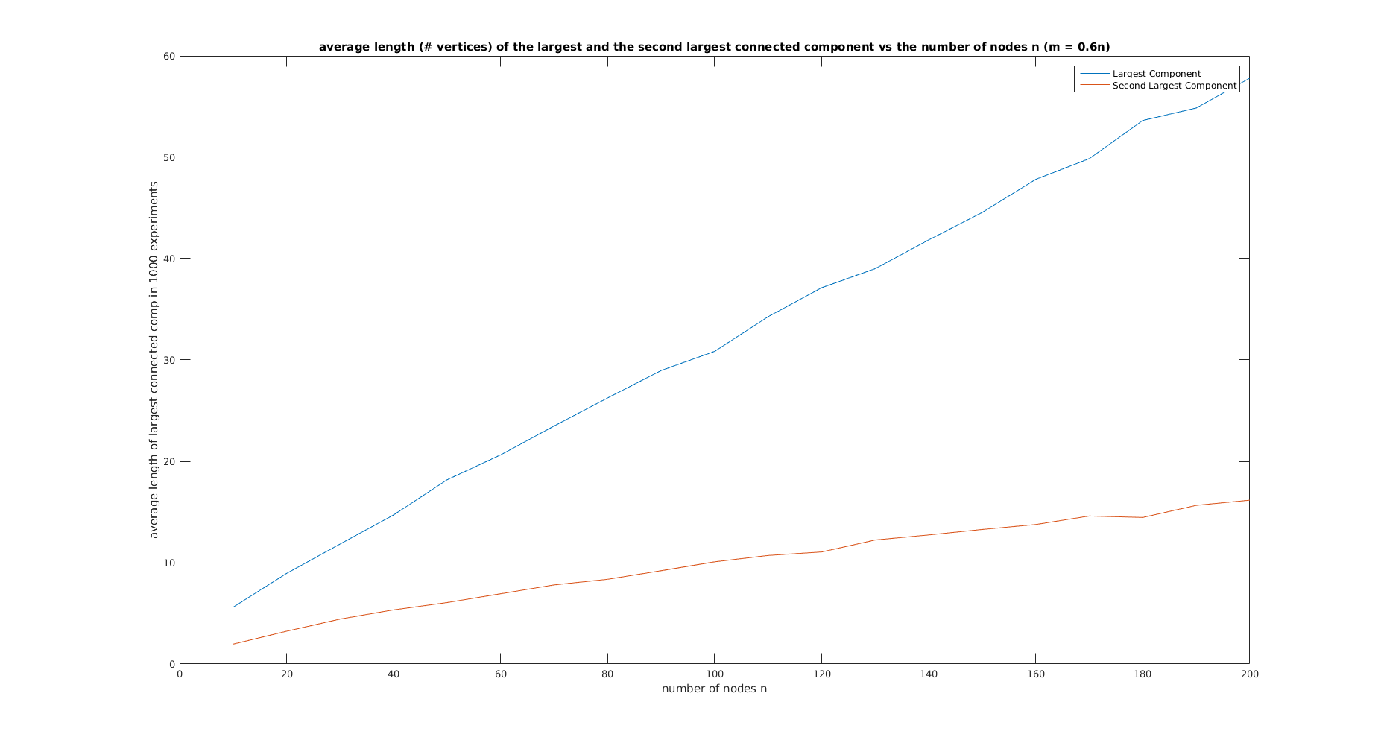

Q1.d m\* varies linearly with n, for the property that there are at least n/2 nodes in the largest connected component. This is in consistency with the discussion in the class that for m = O(n) or m = cn, a giant component emerges, whose size is a fraction of total number of nodes, the fraction being ½ here.

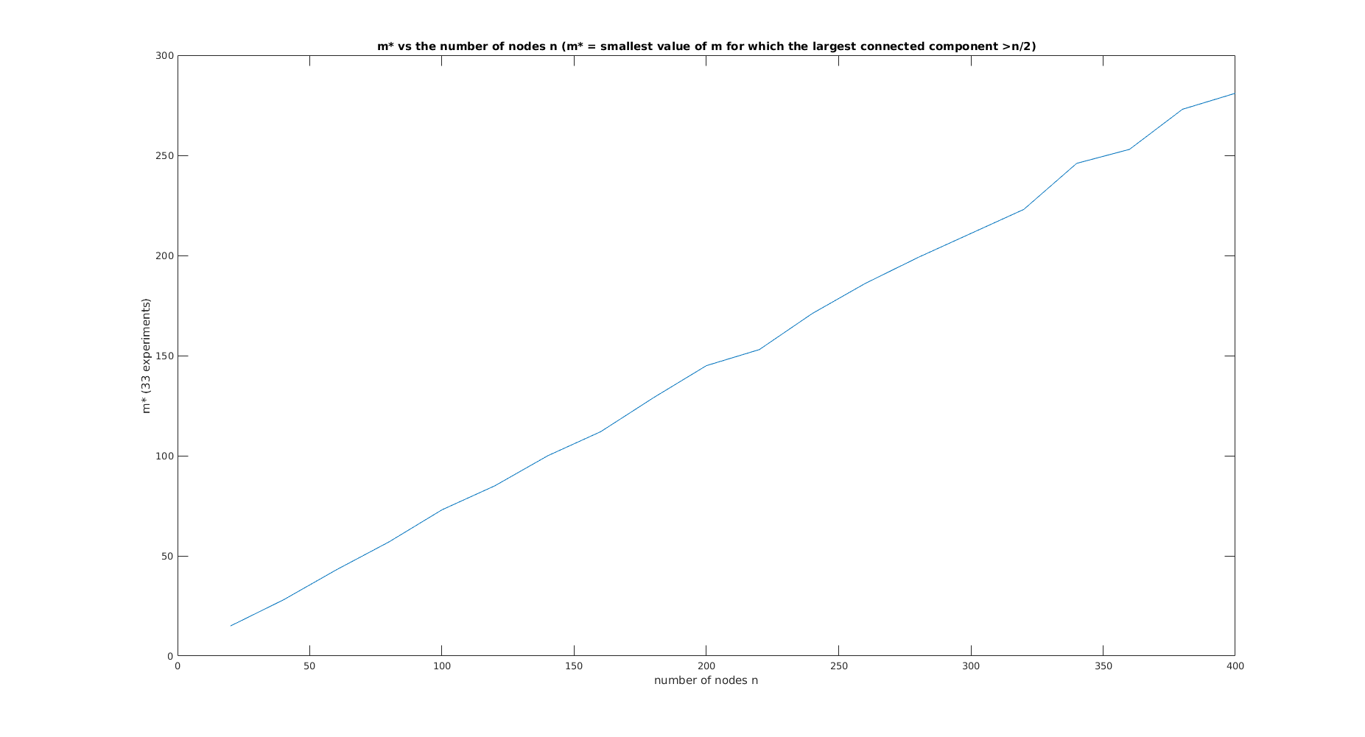

Q1.e m’/n varies as log(n), i.e. m’ varies as O( nlog(n) ). Theoretically, we derived the same result in class for full connectivity.

