Research Paper Summary

Title: Autonomous Assembly of Structures using Pinning Control and Formation Algorithms

Author(s): Kleber M. Cabral, Sidney N. Givigi, Peter T. Jardine

Date: 2020-08

Link to paper: https://github.com/albud187/Thesis_Literature_Review/blob/main/finished_reading/Autonomous_Assembly_of_structures.pdf

Section 1 - Overall Idea

- Autonomous construction system using multiple robots
- Formation control, network based approach for autonomous assembly
- Multi-agent system modelled as a network, assembly of structure is problem formulation

Section 2 - Methodology

- Pinning control - placement of local feedback controllers on a small fraction of network nodes, which are called pins. Robots not directly actuated will be influenced via their connections with the pins.
- Instructure assembly, each block is described as an agent in the network, and each robot is (logically - programmatically) connected to its adjacent neighbours. Overall assembly can be represented as a graph set G = {V,E,A}. finite set V with N nodes, finite edge set E, adjacency matrix A.
- Algorithm 1 = Position control, local at each robot. algorithm 2 = centralized planner, one instance active.
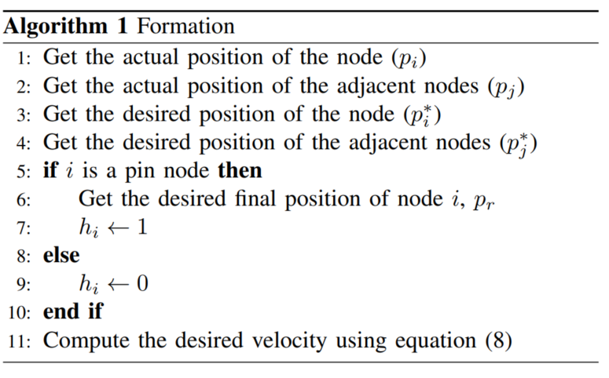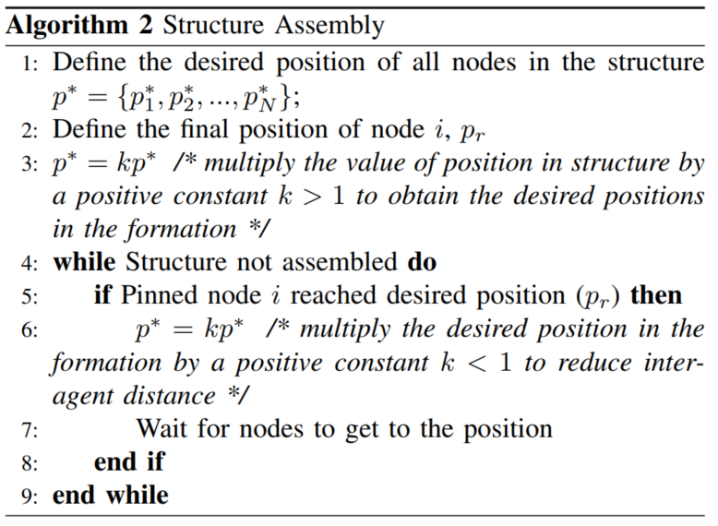
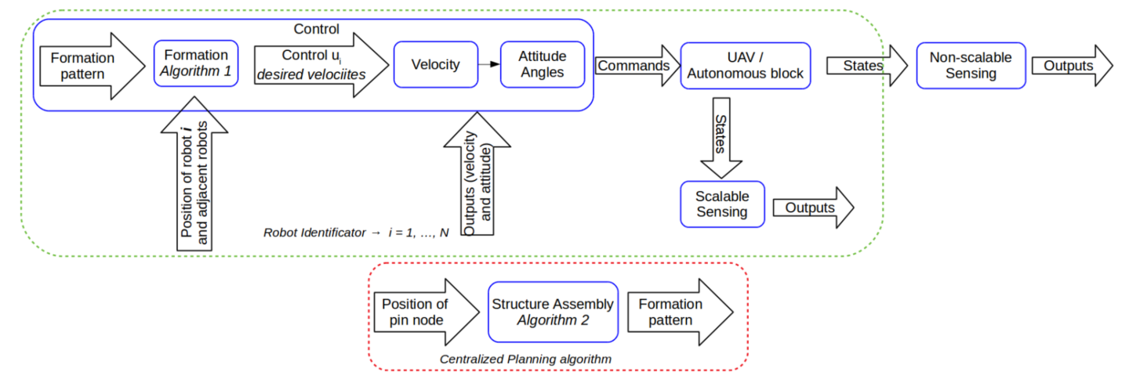

Section 3 - Applications

- The pinning control algorithm was simulated with the autonomous construction of a pyramidal structure. A possible application is using it for the construction of any other modular structure.
- It may be possible to use this algorithm for the coordination a complex end effector at the end of a manipulator. For example, if the end effector is a robotic hand with 5 fingers, each finger basically it’s own manipulator with it’s own end effector. A main finger can be the pin while the motion of other 4 figures is influenced by the motion of the main finger.

Section 4 - Future Development

- Explore priority on mounting sequence and control techniques after structure is assembled.
- Backup pinning. What happens if a pin goes down? Can another robot in the network / system take cover as a new pin?
- Can a form of adaptive control be combined with pinning control?

Section 5 - Questions

- What would the system architecture look like with a hybrid coordination approach ? This approach combines features of both centralized and de-centralized coordination.
- Regarding future development, does mean priority of structure assembly? Is this the order in which structural components are placed / assembled?

Section 6 - Anything Else
Nil

