Research Paper Summary

Title: Cooperative System with UAV and UGV for Disaster Area Exploration

Author(s): Takaya Hakukawa, Kenji Uchiyama, Kai Masuda

Date: 2018-10

Link to paper: https://github.com/albud187/Thesis_Literature_Review/blob/main/finished_reading/Cooperative_System_with_UAV_and_UGV_for_Disaster_Area_Exploration.pdf

Section 1 - Overall Idea

- Use different strengths / characteristics of UAVs and UGVs to complement each other in search and exploration tasks.
- UAVs transit obstacle data to UGV. Super-twisting sliding mode observer (STSMO) for estimating velocities of vehicles.

Section 2 - Methodology
- UAV: Nonlinear motion equation and control system. Get dynamics, find error in position, velocity and acceleration to determine control input. Linear-Quadratic Regulator (LQR) applied to linearized motion equation.
- UGV: get translational and rotational dynamics, find error in acceleration to find overall error equations for translational and rotational motion. Apply LQR.
- STSMO: observer generally estimates state of vehicles due to payloads, but robustness is needed to deal with disturbances. Velocity of UAV and UGV from dynamic model and additional factor from observer related param. STSMO to estimate velocities under existence of disturbances.
- Guidance Law: use attractive and repulsive potential functions, factoring in current and desired values as well as design parameters. Potential functions to avoid obstacles.
- 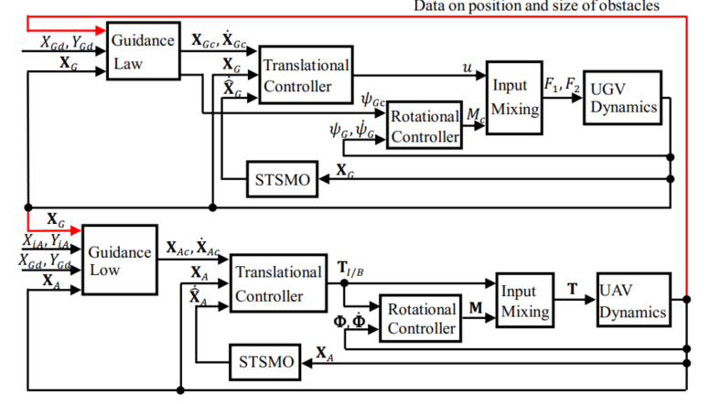

Section 3 - Applications
- Combined air/land exploration and reconnaissance of complex environments.

Section 4 - Future Development
- This method can be applied with more and different robots, for example, 2 different wheeled robots and 2 different types of areal robots.
- ROS implementation

Section 5 - Questions
- In the real world, how would data be shared between each robot? For example, would there be a higher level controller or would the UGV fulfill that role? Or would it be a de-centralized control scheme?

Section 6 - Anything Else
- This paper seems to be primarily concerned on the controls between the UAVs and UGVs. Rather, how behaviour in one system is supposed to effect behaviour in one system.

