Research Paper Summary

Title: 3D Exploration with an Air-Ground Robotic System

Author(s): Jonathan Butzke, Andrew Dornbush, Maxim Likhachev

Date: 2015-09

Link to paper: https://github.com/albud187/Thesis_Literature_Review/blob/main/finished_reading/3-D_exploration_with_an_air-ground_robotic_system.pdf

Section 1 - Overall Idea

- Combined air-ground system for 3D exploration in cluttered environments
- Algorithms for planning 3D goal locations for heterogenous team of robots to explore.

Section 2 - Methodology

- Frontier based exploration - known and unknown portions of an environment - direct robot to explore unknown.
- Find objects of interest (OOI) with minimal human input. System must do navigation, sensing and decision making.
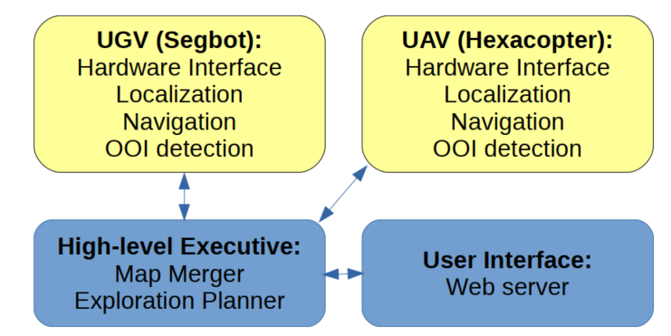
- Map merging: generate unified 3D map from the 2 robot’s maps and offset between the 2. Exploration planner assigns goals / desitnations to each robot.
- Planning algorithm as follows in each iteration:
  - Generate new goals to all robots
  - Inflate obstacles to account for footprints of robots
  - Dijkstra Search from current location of each robot.
  - Determine cost
  - Parse map to determine frontier cells.
  - Score potential state in reachable space.
- Algorithm supposed to guarantee robots can reach objective without running out of battery.

Section 3 - Applications

- Possible application in supporting tactical reconnaissance missions, or in dangerous environments.
- A bigger UGV can be used as well to transport supplies with navigation / guidance support from aerial UAV.

Section 4 - Future Development

- Distributed high-level executive so it can continue even with loss of a single robot.
- Integration with different sensor packages and location modes.

Section 5 - Questions

- What is “Dijkstra Search”?
- What happens if communication between a robot and the high level executive is lost?

Section 6 - Anything Else

nil

