Research Paper Summary

Title: Generic ROS-based Architecture for Heterogeneous Multi-Autonomous Systems Development

Author(s): Mustafa Alberri, Sherif Hegazy, Mohamed Badra, Mohamed Nasr, Omar M. Shehata, Elsayed I. Morgan

Date: 2018-09

Link to paper: https://github.com/albud187/Thesis_Literature_Review/blob/main/finished_reading/Generic_ROS-based_Architecture_for_Heterogeneous_Multi-Autonomous_Systems_Development.pdf

Section 1 - Overall Idea
- Design and implementation of generalized ROS based architecture for multi-autonomous systems.
- Vehicle to vehicle communications, hierarchical and multi-layer structure.

Section 2 - Methodology
- 3 main levels operating simultaneously: higher level, intermediate level, lower level
- Higher level = software modules that require high processing power. Recevies filtered / simplified sensor data. Linux based computer.
- Intermediate level = connection between higher level and lower level. Filters raw sensor data. Raspberry Pi single board computer.
- Lower Level = interface for sensors and actuators. Receives raw data and sends actuating signals. Arduino / Atmega328p microcontroller.
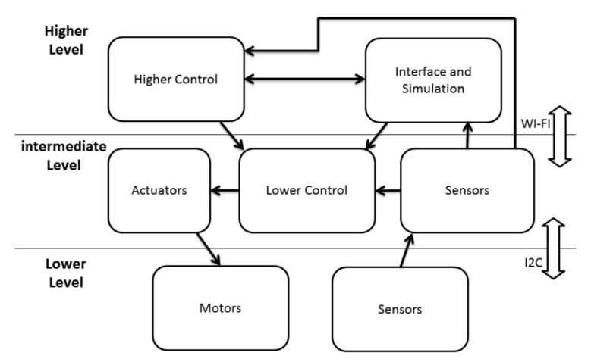
- Software consists of 3 main ros nodes (diagnose, control, heartbeat), along with actuators and sensors packpage. Communication between raspberry pi and higher level computer was over wireless LAN and multimaster_fkie package

Section 3 - Applications
- Control of several robots over a wide area. This can be achieved by leveraging cloud based / modbile data technologies.
- Anywhere with mobile data access can be the operational space of such a multi-agent system.

Section 4 - Future Development
- Instead of wifi, use mobile data. Instead of a linux based computer, either a ros master that all robots connect to, or each robot is its own ros master and “subscribes” to a web application, while the web application “publishes” to each robot.
- Each robot would have to “register” onto the web application as well.

Section 5 - Questions
nil

Section 6 - Anything Else
nil

