**MY JOURNEY TOWARDS BECOMING A SOFTWARE DEVELOPER.**

My name is Brenda Andeso Kanale . I am a 20 year old on a journey of being a Software Developer.

My journey started when I was a student at the University of Nairobi pursuing a Bachelor’s Degree in Statistics. While in first year we were introduced to programming using a language called Python , and that’s when my passion of coding started .

Since that day I have always wanted to study coding in-depth. I used to google what coding is all about and what it’s uses are in the real world . So my dream has always been to be a **Full Stack Software Developer** that is both a **web developer and a mobile-app developer.**

**LIFE AT MORINGA SCHOOL.**

By God’s Grace, through our sponsor, I joined Moringa School .

We started with **Moringa Prep** ran for 5 weeks.

Moringa Prep wasn’t easy because everything was new starting from orientation, using laptops to study because in University, the lecturers used white boards only. During orientation week, we had to install **LINUX OS (Ubuntu)**, meaning we had to get rid of **windows.** So we had to familiarize ourselves with Ubuntu but by God’s Grace we managed. We also installed **Visual Studio Code** for coding ,this app we use it for writing our codes and **Google Chrome** for viewing our web-pages. We also got introduced to an app called **Terminal** . Terminal is found in Ubuntu so we didn’t download it.

The Terminal is where we write our lines of coding , you can call it the **command line .** With this you can detect errors in your codes plus also some apps can be installed using the command line which is interesting.

The Terminal can also be used for making folders and files.

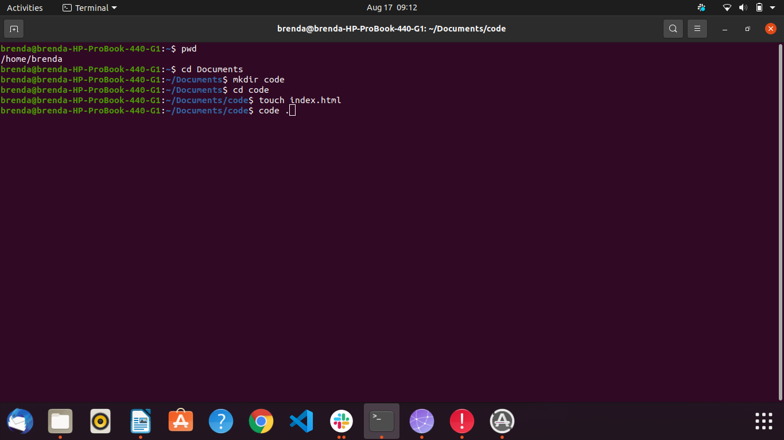

* **Cd** means where you want your file to be located is it on the Documents/Desktop.
* **Mkdir** command means giving your folder a name. My **folder** is called **Code.** (making a folder)
* **Touch** command means giving your file a name. My **file** is called **index.html**.(making a file).
* **Code .** Command means opening the visual studio code.

The **Visual Studio Code** is where now the writing of codes takes place.

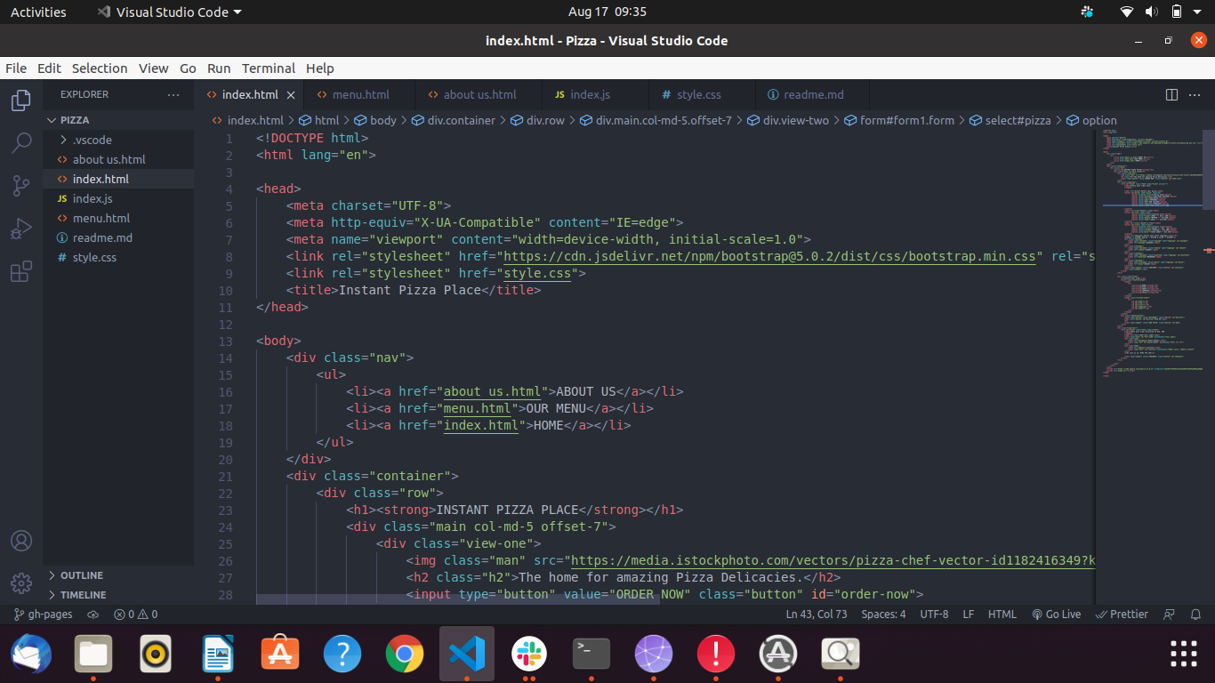

This is my Visual Studio page .

* Pizza name on the left is the name of the folder
* Index.html is the HTML file.
* Index.js is the JavaScript file.
* Style.css is the CSS file.

I have other HTML files which are sub pages of the min HTML file.

On my screen at the bottom right there is the **Go Live** button. When you click it ,you will go to google chrome and view this work .This is done by the help of an Extension called **Live Server Extension.**

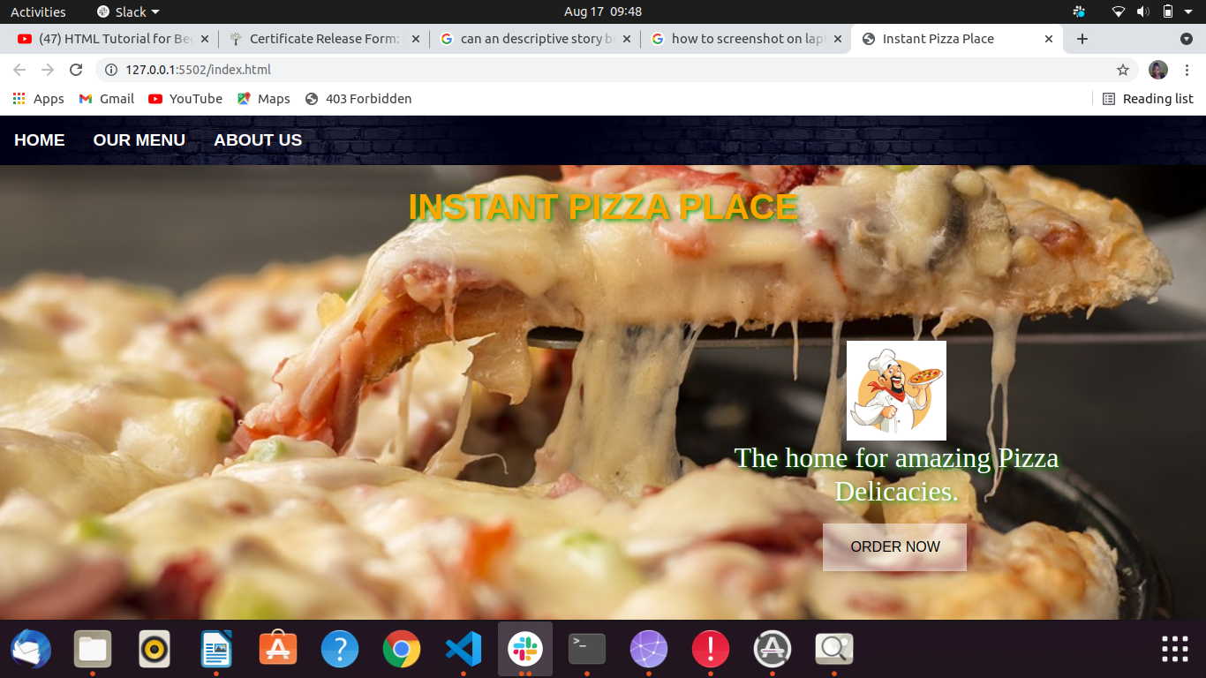

That is how my Pizza Website looks like . If you click the **ORDER NOW** button, you will be able to see how you can order your pizza. This was actually the last project we did during prep.

Moringa Prep was very interesting because we got to learn different languages.

* **HTML-** Hyper-Text Markup Language
* **CSS –** Cascading Style Sheet
* **BOOTSTRAP**
* **JAVASCRIPT**
* **J QUERY**

**HTML** helps us to develop the entire web-page by typing what is required in the web page.

**CSS**  helps us is styling or modifying the web page.

**BOOTSTRAP** is an advanced form of CSS.

**JAVASCRIPT** adds functionality to the web page.

**J QUERY** is used together with JavaScript . It acts as bootstrap in JavaScript.

We also studied about **GITHUB .** GitHub is an app where we store our projects and anyone can access it and see our various works. So to make it possible, one has to create a **Repository** . This is like a folder in git hub where your project will be stored. To enable Git hub to store your projects, you should always **commit** your work then push to your repository in Git hub.

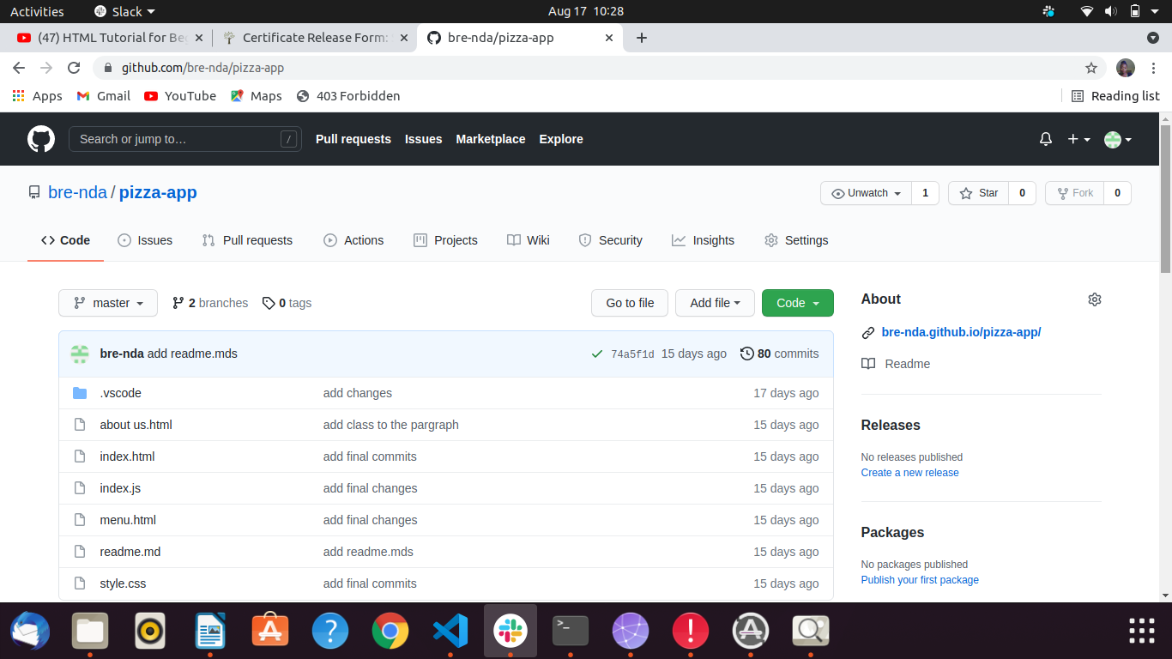

This is my Git Hub account on the Pizza Repository, where I stored the pizza project. There are many more repositories on the various projects I have worked on.

We also introduced to an app called **slack.** This is like Whats App but very different. In here we re able to communicate with our fellow classmates and our Technical Mentor.

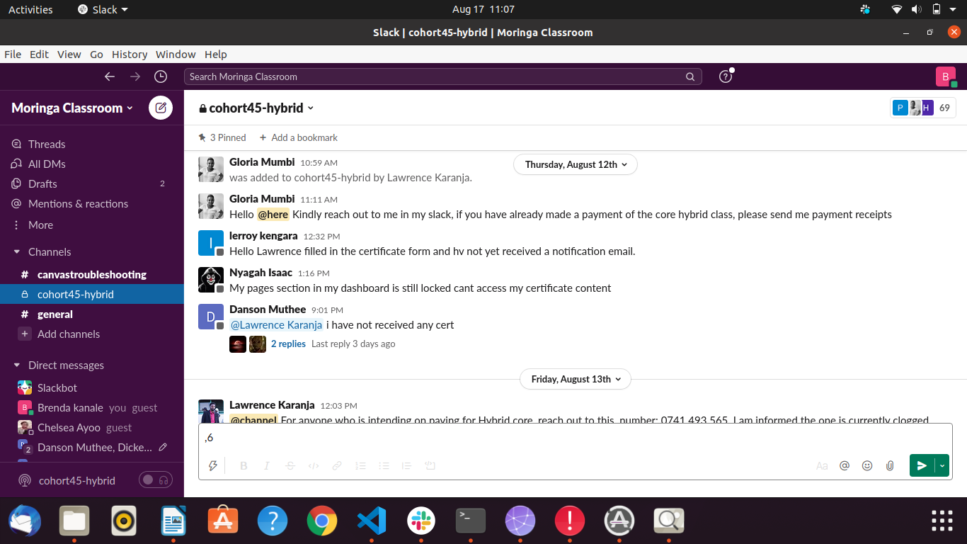

Our slack group.

Moringa Prep has actually taught us the basics of coding in software development. After our graduation from prep on 6th August, we are hoping to join core on 4th October now to face the real Coding/Software development. For me am hoping to study **Web Development.** In web development, the main language used is **Python.** I am choosing web development because I am comfortable with it . But in future I hope to also study **Mobile-app Development** so that I can fulfill my dream of becoming a **Full Stack Software Developer.**

When I join core I want to work extra hard because its not easy too. This is because we have already been introduced to a language called **ANGULAR**. So this language we are expected to know how to it works so that when we join core learning will be easier. I know I will do this.

God willing if I graduate from core, I hope to join **Andela Kenya .** Andela helps in nurturing the dream of software developers by giving them an opportunity to work with the company under the guidance of senior developers within a period of **4 years.** Later now after improving my skills , that is after leaving Andela, I hope to work for **Microsoft Companies** as a software developer .Being software developer, we are also taught to be flexible that is I can work remotely and physically too as a **freelancer** for **any company** across the world meaning even employment I go for it. Apart from employment, I can choose to go for **internship** at any company if I get one offering internships. Then after my internship, I can choose to freelance , even open up my own tech school , start my own business/company in the tech world or even go employment across the world.

As I conclude , I would to thank the Almighty for everything, our lady sponsor for helping us by paying our fees and rent .She is truly God-sent and may God bless her so much. My sister Lucy for believing in me in my journey towards becoming a **SOFTWARE DEVELOPER.**