Criterion B: Design

**NOTE:** Every input is verified and once the verification is complete, the user proceeds through the next step of the flowchart algorithm

Attendance Process Flowchart

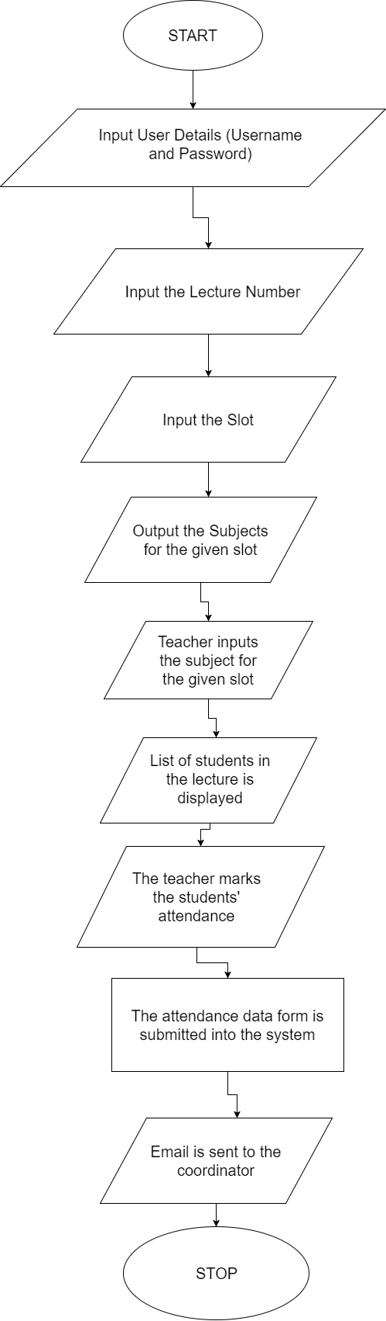

Slot Details Process Flowchart

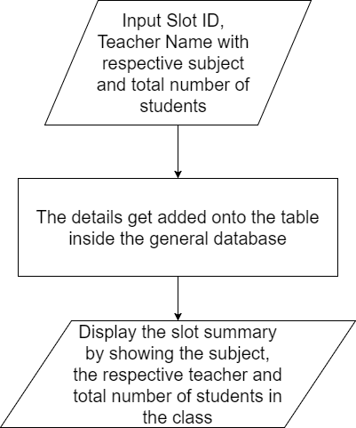

Subject Selection Process Flowchart

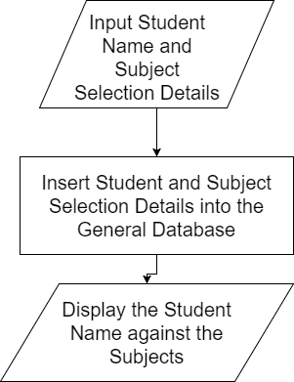

Teacher Details and Subject Adding Flowchart

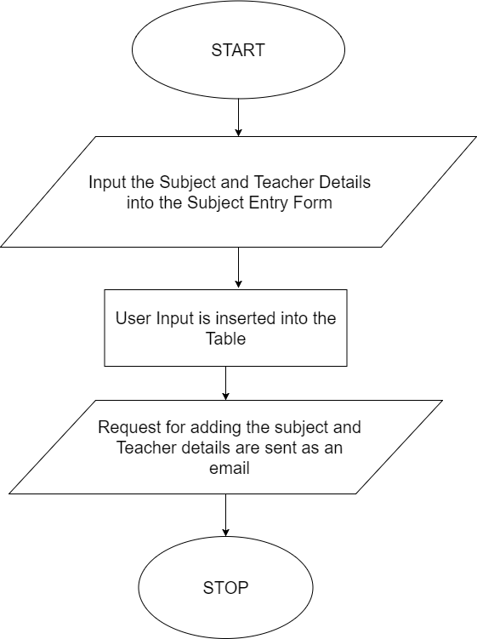

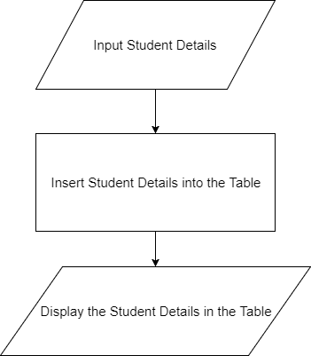Student Entry Details Process Flowchart

Entity Relationship Diagram

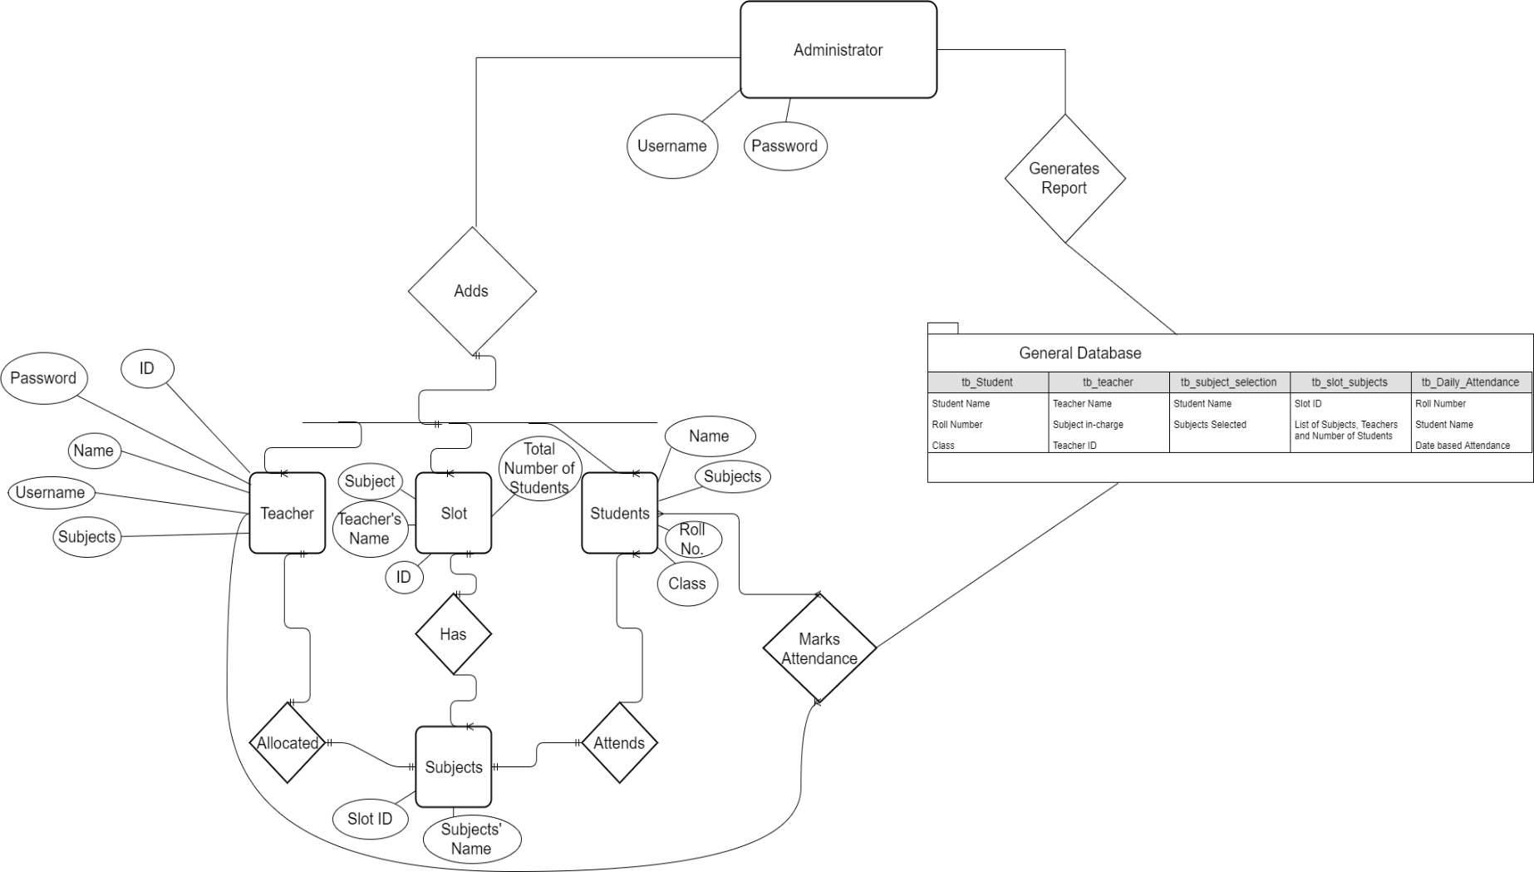

Databases:

General Database: This database contains all the information of students, teachers, subject choices, slots and the logins for the system.

Tables:

tb_Student - This table contains the Student details such as the name, roll number and class.

tb_teacher - This table contains the details of the teachers and the administrator (which is the coordinator). Details such as the name, username, password, ID and subject in-charge are stored in this table.

tb_subject_selection - This table contains the details of the subject choices of the students. The students’ names and subject choices are stored here.

tb_slot_subjects - This table contains details pertaining to the slots. Information such as Slot Numbers and their respective allotments of teachers and subjects are found here. The total number of students in a subject of a slot is also given.

tb_Daily_Attendance - This table contains the daily attendance table of students with respect to their lectures.

Graphical User Interface Diagrams for the Forms

**NOTE:** Upon pressing the “Enter” key all the data data forms input their data

Slot ID

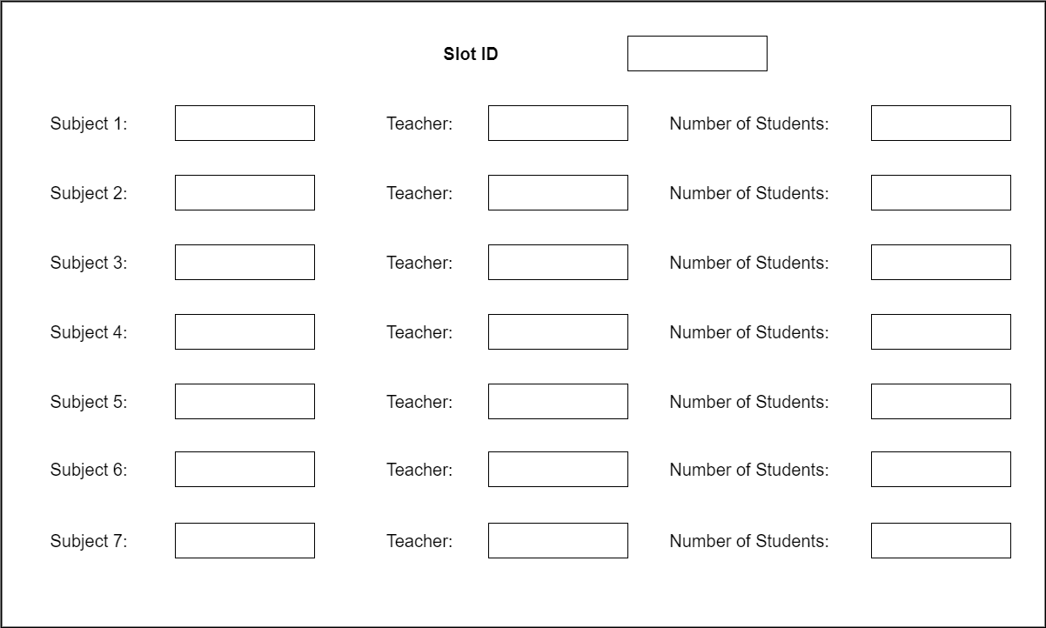

Student Entry Details Form

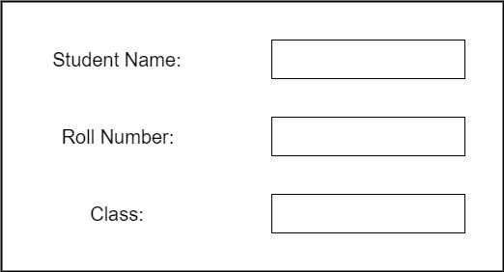

Teacher and Subject in-charge Details

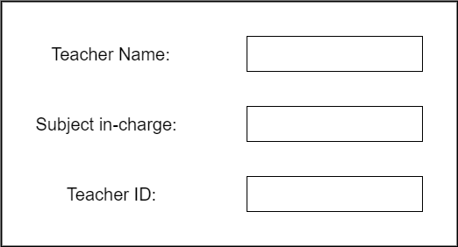

Subject Combination Details

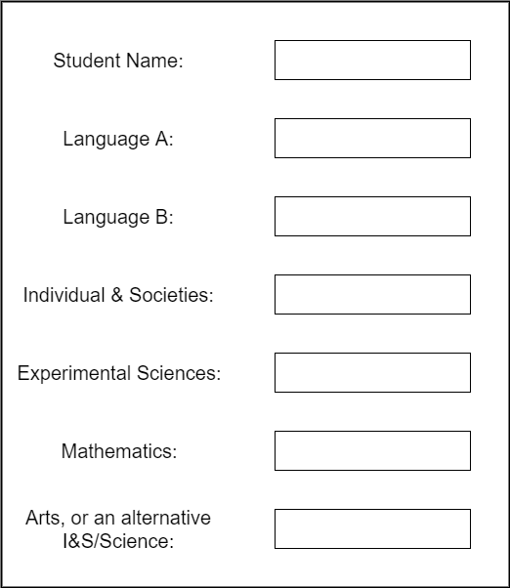

Test Plan

|  |  |
| --- | --- |
| **Action to be Tested** | **Test Method** |
| Check whether the username and password work | This can be tested by running the program and then checking for false positives and true negatives when entering into the system. |
| Check that the Attendance gets marked and a new table which is named as a date is made with lecture-by-lecture record of students’ presence and/or absence | After having ran the application, we can then check to see if there has been a new table added to the Attendance database. Then, we can also note whether there is data related to the students’ presence and/or absence during their lectures. |
| Check whether the administrator rights work by making changes to the overall tables and databases. | By checking whether deleted tables exist, or if modified tables have been accordingly changed, we can test whether the administrator rights work. |
| Check whether a report can be created for the Coordinator regarding information on that day’s absenteeism and presentism of students | By clicking the generate report feature, we can check data matches the presence/absence of the students’ attendance. |
| Check if Validation and Verification of User input takes place | This can be tested by seeing if any of the data forms generate an error message wherein the reason of invalid input or invalid details are cited by the application. |
| Check whether the data entry forms work | This can be checked by looking at the respective data entry form backend table in the General database. |
| Check whether mouse clicking of empty boxes to mark attendance are recorded as user input | By looking at the Attendance Database, we can check whether the mouse is recording the user input by ticking boxes by seeing if there are any anomalies in the data entered in the database. |