

TEST
DIPLOMA IN COMPUTER SCIENCE
COURSE | : | FUNDAMENTALS OF PROGRAMMING
COURSE CODE | : | SWC1043
DURATION | : | 1/6 - 3/6

INSTRUCTIONS TO CANDIDATES:

1. This question paper consists of TWO (2) PARTS: PART A: 20 Questions.
PART B: 3 Questions.
Answer ALL questions.

- Download and write your answer below each question in the question paper. Save your answer file as IDNo_SWC2123_Test_Answer email to amoskptm@gmail.com
OR
b. Write your answer in the answer sheets, snap/scan email to amoskptm@gmail.com

Resources of any kind are allowed such as module resources, external websites, other software applications but plagiarisms are strictly prohibited.

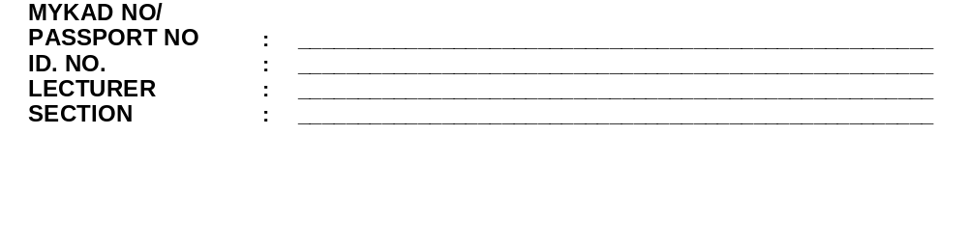

PART A: MULTIPLE CHOICE : Circle the correct answer
1. |  | What is software development life cycle (SDLC)?
 |  |  | A methodology in defining gathering requirement.
 |  |  | A process that defines the implementation of software project.
 |  |  | A process that in defining the testing of a budget software project.
 |  |  | A methodology that defines the steps in a software development project.
2. |  | Which of the following is NOT a valid identifier name?
 |  | A. | double
 |  | B. | monthly20
 |  | C. | monthly_sale
 |  | D. | weeklySALARY
3. |  | Every C++ statement must end with a ________.
 |  | A. | full stop (.)
 |  | B. | comma (,)
 |  | C. | colon (:)
 |  | D. | Semicolon (;)
4. |  | Which of the following is used for comments in C++?
 |  |  | / comment */
 |  |  | // comment
 |  |  | /* comment *
 |  |  | * comment *
5. |  | Which of the following declaration statements is correct in C++ for the value x?
 |  |  | x = 3;
 |  |  | Int x= 3;
 |  |  | const x =3;
 |  |  | int x= 3;
6. |  | Which of the following is NOT a data type?
 |  |  | real
 |  |  | char
 |  |  | double
 |  |  | float
7. |  | Identify the CORRECT C++ statement:
 |  |  | cout<< ″Beauty and health″<<endl;
 |  |  | cout<< ″Beauty and health″;<<endl;
 |  |  | cout<< ″Beauty and health;>>endl;
 |  |  | cout>> ″Beauty and health;>>endl;
8. |  | The two categories of function are ______and ______.
 |  | A. | user defined , statistical library function
 |  | B. | predefined function, user defined function
 |  | C. | predefined function, string library function
 |  | D | predefined function, mathematical library function
9. |  | What is the value of 77 % 2 + 3 * 4;
 |  | A. | 16
 |  | B. | 17
 |  | C. | 13
 |  | D. | 12
10. |  | Assume that we have the following variables declaration:  int num = 4, a = 25, b=4, c;  and the arithmetic assignment expression statement:  c = sqrt(a)+num+b;  The value of the variable c is:
 |  | A. | 13
 |  | B. | 15
 |  | C. | 14
 |  | D. | 29
11. |  | Consider the following if statement.  if (quantity> 50)  price = 30;  else if (quantity> 60)  price = 60;  else if (quantity> 80)  price = 90;  What is the value for the variable price if the value of quantity is 61?
 |  | A. | 30
 |  | B. | 60
 |  | C. | 90
 |  | D. | Undefined
12. |  | A user-defined function consists of three elements EXCEPT:
 |  | A. | Function prototype / declaration
 |  | B. | Function call
 |  | C. | Function debug
 |  | D. | Function definition
13 |  | In a flowchart, a calculation process is indicated by the symbol
 |  | A. | a diamond shape.
 |  | B. | a rectangle shape
 |  | C. | a rhombus shape
 |  | D. | a parallelogram shape
14. |  | What is the output of the following C++ program segment?
 |  |  | int total = 0;
 |  |  | int num = 5;
 |  |  | if (num > 0)
 |  |  | total = total + 10;
else
if (num > 8)
 |  |  | total = num + 15;
 |  |  | total = total + 10;
 |  |  | cout<<total;
 |  |  | 25
 |  |  | 20
 |  |  | 30
 |  |  | 40
15. |  | How many times will the following loop be executed?
 |  |  | int y=1;
 |  |  | do
 |  |  | {
 |  |  | cout<<"My grade is A\n";
 |  |  | y++;
 |  |  | } while (y<9);
 |  |  | 10
 |  |  | 9
 |  |  | 8
 |  |  | 7
16. |  | What is the output of the following program fragment?  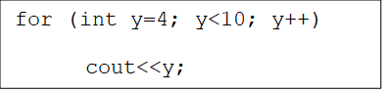
 |  | A. | 9
 |  | B. | 10
 |  | C. | 456789
 |  | D. | 45678910
17. |  | Choose the correct way to declare an array:
 |  |  | double marks[5];
 |  |  | double marks;
 |  |  | double marks{5};
 |  |  | double array marks[5];
18. |  | What is the value in index element 2 for the array  booklist [7]={11,12,13,14,15,16,17};
 |  |  | 17
 |  |  | 11
 |  |  | 12
 |  |  | 13
19. |  | Which of the following are types of errors defined in programming?  - Logic errors  - Run-time errors  - Sentataic errors  - Sistematic errors
 |  | A. | I, IV
 |  | B. | I, II
 |  | C. | III, IV
 |  | D | All of the above
20. |  | 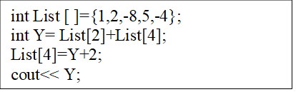
 |  | What is the value of Y?
 |  | A. | 11
 |  | B. | -10
 |  | C. | 3
 |  | D. | -12

(20 marks)

PART B: STRUCTURED
QUESTION 1
a. | Given the formula to calculate the volume of a cylinder as shown in Figure 1 below. Prompt the user to enter the radius and height separately for the cylinder and the program will display the volume of the cylinder.  volume = πr²h  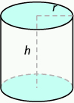  Figure 1  Write a pseudocode and flow chart for the above given problem statement.
 | (10 marks)
 | Answer:
b. | Given below is a sample of a C++ program. Draw a flow chart of the program.
#include <iostream>
using namespace std;

int main()
{
double gpa;

cout << "Enter your GPA results: ";
cin >> gpa;

if (gpa >= 3.5 )
cout<<"Dean's List Award!!"<<endl;

cout << "Thank you."<<endl;
}
 | (4 marks)
 | Answer:
c. What are the values of x after the following statements are executed?

^{i}. m = 8 + 6 / 4 * 4 / 4 + 3 * 2/ 2 – 1; _________________

ii. k = 25 % 5 + 12 * 4 % 5; _________________

iii. s= 45 + 46 % 5 * ( 12 * 3 % 2 ); _________________

( 6 marks)

(Total:20 marks)

QUESTION 2
a. | Determine whether the variable name below is VALID or INVALID: and state the reason for your answers.
 | (6 marks)
 |  | Quantity%
 |  | Answer
 |  | 20book
 | A | Answer:
 |  | Quantity2
 |  | Answer:
b. | Write a C++ code for the following statement.
 | (4 marks)
 | i. | Declare a constant named PI with value 3.142
 |  | Answer:
 | ii. | Calculate the sum of two numbers, num1 and num2. Then assign to variable total.
 |  | Answer:
c. | Assuming d = 6, e = 7, f = 8 and g = 6; Evaluate the following logical expression and show the working steps.
 | (6 marks)
 | i. | (f != 5) || (( e >= 9) || ( g <= 10))
 |  | Answer:
 | ii. | d % e > f && f % e != d
 |  | Answer:
 | iii. | 3 < f || (d == g - 2)
 |  | Answer:
d. | Write a program segment that will display all the marks between 70 and 99 using for loop.
 | Answer:
 | (4 marks)
 | (Total:20 marks)
QUESTION 3
a. | For each of the following function description:
 |  | (4 marks)
 |  | Write the function prototype;
 | i | Function Maximum() that takes two integers, x and y, returns an integer.
 |  | Answer:
 | ii. | Function total()that takes three double arguments a, b and c, returns double value.
 |  | Answer:
 |  | Write the function header;
 | i. | Function volume() that takes three integers, a, b and c, and does not return any value.
 |  | Answer:
 | ii. | Function calculate() that takes two doubles, u and v, and returns double.
 |  | Answer:
b. | Write a function definition called SMALLEST(). This function takes two integer parameters M and N, and returns the largest number of the two numbers.  (5 marks)
 | Answer:
c. | Determine the value of the variable int x,y,z of the following arithmetic expressions: Show your working.
 | (8 marks)
 | i. | x=ceil(7.8)*2;
 |  | Answer:
 | ii. | y=pow(3.0,2)/3;
 |  | Answer:
 | iii. | z=sqrt(pow(8,2))%3 ;
 |  | Answer:
 | iv. | int x = 15;  double result;  result = floor(x);  cout << "Floor of " << x << " = " << result << endl;
 |  | Answer:
d. | Convert the following mathematic expressions into C++ statement.
 |  | ( 3 marks)
 | i. | 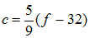
 | Answer:
 | ii. | k =
 |  | Answer:
 |  | ( Total:20 marks)
 |  | (TOTAL:80 MARKS)

GOOD LUCK!

END QUESTION PAPER

