**Family bereavement due to Covid-19 and its consequences for society: a new approach combining macro-level demographic estimations and micro-level analysis**

**Applicants**

Dr., **Diego Alburez-Gutierrez**, Postdoctoral Research Scientist, Max Planck Institute for Demographic Research (Lab of Digital and Computational Demography)

Prof. Dr., **Emilio Zagheni**, Director, Max Planck Institute for Demographic Research

**Keywords:** bereavement, family support, excess mortality, mental health, methodology

**In a Nutshell**

Much attention has been given to Covid-19 excess mortality rates, but little is known about how the pandemic will increase the exposure to the death of relatives (parents, siblings, etc.) and how this will affect people around the world. This project will produce the first estimates of family bereavement due to Covid-19 and quantify its consequence for the well-being of individuals. We do this by combining novel methods from mathematical and computational demography with sociological analysis on mental health outcomes using micro-level data.

**Project Description**

This project will combine existing and future data on Covid-19 excess mortality with pioneering demographic methods to estimate the indirect consequences of Covid-19 for individuals. We will quantify the number of people who have suffered or will suffer the death of a relative because of the disease (parent, grandparent, great-grandparent, uncle, cousin, nephew, sibling, or child). This information can help officials target the segments of the population at a highest risk of bereavement, minimizing the indirect public health consequences of the pandemic. Our project will use the latest available data to estimate the impact of bereavement on the well-being of people in different countries by age and sex.

**Objectives**

1. Produce the first set of international estimates of family bereavement from Covid-19 using a novel methodology and existing data on Covid-19 excess mortality
2. Identify which demographic groups are at the highest risk of losing a relative to Covid-19 in different countries and how this varies by type of relative
3. Building on Obj 2, explore the effect of Covid-19 family bereavement on the mental health of grieving relatives and how this differs from bereavement from other causes

**Innovative aspects of the project**

We know little about the indirect health effects of the current pandemic and nothing about family bereavement in the context of Covid-19. Data initiatives have focused on tracking excess mortality, number of cases, testing coverage, and government responses to the crisis. No attention has been given to the extent to which the pandemic will result in millions of individuals experiencing the death of a relative. This will be the first attempt to develop a scientific method to estimate family bereavement attributable to Covid-19. Our interdisciplinary approach combines demographic methods, data science, and sociological theory to improve our understanding of the indirect effects of mortality crises. The proposed methodology can also be used to estimate levels of bereavement in other mortality crises worldwide, such as natural disasters, famines, or wars (Alburez-Gutierrez 2019).

**Approach and methodology**

As a first step, we will build on previous work (Alburez-Gutierrez, Kolk, and Zagheni 2019; Nepomuceno et al. Forthcoming) to develop a methodology to estimate the probability of experiencing family bereavement given a set of age-specific Covid-19 mortality rates. We will obtain the population-level burden of family bereavement and the age distribution of the bereaved population using models that translate changes in mortality to prevalence of bereavement (Fig 1). Our method will be implemented in the R language for statistical programming. We will use demographic microsimulations to model family bereavement for complex kinship ties, such as cousins or in-laws, by adapting a series of already existing microsimulations from a previous project (Mason and Zagheni 2014). Our models will initially be calibrated using data from 13 countries for which monthly data on Covid-19 death rates is already available.[1] We will extend our analysis to other countries once reliable data on Covid-19 excess mortality becomes available. The current project will produce a range of estimates to reflect the uncertainty inherent in the Covid-19 mortality statistics. We expect the accuracy of our models to improve as more quality data becomes available.

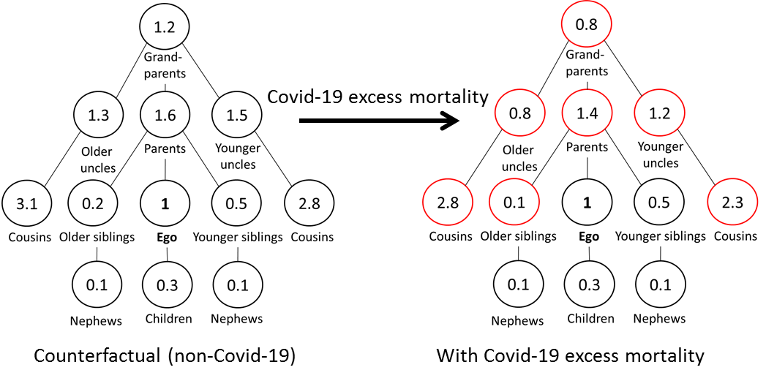

Fig 1. Expected number of living relatives for a man aged 45 (‘Ego’) in a hypothetical population without Covid-19 mortality (left, counterfactual scenario) and with Covid-19 mortality (right, observed values). The sum of the difference between the values in each diagram is the bereavement attributable to Covid-19. In our example, this is .4+.5+.2+.3+.3+.1+.5 = 2.3 ‘extra’ deaths that Ego will experience due to the pandemic. Later on, we will obtain population-level estimates of bereavement by including weights in our estimation to represent the real size and structure of different populations.

We will assess the impact of Covid-19 family bereavement on well-being using standard quantitative methodologies. We expect micro-level survey data on the health outcomes of the pandemic to become available soon (e.g. in well-established surveys such as SHARE, GGS, and the British Cohort Study). The PI is an associated researcher at Stockholm University, which has access to register data that could be used for this, once it is made available. If for any reason these do not become available, as a mitigation strategy, colleagues at the MPIDR managing the “Health Behavior Survey” will provide access to their valuable data on Covid-19 collected from online surveys.[2]

**Work plan**

Stage 1. Methodological development and empirical analysis

1. Develop methodology to estimate excess bereavement due to Covid-19
2. Estimate levels of bereavement for the 13 countries in the “Short-term Mortality Fluctuations” database and for other countries as quality data becomes available
3. Conduct statistical analysis to link the experience of bereavement to mental health outcomes using appropriate micro-level data

Stage 2. Science communication

1. Write academic papers to present the methodology and substantive results
2. Create digital dashboard for sharing datasets and visualizations with stakeholders

**Expected Main Results and Achievements**

1. The first dataset of excess bereavement from Covid-19 by age and sex of the grieving population (in thousands or millions of bereaved individuals by country)
2. A flexible methodology to estimate excess bereavement caused by Covid-19 that can be used to analyze any past or future crisis for which mortality rates are known
3. Two publications in high-impact journals describing the methodology and main results
4. An online platform for scientists and policy makers to explore and download the data (see this app from the Principal Investigator: <https://research-app.shinyapps.io/child_death_paa/>) and a policy brief to be disseminated via Population Europe (<https://population-europe.eu/policy-briefs>)

**Relevance of the topic for society in light of the Corona Pandemic**

Death and bereavement have come to the forefront of public debate as the world grapples with the global pandemic of Covid-19. The infectious disease has already caused the death of hundreds of thousands of mainly elderly people. Each death is meaningful in itself, but it also represents the loss of a parent, grandparent, great-grandparent, aunt, uncle, cousin, or child. Studies in sociology and public health have consistently shown the negative and long-term consequences of bereavement on mental, physical, and emotional health. An increased exposure to mortality poses a major societal challenge in the median and long term (Raker, Zacher, and Lowe 2020). Bereavement also matters because relatives are crucial providers of social and financial support, the loss of which affects the individuals left behind. However, there are currently no international estimates of the number of people who will lose a relative to the Covid-19 disease, in spite of the recognized importance of the problem.

Information on the expected number of bereaved relatives can help policy makers develop appropriate plans for supporting the grieving relatives. Data on the age gradient of bereavement is essential for targeting these programs more effectively. Orphaned children may need a different type of support than widowers or elderly parents who lose a middle-aged child. We expect levels of bereavement to vary by geographic region, reflecting population structure and the spread of the disease. For many people living in the Global North this will be their first close encounter with death, as historically low mortality rates have implied a reduction in the exposure to mortality at all ages in high-income countries (Alburez-Gutierrez, Kolk, and Zagheni 2019). For people in the Global South, it will add to an already high burden of bereavement (Smith-Greenaway and Trinitapoli 2020; Zagheni 2011).

**Relevance of the topic for Science**

Methodologically, our project is the first to operationalize a set of demographic equations to estimate the expected number of surviving kin and the number of kin expected to die in the context of dramatic changes in mortality. Our novel and flexible methodology can be used to understand the prevalence of family bereavement in past and future global mortality crises worldwide, including epidemics, famines, wars, etc., using simple mortality rates as input.

Empirically, we will produce the first set of estimates of excess bereavement during a global mortality crises. The question of kin survival is central to demographic theory, and historical demographers draw liberally on assumptions about kin availability and individual's exposure to bereavement to explain human behavior, especially in the context of mortality crises but these assumptions are often untested given data scarcity. This project will produce reliable quantitative estimates about the exposure to mortality in the context of a current pandemic.

For theory, this study will help elucidate the mechanisms linking bereavement and mental health. Previous studies have documented a negative relationship between the two (Raker, Zacher, and Lowe 2020), but we know nothing about how generalized increases in the frequency of death will affect the well-being of grieving relatives during a global pandemic.

**Details on collaboration**

Diego Alburez-Gutierrez will lead the project and contribute to the methodological and empirical work and to writing the final papers. Emilio Zagheni will provide methodological supervision and assistance for project management. Ivan Williams (Universidad de Buenos Aires, Argentina) will lead the formal methodological development as a research assistant. A PhD student supervised by the Alburez-Gutierrez will lead the empirical analyses. Our team includes the foremost experts in the intersection of the formal demography of kinship and excess mortality estimates. Our proven track record of individual and collaborative work on the subject (Alburez-Gutierrez 2019; Alburez-Gutierrez, Kolk, and Zagheni 2019; Zagheni 2011) makes us the ideal candidates to estimate family bereavement due to Covid-19.

**References**

Alburez-Gutierrez, D. (2019). Blood is thicker than bloodshed: A genealogical approach to reconstruct populations after armed conflicts. *Demographic Research* 40:627–656.

Alburez-Gutierrez, D., Kolk, M., and Zagheni, E. (2019). *Women’s Experience of Child Death over the Life Course: A Global Demographic Perspective*. SocArXiv. doi:10.31235/osf.io/s69fz.

Mason, C. and Zagheni, E. (2014). The sandwich generation: demographic determinants of global trends. Paper presented at Annual Meeting of the Population Association of America-PAA, Washington, D.C., 2014.

Nepomuceno, M., Acosta, E., Alburez-Gutierrez, D., Aburto, J.M., Gagnon, A., and Turra, C. (Forthcoming). Besides population age-structure, health and other demographic factors can contribute to understanding the COVID-19 burden across the globe. *Proceedings of the National Academy of Sciences*(Accepted for publication).

Raker, E.J., Zacher, M., and Lowe, S.R. (2020). Lessons from Hurricane Katrina for predicting the indirect health consequences of the COVID-19 pandemic. *Proceedings of the National Academy of Sciences*:202006706.

Smith-Greenaway, E. and Trinitapoli, J. (2020). Maternal cumulative prevalence measures of child mortality show heavy burden in sub-Saharan Africa. *Proceedings of the National Academy of Sciences*:201907343.

Zagheni, E. (2011). The Impact of the HIV/AIDS Epidemic on Kinship Resources for Orphans in Zimbabwe. *Population and Development Review* 37(4):761–783.

1. AUT, BEL, BGR, CZE, DNK, ESP, FIN, UK, ISL, NLD, NOR, PRT, SWE, USA ([www.mortality.org](http://www.mortality.org))
2. <https://www.medrxiv.org/content/10.1101/2020.05.15.20102657v1>