**Global Inequality in Maternal Experiences of Child Mortality**

**Abstract**

As part of broader patterns of demographic convergence, fertility and child mortality rates have declined worldwide over the past several decades. Demographic convergence is intrinsically tied to the increasing similarity in women’s reproductive experiences, yet persistent differences in fertility and mortality across the globe yield inequalities in key aspects of motherhood, including one of the most life altering experiences: having a child die. Maternal bereavement is known to have severe and long-lasting health, relational, and social consequences, thus making it relevant to global inequality; however, we lack research on global patterns of maternal bereavement. In this research brief, we present estimates of the cumulative prevalence of bereaved mothers for 168 countries. We present three metrics that capture the maternal cumulative prevalence of infant mortality, under-five mortality, and offspring mortality. We generate these estimates using a direct estimation approach from nationally representative surveys, and an indirect approach based on kinship models. The study demonstrates an exceptionally high prevalence of bereaved mothers in the global south: in several African and Asian countries where upwards of one-third to one-half of living mothers have lost a child. and startling inequality in the burden of maternal bereavement across countries. There is an exceptionally high burden in several African and Asian countries where upwards of one-third to one-half of living mothers have lost a child. Although it is well known that infants and children face strikingly different risk of mortality depending on where they are born, this study shows that the differential risk of child loss that mothers face is even far greater, and distinctly patterned due to confluence of mortality and fertility patterns.

Global convergence in demographic trends has occurred at a remarkable pass over the second half of the twentieth century: across the globe, mortality and fertility patterns are increasingly similar (Wilson, 2001). This demographic convergence is part and parcel of the increasing similarity in women’s reproductive experiences worldwide, including in the number of children they bear and those individual children’s risk of premature death.

Even with global demographic convergence, stubborn differences in mortality and fertility patterns persist and produce global inequalities in maternal experiences that deserve attention. One maternal experience that has not been well-studied is arguably among the most dreaded by mothers: the death of a child. Although the level of infant and under-five mortality intimately impacts parents’ lives, its population prevalence has only recently been studied from a parental vantage point. A recent study of sub-Saharan Africa shows that the confluence of high fertility and mortality results in as many as one-third of younger mothers and one-half of mothers age 45-49 years old having cumulatively experienced at least one child die in several countries (Smith-Greenaway & Trinitapoli, 2020). The extent to which these high levels of child loss observed in select African countries are replicated in other countries in the global south, and the extent to which they differ from mothers’ experiences in high-income contexts, remains unknown.

Documenting global inequality in maternal bereavement can offer a window into how demographic realities intimately affect the lives and wellbeing of mothers. Growing research demonstrates that experiencing a child die not only influences women’s future childbearing (Nobles et al., 2015), but also her mental health (Rogers et al., 2008; Song et al., 2010) and physical health and mortality (Li et al., 2003; Rostila et al., 2012). Because of the intense grief resulting from child death, many of the adverse effects persist for years—even decades (cite). Studying global inequality in the prevalence of maternal bereavement will reveal how inequality in infant, child, and adolescent mortality conditions pose risks for the wellbeing of the surviving adult population.

In this article we offer the first, global analysis of the prevalence of bereaved mothers by leveraging data collected between 2010 and 2018 from 168 countries. We generate three indicators of the cumulative prevalence of mothers who have lost at least one infant, under-five year old, or any age child using both survey data and, where data are unavailable, an indirect approach. We label these indicators as follows: the maternal cumulative prevalence of infant mortality (mIM), under-five mortality (mU5M), and offspring mortality (mOM) (Smith-Greenaway & Trinitapoli, 2020). We calculate these three measures for two key groups of mothers: those in the peak of their reproductive years (ages 20-44), as well as those who have recently completed, or are soon to complete, childbearing (ages 45-49). The study findings offer a new perspective of global inequality and highlight the value of studying persist disparities in maternal experiences even amid global demographic convergence.

**Approach**

We generate the key study indicators directly, using data from nationally representative surveys that feature women’s reproductive histories and, in countries where such data are unavailable, we use a kin-cohort approach to indirectly estimate the prevalence of bereaved mothers. Beginning with our direct estimation strategy, we make use of three data sources. In 56 countries, we leverage Demographic and Health Surveys (DHS) data—the most widely used dataset for global studies of child mortality. DHS data come from nationally representative household surveys that collect detailed information from various household members, including women ages 15-49. The public use surveys, funded by the United States Agency for International Development (USAID) are available at <https://dhsprogram.com/>. In 32 countries, where recent DHS surveys have not been administered, we make use of Multiple Indicator Cluster Surveys (MICS). MICS data are publicly available, and come from nationally representative household surveys funded by UNICEF (data are available at <https://mics.unicef.org/>). Finally, in the United States, we make use of the National Survey of Family Growth (NSFG). NSFG collects reproductive history calendars from women ages 15-44 years old. The public use surveys are available at <https://www.cdc.gov/nchs/nsfg/index.htm>.

In each survey, to calculate the mIM, mU5M, and mOM, we first restrict samples to women who have had at least one live birth, given these are the women at risk of child loss. Using information from women’s reproductive histories, including the vital status of each child and, for those deceased, the age at death, we calculate the mIM, mU5M, and mOM. Specifically, for the mIM, we tabulate the prevalence of mothers who have experienced the death of at least one infant. We sum the number of mothers who had a child die before age 1 among those who ever had a live birth and express this per 1,000 mothers. Next, to estimate the mU5M, we do the same for mothers who have ever had a child die before reaching age 5. Note that for select countries wherein we rely on MICS data, we lack direct survey estimates of the mIM and mU5M because information on the age of the child at the time of death was not included.

Finally, the mOM indexes the prevalence of mothers who have experienced a child death, regardless of the child’s age at the time of death. We calculate the mOM for 45- to 49-year-old mothers only, given that this age group of women are more likely to have children over age 5. See Appendix A provides for a list of countries, data sources, survey years, and analytic sample sizes.

Because recent, reproductive history survey are not available in all countries, we employ an indirect approach to calculate the mIM, mU5M, and mOM in the 79 remaining countries, and demonstrate the accuracy of this approach in countries where survey data are available. This kin-cohort method is an extension to the Goodman-Keyfitz-Pullum kinship equations (GKP equations)(Keyfitz, 1985). To estimate the cumulative number of offspring deaths experienced by a woman born in cohort *c* surviving to age *a* as follows:

(1)

where for infant deaths, for child deaths and 00 for all-age offspring deaths. We restrict the female reproductive age to , so that for all cases.

To determine the prevalence of bereaved women in a population, we start by considering the age-specific probability that an average woman will experience the death of a child:

(2)

where is the hazard rate of experiencing the death of a child younger than *k* (Wachter, 2014). We create a life table (Preston et al., 2001) with a unit radix where is the probability of losing a child. We define as the fraction of women aged *a* in cohort *c* who ever experienced the death of a child younger than *k*.

Next, we account for the mortality of women with the help of the fraction of women that survived up to age *a* after the start of reproductive age in each birth cohort (where ). We approximate this using country-specific period life tables from the United Nations World Population Prospects (UN WPP).[1] The proportion of women (per 1,000 mothers) who have ever lost one or more children younger than *k* is:

. (3)

To tailor the estimate to reflect an equivalent measure for mothers, we rescale our estimates using a similar life table approach. We consider fertility as a “hazard rate” to approximate the number of women that “survive” without having children (i.e. remain childless) after experiencing a set of age-specific fertility rates. The fraction of women who have ever been mothers is approximated as 1 minus the fraction of childless women. We can now define, for a given cohort, the proportion of mothers (per 1,000 mothers) who have ever lost one or more children younger than *k*:

. (4)

We generate period estimates of the prevalence of bereaved mothers, comparable to the direct estimates derived from surveys. Supplementary analyses wherein we indirectly generated the mIM, mU5M, and mOM for the same survey years in which we have direct estimates for each country shows a strong correlation between estimates (see Appendix B). The indirect approach tends to yield higher estimates than the direct estimates. This appears driven by clustering of deaths in high-risk families in some countries—a pattern the indirect approach does not correct for. That is, in some populations, child deaths are concentrated among a disadvantaged group of women, thus child deaths are not evenly dispersed across mothers as this approach assumes. Of course, it is also possible that where disparate, the indirect estimates are more accurate than the direct ones due to an underestimation of child loss in the survey data. Even though the survey estimates are derived from nationally representative samples, hard to reach, especially disadvantaged populations are often underrepresented.

**Results**

Figure 1 depicts the mIM to demonstrate the prevalence of mothers who have experienced an infant die. The top panel depicts the mIM values for younger mothers ages 20-44, whereas the bottom panel presents mIM values for older mothers ages 45-49 years old. In several countries throughout Europe, and select countries in Asia, fewer than 1% (i.e., 10 per 1,000) of mothers 20-44 and 2% of mothers 45-49 (i.e., 20 per 1,000 mothers ages 45-49) have ever lost an infant. Yet, in more than half of the 168 countries, over 45 per 1,000 young mothers and 160 per 1,000 older mothers have experienced an infant die. In several countries throughout the Middle East and Northern and sub-Saharan Africa, more than 150 per 1,000 younger mothers and over 300 per 1,000 older mothers have ever lost an infant. The significantly higher levels of child loss among older mothers in the Middle East and Africa relative to younger mothers owes to the swift improvements in mortality conditions in recent years. Even so, the degree to which young mothers have experienced infant loss is striking. Angola has the highest mIM value for reproductive age mothers (336 per 1,000).

These findings demonstrate not only the exceptionally high prevalence of bereaved mothers across Asia and Africa, but also the tremendous inequality in surviving mothers’ experience of child loss across countries. These inequalities are significantly larger than comparable inequality in infant mortality rates across countries, which are also shown in the Appendix A. For instance, the infant mortality rate is 20 times higher in Angola than it is in Hong Kong, with 57.8 infants dying before their first birthday in the former versus 1.4 in the latter (see Appendix A). However, as the mIM demonstrate, the mIM in Angola is *124 times* higher than it is in Hong Kong: whereas 2 out of 1,000 young mothers in Hong Kong have lost an infant, similarly aged mothers in Angola are 124 times more likely to have lost an infant than those in Hong Kong. These estimates confirm that the mIM offers a new sense of the vast inequality in maternal experiences that women in these populations have endured.

The estimates, of course, pertain only to the death of children before age one, offering no indication of the prevalence by which mothers have experienced the death of older children. Thus, Figure 2 depicts the mU5M to demonstrate the prevalence of mothers who have experienced a young child die. The top panel depicts the mU5M values for younger mothers ages 20-44 and the bottom panel presents the mU5M values for older mothers ages 45-49 years old. In several countries across Europe and Asia, fewer than 10 per 1,000 young mothers had experienced a child die before age five, whereas upwards of 35 per 1,000 older mothers had. In as many as 15 countries across the Middle East and West and Central Africa, more than 300 per 1,000 reproductive age mothers had lost a child, whereas more than half of all older mothers had in most of these countries.

Like the mIM, these estimates reveal even larger inequalities in mothers’ experiences of under-five mortality than current under-five mortality rates. For example, a child born in Niger is roughly 41 times more likely to die before their fifth birthday than a child born in Hong Kong (see Appendix A). Yet, the difference in mothers’ accumulated experiences of loss is far greater: a mother in Niger is roughly *157 times* more likely to have experienced a child die before age five than a mother in Hong Kong.

While there is considerable demographic interest in the experience of infant and under-five mortality across the globe, the focus on maternal losses of children in these age groups overlooks the extent to which the same age groups of mothers experience the death of older children, adolescents, and even young adults. To offer a more comprehensive overview of the burden of child loss regardless of the child’s age at the time of death, Figure 3 depicts the burden of all offspring mortality (mOM) among mothers 45-49 years old. Unsurprisingly, the mOM indicators are globally patterned very similarly to both the mIM and mU5M: countries where a high prevalence of mothers have lost an infant or under-five year old child are those with overall high levels of maternal bereavement. Yet, what is striking is how many more mothers have ever lost a child, relative to only those bereaved by the death of an infant or under-five year old. In as many as 37 countries across the global south more than 400 per 1,000 mothers—40%—have ever experienced a child die and in as many 22 countries, more than one half of mothers have experienced a child die. Yet, in as many as 48 countries across Europe, North America, and parts of Asia, fewer than 50 per 1,000—that is, less than 5% of mothers—have ever lost a child, reflecting the stark inequality in maternal experiences that mortality and fertility conditions generate.

**Discussion**

Demographers have long studied macro-level mortality trends, noting patterns of global demographic convergence; however, more recently, studies have begun to track mortality conditions from the perspective of the surviving population. That is, expanding beyond an individual-risk framework, demographers have increasingly pursued empirical approaches that summarize macro-level mortality conditions explicitly from the vantage point of the surviving population—namely, family members (Fletcher et al., 2013; Smith-Greenaway & Trinitapoli, 2020; Thomas, 2020; Umberson et al., 2017; Verdery & Margolis, 2017). In line with these efforts, in this study, we document global inequalities in the burden of child mortality as experienced by mothers. We demonstrate that such an approach better reveals how recent and persistent differences in mortality and fertility conditions help to sustain enormous disparities in the burden of child loss. Even amid demographic convergence, mothers in select Middle Eastern and sub-Saharan African countries are more than *100 times* more likely to have experienced a child die than mothers in parts of Asia and Europe.

These results also highlight the need for increasing research on the implications of child loss for mothers in the settings where it remains a common element of motherhood. The world regions where maternal bereavement is concentrated are the ones where few empirical studies have investigated the long-lasting consequences of it. There is a pressing need for further studies on the consequences of child loss, and how global inequality in its frequency helps to fuel broader disparities in adult wellbeing.

**References**

Fletcher, J., Mailick, M., Song, J., & Wolfe, B. (2013). A sibling death in the family: Common and consequential. *Demography*, *50*(3), 803–826.

Graham, W., Brass, W., & Snow, R. W. (1989). Estimating maternal mortality: The sisterhood method. *Studies in Family Planning*, *20*(3), 125–135.

Hill, K. (1977). Estimating adult mortality levels from information on widowhood. *Population Studies*, *31*(1), 75–84.

Hill, K., Thomas, K., AbouZahr, C., Walker, N., Say, L., Inoue, M., Suzuki, E., & Group, M. M. W. (2007). Estimates of maternal mortality worldwide between 1990 and 2005: An assessment of available data. *The Lancet*, *370*(9595), 1311–1319.

Keyfitz, N. (1985). *Applied mathematical demography*. Springer. http://public.eblib.com/choice/publicfullrecord.aspx?p=3084208

Li, J., Precht, D. H., Mortensen, P. B., & Olsen, J. (2003). Mortality in parents after death of a child in Denmark: A nationwide follow-up study. *The Lancet*, *361*(9355), 363–367.

Nobles, J., Frankenberg, E., & Thomas, D. (2015). The effects of mortality on fertility: Population dynamics after a natural disaster. *Demography*, *52*(1), 15–38.

Obermeyer, Z., Rajaratnam, J. K., Park, C. H., Gakidou, E., Hogan, M. C., Lopez, A. D., & Murray, C. J. (2010). Measuring adult mortality using sibling survival: A new analytical method and new results for 44 countries, 1974–2006. *PLoS Medicine*, *7*(4).

Preston, S. H., Heuveline, P., & Guillot, M. (2001). *Demography: Measuring and modeling population processes*. Blackwell Publishers.

Rogers, C. H., Floyd, F. J., Seltzer, M. M., Greenberg, J., & Hong, J. (2008). Long-term effects of the death of a child on parents’ adjustment in midlife. *Journal of Family Psychology*, *22*(2), 203.

Rostila, M., Saarela, J., & Kawachi, I. (2012). The forgotten griever: A nationwide follow-up study of mortality subsequent to the death of a sibling. *American Journal of Epidemiology*, *176*(4), 338–346.

Smith-Greenaway, E., & Trinitapoli, J. (2020). Maternal cumulative prevalence measures of child mortality show heavy burden in sub-Saharan Africa. *Proceedings of the National Academy of Sciences*, *117*(8), 4027–4033.

Song, J., Floyd, F. J., Seltzer, M. M., Greenberg, J. S., & Hong, J. (2010). Long‐Term Effects of Child Death on Parents’ Health‐Related Quality of Life: A Dyadic Analysis. *Family Relations*, *59*(3), 269–282.

Thomas, K. J. (2020). Child deaths in the past, their consequences in the present, and mortality conditions in sub-Saharan Africa. *Proceedings of the National Academy of Sciences*, *117*(9), 4453–4455.

Umberson, D., Olson, J. S., Crosnoe, R., Liu, H., Pudrovska, T., & Donnelly, R. (2017). Death of family members as an overlooked source of racial disadvantage in the United States. *Proceedings of the National Academy of Sciences*, *114*(5), 915–920.

Verdery, A. M., & Margolis, R. (2017). Projections of white and black older adults without living kin in the United States, 2015 to 2060. *Proceedings of the National Academy of Sciences*, *114*(42), 11109–11114.

Wachter, K. W. (2014). *Essential demographic methods*. Harvard Univ. Press.

Wilson, C. (2001). On the scale of global demographic convergence 1950–2000. *Population and Development Review*, *27*(1), 155–171.

Figure 1. Maternal Infant Mortality (mIM) Indicators for mothers 20-44-years-old (top panel) and ages 45-49-years-old (bottom panel)

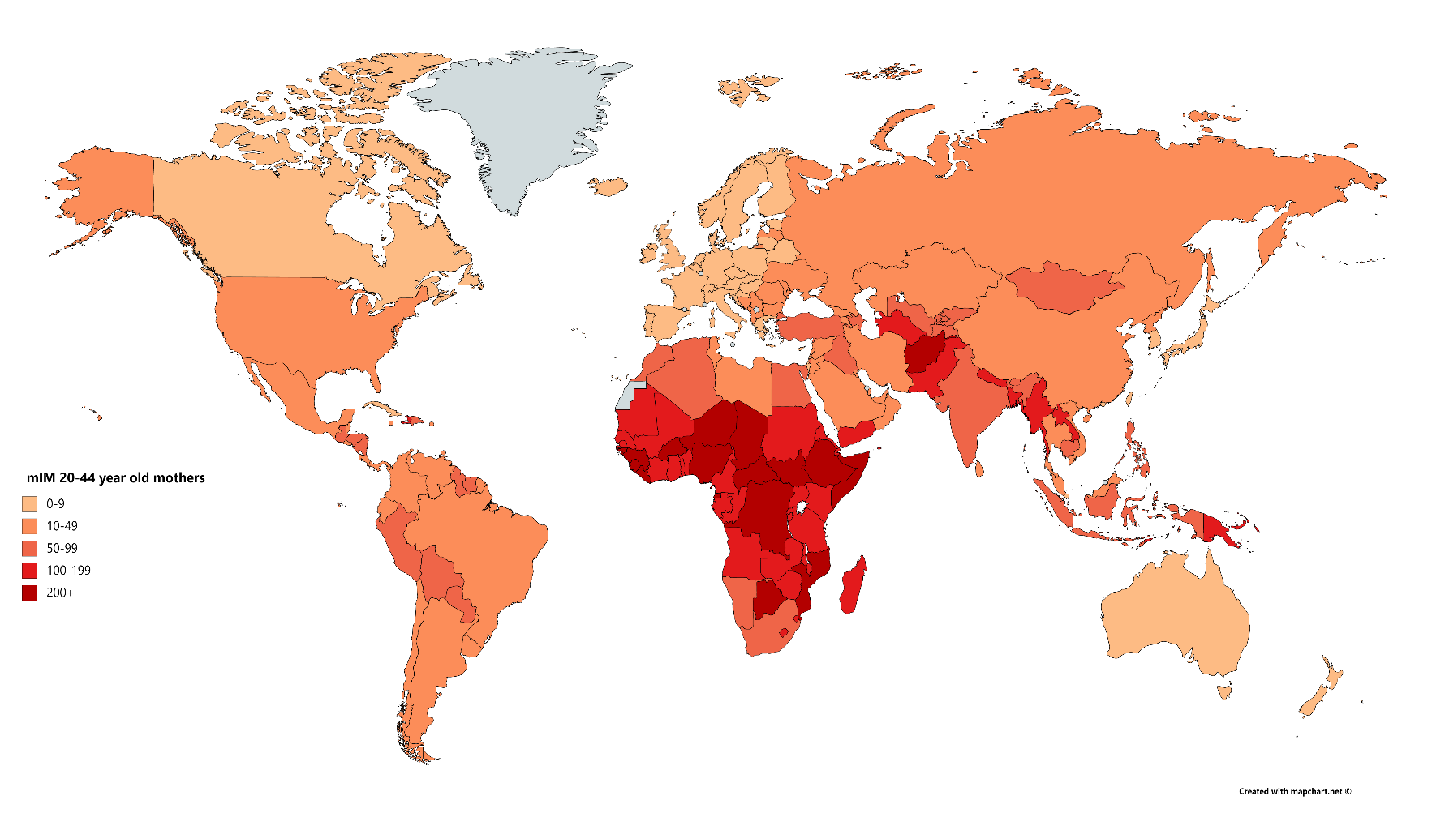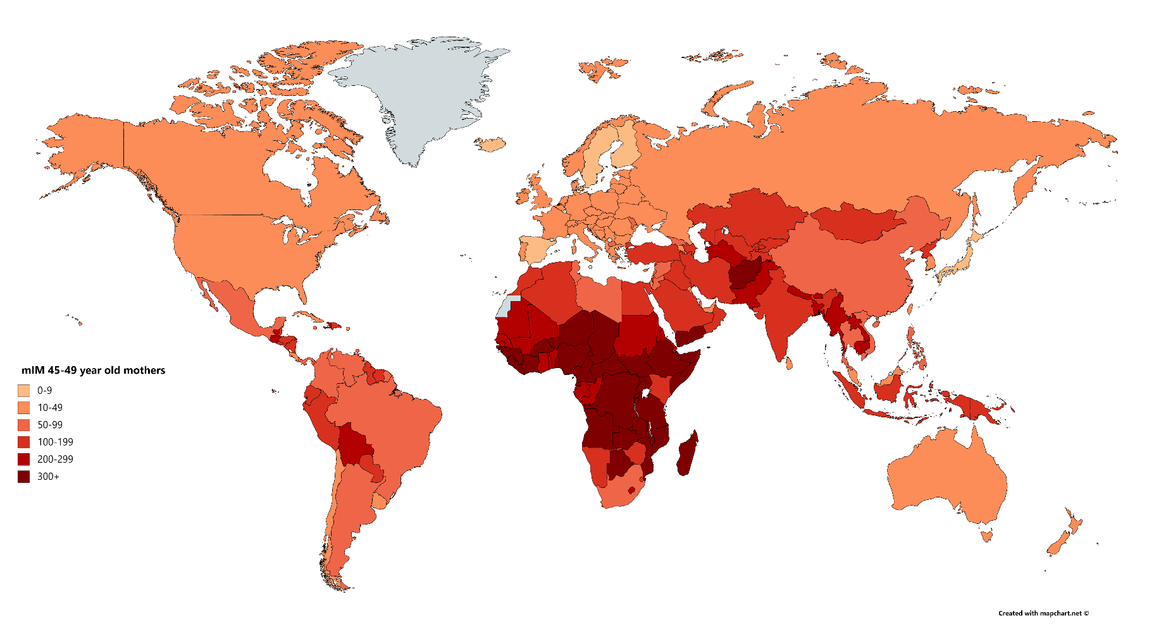

See the Appendix for a full list of results

Figure 2. Maternal Under-Five Mortality (mIM) Indicators for mothers ages 15-44-years-old (top panel) and ages 45-49-years-old (bottom panel)

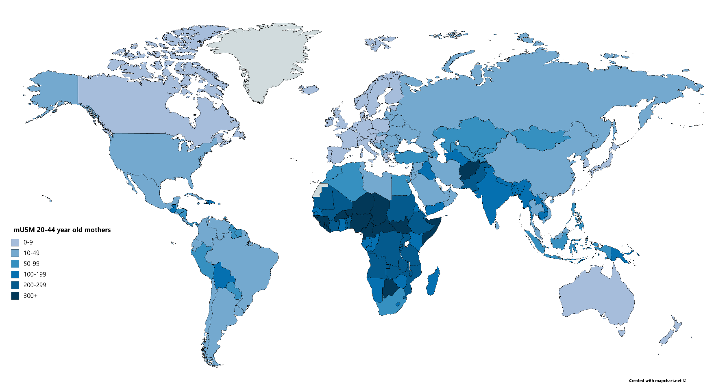

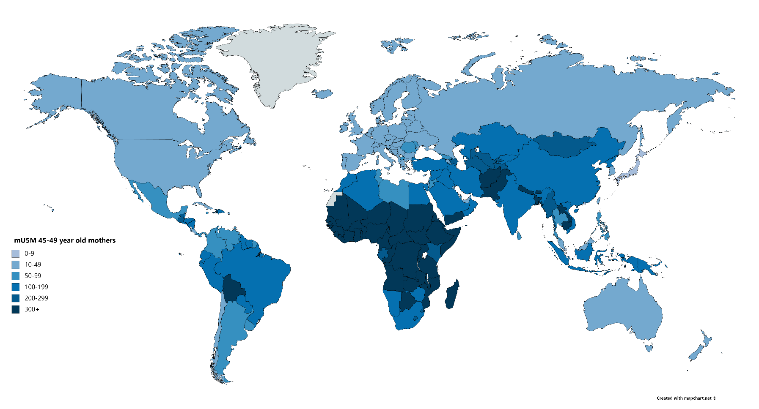

See the Appendix for a full list of results

Figure 3. Maternal Offspring Mortality (mOM) Indicators for mothers ages 45-49-years-old

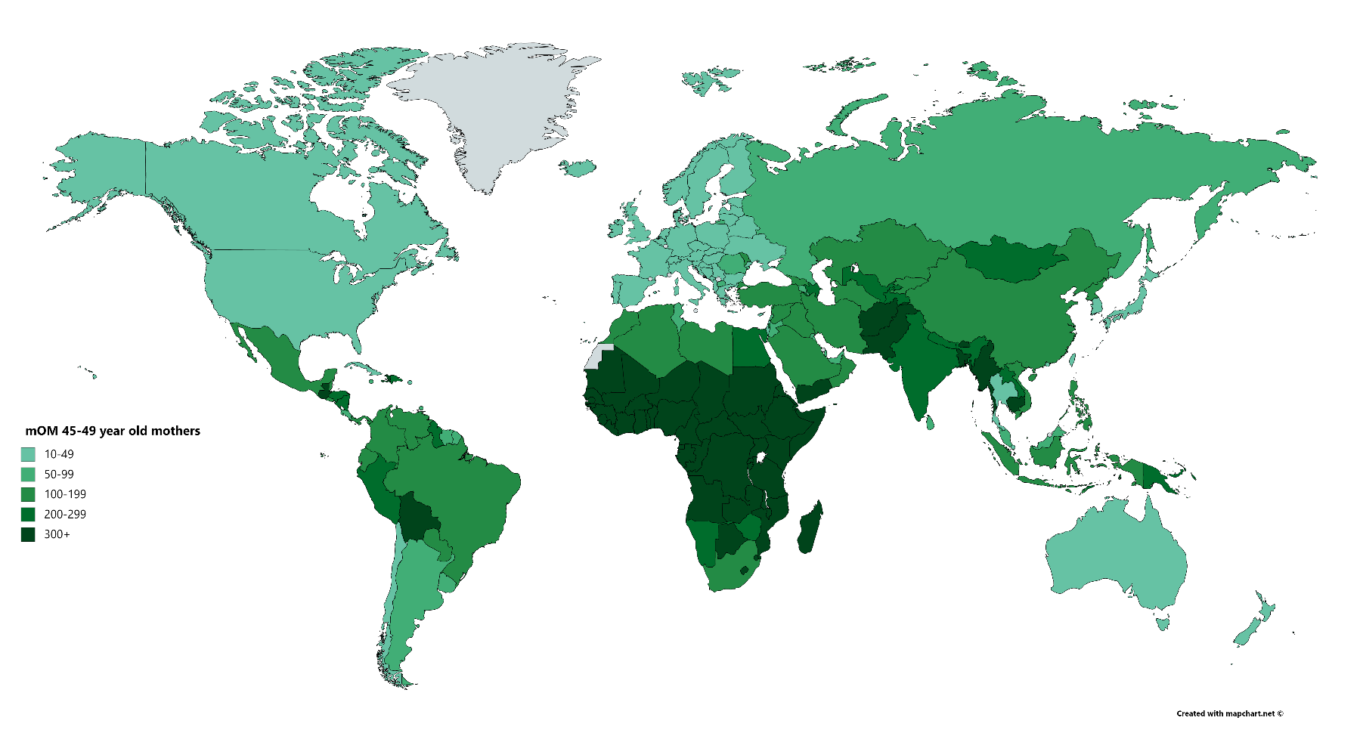

See the Appendix for a full list of results

1. UN WPP data rely on model life tables in select countries, especially those in sub-Saharan Africa.