**Global Inequality in Maternal Experiences of Child Mortality**

**Abstract**

As part of broader patterns of demographic convergence, fertility and child mortality rates have declined worldwide over the past several decades. Demographic convergence is intrinsically tied to the increasing similarity in women’s reproductive experiences, yet persistent differences in fertility and mortality across the globe yield inequalities in key aspects of motherhood, including one of the most life altering experiences: having a child die. Maternal bereavement is known to have severe and long-lasting health, relational, and social consequences, thus making it relevant to global inequality; however, we lack research on global patterns of maternal bereavement. In this research brief, we present estimates of the cumulative prevalence of bereaved mothers for 168 countries. We present three metrics that capture the maternal cumulative prevalence of infant mortality, under-five mortality, and offspring mortality. We generate these estimates using a direct estimation approach from nationally representative surveys, and an indirect approach based on kinship models. The study demonstrates an exceptionally high prevalence of bereaved mothers in the global south: in several African and Asian countries where upwards of one-third to one-half of living mothers have lost a child. and startling inequality in the burden of maternal bereavement across countries. There is an exceptionally high burden in several African and Asian countries where upwards of one-third to one-half of living mothers have lost a child. Although it is well known that infants and children face strikingly different risk of mortality depending on where they are born, this study shows that the differential risk of child loss that mothers face is even far greater, and distinctly patterned due to confluence of mortality and fertility patterns.

~~Global convergence in demographic trends has occurred at a remarkable pass over the second half of the twentieth century: across the globe, mortality and fertility patterns are increasingly similar (Wilson, 2001). This demographic convergence is part and parcel of the increasing similarity in women’s reproductive experiences worldwide, including in the number of children they bear and those individual children’s risk of premature death.~~

~~Even with global demographic convergence, stubborn differences in mortality and fertility patterns persist and produce global inequalities in maternal experiences that deserve attention.~~

~~One maternal experience that has not been well-studied is arguably among the most dreaded by mothers: the death of a child.~~

Infant and child mortality rates have been steadily declining worldwide over the last fifty years. Even though the rates themselves vary markedly by country and region, the recent trends all point in a positive direction for child survival across the globe; longstanding disparities in infant mortality are also narrowing. Without reservation, these trends represent good news for children and for their parents, but the link between child mortality and parents experiences, however, remains loosely defined. Each infant and child death is an event that has grave consequences for surviving parents, but population-level estimates representing the vantage point of parents have only been generated for one world region. In sub-Saharan Africa, the confluence of high fertility and high mortality results in as many as one-third of younger mothers and half of mothers age 45-49 years old having experienced at least one child die (Smith-Greenaway & Trinitapoli, 2020). Whether such high levels of child loss also characterize other countries across the global south is unclear, and the magnitude of difference between and within world regions remains an open question.

Documenting global inequality in maternal bereavement offers a window into the demographic realities that affect the lives and wellbeing of mothers. The experience of a child death influences women’s future childbearing (Nobles et al., 2015), mental health (Rogers et al., 2008; Song et al., 2010), physical health, and longevity (Li et al., 2003; Rostila et al., 2012). And because the resulting grief is so intense, the adverse effects can persist for years—even decades (cite). Clearly establishing the population-level prevalence of maternal bereavement accomplishes two things – first it clarifies the contemporaneous vs. lagged nature of the relationship between annualized rates and the experiences of parents, which are cumulative. Second, it reveals how inequalities in infant, child, and adolescent mortality conditions generate a secondary set of inequalities for the surviving adult population.

In this article we offer the first, global analysis of the prevalence of bereaved mothers by leveraging data collected between 2010 and 2018 from 168 countries. We generate three indicators of the cumulative prevalence of mothers who have lost at least one infant, under-five year old, or any-age child using both survey data where reproductive histories have been collected. We label these indicators: the maternal cumulative prevalence of infant mortality (mIM), under-five mortality (mU5M), and offspring mortality (mOM) (Smith-Greenaway & Trinitapoli, 2020). We calculate these three measures separately for two groups of mothers: those in the peak of their reproductive years (ages 20-44) and those who have recently completed, or are soon to complete, childbearing (ages 45-49). To address the reality of data poverty as yet another layer of global health inequality, we also advance an innovative, indirect estimation approach rooted in the tradition of formal demography. Our indirect estimates of the mIM, mU5M, and mOM can be constructed for countries about which we lack micro-level data on reproductive histories but have just two crude tools: lifetables and age-specific fertility schedules. The findings offer a new perspective on global-health inequalities and highlight the value of persistently studying disparities in maternal experiences even as many global demographic metrics converge.

**Approach**

We first generate the three key study indicators directly, using data from nationally representative surveys that feature women’s reproductive histories. Second, we introduce a novel formal demographic approach to indirectly estimate the prevalence of bereaved mothers. We refer to the approach as the kin-cohort method, as it relies on kinship equations and cohort reconstructions. Third, using data from countries for which both types of estimates could be produced, we systematically compare the two and assess their validity. For countries where available data are insufficient for calculating maternal measures of infant and child mortality using the direct method, we present only the kin-cohort estimates to provide a thoroughly global overview.

Beginning with our direct estimation strategy, we make use of three data sources. For 56 countries, we leverage data from the Demographic and Health Surveys (DHS) program —the most widely used data source for global studies of child mortality. DHS data come from nationally representative household surveys that collect detailed information from various household members, including women ages 15-49. These public use surveys, funded by the United States Agency for International Development (USAID) are available to researchers at <https://dhsprogram.com/>. For 32 countries, without a recent DHS survey, we make use of Multiple Indicator Cluster Surveys (MICS), which come from nationally representative household surveys funded by UNICEF (these data are publicly available at <https://mics.unicef.org/>). Finally, in the United States, we make use of the National Survey of Family Growth (NSFG). NSFG collects reproductive history calendars from women ages 15-44 years old. The public use surveys are available at <https://www.cdc.gov/nchs/nsfg/index.htm>. Appendix A provides a comprehensive list of countries, data sources, survey years, and analytic sample sizes.

In each survey, we restrict the analytic samples to women who have had at least one live birth; only these women are at risk of child loss. Using information from women’s reproductive histories, including the vital status of each child and, for those deceased, the age at death, we calculate the mIM, mU5M, and mOM. To estimate the mIM, we tabulate the prevalence of mothers who have experienced the death of at least one infant. We sum the number of mothers who had a child die before age 1 among those who ever had a live birth and express this per 1,000 mothers. Next, to estimate the mU5M, we do the same for mothers who have ever had a child die before reaching age 5. ~~Note that for select countries wherein we rely on MICS data, we lack direct survey estimates of the mIM and mU5M because information on the age of the child at the time of death was not included.~~

Finally, the mOM indexes the prevalence of mothers who have experienced a child death, regardless of that child’s age. Due to censoring concerns, we calculate the mOM for 45- to 49-year-old mothers only.

Because recent, reproductive-history surveys are not available worldwide, we developed a novel indirect approach for calculating the mIM, mU5M, and mOM from macro-level fertility and mortality data alone. We use country-specific period life-tables and age-specific fertility rates from the United Nations World Population Prospects (UN WPP, historical and projected rates for the 1950-2100 years).[1] Our indirect models require age-specific cohort rates as input, which we approximate as the values along the diagonal of the available period rates. We demonstrate the accuracy of this approach in countries where survey data are also available and generate new, indirect estimates for the 79 countries for which direct estimates were not possible. This kin-cohort method is an extension to the Goodman-Keyfitz-Pullum kinship equations (GKP equations)(Keyfitz, 1985). Crucially, the kin-cohort method allows us to estimate the cumulative number ofinfant, child, and offspring deaths experienced by a woman born in cohort *c* surviving to age *a* given a set of cohort mortality and fertility schedules:

(1)

where for infant deaths, for child deaths and 00 for all-age offspring deaths. We restrict the female reproductive age to , so that for all cases.

To determine the prevalence of bereaved women in a population, we start by considering the age-specific probability that an average woman will experience the death of a child:

(2)

where is the hazard rate of experiencing the death of a child younger than *k* (Wachter, 2014). We create a life table (Preston et al., 2001) with a unit radix where is the probability of losing a child. We define the fraction of women aged *a* in cohort *c* who ever experienced the death of a child younger than *k* as.

Next, we account for the mortality of women with the help of the parameters the fraction of women that survived up to age *a* after the start of reproductive age in each birth cohort (where ). The proportion of women (per 1,000 mothers) who have ever lost one or more children younger than *k* is:

. (3)

To tailor the estimate to reflect an equivalent measure for mothers, we rescale our estimates using a similar life-table approach. We consider fertility as a “hazard rate” to approximate the number of women that “survive” without having children (i.e. remain childless) after experiencing a set of age-specific fertility rates. The fraction of women who have ever been mothers is approximated as 1 minus the fraction of childless women. We can now define, for a given cohort, the proportion of mothers (per 1,000 mothers) who have ever lost one or more children younger than *k*:

. (4)

Eq.4 provides single-age cohort estimates of the prevalence of bereaved mothers. As a last step of the indirect estimation, we approximate period values which are comparable to the direct estimates derived from surveys.

Supplementary analyses wherein we indirectly generated the mIM, mU5M, and mOM for the same survey years in which we have direct estimates for each country show a strong correlation between estimates (see Appendix B). The indirect approach tends to yield higher estimates than the direct approach; the discrepancy is driven by the fact that the direct method adjusts for the clustering of deaths in high-risk families in some countries, while the indirect approach does not. Where child deaths are concentrated among a disadvantaged group of women, the two types of estimates will diverge, but in contexts wherein child deaths are evenly dispersed across mothers, the differences are negligible. Of course, it is also possible that where disparate, the indirect estimates are more accurate than the direct ones due to an underestimation of child loss in the survey data. Even though the survey estimates are derived from nationally representative samples, hard to reach, especially disadvantaged populations are often underrepresented.

**Results**

Figure 1 maps the mIM across the globe, painting a worldwide portrait of the prevalence of mothers who have experienced an infant death. The top panel depicts the mIM values for younger mothers (ages 20-44), and the bottom panel presents mIM values for older mothers (ages 45-49). Throughout Europe and much of Asia, fewer than 1% (i.e., 10 per 1,000) of mothers 20-44 and 2% of mothers 45-49 (i.e., 20 per 1,000 mothers ages 45-49) have ever lost an infant. Yet, in more than half of the 168 countries, over 45 per 1,000 young mothers and 160 per 1,000 older mothers have experienced an infant die. Throughout the Middle East and Northern and sub-Saharan Africa, more than 150 per 1,000 younger mothers and over 300 per 1,000 older mothers have ever lost an infant. These high levels of child loss among older mothers in the Middle East and Africa relative to younger mothers in those same countries flows from the swift and recent improvements in mortality conditions. Even so, the degree to which young mothers have experienced infant loss is striking. Angola has the highest mIM value for reproductive-age mothers (336 per 1,000).

These findings demonstrate not only the exceptionally high prevalence of bereaved mothers across Asia and Africa, but also the tremendous inequality in surviving mothers’ experience of child loss across countries. These inequalities are significantly larger than comparable inequality in infant mortality rates across countries, which are also shown in the Appendix A. For instance, the infant mortality rate is 20 times higher in Angola than it is in Hong Kong, with 57.8 infants dying before their first birthday in the former versus 1.4 in the latter (see Appendix A). However, the mIM in Angola is *124 times* higher than it is in Hong Kong: 2 out of 1,000 young mothers in Hong Kong have lost an infant compared to 168 in Angola. In this way, the mIM completely re-scales the inequality in maternal experiences that women in these populations have endured and shows it to be far more vast than the annualized, child-centered metrics suggest.

The estimates pertain only to the death of children before age one, offering no indication of the prevalence by which mothers have experienced the death of children under five or older children. Figure 2 depicts the global mU5M, summarizing the prevalence of mothers who have experienced a young child die. The top panel depicts the mU5M values for younger mothers ages 20-44 and the bottom panel presents the mU5M values for older mothers ages 45-49 years old. In several countries across Europe and Asia, fewer than 10 per 1,000 young mothers had experienced a child die before age five, whereas upwards of 35 per 1,000 older mothers had. In as many as 15 countries across the Middle East and West and Central Africa, more than 300 per 1,000 reproductive age mothers had lost a child, whereas more than half of all older mothers had in most of these countries.

As with the mIM, the inequality in mothers’ experiences of under-five mortality far exceeds both current and historical differences in the under-five mortality rates themselves. By way of example, a child born in Niger today is roughly 41 times more likely to die before their fifth birthday than a child born in Hong Kong (see Appendix A). Yet, the difference in mothers’ accumulated experiences of loss is far greater: a mother in Niger is roughly *157 times* more likely to have experienced the death of a child under age five than is a mother in Hong Kong. This compounded disparity results from the combined legacy of the mortality and fertility rates that characterize each country. In Niger, not only is the child mortality rate high; women have high fertility, and each birth increases the mother’s overall exposure to the risk of experiencing a child’s death. In contexts like these, among highest fertility women (i.e., 7+) the probability of having lost a child approximates 1.

The risk of child death for parents persists well beyond the 60-month mark that so thoroughly permeates contemporary approaches to measuring and monitoring health in early childhood. To offer a comprehensive overview of the total burden of child loss (i.e., regardless of the child’s age at the time of death), Figure 3 depicts the burden of all offspring mortality (mOM) among mothers 45-49 years old. For obvious reasons, the global patterning of the mOM indicators closely follows the trends of both the mIM and mU5M: countries wherein a high prevalence of mothers have lost an infant or under-five year old child also carry high levels of maternal bereavement when measured on a longer time horizon. Still, the differences in magnitude are striking; even though an individual child’s risk of death declines precipitously after 60 months, the risk to parents remains sizable. In as many 22 countries – all located in sub-Saharan Africa and the Middle East and all featuring the combination of high mortality and high fertility rates – more than one half of mothers have experienced a child die. At the other end of the spectrum, the reigning pattern across Europe, North America, and parts of Asia (48 countries total, all of which have secured high rates of child survival and low or very-low fertility) is that fewer than 50 per 1,000 have ever lost a child, reflecting the stark inequality this combination of mortality and fertility conditions generate for maternal experiences.

JT: ^^ A note about my edits to the paragraph above. I’m conflicted about the approach of counting up countries. 37 countries isn’t a fact that people will remember. In and of itself, it’s not that interesting. And whether these are really big or really small countries matters a lot for the global weight of this argument. ESG – you and I worked on this a lot in the PNAS paper as we were figuring out how to write-it up. I think we have to use this construction sometimes, but I tried here to just reduce the number of times we do this – count up the countries over some threshold -- and instead, replace this construction with facts/insights that will be more memorable and more concrete. Below I added a paragraph that tried to inject specifics and also link these examples to a literature people already know. That way it doesn’t seem like we’re cherry-picking countries and examples.

Of course, there is no “typical” country or modal mortality regime when it comes to the mOM. To understand the divergent experience of transitional countries, we find it helpful to examine, in particular, the most recent mOM estimates for countries Caldwell (1986) and later Kuhn (2010) identified as “superior health achievers”: Bangladesh (414 per 1000 in 2014), Paraguay (167 per 1000 in 2016), Nicaragua (220 per 1000 in 2016), Costa Rica (63 per 1000 in 2016), Vietnam (126 per 1000 in 2013), and Nigeria (524 in 2013). During the past 30 years, all of these countries experienced astonishing declines in both mortality and fertility rates -- declines that have been touted as exemplary by the global health community. The mOM estimates show, however, that the legacy of higher morality is still very present in the lives of the mothers now aged 45-49; furthermore, despite their similar trajectories, the mOM estimates for these countries diverge considerably from one another.

**Discussion** JT ADDING: I agreed with your note, Emily. Since ‘convergence” isn’t really our big idea here, we probably don’t want to open and close the paper with that idea. Below I’ve attempted something a little different. It’s a big swing, tying this back to a foundational text. But I think it’s correct and will be compelling to Demography or PDR readers. LMK what you think!

Macro-level mortality tends have been a cornerstone of demographic research since John Graunt’s *Bills of Mortality*; only recently, however, have population scholars begun to track mortality conditions from the perspective of the surviving population. Doing so represents a departure from the individual-risk framework that has characterized our discipline for the past 50 years, but it also represents a return to some of the core concerns that motivated the formalization of mortality research over 350 years ago. When Graunt observed that “…most of them who constantly took in the weekly Bills of Mortality made little other use of them than to look at the foot how the burials increased or decreased….” he understood that mortality statistics have importance beyond the task of counting. Here, we look beyond “the foot” to show how mortality regimes shape the world for living parents.

Scholarly attempts to summarize macro-level mortality conditions explicitly from the vantage point of the surviving population—namely, family members (Fletcher et al., 2013; Smith-Greenaway & Trinitapoli, 2020; Thomas, 2020; Umberson et al., 2017; Verdery & Margolis, 2017) have been generative as stand-alone efforts and have been accumulating in recent years. In line with these efforts, here we take an initial step to formalize the measurement of parental bereavement -- accurately and systematically – using strategies from demography that are conducive to making cross-national comparisons – both global and regional. At the same time, we endeavor to identify parental bereavement as among the most fundamental health inequalities in contemporary populations, and we begin by focusing on the experience of mothers, from whom we have data of a much higher quality than we have from men. Our approach underscores how recent and persistent differences in mortality and fertility conditions are manifest in enormous disparities in the burden of child loss. Even in this age of demographic convergence, mothers in high mortality contexts are more than *100 times* more likely to have experienced a child die than mothers who inhabit the low-mortality enclaves of our world.

We close with a call to increase research on the implications of child loss for parents, starting with mothers, including fathers, and, perhaps -- in a framework of family demography -- extending to sibling bereavement. We note that different methodologies, theories, questions, and approaches should guide research undertaken in settings where child death remains a common correlate of motherhood and in contexts where the experience is increasingly rare and, therefore, perhaps even more isolating for women. And we highlight yet another a meta-inequality that cuts across the trends and patterns we’ve established here: that the world regions in which maternal bereavement is concentrated lack, almost completely, empirical studies investigating the long-term consequences of this experience. There is a pressing need for further studies on the consequences of child loss, and how global inequality along this dimension of life both generates new and exacerbates existing disparities in adult wellbeing.

**References**

Fletcher, J., Mailick, M., Song, J., & Wolfe, B. (2013). A sibling death in the family: Common and consequential. *Demography*, *50*(3), 803–826.

Graham, W., Brass, W., & Snow, R. W. (1989). Estimating maternal mortality: The sisterhood method. *Studies in Family Planning*, *20*(3), 125–135.

Hill, K. (1977). Estimating adult mortality levels from information on widowhood. *Population Studies*, *31*(1), 75–84.

Hill, K., Thomas, K., AbouZahr, C., Walker, N., Say, L., Inoue, M., Suzuki, E., & Group, M. M. W. (2007). Estimates of maternal mortality worldwide between 1990 and 2005: An assessment of available data. *The Lancet*, *370*(9595), 1311–1319.

Keyfitz, N. (1985). *Applied mathematical demography*. Springer. http://public.eblib.com/choice/publicfullrecord.aspx?p=3084208

Li, J., Precht, D. H., Mortensen, P. B., & Olsen, J. (2003). Mortality in parents after death of a child in Denmark: A nationwide follow-up study. *The Lancet*, *361*(9355), 363–367.

Nobles, J., Frankenberg, E., & Thomas, D. (2015). The effects of mortality on fertility: Population dynamics after a natural disaster. *Demography*, *52*(1), 15–38.

Obermeyer, Z., Rajaratnam, J. K., Park, C. H., Gakidou, E., Hogan, M. C., Lopez, A. D., & Murray, C. J. (2010). Measuring adult mortality using sibling survival: A new analytical method and new results for 44 countries, 1974–2006. *PLoS Medicine*, *7*(4).

Preston, S. H., Heuveline, P., & Guillot, M. (2001). *Demography: Measuring and modeling population processes*. Blackwell Publishers.

Rogers, C. H., Floyd, F. J., Seltzer, M. M., Greenberg, J., & Hong, J. (2008). Long-term effects of the death of a child on parents’ adjustment in midlife. *Journal of Family Psychology*, *22*(2), 203.

Rostila, M., Saarela, J., & Kawachi, I. (2012). The forgotten griever: A nationwide follow-up study of mortality subsequent to the death of a sibling. *American Journal of Epidemiology*, *176*(4), 338–346.

Smith-Greenaway, E., & Trinitapoli, J. (2020). Maternal cumulative prevalence measures of child mortality show heavy burden in sub-Saharan Africa. *Proceedings of the National Academy of Sciences*, *117*(8), 4027–4033.

Song, J., Floyd, F. J., Seltzer, M. M., Greenberg, J. S., & Hong, J. (2010). Long‐Term Effects of Child Death on Parents’ Health‐Related Quality of Life: A Dyadic Analysis. *Family Relations*, *59*(3), 269–282.

Thomas, K. J. (2020). Child deaths in the past, their consequences in the present, and mortality conditions in sub-Saharan Africa. *Proceedings of the National Academy of Sciences*, *117*(9), 4453–4455.

Umberson, D., Olson, J. S., Crosnoe, R., Liu, H., Pudrovska, T., & Donnelly, R. (2017). Death of family members as an overlooked source of racial disadvantage in the United States. *Proceedings of the National Academy of Sciences*, *114*(5), 915–920.

Verdery, A. M., & Margolis, R. (2017). Projections of white and black older adults without living kin in the United States, 2015 to 2060. *Proceedings of the National Academy of Sciences*, *114*(42), 11109–11114.

Wachter, K. W. (2014). *Essential demographic methods*. Harvard Univ. Press.

Wilson, C. (2001). On the scale of global demographic convergence 1950–2000. *Population and Development Review*, *27*(1), 155–171.

Figure 1. Maternal Infant Mortality (mIM) Indicators for mothers 20-44-years-old (top panel) and ages 45-49-years-old (bottom panel)

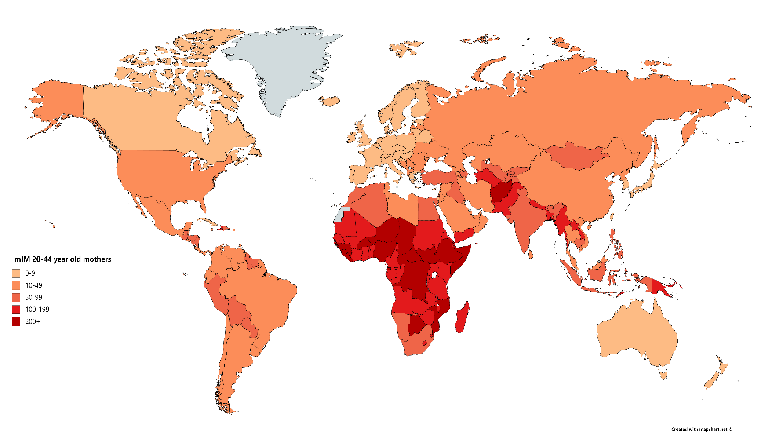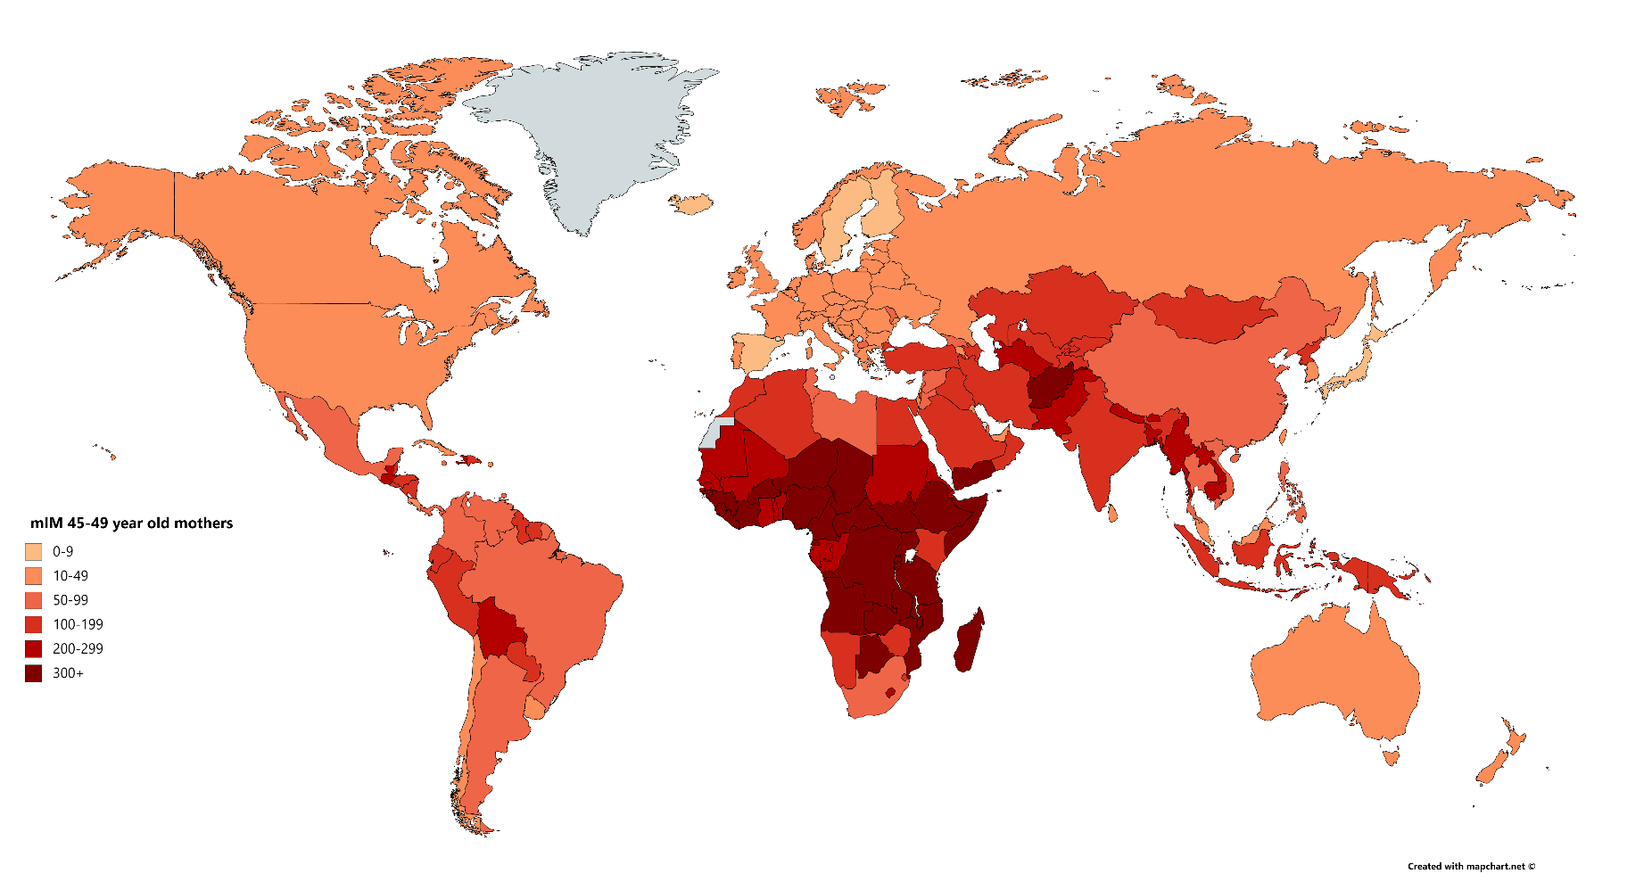

See the Appendix for a full list of results

Figure 2. Maternal Under-Five Mortality (mIM) Indicators for mothers ages 15-44-years-old (top panel) and ages 45-49-years-old (bottom panel)

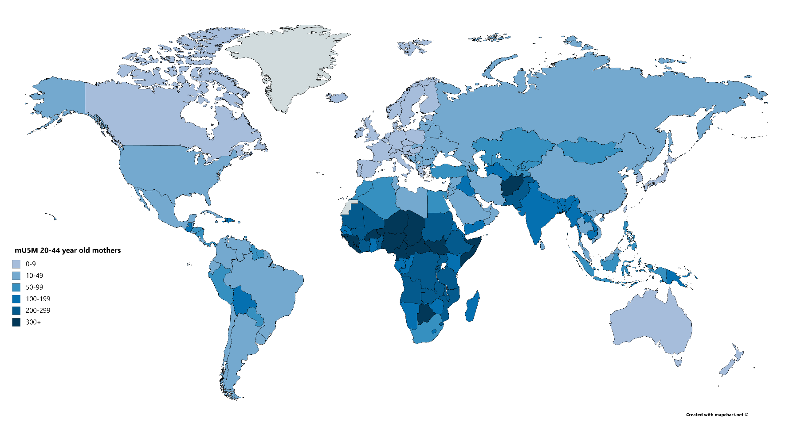

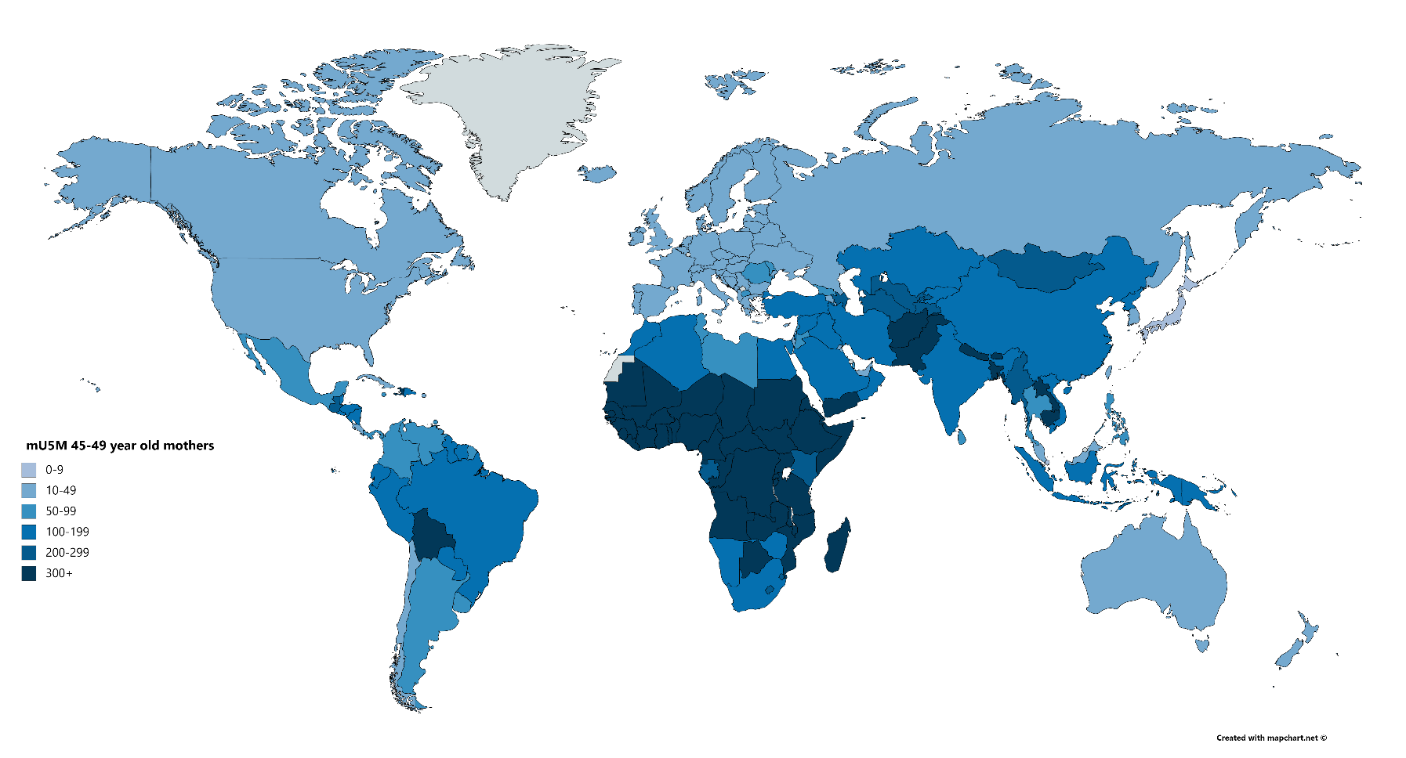

See the Appendix for a full list of results

Figure 3. Maternal Offspring Mortality (mOM) Indicators for mothers ages 45-49-years-old

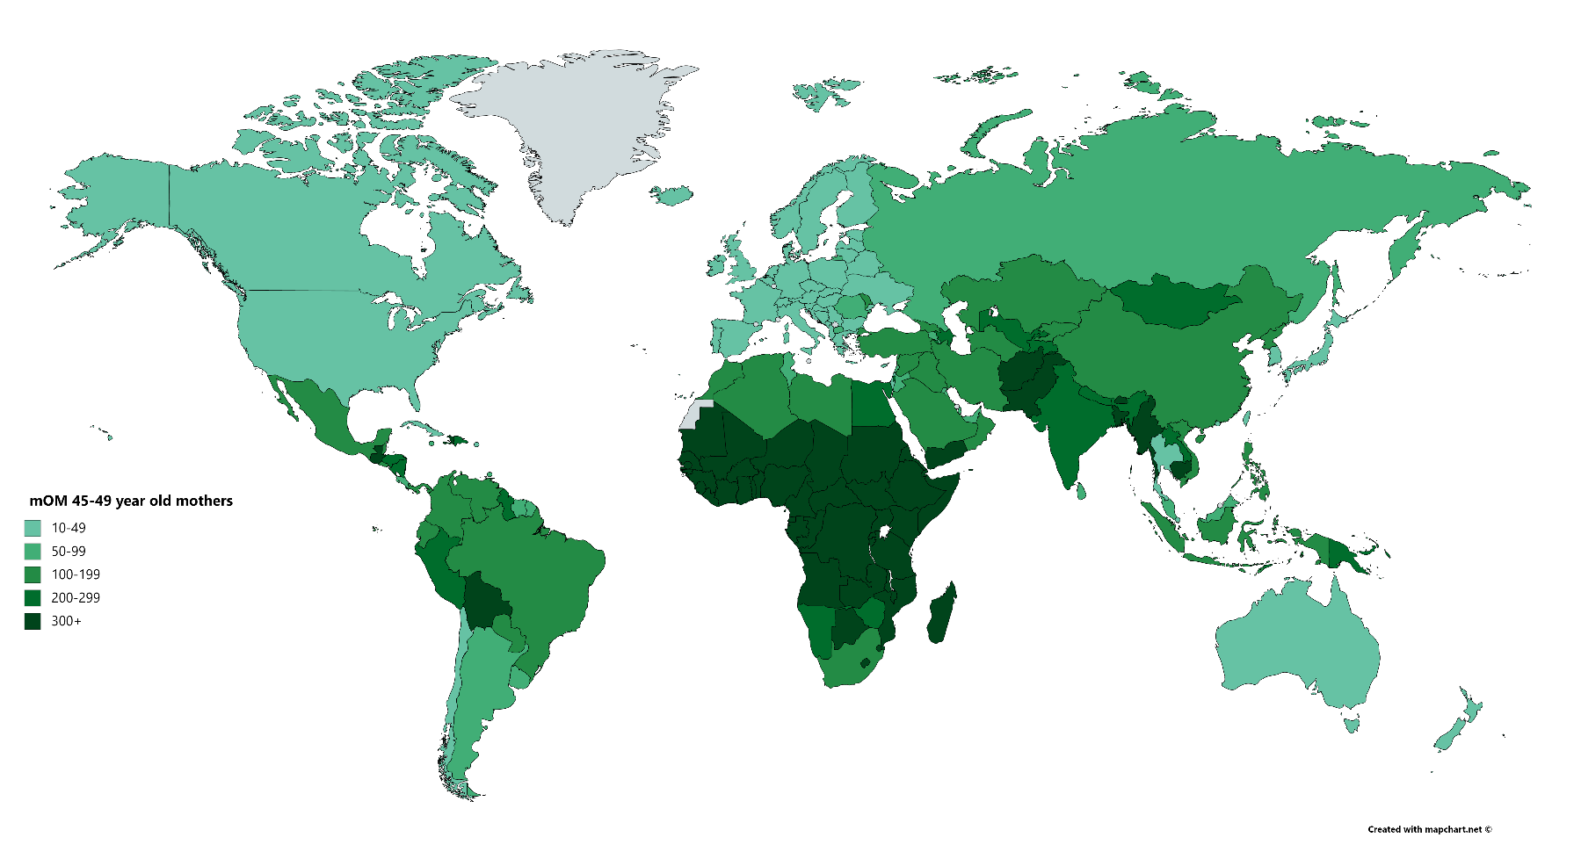

See the Appendix for a full list of results

1. UN WPP data rely on model life tables in select countries, especially those in sub-Saharan Africa.