**Global Estimates of Maternal Bereavement: An Analysis of 168 Countries**

Infant and child mortality rates have declined steadily worldwide over the last fifty years1, including marked declines in the United States.2 Even with short periods of stagnant improvement, and persistent between- and within-country inequality, the global trends represent good news for children and their parents. Yet, how improvements in annualized rates of infant and child mortality reflect in parents’ cumulative experience of child loss is unknown. A child’s death has grave and lasting consequences for parents, but population-level estimates of the prevalence of bereaved parents, mothers specifically, are available for only one world region. In several sub-Saharan African countries as recently as 2015, upwards of one-third of younger mothers (ages 20-44) and one-half of mothers age 45-49 years old having had at least one child die.3

Whether such high levels of maternal bereavement characterize other low- and middle-income countries, and how they compare to levels in high-income countries is unknown. In this article, we offer the first population-level estimates of the prevalence of bereaved mothers in the United States, and in 167 additional countries. We generate three indicators of the cumulative prevalence of mothers who have had an infant, under-five year old, or any-age child ever die. We label these population-level indicators: the maternal cumulative prevalence of infant mortality (mIM), under-five mortality (mU5M), and offspring mortality (mOM).3 We calculate these three measures separately for two groups of mothers: those in the peak of their reproductive years (ages 20-44) and those who have recently completed, or are soon to complete, childbearing (ages 45-49). We generate these indicators using survey data for 89 countries and, to achieve global coverage, in 79 countries we supplement these estimates with an indirect estimation strategy, which applies insights from formal demography and combines information from life tables and age-specific fertility schedules.4

Generating country-level indicators of maternal bereavement offers two contributions. First, this exercise clarifies that the relationship between a country’s annualized infant and under-five mortality rates, which are contemporaneous, and parents’ experiences of child death, which are cumulative, is not readily apparent. This is because, aside from mortality conditions, a country’s fertility level determines how many years an average mother has young children at risk of the annualized rates of infant and child mortality, and thus what her cumulative risk of ever experiencing a child die. Moreover, the degree to which child deaths are dispersed across a population in a given country, versus concentrated among a small, disadvantaged subgroup of mothers, determines if child mortality affects only a smaller fraction of parents repeatedly, or if it is a more prevalent population experience. Finally, the legacy of higher child mortality years earlier, when older mothers had their first child, can also linger in the population and contribute to higher cumulative estimates of maternal bereavement than newly lowered mortality rates imply; yet maternal and adult mortality conditions dictate how many bereaved mothers survive to share their experience versus how many also die prematurely, deleting their account of child loss. The confounding influence of these population dynamics require explicit analysis of the prevalence of bereaved mothers.

In revealing that the prevalence of bereaved mothers is a distinct feature of a country’s reproductive health profile, the study’s second contribution is to draw attention to how inequalities in infant, child, and adolescent mortality conditions can give rise to a large population of grieving parents—parents deserving of public health attention. Family bereavement and kin loss not only reflects health inequality, but can also be a precursor to future health disadvantage.3,5–9 A child’s death, in particular, has profound and lasting influence on parents’ wellbeing, including their mental health10,11 and physical health and longevity.12,13 A child’s death bears heavy on mothers, in particular, and the adverse effects of their grief can persist for years—even decades.10,12,14 Yet, the global burden of maternal bereavement remains unknown. And even as infant and child mortality conditions hint to the world regions that likely bear an outsized burden of bereavement, it is unclear how confounding population dynamics further contribute to disparities in the global distribution of bereaved mothers. By demonstrating the size and distribution of inequalities in the burden of child loss, this study offers a new view of global health inequality highly relevant to maternal wellbeing.

**METHODS**

We first generate three maternal indicators of the cumulative prevalence of child death directly, using data from nationally representative surveys that feature women’s reproductive histories. Our direct estimation strategy makes use of three data sources. For the United States, we make use of the National Survey of Family Growth (NSFG) (2013-17). NSFG collects reproductive history calendars from women ages 15-44 years old.[1] For 56 countries across Africa, Asia, Europe, Latin America and the Caribbean, and Oceania, we leverage data from the Demographic and Health Surveys (DHS) program. DHS data come from nationally representative household surveys that collect detailed information from various household members, including women ages 15-49, and were collected between 2010 and 2018.[2] Finally, for 32 additional countries in Africa, Asia, Europe, and Latin America and the Caribbean that lack recent DHS data, we make use of Multiple Indicator Cluster Surveys (MICS), which come from nationally representative household surveys collected between 2010-2018.[3] Table 1 in the supplemental file provides the full list of countries, data sources, survey years, and analytic sample sizes.

In each survey, we restrict the analytic samples to women who have had at least one live birth; only these women are at risk of child loss.[4] Using information from women’s reproductive histories, including the vital status of each child and, for those deceased, the age at death, we calculate the mIM, mU5M, and mOM. To estimate the mIM, we tabulate the prevalence of mothers who have experienced the death of at least one infant. We sum the number of mothers who had a child die before age 1 among those who ever had a live birth and express this per 1,000 mothers. To estimate the mU5M, we make the same calculation, but sum mothers who have ever had a child die before reaching age 5. The mOM indexes the prevalence of mothers who have experienced a child death, regardless of that child’s age.[5] Due to censoring, we calculate the mOM for 45- to 49-year-old mothers only.

**VERSION 1 : Abbreviated**

To expand our perspective beyond our survey coverage, we introduce a formal demographic approach to indirectly estimate the prevalence of bereaved mothers in 79 additional countries. Not all countries feature recent, nationally-representative surveys with reproductive information from women; thus, this approach allows us to estimate the prevalence of bereaved mothers by drawing on other, publicly-available, demographic data from the United Nations World Population Prospects.[6] We set all of our indirect estimates to the year 2016—the modal year of survey coverage in our data. We refer to the approach as the kin-cohort method, as it relies on kinship equations and cohort reconstructions using country-level period mortality and fertility rates.4 This kin-cohort method is an extension to the Goodman-Keyfitz-Pullum kinship equations.15 Our indirect models require age-specific cohort rates as input, which we approximate as the values along the diagonal of the available period rates.

To determine the prevalence of bereaved women in a population, we start by considering the age-specific probability that an average woman will experience the death of a child. We create a life table16 that enables us to estimate the probability of losing a child. In doing so, we account for the mortality of women, specifically the fraction of women that survived up to the age after the start of reproductive age in each birth cohort. With this information, we can solve for the proportion of women (per 1,000 mothers) who have ever lost one or more children.

To tailor the estimate to reflect an equivalent measure for mothers specifically, rather than all women, we rescale our estimates using a similar life-table approach. We consider fertility as a “hazard rate” to approximate the number of women that remain childless at specific ages after experiencing a set of age-specific fertility rates. We then define, for a given cohort, the proportion of mothers (per 1,000 mothers) who have ever lost a child of a specific age, from which we can then derive period estimates. These indirectly estimated period values can be interpreted exactly as the direct survey estimates and reference as a child’s death before age one (mIM), age five (mU5M), or any age (mOM).

**VERSION 2: FULL**

Second, we introduce a novel formal demographic approach to indirectly estimate the prevalence of bereaved mothers. We refer to the approach as the kin-cohort method, as it relies on kinship equations and cohort reconstructions. Because recent, reproductive-history surveys are not available worldwide, we developed an indirect approach for calculating the mIM, mU5M, and mOM from country-level period mortality and fertility rates.4 This kin-cohort method is an extension to the Goodman-Keyfitz-Pullum kinship equations (GKP equations).15 We use country-specific period life-tables and age-specific fertility rates from the United Nations World Population Prospects (UN WPP, historical and projected rates for the 1950-2100 years).[7] Our indirect models require age-specific cohort rates as input, which we approximate as the values along the diagonal of the available period rates. We demonstrate the accuracy of this approach in countries where survey data are also available and generate new, indirect estimates for the 79 remaining countries. This kin-cohort method is an extension to the Goodman-Keyfitz-Pullum kinship equations (GKP equations) 15. Crucially, the kin-cohort method allows us to estimate the cumulative number of infant, child, and offspring deaths experienced by a woman born in cohort *c* surviving to age *a* given a set of cohort mortality and fertility schedules:

(1)

where for infant deaths, for child deaths and 00 for all-age offspring deaths. We restrict the female reproductive age to , so that for all cases.

To determine the prevalence of bereaved women in a population, we start by considering the age-specific probability that an average woman will experience the death of a child:

(2)

where is the hazard rate of experiencing the death of a child younger than *k* 17. We create a life table 16 with a unit radix where is the probability of losing a child. We define the fraction of women aged *a* in cohort *c* who ever experienced the death of a child younger than *k* as.

In doing so, we account for the mortality of women, specifically the fraction of women that survived up to the age after the start of reproductive age in each birth cohort (where ). With this information, we can solve the proportions of women (per 1,000 mothers) who have ever lost one or more children younger than *k* is:

. (3)

To tailor the estimate to reflect an equivalent measure for mothers, we rescale our estimates using a similar life-table approach. We consider fertility as a “hazard rate” to approximate the number of women that “survive” without having children (i.e. remain childless) after experiencing a set of age-specific fertility rates. The fraction of women who have ever been mothers is approximated as 1 minus the fraction of childless women. We can now define, for a given cohort, the proportion of mothers (per 1,000 mothers) who have ever lost one or more children younger than *k*:

. (4)

Eq.4 provides single-age cohort estimates of the prevalence of bereaved mothers.

[Note: regardless of whether we adopt abbreviated text, this is where we’d pick back up…]

In addition to evidence validating the accuracy of this approach using registry data from Sweden4, in this study, we demonstrate the accuracy of our indirect approach in countries where survey data are also available by comparing the two estimates. Figure 1 in the online supplement shows the correlation between the indirectly generated mIM, mU5M, and mOM and the direct survey estimates for the 89 countries where we can estimate both. The indirect approach tends to yield higher estimates than the direct approach; the discrepancy is likely driven by the fact that the indirect approach cannot address the clustering of deaths to specific mothers—an issue that a survey approach addresses. The clustering of child deaths occurs in countries with the highest levels of infant and child mortality—the precise countries where we have almost full survey coverage. Thus, when presenting results, we prioritize the survey estimates, and reference the indirect estimate where appropriate; we only rely on indirectly generated estimates where survey-based ones are unavailable. However, we also acknowledge that where disparate, the indirect estimates could be the result of an underestimation of child loss in the survey data. Even though the survey estimates are derived from nationally representative samples, mothers may underreport on the deaths of children. Moreover, some hard to reach, especially disadvantaged populations—including those affected by war or conflict and thus who are more likely to have higher levels of child loss—can be underrepresented in national surveys.

**RESULTS**

**Maternal Burden of Infant Mortality**

**Fig. 1** maps the mIM, offering a worldwide portrait of the prevalence of mothers who have experienced an infant death. The top panel depicts the mIM values for mothers ages 20-44, and the bottom panel presents mIM values for mothers ages 45-49. In select European and Asian countries, fewer than 5 per 1,000 of mothers 20-44 and 20 per 1,000 mothers 45-49 have ever lost an infant (Hong Kong, Singapore, Iceland, Japan, Finland, Sweden, Slovenia, Spain, Republic of Korea, Czech Republic, Italy, Norway, Portugal). The mIM is slightly higher in the United States: NSFG survey estimates 7.2 per 1,000 in US have lost a child, with the kin-cohort approach yielding a slightly higher estimate of 12.1 per 1,000, a difference of 0.5 percentage points.

As many as 50 countries have mIM values exceeding 120 per 1,000 mothers ages 20-44 years old, meaning that ten or more times as many mothers have experienced an infant death than in the US. In 16 countries in the Middle East and sub-Saharan Africa, more than 200 per 1,000 younger mothers have ever lost an infant (i.e., Afghanistan, Burkina Faso, Central African Republic, Chad, Democratic Republic of the Congo, Ethiopia, Equatorial Guinea, Guinea ,Liberia, Niger, Nigeria, Guinea-Bissau, Mozambique, Sierra Leone, Somalia, South Sudan). Several of these countries have among the highest infant mortality rates, yet, that 20% of younger mothers have lost an infant is jarring. Tdifferent countriesthis inequality For example, in Sierra Leone, the country with the highest mIM (303 per 1,000 mothers), young mothers are 46 times more likely to have experienced a child die than mothers in the US. This enormous difference far exceeds the still large discrepancy in the countries’ infant mortality rates: infants born in Sierra Leone are 16 times more likely to die (95.5 infant deaths per 1,000 live births) than those born in the US (6 infant deaths per 1,000 live births). Overall, the global range of mIM values for mothers ages 20-44 stretches from the low of 2.29 per 1,000 mothers in Hong Kong to 303 per 1,000 mothers in Sierra Leone, meaning that young mothers in the latter are 132 times more likely to have had an infant die than mothers in Hong Kong.

The bottom panel of **Fig. 1** presents the mIM estimates for older mothers. The US ranks 30th in terms of the mIM for older mothers: 20 per 1,000 mothers ages 45-49 are estimated to have lost an infant—a prevalence of maternal bereavement also documented in Cuba, Cyprus, and Israel. In more than 50 countries, concentrated in the Middle East and sub-Saharan Africa, mothers ages 45-49 are more than ten times likely to have lost an infant than mothers in the US. Liberia has the highest mIM for older mothers, with an estimated 465 per 1,000 mothers age 45-49 having lost an infant. An older mother in Liberia is 76 times more likely to have experienced an infant die than an older mother in Hong Kong, the population with the lowest recorded mIM for older mothers (6 per 1,000), and are 23 times more likely to than mothers in the US (20 per 1,000). Again, this difference is far greater than the infant mortality rates: infants in Liberia are ten times more likely to die before than first birthday than infants in the US (62.5 infant deaths versus 6 infant deaths per 1,000 live births). Overall, the mIM values for older mothers are higher, with the average across 168 countries at an estimated 145 mothers having lost an infant per 1,000. In general, however, global inequality in infant loss for older mothers is smaller than that for younger mothers, possibly owing to the legacy of higher mortality worldwide. This could also be the result of bereaved mothers in the highest mortality contexts having also died prematurely, resulting in their omission and thus a cap on the prevalence of bereaved mothers in the most affected countries.

**Maternal Burden of Under-Five Mortality (mU5M)**

**Fig. 2** maps the mU5M, summarizing the prevalence of mothers who have experienced a child die between birth and age five. Starting with younger mothers (top panel), in select countries, fewer than 5 per 1,000 young mothers had experienced a child die before age five (Hong Kong, Singapore, Iceland, Japan, Finland, Sweden, Slovenia, Spain). The estimates are higher in the US: NSFG survey estimate that 9.3 per 1,000 mothers age 20-44 have lost a child, whereas the kin-cohort method estimates 13.9 per 1,000 mothers have (a difference of less than 0.5 percentage points). Even so, in nearly 70 countries, the mU5M for young moms is ten or more times higher than in the US. In as many as 15 countries across the Middle East and West and Central Africa, more than 300 per 1,000 mothers have lost a child. The mU5M ranges from a low of 3.28 per 1,000 mothers ages 20-44 (Hong Kong) to 437 per 1,000 mothers (Niger). As with the mIM, the inequality in mothers’ experiences of under-five mortality far exceeds both current and historical differences in the under-five mortality rates themselves. By way of example, the mU5M in Niger is 133 times that of Hong Kong, even as the under-five mortality rate in the former is only 49 times higher than the latter (2.22 child deaths per 1,000 in Hong Kong versus 108.7 child deaths per 1,000 in Niger).

As expected, mU5M levels are higher among older mothers (bottom panel **Fig. 2)**, who not only entered motherhood during higher mortality conditions, but also have been more fully exposed to the risk of having lost a child over their entire reproductive career. An estimated 24 per 1,000 mothers ages 45-49 have experienced a child die before age 5 in the US, with similar levels of maternal loss in Croatia, Cyprus, Cuba, and Israel. The US ranks 30th in the mU5M values, with a lower prevalence of bereaved mothers in this age group in 29 countries. Even so, more than 50 countries have levels of maternal loss of young children that are *ten times* higher than the US. In total, the estimates range from a low of from 8.2 mothers per 1,000 (Hong Kong) to 705 mothers per 1,000 (Niger): in Niger, a mother ages 45-49 is more than 86 times likely to have lost a young child than a mother in Hong Kong.

Additional analysis of the mIM and mU5M demonstrates how this explicitly maternal perspective reveals realities that cannot be inferred based on current infant and child mortality rates. Among the 20 countries with the lowest infant or child mortality rate, nine of these countries do *not* feature among the 20 countries with the lowest mIMs and mU5Ms, suggesting that these countries could be viewed inappropriately as countries where the maternal burden of child loss is among the lowest globally. Similarly, 10 of the top 20 countries with the highest mIMS and mU5Ms do not feature the highest infant and under-five mortality rates. These are countries where the maternal burden of child loss is not made apparent by contemporary child mortality conditions, even as these are settings with among the highest burdens of maternal bereavement in the world.

**Maternal Burden of Offspring Mortality (mOM)**

Despite the global emphasis on measuring and monitoring mortality before age five, parents’ risk of losing a child persists beyond the child’s fifth birthday. To understand the total burden of child loss (i.e., regardless of the child’s age at the time of death), **Fig. 3** depicts the mOM, capturing the burden of all offspring mortality among mothers 45-49 years old. As expected, the global patterning of the mOM indicators closely aligns with that of the mIM and mU5M: countries where many surviving mothers have had an infant or under-five year old die are also those where mothers have lost adolescent and young adult children. The reigning pattern across Europe and East Asia is that fewer than 20 per 1,000 mothers have ever lost a child. The level in the US is slightly higher: 33 per 1,000 mothers ages 45-49 have lost a child—a prevalence similar to Ukraine, Israel, and Hungary. Even as 31 countries have lower mOM values than the US, nearly 50 countries have mOM levels that are ten times as high as those observed in the US. In as many 22 countries—all located in sub-Saharan Africa—more than one half of mothers have experienced the death of a child. This is striking: in these countries it is more common for a surviving mother to be bereaved than not. The highest mOM documented in Niger (792 per 1,000 mothers) is 73 times higher than the lowest mOM value in Hong Kong (10.75 per 1,000 mothers).

**DISCUSSION**

To offer a new perspective of global health inequality, here we formalize the measurement of maternal bereavement—accurately and systematically. Our approach highlights enormous disparities in the burden of child loss. Even as infant and mortality conditions improve worldwide, mothers in select sub-Saharan African countries are more than 100 times more likely to have experienced a child die than mothers who inhabit the low-mortality enclaves of our world. And we highlight yet another a meta-inequality that cuts across the trends and patterns we’ve established here: that the world regions in which family bereavement is concentrated are the ones where fewer empirical studies have quantified and studied the consequences of this experience. Future efforts to acknowledge the family bereavement burden as another indicator of global inequality—one that offers a unique view of how disparities reflect in the lives of individuals—will spur additional understanding of its implications for additional dimensions of population wellbeing.

**REFERENCES**

1. Wang, H. *et al.* Global, regional, and national levels of neonatal, infant, and under-5 mortality during 1990–2013: a systematic analysis for the Global Burden of Disease Study 2013. *The Lancet* **384**, 957–979 (2014).

2. Ely, D. M. & Driscoll, A. K. Infant mortality in the United States, 2017: Data from the period linked birth/infant death file. (2019).

3. Smith-Greenaway, E. & Trinitapoli, J. Maternal cumulative prevalence measures of child mortality show heavy burden in sub-Saharan Africa. *Proceedings of the National Academy of Sciences* **117**, 4027–4033 (2020).

4. Alburez-Gutierrez, D., Kolk, M. & Zagheni, E. Women’s experience of child death over the life course: A global demographic perspective. (2019).

5. Fletcher, J., Mailick, M., Song, J. & Wolfe, B. A sibling death in the family: Common and consequential. *Demography* **50**, 803–826 (2013).

6. Thomas, K. J. Child deaths in the past, their consequences in the present, and mortality conditions in sub-Saharan Africa. *Proceedings of the National Academy of Sciences* **117**, 4453–4455 (2020).

7. Umberson, D. *et al.* Death of family members as an overlooked source of racial disadvantage in the United States. *Proceedings of the National Academy of Sciences* **114**, 915–920 (2017).

8. Verdery, A. M., Smith-Greenaway, E., Margolis, R. & Daw, J. Tracking the reach of COVID-19 kin loss with a bereavement multiplier applied to the United States. *Proceedings of the National Academy of Sciences* **117**, 17695–17701 (2020).

9. Verdery, A. M. & Margolis, R. Projections of white and black older adults without living kin in the United States, 2015 to 2060. *Proceedings of the National Academy of Sciences* **114**, 11109–11114 (2017).

10. Rogers, C. H., Floyd, F. J., Seltzer, M. M., Greenberg, J. & Hong, J. Long-term effects of the death of a child on parents’ adjustment in midlife. *Journal of family psychology* **22**, 203 (2008).

11. Song, J., Floyd, F. J., Seltzer, M. M., Greenberg, J. S. & Hong, J. Long‐Term Effects of Child Death on Parents’ Health‐Related Quality of Life: A Dyadic Analysis. *Family relations* **59**, 269–282 (2010).

12. Li, J., Precht, D. H., Mortensen, P. B. & Olsen, J. Mortality in parents after death of a child in Denmark: a nationwide follow-up study. *The lancet* **361**, 363–367 (2003).

13. Rostila, M., Saarela, J. & Kawachi, I. The forgotten griever: a nationwide follow-up study of mortality subsequent to the death of a sibling. *American journal of epidemiology* **176**, 338–346 (2012).

14. Li, J., Laursen, T. M., Precht, D. H., Olsen, J. & Mortensen, P. B. Hospitalization for mental illness among parents after the death of a child. *New England Journal of Medicine* **352**, 1190–1196 (2005).

15. Keyfitz, N. *Applied mathematical demography*. (Springer, 1985).

16. Preston, S. H., Heuveline, P. & Guillot, M. *Demography: measuring and modeling population processes*. (Blackwell Publishers, 2001).

17. Wachter, K. W. *Essential demographic methods*. (Harvard Univ. Press, 2014).

18. Wilson, C. On the scale of global demographic convergence 1950–2000. *Population and Development Review* **27**, 155–171 (2001).

**Extra demography audience text**

Macro-level mortality tends have been a cornerstone of demographic research since John Graunt’s *Bills of Mortality*; only recently, however, have population scholars begun to track mortality conditions from the perspective of the surviving population. Doing so represents a departure from the individual-risk framework that has characterized our discipline for the past 50 years, but it also represents a return to some of the core concerns that motivated the formalization of mortality research over 350 years ago. When Graunt observed that “…most of them who constantly took in the weekly Bills of Mortality made little other use of them than to look at the foot how the burials increased or decreased….” he understood that mortality statistics have importance beyond the task of counting. Here, we look beyond “the foot” to show how mortality regimes shape the world for living parents.

Global convergence in demographic trends has occurred at a remarkable pass over the second half of the twentieth century: across the globe, mortality and fertility patterns are increasingly similar 18. This demographic convergence is part and parcel of the increasing similarity in women’s reproductive experiences worldwide, including in the number of children they bear and those individual children’s risk of premature death.

Even with global demographic convergence, stubborn differences in mortality and fertility patterns persist and produce global inequalities in maternal experiences that deserve attention.

One maternal experience that has not been well-studied is arguably among the most dreaded by mothers: the death of a child.

Note that for select countries wherein we rely on MICS data, we lack direct survey estimates of the mIM and mU5M because information on the age of the child at the time of death was not included.

Of course, there is no “typical” country or modal mortality regime when it comes to the mOM. To understand the divergent experience of transitional countries, we find it helpful to examine, in particular, the most recent mOM estimates for countries Caldwell (1986) and later Kuhn (2010) identified as “superior health achievers”: Bangladesh (414 per 1000 in 2014), Paraguay (167 per 1000 in 2016), Nicaragua (220 per 1000 in 2016), Costa Rica (63 per 1000 in 2016), Vietnam (126 per 1000 in 2013), and Nigeria (524 in 2013). During the past 30 years, these countries experienced astonishing declines in both mortality and fertility rates -- declines that have been touted as exemplary by the global health community. The mOM estimates show, however, that the legacy of higher morality is still very present in the lives of the mothers now aged 45-49; furthermore, despite their similar trajectories, the mOM estimates for these countries diverge considerably from one another.

This compounded disparity results from the combined legacy of the mortality and fertility rates that characterize each country. In Niger, not only is the child mortality rate high; women have high fertility, and more offspring increases the mother’s overall exposure to the risk of experiencing a child’s death.

Scholarly attempts to summarize macro-level mortality conditions explicitly from the vantage point of the surviving population—namely, have been generative as stand-alone efforts and have been accumulating in recent years. —using strategies from demography that are conducive to making cross-national comparisons, both global and regional. At the same time, we endeavor to identify family bereavement as among the most fundamental health inequalities in contemporary populations.

We close with a call to increase research on the implications of child loss –not just for mothers, but other immediate kin, including fathers and siblings. Increasing research reminds us that siblings frequently experience the loss of one another5, especially in low- and middle-income countries.

**Abstract**

As part of broader patterns of demographic convergence, fertility and child mortality rates have declined worldwide over the past several decades. Demographic convergence is intrinsically tied to the increasing similarity in women’s reproductive experiences, yet persistent differences in fertility and mortality across the globe yield inequalities in key aspects of motherhood, including one of the most life altering experiences: having a child die. Maternal bereavement is known to have severe and long-lasting health, relational, and social consequences, thus making it relevant to global inequality; however, we lack research on global patterns of maternal bereavement. In this research brief, we present estimates of the cumulative prevalence of bereaved mothers for 168 countries and territories. We present three metrics that capture the maternal cumulative prevalence of infant mortality, under-five mortality, and offspring mortality. We generate these estimates using a direct estimation approach from nationally representative surveys, and an indirect approach based on kinship models. The study demonstrates an exceptionally high prevalence of bereaved mothers in the global south: in several African and Asian countries where upwards of one-third to one-half of living mothers have lost a child. and startling inequality in the burden of maternal bereavement across countries. There is an exceptionally high burden in several African and Asian countries where upwards of one-third to one-half of living mothers have lost a child. Although it is well known that infants and children face strikingly different risk of mortality depending on where they are born, this study shows that the differential risk of child loss that mothers face is even far greater, and distinctly patterned due to confluence of mortality and fertility patterns.

Figure 1. Maternal Infant Mortality (mIM) Indicators for mothers 20-44-years-old (top panel) and ages 45-49-years-old (bottom panel)

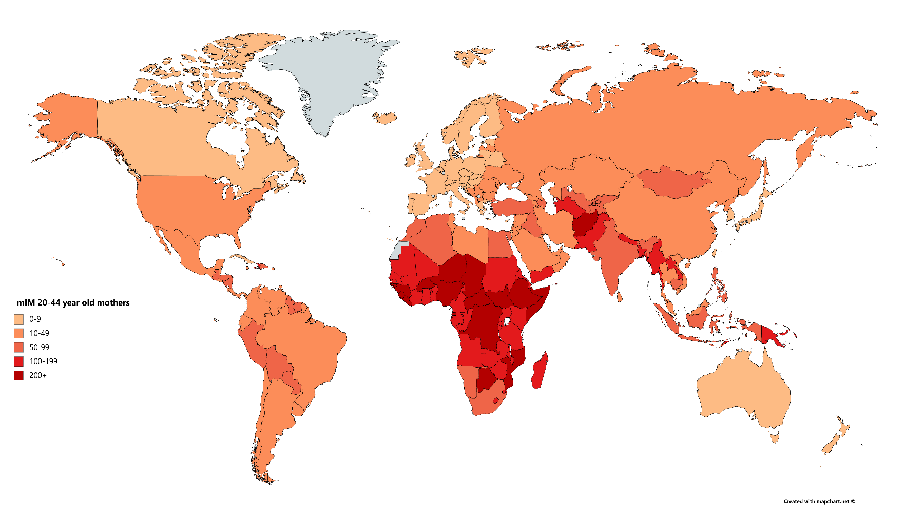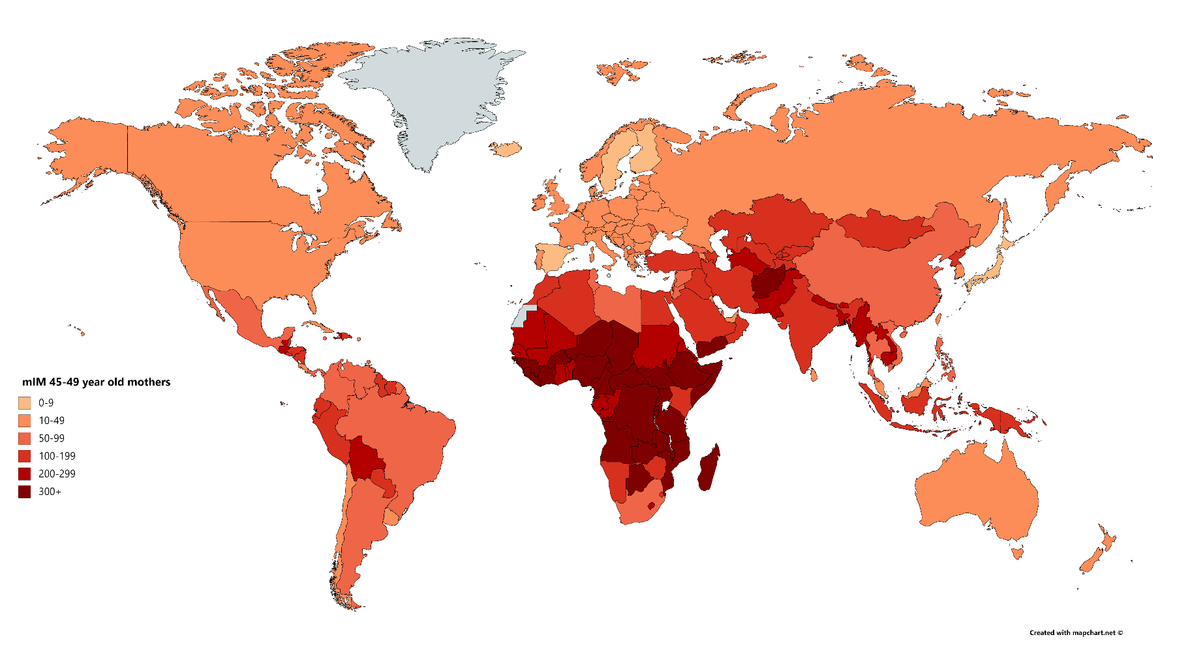

Figure 2. Maternal Under-Five Mortality (mIM) Indicators for mothers ages 15-44-years-old (top panel) and ages 45-49-years-old (bottom panel)

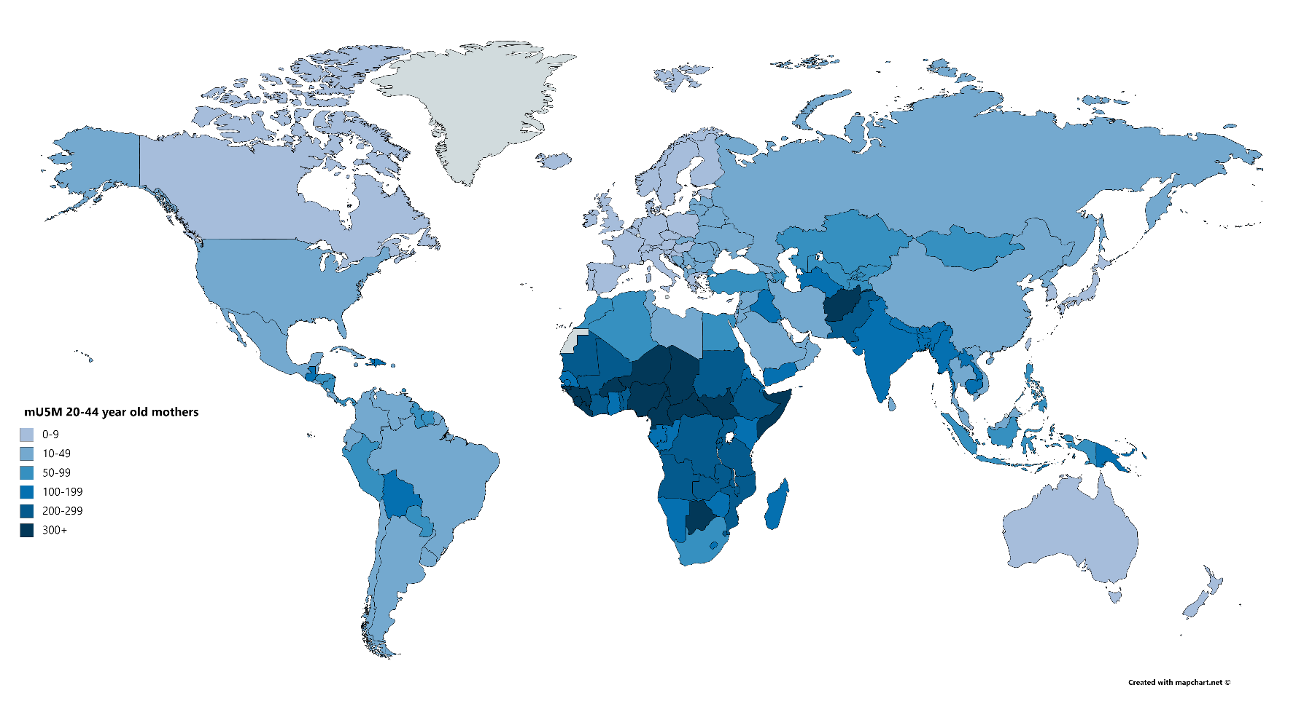

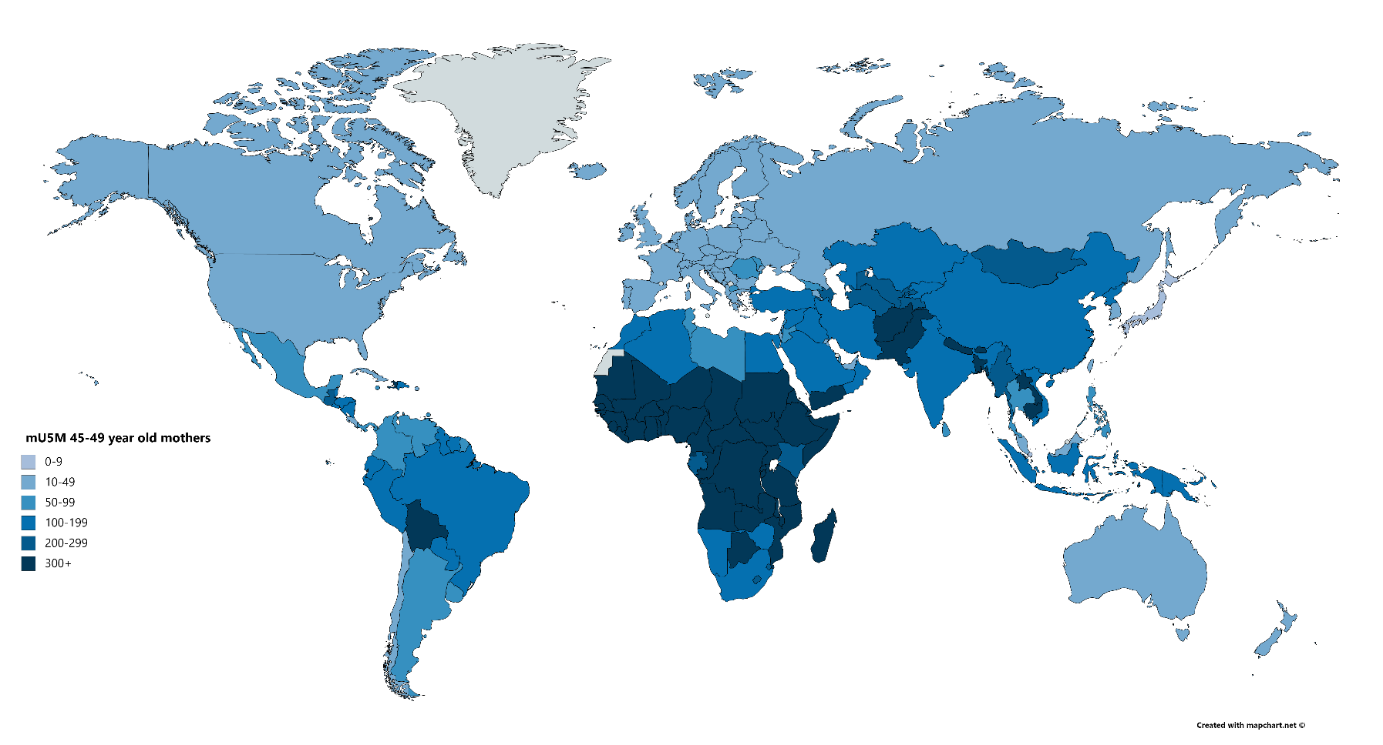

Figure 3. Maternal Offspring Mortality (mOM) Indicators for mothers ages 45-49-years-old

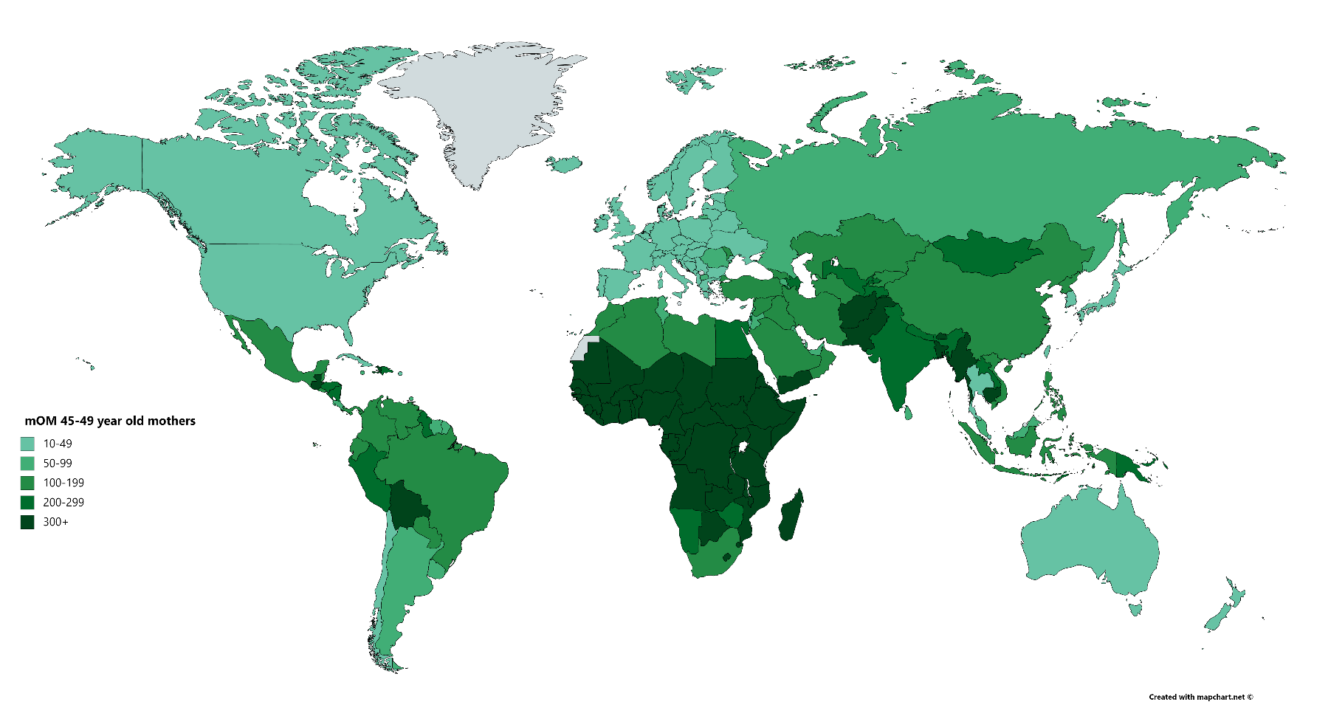

1. The public use surveys are available at <https://www.cdc.gov/nchs/nsfg/index.htm>. Because the NSFG did not include women ages 45-49 in only one survey round, and because of the small resulting sample for this age group, we rely on the indirect estimates of the mIM, mU5M, and mOm for older mothers.
2. These public use surveys, funded by the United States Agency for International Development (USAID) are available to researchers at <https://dhsprogram.com/>
3. Funded by UNICEF (these data are publicly available at <https://mics.unicef.org/>).
4. Given data constraints, we cannot include women bereaved by the loss of a fetus or stillbirth.
5. More than 95% of women in our survey estimates had their first child at age 14 or older; because our oldest respondents are 49 years old, children on which women were reporting could be no more than could be no more than 35 years old. Thus, these estimates pertain most to children who died between infancy and young adulthood.
6. UN WPP data are publicly available at: <https://population.un.org/wpp/>. The data offer historical and projected population estimates for 1950 to 2100. Note that, in select countries, UNWPP relies on model life tables given the lack of vital statistics. This is especially true in sub-Saharan Africa. Fortunately, DHS and MICS survey coverage is exceptionally high in sub-Saharan Africa.
7. UN WPP data rely on model life tables in select countries, especially those in sub-Saharan Africa.