**Global Estimates of Maternal Bereavement:**

**New Indicators of the Cumulative Prevalence of Child Loss in 168 Countries and Territories**

**Abstract**

**Background**

Social epidemiologists have established the negative health consequences of parental bereavement; yet we lack a standardized approach for estimating the prevalence of bereaved parents.

**Methods**

We generate indicators of the cumulative prevalence of mothers who have had an infant, under-five-year-old, or any-age child ever die by using publicly available survey data, and a novel, indirect approach that combines formal kinship models and life table methods. We label these measures the maternal cumulative prevalence of infant mortality (mIM), under-five mortality (mU5M), and offspring mortality (mOM) and generate prevalence estimates for 168 countries and territories.

**Results**

In several Asian and European countries, the mIM and mU5M are below 10 per 1000 mothers yet exceed 200 per 1000 mothers in many Middle Eastern and African countries. Global inequality in mothers’ experience of child loss is enormous: mothers in high-mortality-burden African countries are more than 100 times more likely to have had a child die than mothers in low-mortality-burden Asian and European countries. In more than 20 African countries, the mOM exceeds 500 per 1000 mothers, meaning it is typical for a surviving mother to be a bereaved mother.

**Conclusion**

The relationship between a country’s annualized infant and under-five mortality rates and parents’ cumulative experience of child death is not readily apparent; we must measure parental bereavement as a unique population feature. Our study reveals enormous global disparities in mothers’ experience of child loss and underscores the implications for the downstream mental and physical health risks associated with bereavement.

**Key Messages**

* Social epidemiology acknowledges the health significance of parental bereavement, yet we lack estimates of its global prevalence.
* We use survey data and indirect methods to generate three population-level bereavement indicators: the maternal cumulative prevalence of infant mortality (mIM), under-five mortality (mU5M), and offspring mortality (mOM).

Mothers in select Middle Eastern and sub-Saharan African countries are 100 times more likely to have experienced an infant or under-five child die than mothers in some Asian and European countries. In numerous African countries the mOM exceeds 500 per 1000 older mothers.

* Studying maternal bereavement reveals how health disparities accumulate in mothers’ lives, potentially exacerbating other social inequalities.

Infant and child mortality rates have declined steadily worldwide over the last fifty years.1 Even with periods of stagnant improvement, and persistent between- and within-country inequality, the global trends represent good news for children and their parents. The improvements in annualized rates of infant and child mortality, however, do not necessarily reflect in parents’ cumulative experience of child loss. A child’s death has serious consequences for parents, but population-level estimates of the prevalence of bereaved parents are available only for select sub-Saharan African countries.2 In multiple sub-Saharan African countries as recently as 2015, upwards of one-third of younger mothers (ages 20-44) and one-half of mothers age 45-49 years old have had at least one child die.2 It is unclear whether such high levels of maternal bereavement characterize other low- and middle-income countries, and how they compare to levels in high-income countries.

In this article, we offer a global perspective on maternal bereavement. Using data from 168 countries and territories, we generate three indicators of the cumulative prevalence of mothers who have had an infant, under-five year old, or any-age child ever die. We label these indicators: the maternal cumulative prevalence of infant mortality (mIM), under-five mortality (mU5M), and offspring mortality (mOM).2 We calculate these measures separately for two groups of mothers: those in the peak of their reproductive years (ages 20-44) and those nearing the end of their reproductive careers (ages 45-49). To achieve global coverage, we generate these indicators using survey data and an indirect estimation strategy using widely available age-specific fertility and mortality schedules.3

These country-level measures of maternal bereavement make two contributions. First, this exercise clarifies that the relationship between a country’s annualized infant and under-five mortality rates, which are contemporaneous, and parents’ experiences of child death, which are cumulative, is not readily apparent. The prevalence of bereaved parents is a truly unique aspect of a population’s epidemiological profile that results from a complex combination of its past and present mortality conditions and its fertility levels: childbearing patterns, child mortality conditions, and adult mortality conditions. That is, a mother’s cumulative risk of ever experiencing a child die is determined by the number of children she bears and the number of years she spends as a parent. The degree to which child deaths are dispersed across a population in a country, versus concentrated among a small, disadvantaged subgroup of mothers, also plays a role. Adult mortality conditions dictate how many bereaved mothers survive to share their experience versus how many also die prematurely, thereby erasing their account of child loss. Finally, the legacy of higher child mortality years earlier, when older mothers had their first child, will linger as an earlier maternal experience, further contributing to higher cumulative estimates of maternal bereavement than recent annualized mortality rates imply. The confounding influence of these population dynamics and epidemiological conditions mandate that we explicitly estimate the prevalence of bereaved mothers.

Second, these measures show the process by which infant, child, and adolescent mortality conditions accumulate and form a corresponding shadow population of bereaved parents—a population of parents that deserves public health attention. Cross-national inequalities in the burden of family bereavement both reflect disparate health environments and also create inequalities by generating the poor health outcomes associated with bereavement.2,4–8 A child’s death has profound and lasting influence on parents’ wellbeing, including their mental health9,10 and physical health and longevity.11,12 The consequences are especially severe for mothers, and the adverse effects of grief can persist for years—even decades.9,11,13 By clearly demonstrating the size and distribution of child loss as its own health burden, these metrics render visible an epidemiological disparity that has been overlooked in the global mortality literature.

**METHODS**

We first generate indicators of the maternal cumulative prevalence of child death directly using microdata from nationally representative surveys that collect full reproductive histories from female respondents. Then, to expand the global perspective further, we introduce a formal demographic approach that indirectly estimates the prevalence of bereaved mothers in a population.

Our direct estimation strategy makes use of three data sources. For the United States, we make use of the National Survey of Family Growth (NSFG) (2013-17). NSFG collects reproductive history calendars from women ages 15-44 years old (<https://www.cdc.gov/nchs/nsfg/index.htm>). Because the NSFG included women 45 years and older in only one survey round, and because of the small sample for this age group, we rely on the indirect estimates of the mIM, mU5M, and mOM for older mothers. For 56 countries across Africa, Asia, Europe, Latin America and the Caribbean, and Oceania, we leverage data from the Demographic and Health Surveys (DHS) program. DHS data come from household surveys that collect detailed information from various household members, including women ages 15-49, and were collected between 2010 and 2018 (accessible at <https://dhsprogram.com/>). Finally, for 32 additional countries in Africa, Asia, Europe, and Latin America and the Caribbean that lack recent DHS data, we make use of Multiple Indicator Cluster Surveys (MICS), which come from household surveys collected between 2010-2018 (accessible at <https://mics.unicef.org/>). Supplementary Table S1 lists all countries, data sources, survey years, and sample sizes.

In each survey, we restrict the analytic sample to women who have had at least one live birth (i.e., the women exposed to the risk of child death) and use women’s reproductive histories, specifically the vital status of each child and, for those deceased, the age at death, to calculate the mIM, mU5M, and mOM. Given data constraints, we cannot include bereavement associated with pregnancy loss. To estimate the mIM, we sum the number of mothers who had a child die before age one among those who ever had a live birth and express this per 1000 mothers. To estimate the mU5M, we do the same for mothers who ever had a child die before reaching age five. The mOM indexes the collective experience of a child death, regardless of that child’s age. More than 95% of women in our survey estimates had their first child at age 14 or older; because our oldest respondents are 49 years old, children on which women were reporting could be no more than 35 years old. Thus, these estimates pertain specifically to children who died between infancy and early adulthood. Due to censoring, we calculate the mOM for 45- to 49-year-old mothers only.

Not all countries regularly collect publicly-available surveys with detailed reproductive histories; our indirect kin-cohort approach allows us to estimate the prevalence of bereaved mothers from publicly-available demographic data from the United Nations World Population Prospects (UNWPP, estimates from the 1950-2020 period and projections, medium scenario, for 2020-2100) (<https://population.un.org/wpp/>). This approach extends the Goodman-Keyfitz-Pullum kinship equations from mathematical demography14 to non-stable populations with changing demographic rates and combines them with standard life table methods.

Specifically, we use discrete kinship equations to determine the age-specific probability that an average woman will experience the death of an infant, child under age five, or older child. With these probabilities, we construct life tables to estimate the age- and cohort-specific fractions of women who ever experienced the death of a child. To do so, we account for the mortality of women using estimated country-specific life tables from the UNWPP data. Note that in select countries, mostly in Africa, the UNWPP data relies on model life tables given the lack of vital statistics; fortunately, our survey coverage is exceptionally high in sub-Saharan Africa. We then solve for the proportion of women (per 1000 mothers) who have ever lost a child. Next, we use a different set of life table equations to estimate the proportion of mothers, rather than all women, who have experienced the death of an offspring. We consider fertility as a “hazard rate” to approximate the number of women that have had at least one child at specific ages after experiencing a set of age-specific fertility rates. We then define, for a given cohort, the proportion of mothers (per 1000 mothers) who have ever lost a child of a specific age. We convert our cohort estimate to period estimates so that they are interpreted exactly as the direct survey estimates and refer to a child’s death before age one (mIM), age five (mU5M), or any age (mOM). Note that for countries with no survey estimates, our kin-cohort estimates refer to calendar year 2016—the modal year of survey coverage.

In presenting results of maternal bereavement, we prioritize the survey-based estimates and only rely on the indirectly generated kin-cohort estimates for populations where survey data were unavailable (kin-cohort estimates are italicized in Table S1). Although we have almost complete survey coverage in Africa, we rely more heavily on the indirect estimates for all other world regions. Thus, for the 45 countries and territories with survey data in these other world regions, we also generated estimates using the kin-cohort method for comparison. As shown in Supplementary Figure S1, we found high correspondence: the two estimation strategies produced values that were, on average, less than a fraction of a one % different for 20-44 year old mothers (mIM and mU5M) and between 3-5% for older mothers (mIM, mU5M, mOM). When the measures diverge, the indirect approach tends to yield slightly higher estimates of bereavement than the survey estimates, possibly because the indirect approach cannot account for the clustering of deaths to specific mothers. Thus, because we rely on the kin-cohort method for several countries in Asia and Europe, our estimates of the child loss burden in these low-mortality-burden regions may be elevated; thus, any comparison drawn between these contexts and Africa—a high-mortality-burden region where we have almost complete survey coverage—may be conservative. In select cases, the kin-cohort method produces estimates that are lower than the survey-based estimates (see Figure S1). This could be because child deaths are underestimated in the survey data; even though the survey estimates are derived from nationally representative samples, mothers may underreport the deaths of children or there may be hard-to-reach populations—including those affected by conflict and thus more burdened by child loss—that are underrepresented in national surveys.

**RESULTS**

**Maternal Burden of Infant Mortality**

**Fig. 1** maps the mIM for young mothers (20-44 years old), offering a worldwide portrait of the prevalence of mothers who have experienced an infant death. In 13 countries and territories, fewer than 5 per 1000 of mothers 20-44 have ever lost an infant (Hong Kong, Japan, Singapore, South Korea, Czech Republic, Slovenia, Finland, Iceland, Italy, Norway, Portugal, Spain, Sweden; see Table S1). The mIM is slightly higher in the United States, where NSFG survey data shows that 7.2 per 1000 mothers have lost a child.

In more than 30 countries, the mIM exceeds 150 per 1000 mothers ages 20-44 years old. And in as many as 16 of these countries, all located in sub-Saharan Africa and the Middle East, more than 200 per 1000 younger mothers have lost an infant (Afghanistan, Burkina Faso, Central African Republic, Chad, Democratic Republic of the Congo, Ethiopia, Equatorial Guinea, Guinea, Guinea-Bissau, Liberia, Mozambique, Niger, Nigeria, Sierra Leone, Somalia, and South Sudan; see Table S1).

The mIM indexes a profound inequality that mothers in different countries endure and shows this inequality to be even more pronounced than differences in annualized child-centered mortality metrics imply. Overall, the global range of mIM values for mothers ages 20-44 stretches from the low of 2.2 per 1000 mothers in Hong Kong to 303.3 per 1000 mothers in Sierra Leone. This difference far exceeds the discrepancy between the two populations’ infant mortality rates. Infants born in Sierra Leone are 67 times more likely to die than those born in Hong Kong (95.5 versus 1.4 infant deaths per 1000 live births), but young mothers in Sierra Leone are 138 times more likely to have experienced a child die than their counterparts in Hong Kong.

**Fig. 2** presents the mIM estimates for older mothers (45-49 years old), which of course are higher than results for mothers 20-44 years old. In Hong Kong, Finland, Iceland, Japan, Singapore, Spain, and Sweden, fewer than 10 per 1000 of older mothers have lost an infant. In more than 50 countries across the Middle East and sub-Saharan Africa, however, over 200 per 1000 mothers ages 45-49 have. Older mothers in Liberia (mIM of 465.3 per 1000 mothers) are 78 times more likely to have experienced an infant die than older mothers in Hong Kong, the country with the lowest recorded mIM for older mothers (6.0 per 1000 mothers). Global inequalityin infant loss for older mothers is smaller than that for younger mothers, possibly due to the legacy of higher mortality worldwide, or because a disproportionate number of bereaved mothers in the highest mortality contexts have also died prematurely, resulting in their erasure from the population estimates of bereavement.

**Maternal Burden of Under-Five Mortality (mU5M)**

**Fig. 3** maps the mU5M for younger mothers, summarizing the prevalence of mothers (20-44 years old) who have experienced a child die between birth and age five. The list of very low-mortality-burden countries and territories is similar to that for the mIM; in Hong Kong, Finland, Iceland, Japan, Singapore, Slovenia, Spain, and Sweden, fewer than 5 per 1000 young mothers have experienced a child die before age five. In the United States, nearly 15 per 1000 younger mothers have lost a young child; a prevalence of bereaved mothers comparable to the levels observed in Latvia, Malaysia, Puerto Rico, and Serbia. In more than a dozen countries across the Middle East and West and Central Africa, however, more than 300 per 1000 mothers have lost a child (Afghanistan, Burkina Faso, Cameroon, Central African Republic, Chad, Equatorial Guinea, Guinea, Guinea-Bissau, Liberia, Niger, Nigeria, Sierra Leone, Somalia, and South Sudan; see Table S1). Globally, the mU5M for mothers 20-44 years old ranges from 3.2 per 1000 mothers in Hong Kong to 437.2 per 1000 in Niger. As with the mIM, the inequality in mothers’ experiences of under-five mortality far exceeds both current and historical differences in the under-five mortality rates themselves: the mU5M in Niger is 137 times that of Hong Kong, though the under-five mortality rate in the former is only 49 times higher than the latter (2.2 child deaths per 1000 in Hong Kong versus 108.7 per 1000 in Niger).

As expected, the mU5M levels are even higher for older mothers who entered motherhood during higher mortality conditions, have been mothers for several years, and typically have more children—all factors that increase their exposure and risk of child loss. **Fig. 4** shows a picture that is consistent with the previous three: in very-low-mU5M countries, fewer than 30 per 1000 mothers have ever lost a child, and in Hong Kong, Japan, and Singapore, the estimates are less than 10 per 1000. Yet nearly 50 countries have levels of maternal loss of children under age five that are ten times higher—this means that in one-third of countries, nearly one-third of older mothers have experienced a young child die. In total, the estimates range from 8.2 (Hong Kong) to 705.7 per 1000 mothers (Niger).

Additional comparisons of the mIM and mU5M versus the infant and under-five mortality rates (also shown in the SI Table) underscore that our explicitly maternal perspective reveals global patterns of bereavement that are not captured by annualized infant and child mortality indicators. Among the 20 countries with the lowest infant or child mortality rates, nine do notfeature among the 20 countries with the lowest mIMs and mU5Ms. Similarly, 10 of the top 20 countries with the highest mIMs and mU5Ms do not feature the highest infant and under-five mortality rates. Along these same lines, even as mIM and mU5M values are, on average, lower in the countries and territories that have achieved the levels of infant and under-five mortality stated in Goal 3.2 of the Sustainable Development Goals (SDG)15 than those that have not, there is far from perfect correspondence. Several countries and territories that have achieved the SDG goals for infant and child mortality have higher levels of maternal bereavement than countries that have yet to achieve these goals, while a handful of countries that have not met the SDG goals have relatively low levels of maternal bereavement. These comparisons attest to the importance of an explicitly maternal perspective to avoid overlooking countries with a higher than realized maternal burden of child loss despite recent child health success.

**Maternal Burden of Offspring Mortality (mOM)**

Despite the global emphasis on measuring and monitoring mortality among children under age five, parents’ risk of losing a child persists beyond a child’s fifth birthday. Thus, to understand the total burden of child loss, regardless of the child’s age at the time of death, **Fig. 5** depicts the mOM, capturing the burden of all offspring mortality among mothers 45-49 years old. As expected, the global patterning of mOM values closely aligns with those of the mIM and mU5M: where many surviving mothers have had an infant or under-five year old die, many have lost adolescent and young adult children, too. The prevailing pattern across high-income Asian and European countries is that fewer than 30 per 1000 mothers have ever lost a child. In more than 50 countries in Africa, Latin America, the Middle East, and Southeast Asia, however, the mOM levels are at least 10 times higher: in these countries, more than 30% of mothers have ever lost a child. In 22 countries—all within sub-Saharan Africa—more than 50% of older mothers have had a child die.

**DISCUSSION**

We formalized an accurate and systematic way to measure maternal bereavement and identified enormous disparities in the burden of child loss across the globe—disparities that cannot be gleaned from child-centered measures of mortality. Even as infant and mortality conditions improve worldwide, mothers in some countries in the global south are more than 10 times as likely to have had a child die than those in high-income countries; across much of sub-Saharan Africa, mothers are more than 100 times more likely to have experienced a child die than are mothers who inhabit the world’s low-mortality-burden enclaves.

Overlaying these findings with the sheer absence of research on parental bereavement in low-income countries highlights yet another a meta-inequality: the world regions in which child loss is concentrated have only rarely been the focus of empirical research dedicated to quantifying and assessing the consequences of this experience. The unequal bereavement burden is a fundamental aspect of global health inequality. The maternal cumulative prevalence of infant, under-five, and all offspring mortality estimates are valuable metrics that show the extent to which epidemiological inequalities accumulate in mothers’ lives, shedding new light on a vital dimension of population health.

**REFERENCES**

1. Wang, H. *et al.* Global, regional, and national levels of neonatal, infant, and under-5 mortality during 1990–2013: a systematic analysis for the Global Burden of Disease Study 2013. *The Lancet* **384**, 957–979 (2014).

2. Smith-Greenaway, E. & Trinitapoli, J. Maternal cumulative prevalence measures of child mortality show heavy burden in sub-Saharan Africa. *Proceedings of the National Academy of Sciences* **117**, 4027–4033 (2020).

3. Alburez-Gutierrez, D., Kolk, M. & Zagheni, E. Women’s experience of child death over the life course: A global demographic perspective. (2019).

4. Fletcher, J., Mailick, M., Song, J. & Wolfe, B. A sibling death in the family: Common and consequential. *Demography* **50**, 803–826 (2013).

5. Thomas, K. J. Child deaths in the past, their consequences in the present, and mortality conditions in sub-Saharan Africa. *Proceedings of the National Academy of Sciences* **117**, 4453–4455 (2020).

6. Umberson, D. *et al.* Death of family members as an overlooked source of racial disadvantage in the United States. *Proceedings of the National Academy of Sciences* **114**, 915–920 (2017).

7. Verdery, A. M., Smith-Greenaway, E., Margolis, R. & Daw, J. Tracking the reach of COVID-19 kin loss with a bereavement multiplier applied to the United States. *Proceedings of the National Academy of Sciences* **117**, 17695–17701 (2020).

8. Verdery, A. M. & Margolis, R. Projections of white and black older adults without living kin in the United States, 2015 to 2060. *Proceedings of the National Academy of Sciences* **114**, 11109–11114 (2017).

9. Rogers, C. H., Floyd, F. J., Seltzer, M. M., Greenberg, J. & Hong, J. Long-term effects of the death of a child on parents’ adjustment in midlife. *Journal of family psychology* **22**, 203 (2008).

10. Song, J., Floyd, F. J., Seltzer, M. M., Greenberg, J. S. & Hong, J. Long‐Term Effects of Child Death on Parents’ Health‐Related Quality of Life: A Dyadic Analysis. *Family relations* **59**, 269–282 (2010).

11. Li, J., Precht, D. H., Mortensen, P. B. & Olsen, J. Mortality in parents after death of a child in Denmark: a nationwide follow-up study. *The lancet* **361**, 363–367 (2003).

12. Rostila, M., Saarela, J. & Kawachi, I. The forgotten griever: a nationwide follow-up study of mortality subsequent to the death of a sibling. *American journal of epidemiology* **176**, 338–346 (2012).

13. Li, J., Laursen, T. M., Precht, D. H., Olsen, J. & Mortensen, P. B. Hospitalization for mental illness among parents after the death of a child. *New England Journal of Medicine* **352**, 1190–1196 (2005).

14. Keyfitz, N. *Applied mathematical demography*. (Springer, 1985).

15. GA, U. Transforming our world: the 2030 Agenda for Sustainable Development. *Division for Sustainable Development Goals: New York, NY, USA* (2015).

Fig. 1. Maternal infant mortality (mIM) indicator for mothers 20-44-years-old

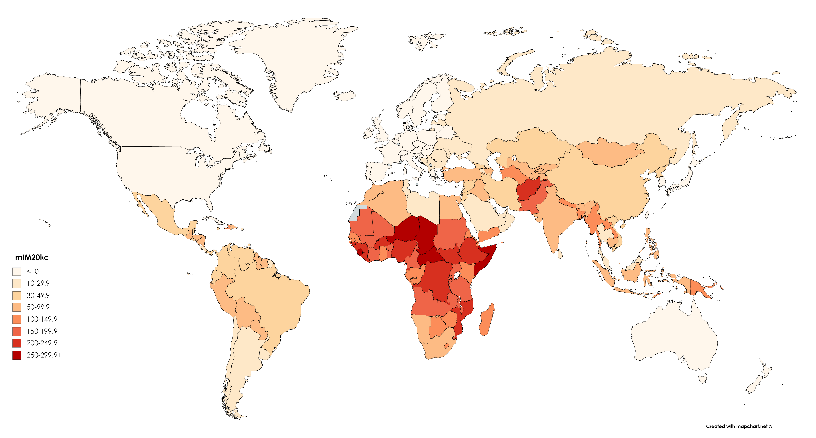

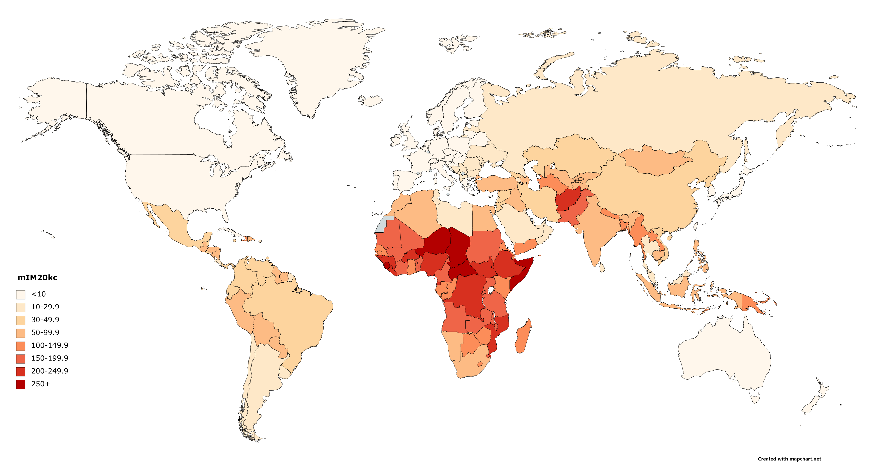

Note: See supplementary Table S1 for list of estimates and data sources

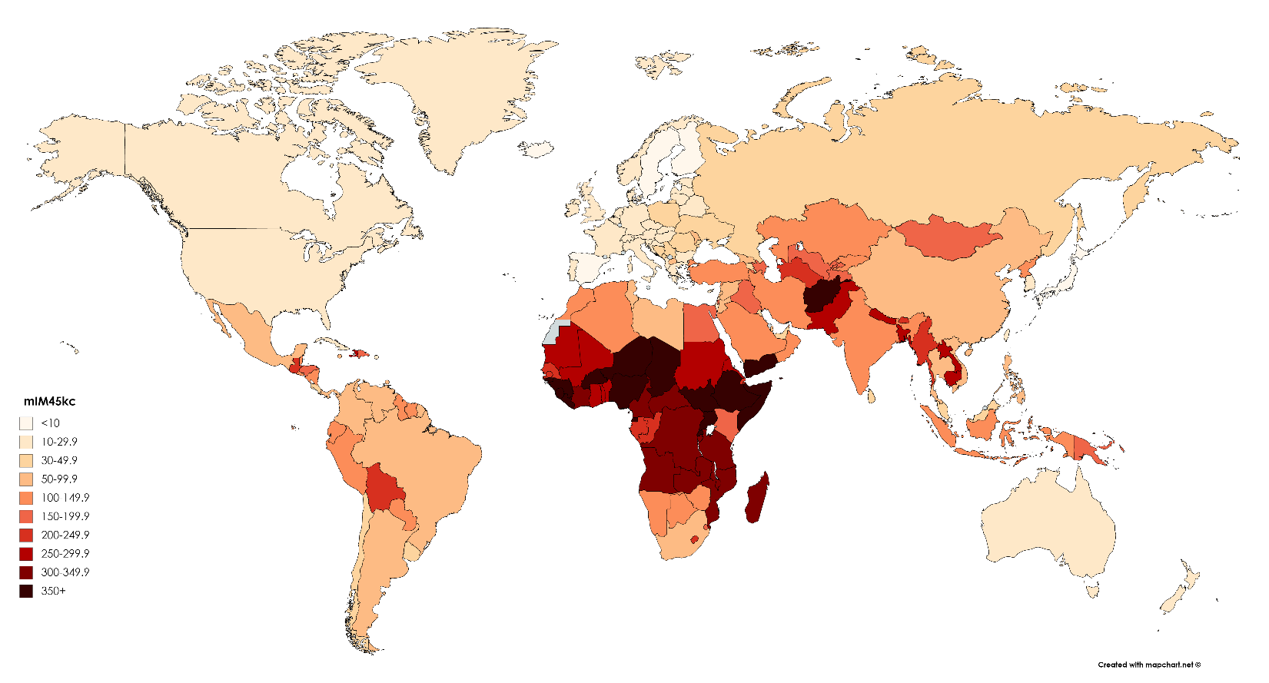Fig. 2. Maternal infant mortality (mIM) indicator for mothers 45-49-years-old

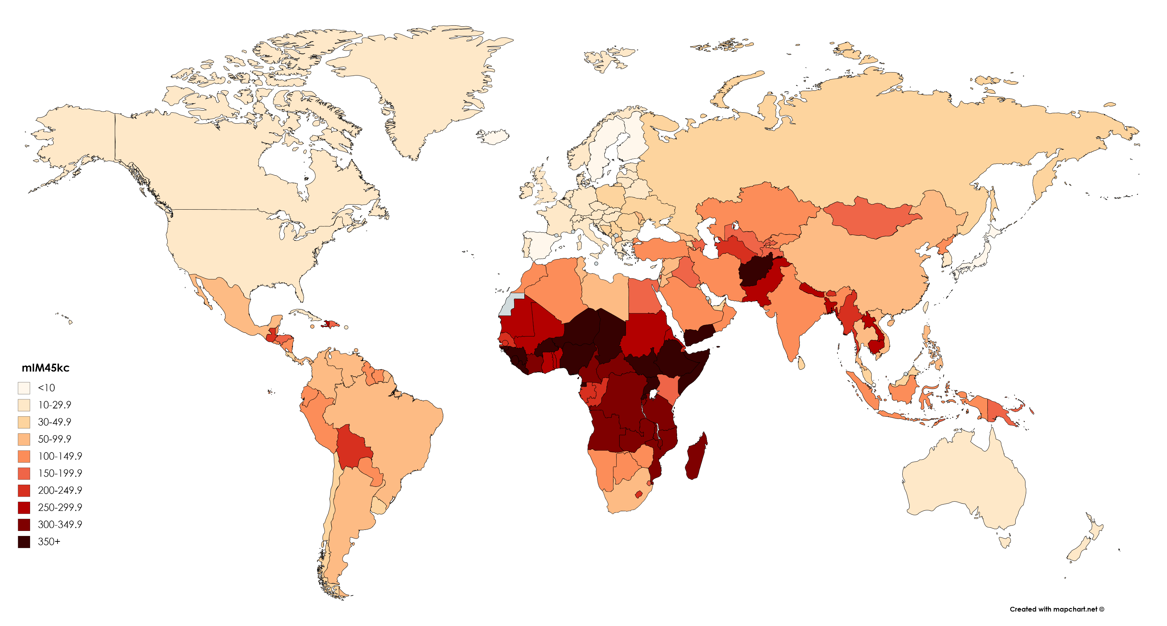

Note: See supplementary Table S1 for list of estimates and data sources

Fig. 3. Maternal under-five mortality (mIM) indicator for mothers ages 20-44-years-old

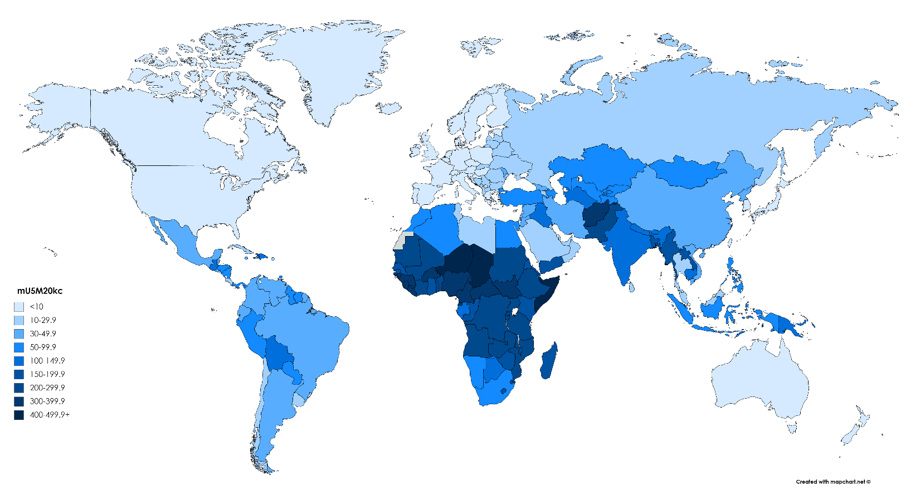

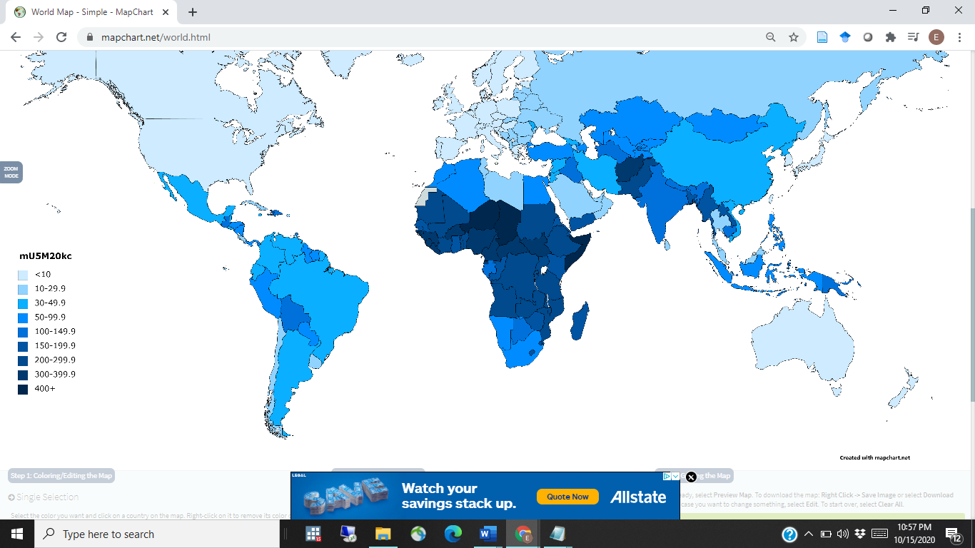

Note: see Supplementary Table S1 for list of estimates and data sources

Fig. 4. Maternal under-five mortality (mIM) indicator for mothers ages 45-49-years-old

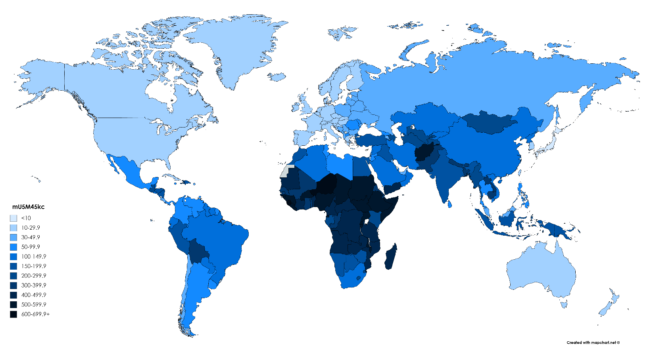

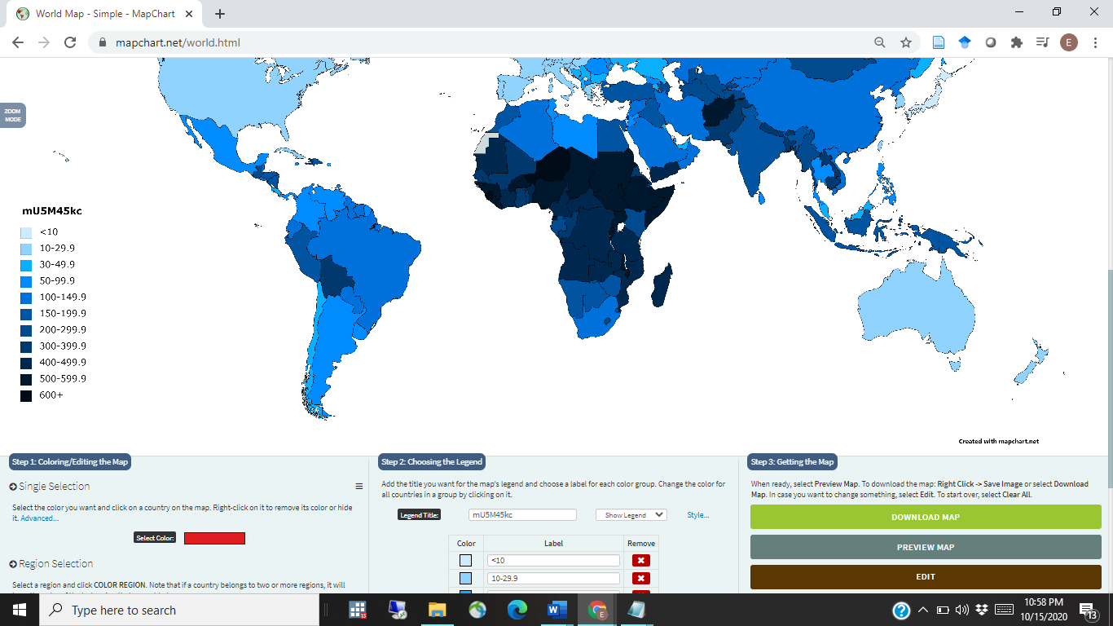

Note: See supplementary Table S1 for list of estimates and data sources

Fig. 5. Maternal offspring mortality (mOM) indicator for mothers ages 45-49-years-old

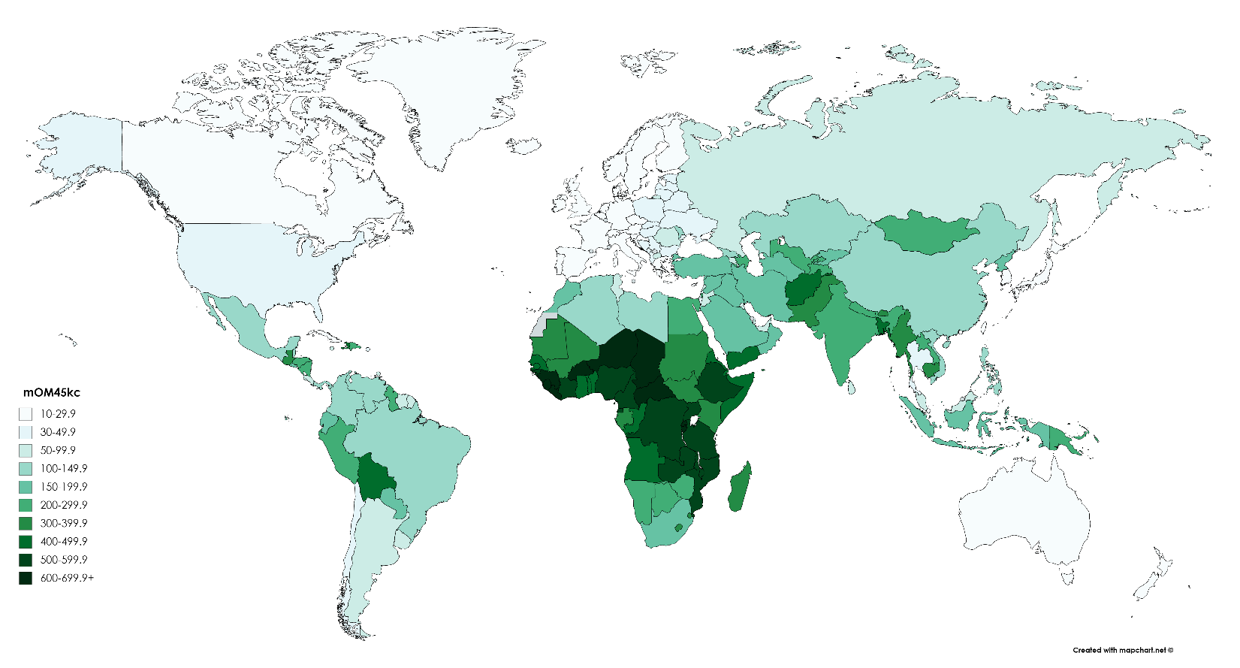

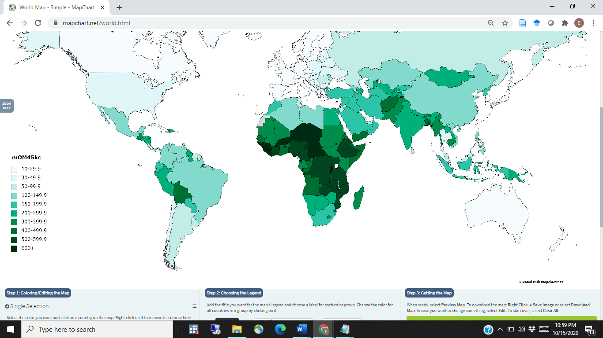

Note: See supplementary Table S1 for list of estimates and data sources