20200213

By “improving” the estimates since 31 Jan 2020, I actually made them worse.

This is the 31 Jan estimate:

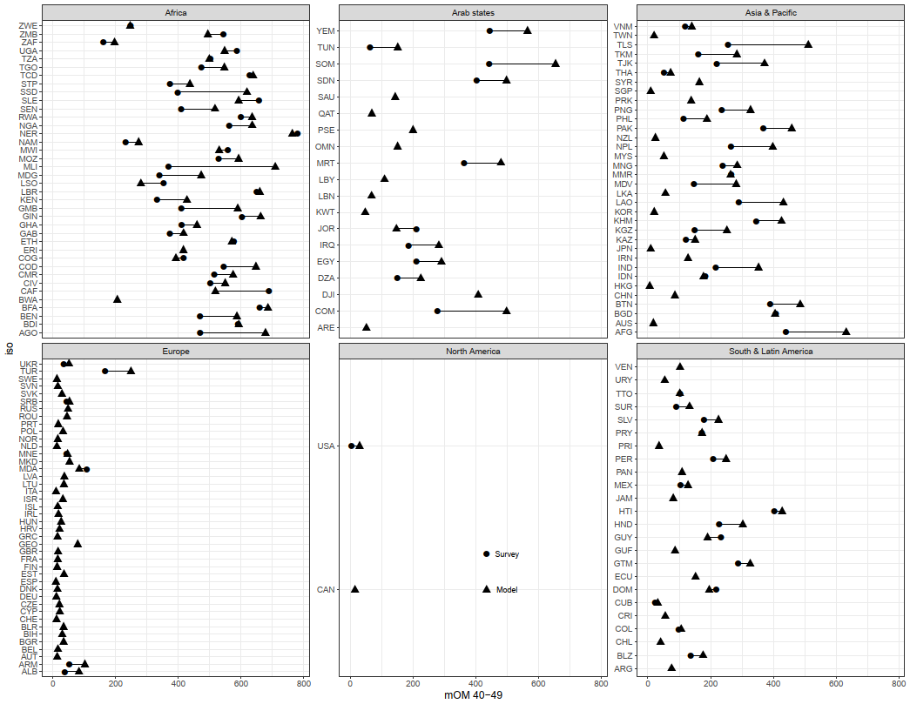

This is the 13 February 2020 one:

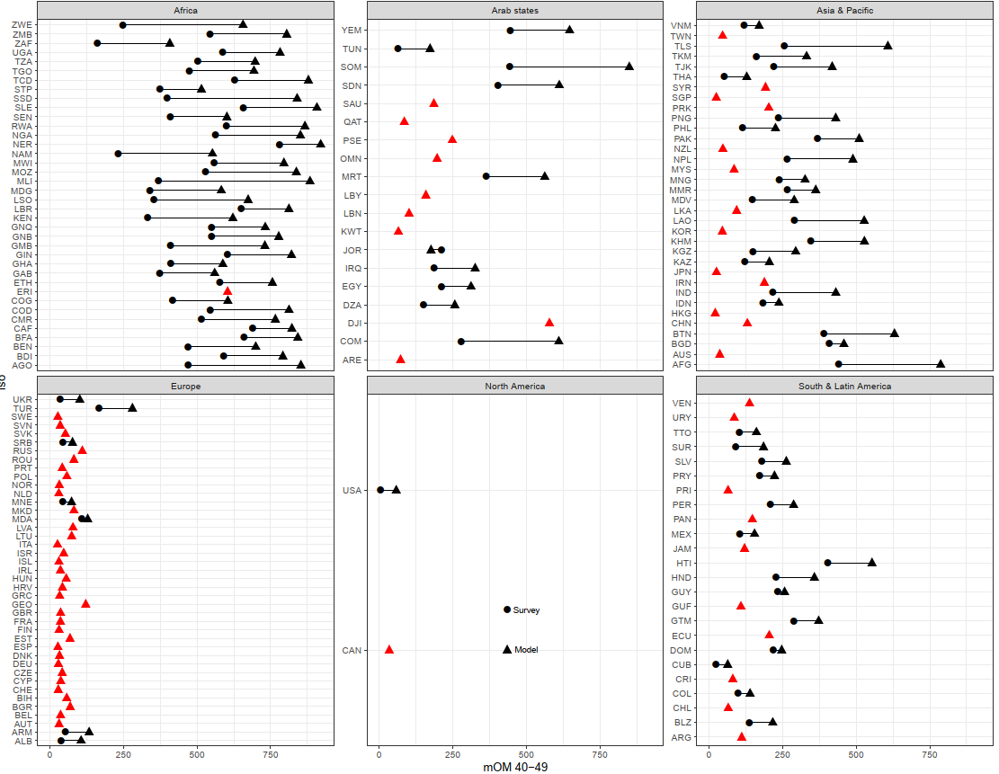

Compare commits “**update model**” (the last one with correct estimates) and “**wrapped estimates in function**” (the first one where estimates fail). Do this in Github, since they are adjacent commits:

<https://github.com/alburezg/child_death_infant/commit/523646f758be5c718e2dfe9dafde88d299285a6e>

**Workflow of things that could have gone wrong**

1. Data Formatting
   1. Expanding ASFR
      1. Increased max age to 50
   2. Matrix of survival probs
      1. Age limit
      2. Check if I edited function, but I don’t think so
2. Analysis
   1. Cumulative mortality
      1. Edited functions to add max_child_age parameter
         1. worker_child_loss
         2. expected_child_death
         3. survival_probs_over_age
      2. abs_df_all has higher values in new commit at all ages for level “0_100”
      3. Wrapped up in functions
         1. No relevant since MoM should not be affected by other values of k
      4. Childless: changed from qx to hazard rate
      5. Delta CD: changed from qx to hazard rate
3. D_cumulative_offspring_mortality
   1. 4_compare_model_survey
      1. Check that same Emily file used for comparisson
      2. Check that right columns are selected from both model and surv dfs
      3. Check that all countries are matche din graph (eg VNM for mim45) – actually this might be right since some of the ones not shown are from the indirect estimations
      4. Add indirect estimation to plot

Track commits