Assignment 4: Build Non-Linear Models Part 2
Abigail Albury-Bloom
National University
DDS-8555 Predictive Analysis
Dr. Mohammad Yavarimanesh
November 23, 2025

Conceptual Question 3 (ISLR p. 326)
This question analyzes a model composed of two basis functions: b₁(X) = X and b₂(X) = (X − 1)²I(X ≥ 1). These basis functions define a piecewise regression curve. For X < 1, the prediction equation simplifies to a linear function with slope 1. For X ≥ 1, the activation of the squared term produces a downward-opening parabola. Despite the change in curvature, both the value and slope remain continuous at X = 1, illustrating how basis expansions allow models to flexibly capture structural shifts in predictor–response relationships (James et al., 2021; Wood, 2017).

Applied Question 8 (ISLR p. 327)
To determine whether non-linear patterns exist in the Auto dataset, three models were fitted: a linear regression model, a cubic polynomial regression model, and a natural spline model. The linear model demonstrated systematic residual patterns, indicating underfitting. Both the polynomial and spline models captured a pronounced non-linear relationship between horsepower and MPG, characterized by a steep decline at lower horsepower values and a plateau at higher values. These results demonstrate strong evidence of non-linearity and highlight the importance of flexible regression techniques when relationships are not adequately modeled by straight-line fits (James et al., 2021; Harrell, 2015).

Executive Summary
This week’s lecture and assigned readings introduced two central approaches for modeling non-linear relationships in regression analysis: polynomial regression and spline-based regression. Polynomial regression expands a linear model by incorporating higher-order transformations of predictors, which allows the fitted function to reflect smooth global curvature. Spline-based regression provides greater local flexibility by partitioning the predictor into segments and fitting lower-degree polynomials within each segment while maintaining smoothness at the boundaries. These methods offer more accurate representations of real-world relationships that do not follow a straight-line pattern (Harrell, 2015; Wood, 2017).
The usefulness of these approaches was demonstrated through their application to the Auto dataset. When predicting miles per gallon from horsepower, both polynomial and spline models captured the curved, non-linear relationship more effectively than a simple linear regression model. Visual patterns and residual diagnostics confirmed that non-linear methods produced better model fits and reduced systematic errors, which aligns with recommended practices in statistical learning when curvature is present in the data (James et al., 2021; Jolliffe & Cadima, 2016).
These modeling strategies were also applied to the Abalone dataset for the Kaggle competition. A polynomial regression model using all numeric predictors generated a flexible global fit that incorporated interactions and curvature across several measurements. A spline-based model applied to Length provided a more targeted representation of local changes, allowing the model to reflect nuanced relationships between shell length and the number of rings. Diagnostic plots and error metrics supported the conclusion that non-linear regression approaches were more suitable than linear alternatives for this dataset (Little & Rubin, 2019; Harrell, 2015; Wood, 2017).
Overall, polynomial and spline-based regression models demonstrated clear advantages in modeling complex patterns and improving prediction accuracy. These methods illustrate the importance of selecting modeling techniques that match the underlying structure of the data rather than relying solely on linear assumptions.

Kaggle Submission Evidence
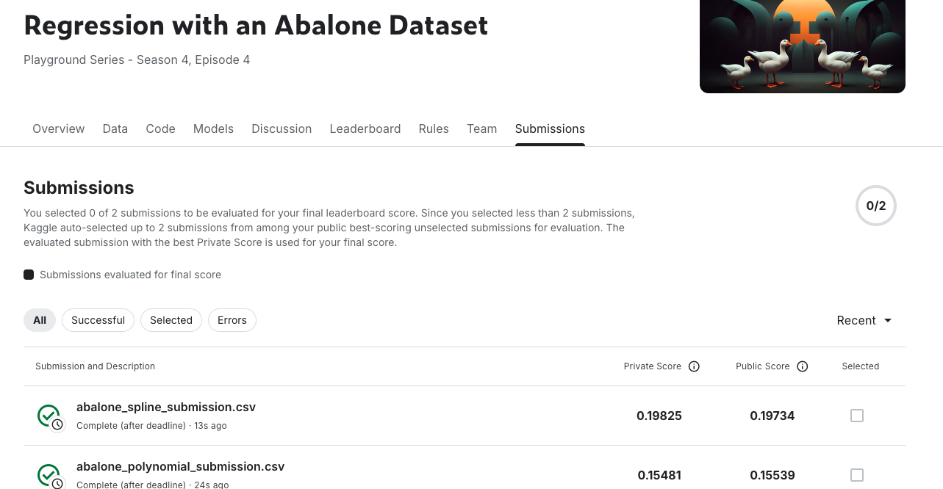

GitHub Repository Link
https://github.com/alburybloom/DDS8555-4

References
Harrell, F. E. (2015). Regression modeling strategies (2nd ed.). Springer.
James, G., Witten, D., Hastie, T., & Tibshirani, R. (2021). *An introduction to statistical learning with Python*. Springer.
Jolliffe, I. T., & Cadima, J. (2016). Principal component analysis: A review and recent developments. Philosophical Transactions of the Royal Society A, 374(2065), 20150202.
Little, R. J. A., & Rubin, D. B. (2019). Statistical analysis with missing data (3rd ed.). Wiley.
Wood, S. N. (2017). Generalized additive models: An introduction with R (2nd ed.). CRC Press.

