Template for an Acta IMEKO paper

Thomas Bruns1, Dirk Röske1, Paul P. L. Regtien2, Francisco Alegria3

1 Physikalisch-Technische Bundesanstalt, Bundesallee 100, 38116 Braunschweig, Germany   
2 Measurement Science Consultancy, Julia Culpstraat 66, 7558JB Hengelo, The Netherlands   
3 Instituto de Telecomunicações and Instituto Superior Técnico, Universidade Técnica de Lisboa, Av. Rovisco Pais 1, 1049-001 Lisbon, Portugal

ABSTRACT

The editorial team of Acta IMEKO encourages authors to follow the instructions as described in this template file to produce their manuscript. The paper must be written in clear British English, and figures should be of high quality, readable without the need to zoom in on details or legends. The abstract should contain the essentials of the paper. Important items are the aim of the research, the basic method and the major achievement (also numerically, when applicable). The length of the abstract should not exceed 200 words.

Section: RESEARCH PAPER

**Keywords:** Journal; template; IMEKO; Microsoft Word (NOTE the semicolon as separator.)

**Citation:** Authors, Template for an Acta IMEKO paper, Acta IMEKO, vol. 13 (2024) no. 1, pp. 1-6. DOI: 10.21014/actaimeko.v13i1.1

**Section Editor:** Section Editor

**Received** January 1, 2024; **In final form** January 31, 2024; **Published** March 2024

**Copyright:** This is an open-access article distributed under the terms of the Creative Commons Attribution 3.0 License, which permits unrestricted use, distribution, and reproduction in any medium, provided the original author and source are credited.

**Funding:** [Optional, if applicable] This work was supported by Measurement Science Consultancy, The Netherlands.

Corresponding author: Paul P. L. Regtien, e-mail: [paul@regtien.net](mailto:paul@regtien.net)

1. Introduction

The introduction describes the background of the research, a short review of related research published in recent literature, together with the major claims setting the framework of the present publication. References should be related to the present publication, not just a list of papers merrily showing the authors’ knowledge of the literature. This relation must be made explicit. The newly presented method is shortly introduced, as an alternative to previously published methods, with mention of the advantages aimed at.

To minimize editing by the editorial team, authors are asked to follow the styles that go with this template. The font size of the body text is 10 pt and the font type is Garamond. For the header of a section use the style named “Level1Title”.

The introduction ends with an outline of the remainder of the paper, for instance as follows. In Section 2 we will discuss how the paper can be divided in sections and subsections, and an indication of the use of numbering and heading format is outlined. In the next two sections the use of illustrations and equations is described. In Section 5 methods for citing references are given. Finally, in the concluding section the major rules are summarized.

Please do NOT change the template. The metadata (citation, section editor and article dates) will be updated during the production phase.

**Submission hints:**

* During the paper submission to the journal’s website please make sure that all (co-)authors are given and their order is the same as in the paper. Later changes cannot be made by submitters, only by journal editors.
* Please indicate the related track (for example, TC4 2023, TC4 Metroarchaeo 2023) in the comments to the editor. If there is no relation to a given TC track, type "General track".
* Please explain the novelty of the paper (what is the extension to a former paper) in the comments to the editor OR in a separate cover letter.

1. First Page

The first page should have the title of the paper, the authors names (do not use initials for the first and last name), and the author affiliations.

Following should be an abstract and 3 to 5 keywords separated by a semicolon. The next 4 items (citation, editor, dates and copyright) are to be updated by the editor. The paper information section ends with reference to the funding (leave blank if not applicable) and the name and email address of the corresponding author.

The header and footer have information about the publication that is to be updated by the editor. Page numbers appear in the bottom right corner and are updated automatically.

1. About sections

The body of the paper is divided into sections and, when readability requires it, subsections. This helps the reader to recognize the various elements of the paper, such as background theory, modelling and simulations, experimental setup, experimental results with evaluation, conclusions, references, acknowledgements and, when appropriate, appendices.

Pages should be laid out using two columns, as done in most journals, to increase readability.

* 1. Subsections

If a section is long or deals with different topics, make a subdivision in subsections. Avoid further subdivision of a subsection. When subsections are used, there must be at least two. Use the style named “Level2Title” for the header of a subsection.

* 1. Numbering of subsections

Subsection numbering follows the outline numbering format which is configured in the template. Subsection headings use the Calibri font and are in bold.

This template uses automatic outlined numbering for the sections and subsections. We recommend that the author makes use of this feature. If the author does not feel comfortable with it, he may choose to manually number the sections and subsections.

Configuring a blank Word document to use automatic outline numbering is not always as straightforward as it should be. We point out, nevertheless, that the configuration is already done in this template and the author just can use it. It suffices to place the cursor in the section or subsection title and select the "Level1Title" or "Level2Title" styles already available from the menu or ribbon. This simple procedure is the same that should be used for all other parts of the paper (paper title, main text, abstract, etc.). The author does not have to worry about the numbering at all.

An even simpler procedure would be just to copy and paste an existing section or subsection title and rewrite the text. The author, however, can choose to use manual numbering by deleting the automatic number that comes with the use of the proper style and input the numbers he wishes for each section.

1. About figures and tables
   1. Location

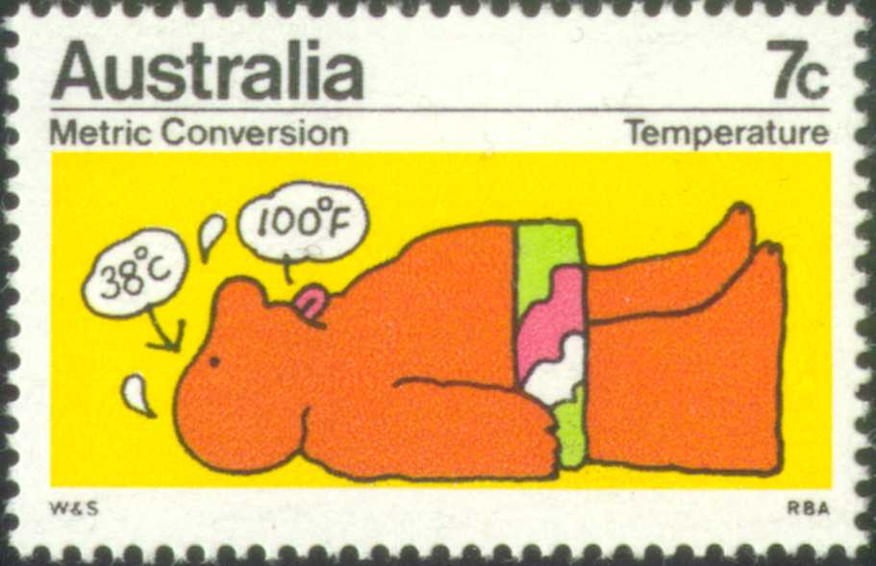

Figure 1. Stamp issued to help people getting familiar with SI units.

Figures and tables can have two formats: column-wide or page-wide. Figure  is an example of the first kind [1]. Figure  gives an example for a page-wide figure.

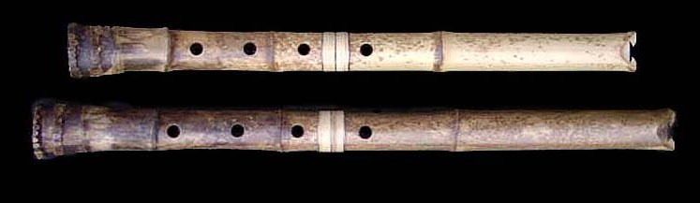

Figure 2. Shakuhachi: old Japanese length standard: 1 shaku = 30.3 cm.

All figures and tables must be placed inside a frame. They should be located on top or bottom in the left or right corner of the page where they are first referred to in the text. If this is not possible, then the frame must be placed on the following page(s). If necessary, more than one table and/or figure can be placed in one frame. Figures should be configured with the "Figure" style.

* 1. Managing frames

To create a frame, we recommend that the author copies and pastes one of the frames in this template. Before doing that, however, it is important to understand how they are configured.

Figure 3 shows the window where the configuration is done. It can be accessed by:

1. clicking on the frame content to make the frame border visible;
2. clicking in the frame border to select it;
3. right clicking the frame border to show up the pop-up menu and choosing the option "Format Frame".

That window has 4 sections organized from top to bottom ("text wrapping", "size", "horizontal" and "vertical"). *Text wrapping* should always be set to *none*. The *size* should be *exactly* *18 cm* for page wide illustrations and tables and *8.75 cm* for column wide ones. The *horizontal* setting should be *center* relative to the *column* or *page* for column wide or page wide content respectively. The *vertical* setting can be *top* relative to *margin* or *bottom* relative to *margin* depending where the frame is supposed to be located (top or bottom) of the page.

The frames in this template have all the proper formatting and can be used as is. The only setting the author will need to manage when crating new frames by copy and pasting existing ones is the vertical setting that will have to be changed from top to bottom depending on the new frame location.

The copying and pasting of frames should be done with care because the new frame will have the same configuration as the original frame and may overlap with it making one of them invisible to the user. We suggest that the author selects the original frame, chose "copy" (CTRL+C), place the cursor in a page or column that has no frame in the same position as the original and chose "paste" (CTRL+V). It is up to the author to manage in which page or column each frame is to be located.

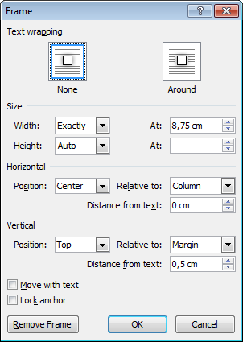

Figure 3. Microsoft Word frame formatting window. It can be accessed by clicking on the frame content to make the frame border visible, clicking in the frame border to select it and finally right click the frame border to show up the pop-up menu and choosing the option "Format Frame".

The more complicated situation is when the author wants to copy a page wide frame that is in the top of a page to a new frame located in the bottom of the same page. Because the original frame vertical setting is *top* the new pasted frame will also have the same setting and will overlap with the original one if placed in the same page. The solution is to paste the frame in a different page where no frames exist in the top (can be a temporary blank page at the end of the document), change the vertical setting to *bottom* and perform a cut and paste to the desired page. It will then show up at the bottom of that page.

If the author prefers to create a frame from scratch, he/she can choose "insert text box". Then he/she should right click on the text box border and select from the pop-up menu the option to format the text box. In the window that becomes visible press "convert to frame". The properties of the frame should be adjusted as described previously.

* 1. Captions

Place the figure captions directly BELOW the figure inside the frame and choose the style “Figure caption”. Figure captions have the format “Figure x. aaa.” where x stands for the figure number and aaa for the figure caption. Figures should be numbered consecutively with Arabic numerals starting from 1. The template uses auto-numbering and the order is given by the order of the frame anchors which become visible when the frame is actiated. Note that the caption should end with a period.

The paragraph spacing before the caption should be 6 pt and after the caption should be 0 pt. This is defined in the “Figure caption” style.

Table captions should be placed inside the frame directly above the table. Format it with the style “Table caption”. Table captions have the format “Table y. aaa.” where y stands for the table number and aaa for the table caption. Tables should be numbered consecutively with Arabic numerals starting from 1. Tables and figures should have separate numberings. Note that table captions should also end with a period.

The paragraph spacing before the table caption should be 0 pt and after the caption should be 6 pt. This is defined in the “Table caption” style.

* 1. Tables

Tables span a full page in width, for example, Table 1, or a full column, see Table 2. Avoid breaking tables across pages.

Table captions are placed ABOVE the table.

Table 1 summarizing the various styles used in this template, whereas Table 2 shows a subset of the data given in Table 1.

* 1. Referring to figures and tables in the text

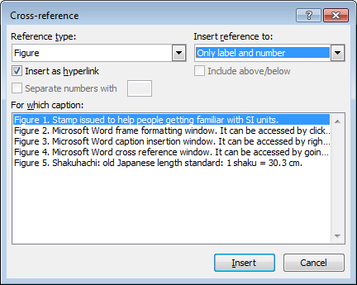

Figure 4. Microsoft Word cross reference window. It can be accessed by going to the menu "References" and choosing "Insert Cross Reference".

If automatic caption numbering is used the author should refer to the figures and tables in the text using automated references. A reference can be inserted in a given point in the text by going to the menu "References" and choosing "Insert Cross Reference" (Figure 4). Select which figure or table are to be cited, the label type ("Figure" or "Table") and that only the label and number should be used in the citation. Keep the option "insert as hyperlink".

* 1. Numbering

Microsoft Word permits to have figure and table numbering done automatically. The author is asked to use this feature, if possible, instead of numbering them by hand. The captions in this template already use automatic numbering. The best way for the author is just to copy and paste those captions and change the text accordingly. Because the number in the copied caption label will not be automatically updated, the author can place the cursor in the caption number and press the key F9 to update it (with the suitable setting in the options the number background turns grey because it is a "field code").

If the author wants to use automatic caption numbering but creates captions from scratch, he/she can right click on the picture or table and select "Insert Caption" from the pop-up menu. A window will be displayed where one can choose the label "Figure" or "Table" and insert the caption text. If those labels are not in the dropdown list the author can add them by using the "New Label" button.

1. About equations

Table 1. Overview of styles and font sizes used in this template.

|  |  |  |  |  |
| --- | --- | --- | --- | --- |
| **Section** | **Font** | **Size (pt)** | **Format** | **Special** |
| Title | Calibri | 20 | bold | Only first letter is capital |
| Authors | Calibri | 12 | bold |  |
| Affiliation and email address | Calibri | 9 | italic |  |
| Abstract text | Calibri | 9 | normal |  |
| Keywords | Calibri | 8 | normal | label in bold |
| Citation | Calibri | 8 | normal | label in bold |
| Editor | Calibri | 8 | normal | label in bold |
| Dates | Calibri | 8 | normal | label in bold |
| Copyright | Calibri | 8 | normal | label in bold |
| Funding | Calibri | 8 | normal | label in bold |
| Corresponding author | Calibri | 8 | normal | label in bold |
| First-level Section headings | Calibri | 10 | Bold | numbered, all caps |
| Subsection headings | Calibri | 9 | Bold | outline numbered |
| Body text | Garamond | 10 | normal | justified |
| Acknowledgements, Appendix | Garamond | 10 | normal | as body text |
| Footnotes[1] | Calibri | 8 | normal | as body text |
| Equations | Garamond/Symbol | 10 | italic | numbered |
| Equations (subscript/superscript) | Garamond/Symbol | 70% of 10 | italic | numbered |
| Equations (sub-subscript/superscript) | Garamond/Symbol | 60% of 10 | italic | numbered |
| Table text | Calibri | 8 | normal | bold headings |
| Figures | Calibri | 9 | normal | centred |
| Captions of figures and tables | Calibri | 8 | normal | justified |
| References | Garamond | 9 | normal | numbered |

All equations should be numbered consecutively throughout the paper. Do not use outline numbering per section.

Numbers are placed between parentheses aligned right, and without a label, see equation (1) as an example, expressing the saturation current $I_{D}$ in a MOSFET transistor [2]:

|  |  |
| --- | --- |
| $$I_{D}=\frac{W μ ε_{0} ε_{ox} V_{GS}^{2}}{2 L t} ,$$ | (1) |

where $W$ is the channel width, $L$ the channel length, $ε_{0}$ the dielectric constant of free space and $ε_{ox}$ of the oxide, $μ$ is the mobility in the channel, $t$ the oxide thickness and $V_{GS}$ the gate voltage [2]. Make sure that all symbols are defined unambiguously. When confusion may arise, add the units of the parameters between parentheses. Use SI and derived units only [3].

Table 2. Example of a small table.

|  |  |
| --- | --- |
| **Section** | **Font** |
| Title | Calibri |
| Authors | Calibri |
| Affiliation and email address | Calibri |
| Abstract text | Calibri |
| Keywords | Calibri |
| Citation | Calibri |
| Editor | Calibri |
| Dates | Calibri |
| Copyright | Calibri |
| Funding | Calibri |
| Corresponding author | Calibri |
| First-level Section headings | Calibri |
| Subsection headings | Calibri |

Equations should be placed into the left column of a two-columns table without frame lines. Use the right column for the equation number and a spacing of 6 pt above and below.

Long equations that normally span more than one column should be wrapped over more lines, broken at a suitable place by arithmetic symbols (=, +, −, ×) as separator. An example is equation (2) about the surface heat flux per unit area along a flat plate [4]

|  |  |
| --- | --- |
| $$P_{f}^{''}\left(x\right)=0.538{{{ κ}_{f}\left(\frac{Pr}{υ}\right)}^{\frac{1}{3}}\left(\frac{τ_{w}\left(x\right)}{μ}\right)}^{\frac{1}{2}}×\int_{0}^{x}{{\left\{\int_{x_{1}}^{x}{\sqrt{\frac{τ_{w}\left(ξ\right)}{μ}}dξ}\right\}}^{-\frac{1}{3}}\frac{∂T_{w}\left(x_{1}\right)}{∂x_{1}}dx_{1}}.$$ | (2) |

Equations are considered part of the previous sentence and should, when appropriate, have a period or a comma after them, as in (2).

Note that punctuation of equations must follow the normal rules of grammar. Therefore, for example, equations can be followed by a dot only if the sentence is finished.

Very short equations that are not further referred to may be inserted in line with the text, for instance $R=U/I$. Make sure that all variables are in italic, also when used in the main body.

Note that the font size for equations is 10 pt and that it must be reduced to 70 % and 60 % in the case of subscript/ superscript and sub-subscript/superscript respectively.

Mind proper notations. Some typical errors or wrong formats should be avoided at the very beginning:

- variables must be italic:

- numbers and units not: 3 V

- protected space between value and unit: 3 kHz, 10 %, 5 °C

- units never in square brackets [...]

wrong: . $U \left[V\right], l [m]$

correct: $U in V, l in m$ or $U/V, l/m$

be careful with divisions: $M in N∙m$ is correct,

whereas $M/N∙m$ can be seen as $M/(N∙m)$ or as $\left(\frac{M}{N}\right)∙m$.

1. About references and citations

References are limited to published works or papers that have been accepted for publication and should give full bibliographical information. They are placed in the section References at the end of the manuscript, in order of their appearance in the text.

References are cited in the text by a number between square brackets. Ensure that every reference cited in the text is also present in the reference list and vice versa.

Citation of multiple or consecutive references must follow the notation [1], [2], [4] or [1]-[3], respectively.

Unpublished results and personal communications may be included in the reference section following the standard reference style and should include a substitution of the publication date with either "Unpublished results" or "Personal communication".

Citation of a reference as "in press" implies that the item has been accepted for publication.

The format of references is as follows:

1. For journal articles: Initials and last name(s) of each author, Title of article (first word only capitalized), Journal title, volume number, (year), pages.
2. Book references: Author(s) as above, Title of book (main words capitalized), publisher, city of publication, year, ISBN.
3. For a chapter in an edited book: Author(s) as above, Title of article (first word only capitalized), in: Title of book (main words capitalized). Editor(s). Publisher, city of publication, year, ISBN, pages.
4. Conference proceedings: Initials and last names of each author, Title of article (first word only capitalized), name of the conference, place, country, date, pages.
5. Links to web content, for example freely downloadable papers, can be included as shown in [5].
6. Where available, DOIs of references must be added as shown in [1].
7. References that are not in English, must be followed by the language, for example, in the form [In Italian] as shown in [7].

There is a section break at the end of the paper (after the references) so that the content of the last page is equally divided between the two columns.

1. Conclusions

The concluding section contains the major achievements of the research presented in the manuscript. It should be concise but informative. When numerical results are an essential part of the research, for instance a wider measurement range, lower uncertainty [6], they should be included in the conclusions.

Notice that conclusions are not the same as an abstract.

Authors' contribution

Please explain here the contribution of each co-author to the research and to this article. If there is only one author, this section can be deleted.

The roles for each Author should be chosen according to the CRediT taxonomy, available here: <https://credit.niso.org/>.

Please consider that each contributor can be assigned multiple roles, and a given role can be assigned to multiple contributors(you don't need to use all the available roles).

Acknowledgement

Here persons or institutes may be acknowledged for their technical, scientific or financial support. List them in this section, and not as a footnote or otherwise.

References

1. M. Fazio, S. L. Rota, Metrology on stamps, Phys. Educ. 30 (1995) pp. 289-297.   
   DOI: <https://doi.org/10.1088/0031-9120/30/5/007>
2. S. Middelhoek, S. A. Audet, Silicon Sensors, Academic Press, London, 1989, ISBN 0-12-495-051-5.
3. K. T. V. Grattan, Measurement: system of scales and units, in: Concise Encyclopedia of Measurement and Instrumentation. L. Finkelstein, K. T. V. Grattan (editors). Pergamon Press, Oxford, 1994, ISBN 0-08-036212-5, pp. 209-214.
4. M. J. Lighthill, Contribution to the theory of heat transfer through a laminar boundary layer, Proc. of Roy. Soc., London, 1950, A 202, pp. 359-377.
5. A. Cruz Serra, L. Van Biesen, IMEKO - The Instrumentation and Measurement Confederation, Proc. of the 12th IMEKO TC1 & TC7 Joint Symposium on Man, Science & Measurement, Annecy, France, 3 – 5 September 2008. Online [Accessed 29 October 2019]  
   <https://www.imeko.org/publications/tc7-2008/IMEKO-TC1-TC7-2008-IKL-001.pdf>
6. V. Pop, P. P. L. Regtien, H. J. Bergveld, P. H. L. Notten, J. H. G. Op het Veld, Uncertainty analysis in a real-time state-of-charge evaluation system for lithium-ion batteries, Proc. of the XVIII IMEKO World Congress, Rio de Janeiro, Brazil, 17 – 22 September 2006, pp. 164-166.
7. R. Spallone, M. Vitali, Volte stellari e planteriane negli atri barocchi in Torino – Star-shaped and Planterian Vaults in Turin Baroque Atria, Aracne, Ariccia, 2017, ISBN 978–88–255–0472–9. [In Italian]

Reference examples: see next page (shall be deleted before submitting the paper).

Patterns for references:

General schema

1. Authors, Title, Source.   
   DOI
2. Authors, Title, Source. [In Italian]   
   DOI
3. Authors, Title, Source.
4. Authors, Title, Source. Online [Accessed 1 May 2023]   
   URL
5. Authors, Title. Online [Accessed 1 May 2023]   
   URL

Note that:

* auto-numeration is active
* references to publications in other languages than English must include the language in square brackets, for example: [In Italian]
* main blocks are separated by COMMA and end with a PERIOD
* the DOI must be given by default with the text ‘DOI: ‘
* DOI or URL start on a new line (not a new paragraph)
* a URL must be provided with the additional text “Online” and the Access date in square brackets following the main blocks, for example, ‘Online [Accessed 1 May 2023]’
* If the URL is a web page, the ‘Source‘ block can be omitted.

**Authors** must be given in the form:

‘**With DOT** **Abbreviated first names, separated by SPACE or PROTECTED SPACE**’ SPACE ‘**Full family names separated by SPACE**’ COMMA - up to eight 8 authors, otherwise followed by   
‘**(+ NUMBER_OF_NOT_NAMED_AUTHORS more author(s))**’

Examples:

M. Fazio, S. L. Rota

V. Pop, P. P. L. Regtien, H. J. Bergveld, P. H. L. Notten, J. H. G. Op het Veld

V. Pop, P. P. L. Regtien, H. J. Bergveld, P. H. L. Notten, J. H. G. Op het Veld, M. Fazio, S. L. Rota, A. Cruz Serra, (+ 1 more author)

V. Pop, P. P. L. Regtien, H. J. Bergveld, P. H. L. Notten, J. H. G. Op het Veld, M. Fazio, S. L. Rota, A. Cruz Serra, (+ 5 more authors)

The **Title** must be exactly that of the original publication, no abbreviations or other changes are allowed.

Examples:

Metrology on stamps

Measurement: system of scales and units

Contribution to the theory of heat transfer through a laminar boundary layer

IMEKO - The Instrumentation and Measurement Confederation

Uncertainty analysis in a real-time state-of-charge evaluation system for lithium-ion batteries

The **Source** format depends on the type of the original publication:

- journal paper:   
‘**JOURNAL_TITLE**’ SPACE ‘**VOLUME**’ SPACE ‘**(YEAR)**’ SPACE ‘**NUMBER**’ COMMA pages (in the form ‘**pp. 1-24**’ or ‘**24 pp**’)

Examples:

Acta IMEKO 10 (2021) 4, pp. 1-2

Acta IMEKO vol. 10 (2021) no. 4, pp. 1-2

Phys. Educ. 30 (1995) 5, 12 pp

J. Pharm. Sci., vol. 104 (2015) 3, pp. 840–849

- conference paper:   
‘**Proc. of the CONF_TITLE**’ COMMA ‘**CONF_VENUE**’ COMMA ‘**CONF_COUNTRY**’ COMMA ‘**CONF_DATE**’ COMMA (if applicable: ‘**PROCEEDINGS_VOLUME**’ COMMA) pages (in the form ‘**pp. 1-24**’ or ‘**24 pp**’)

Examples:

Proc. of the 12th IMEKO TC1 & TC7 Joint Symposium on Man, Science & Measurement, Annecy, France, 3 – 5 September 2008, vol. II, pp. 34-45

- book:   
in: ‘**BOOK_TITLE**’ PERIOD ‘**AUTHOR(S)**’ (if applicable: ‘(editors)‘) PERIOD SPACE ‘**PUBLISHER**’ SPACE ‘**PUBLICATION_PLACE**’ COMMA ‘**PUBLICATION_YEAR**’ COMMA ‘**ISBN**’ COMMA pages (in the form ‘**pp. 1-24**’ or ‘**24 pp**’)

Examples:

in: Concise Encyclopedia of Measurement and Instrumentation. L. Finkelstein, K. T. V. Grattan (editors). Pergamon Press, Oxford, 1994, ISBN 0-08-036212-5, pp. 209-214

The **DOI** must be given as working hyperlink in the form   
‘DOI: **PREFIX\SUFFIX**’ without <https://doi.org/> or <http://dx.doi.org/>

Examples:

DOI: [10.1088/0031-9120/30/5/007](https://doi.org/10.1088/0031-9120/30/5/007)

The **URL** must be given as working hyperlink in the full form

Examples:

<https://www.imeko.org/publications/tc7-2008/IMEKO-TC1-TC7-2008-IKL-001.pdf>

<https://www.ti.com/product/ADS8881>

<https://www.open-daq.com>

1. Footnotes must be kept short, preferably not more than 3 lines.