UNIVERSITY OF DAR ES SALAAM


COLLEGE OF INFORMATION AND COMMUNICATION TECHNOLOGY
DEPARTMENT OF COMPUTER SCIENCE AND ENGINEERING
PROGRESS REPORT
Final Year Project (IS335) For Bachelor Of Science In/With Computer
Title: ENVIRONMENTAL INFORMATION SYSTEM (EIS)

Project Members
S/N | Student Name | Student Reg No:
1 | ISSA, Miraji | 2014-04-02829
2 | SLEYUM, Masoud | 2014-04-02823
3 | ALLY, Azizi | 2014-04-02778

Project Supervisor: Mr. Bernard Mussa

DECLARATION.
As a group of Three members hereby we declare that this project is our own original work, and that all sources have been accurately reported and acknowledged, and that this project has not been previously in its entirety, or in part been submitted at any academic institution so as to obtain an academic qualification.
Students Names
S/N | Student Name | Student Reg No: | Signature
1 | ISSA, Miraji | 2014-04-02819
2 | SLEYUM, Masoud | 2014-04-02823
3 | ALLY, Azizi | 2014-04-02778

Supervisor Name
Bernard Mussa Date...................………. Signature...........................

ABSTRACT
Environment is very important as every living organism interact with it, It is faced by several activities in which some of them are Conservative and others are Destructive. The destruction and Conservation of environment are both outcome of human activities and advancement in technology which is applied in our daily life, For example Energy Crisis, Infrastructure construction which result to the use Firewood, Nuclear Energy production and others both are agents of environmental destruction.

On approach to the solution of this problem the government of Tanzania established National Environmental Management Council (NEMC) in 1983. The council uses the file system on managing the information associated with environment. One of the disadvantage of this information collection approach is that, it is less efficient

Due to the poor approach of environment information management done by NEMC, we have to contribute in ensuring that the information are well collected and managed efficiently on, Thus we are introducing to you the Environmental Information System( EIS ), the software project which results to the development of software for automation of environmental information.

On the road map to project completion we have used the Agile methodology, The methodology that supports flexibility and allows incremental development.
The development followed all SDLC Ffrom the beginning (Requirement collection) to the end (Close-up). The methodology facilitates adaptive planning and evolutionary developments

Upon completion the proposed project will deliver the system software that will do the following in brief:-
- It will act as the centralized tool that will be used by NEMC to store and manage the environment related information.
- It will provide the meaningful information as final output, this include reports and statistical informations.

ACKNOWLEDGEMENT
First we would like to express our thanks to our Academic supervisor for being with us at every stage from the beginning until we finally reach the final stage of our final year project for offering us a guidance.
Also we like to give special thanks to the Management of National Environment Management Council (NEMC) for their help in conducting our Literature review towards our project. Not only that, but also we are thankful to our Final Year Project Coordinator Mr. Cosmas for being perpendicular with us at every part of the project and whole technical team of College of Information and Communication Technologies (CoICT) at University of Dar es Salaam who spent their time for giving us knowledge.
Lastly we also acknowledge our fellow student from CoICT for their contribution.

Table of Contents

DECLARATION. i
ABSTRACT ii
ACKNOWLEDGEMENT iii
LIST OF ABBREVIATIONS AND ACRONYMS vi
CHAPTER ONE 1
INTRODUCTION. 1
Background 1
Statement of the Problem: 1
Objective of the Project 2
Significance of the Project: 2
Rationality to the Community 3
Organization of the Report. 4
CHAPTER TWO 5
LITERATURE REVIEW. 5
National Environmental Management Council (NEMC). 5
Advantage of the proposed Solution: 6
Disadvantages of the Proposed Solution 6
CHAPTER THREE 7
METHODOLOGY. 7
Project Scope. 7
Requirement Collection and Analysis 8
Functional Requirement 8
Non Functional Requirement 9
Tools and Platform Used. 9
CHAPTER FOUR 10
SYSTEM ANALYSIS AND DESIGN 10
System Architecture 10
Use case Diagram. 11
Activity Flow Diagram and Sequence Diagram 12
Database Design. 13
E.R-Diagram 14
Appendix A1 16
Appendix A2 17
Appendix A3 18
Appendix A4 19
Appendix A5 20

LIST OF ABBREVIATIONS AND ACRONYMS

LAMP Linux Apache, Mysql and PHP
HTTP` Hypertext Transfer Protocol
PHP PHP Hypertext Preprocessor
HTML Hypertext Markup Language
CoICT College of Information and Communication Technologies
NEMC National Environment Management Council
ER Entity-Relationship
NGO’s Non-Governmental Organization
CSS Cascading Style Sheet
DBMS Database Management System
EIS Environment Information System
SDLC Software Development Life Cycle
IDE Integrated Development Environment
EMA Environment Management Act
EIA Environment Impact Assesment

LIST OF FIGURES

Figure 1:System architecture 10
Figure 2. Use case Diagram 11
Figure 3. Activity Flow diagram and sequence diagram 12

CHAPTER ONE

INTRODUCTION.

Background
On dealing with environment issues, the government of Tanzania established special organization called National Environmental Management Council (NEMC) in 1983 when the Government of Tanzania enacted the National Environment Management Act No. 19 of 1983, The aim was to oversee environmental management issues and also implement the resolutions of the Stockholm conference (1972) which called upon all nations to establish and strengthen national environmental Councils to advise governments and the international community on environmental issues.

Statement of the Problem:
The Organizations dealing with environmental Management experiences the difficulties in not only obtaining the correct information on what is going on in the environment but also sending those information to the centralized authorities. This result to the late submission of information concerning those events and even failure, simply because the events occurs in areas which are not penetrative hence delay of information and result to the following shortcomings:-
- Use of file based System instead of using the automated system.
- Reporting costs since the communication is by Mobile phones which is costful compared to the solution suggested here.
- It is difficult to manage environment in large country like Tanzania using non automated systems.
- The difficulties that occur during evaluation using the file based system become the bottleneck for the report generated and hence may reduce the performance of an organization.

Objective of the Project

Main Objective
This project aimed at developing the Environmental Information System(EIS) That will help in management, Analysis and dissemination of environmental information, . In the process of accomplishing this main objective the system do the it will result to the following specific objective:-

Specific Objective
  - Identification of requirement (Both user and system requirements)
  - Design and analysis of data management modules
  - Developing a prototype
  - Testing and validating the collected data

Significance of the Project:
The project could provide the following significances related to the issues of Collecting the data and events which particularly occurs in the environment on the followin aspects :-

  - To increase the modern technologies of acquisition, processing, storage, retrieval and dissemination of environmental information.
  - To support and promote research, development and innovation in environmental information technology.

  - To provide national environmental information service relevant to present needs and capable of development to meet the future needs of the users, originators, processors and discriminators of information;
  - To promote, national cooperation for exchange of environment related information;
  - To promote, support and assist education and personnel training programmes designed to enhance environmental information processing and utilization capabilities;

Rationality to the Community
This project is helpful to the community as:-
- This project would be beneficial to the Government and Organizations which deals with environmental issues on how to manage the environmental information system similarly in handling and maintaining environmental project.
- More information and data will enable the government to reach its plan as efficient as possible and at a perfect time, This can encourage development.
Furthermore, this project will Give the Evaluation of the Environment in a given location, and Country in advance.
The system will be used in Environmental Management Organizations like (NEMC)

Organization of the Report.
The report is organized in Chapters and sub-chapters which together provide the complete structure of the report.
The chapter are organized as follows:-
Chapter One: Explains the Introduction of the report and bring the short description of the whole report.
Chapter Two: Explains about the Literature Review , the only section which reveals the work done by others in implementing the project same as what we are going to implement.
Chapter Three: Explains about the Methodology used in this system development project , the strategies that will be used to deliver the project.
Chapter Four: Explains about the System analysis and design , architectural design, database design etc.

CHAPTER TWO

LITERATURE REVIEW.

National Environmental Management Council (NEMC).
NEMC was established by the government aimed to oversee environmental management issues and also implement the resolutions of the Stockholm conference (1972) which called upon all nations to establish and strengthen national environmental Councils to advise governments and the international community on environmental issues.
NEMC use the File based system which collect the information of environmental data, projects and lastly give the evaluations .
But however their approach has got a number of shortcomings and challenges that can be the limit for performance in their activities, The following are the shortcomings of the File based implementation :-
1. Data Redundancy (Repetition): It is possible that the same information may be duplicated in different files, this leads to data redundancy results in memory wastage.
2. Data Inconsistency: This is because of data redundancy, it is possible that data may not be in consistent state.
3. Difficulty in Accessing Data: Accessing data is not convenient and efficient in file processing system. Due to manipulation complexity
4. Security Concerns: We know how is important to secure the data, bu in file based system there is less security of data, data should be accessible to users in limited way.
Each user should be allowed to access data concerning his requirements only.

Advantage of the proposed Solution:
The proposed Solution ie, Development of Environmental Management System has the following advantages over the existing approach of solving this problem
- Effective way of collecting the Information concerning environmental, This is achieved by having a user (reporter) who are responsible in collecting the information as soon as the occur.
- Correctness and enough description about the information collected.
- Network mode of operation of the system provides the complete and accurate information.
- Confidentiality.
- Since the system allows experts to contribute their views, ideas and comments on the events that has occurred, this improve the decision making among the organization members using the system hence the easy in proposing the environment planning strategies.

Disadvantages of the Proposed Solution
- The system requires the staff and other system users to be trained with some sorts of system training after the installation of the system. This is to increase the well use of the system and minimizing undesirable use of the system.
- The system requires high development effort .

CHAPTER THREE

METHODOLOGY.

This system uses traditional System Development Life Cycle (SDLC) this means that the developers followed all development stages starting from requirement collection, analysis, Planning, designing implementation, testing and maintenance. The process insisted on requirement specification and analysis as requirements have great impacts on final products.
Based on the nature of our project, associated with the requirements changes throughout and hence the implementation of this process has followed Agile Software Development methodology.
The Agile software development methodology was applicable in our project due to the fact that the mode of development of our project is flexible and changes continuously throughout the life cycle depending on the change of requirements at a given time. Therefore this methodology provide the mechanism under which the software development requirements and data varies throughout the development and hence compatible with our project mode of development. Furthermore the methodology facilitates adaptive planning/designing, evolutionary development and dynamic improvement during development as it motivate rapid and flexible response to changes while the project in progress, this completely support our project.

Project Scope.
The proposed system will operate in mode same as that of NEMC , It will act as a centralized point for environmental information collection, analysis, evaluation, and dissemination

Requirement Collection and Analysis
The requirements of our project was collected in form of Questionnaire and Document review from the following institution:-
- National Environmental Management Council (NEMC), as it is a trusted government organization that deals with environmental issues countrywide.
Anyone responsible in that organization mentioned above in the will be consulted in requirement collection.
The requirements divided into the three main categories:

Functional Requirement
These are requirement which the system should do at its completion, based on the customer's needs the following were the main functional requirement that the system will do,
- The system will register environmental experts
- The System will register environmental Project
- It will also register the Firm(NGO`s), that will coordinate with NEMC in managing environment.
- The system will also provide the mechanism for users to read, access information, publish report document based on the research done on the field.

Non Functional Requirement
These are requirements which describe how the functional requirements will be achieved, in short the system must have the non-functional requirement in order to operate efficiently. Thus Non-functional requirements are more critical than functional requirements. If these are not met, the system is useless.
The following are the list of non Functional requirement declared in our system.
- Security Concerns
- Usability: The system will be more user friendly to enable user to be interested and work efficient with it..
- The System will be modernized and puts the current responsive web design into account, this means that it is compatible to all devices with different sizes and hence free to use in any platform or device such as mobile phones, Laptop, tablets etc.

Tools and Platform Used.
The tools and platform which are going to be used include both hardware and software,
The main software platforms used in our project are
- Sublime Text 3 IDE,
- Bootstrap Framework to develop the responsive web pages,
- Linux Apache, Mysql, Php (LAMP-server ) with PHP7 scripting language which acted as a server side language, Since the overall system will be web based.

On the other side the main hardware tools used are
- Personal computer(PC), with relative capacity to perform development environment.
- Personnel (man power).
- CASE tools such as Microsoft project, Dia

CHAPTER FOUR

SYSTEM ANALYSIS AND DESIGN

System Architecture
The Environmental Information System will run on any web server (XAMPP, WAMP) and can be installed in Windows, Linux or other platform server environment. The system will be developed using PHP , JavaScript, CSS, HTML current version and MySql database management system.
The system operates in a Client-Server model there by a client/users access the server through the network on HTTP protocol.
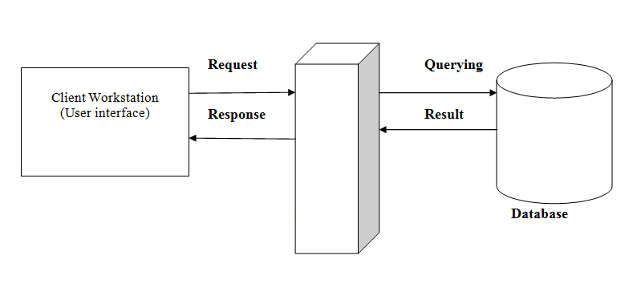
Figure 1:System architecture

Use case Diagram.
Below is the general use case diagram that shows the main users of the Environment Information System(EIS), That is the manager who is responsible for managing the content of the system, Reporter, Proponent and Expert . Each category of actor can access the features associated with the system as shown below.

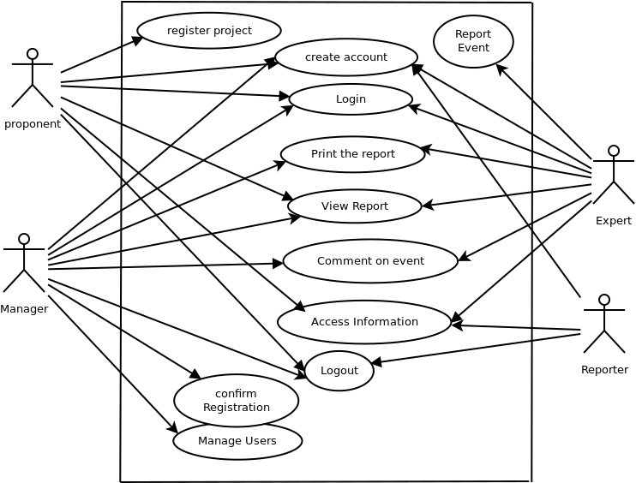

Figure 2. Use case Diagram

Activity Flow Diagram and Sequence Diagram
This system will be implemented using PHP scripting language and MySql Database management System(DBMS). The PHP is a server side programming language. The system will have three interfaces: reporter’s interface, administrator Interface and manager interface. Consider the following diagrams that shows the flow of data in the System
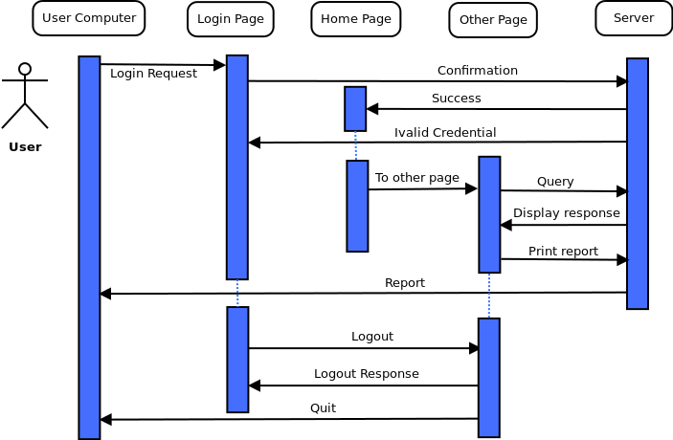
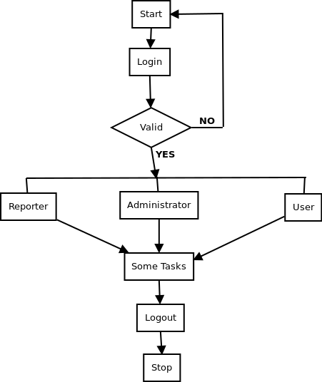

Figure 3. Activity Flow diagram and sequence diagram

Database Design.
The database system observed the following entities towards the implementation of the project.
Event: This refer to the action that occurs in environment done by the environment users such as Human being, animal etc.
User: This a personnel (Administrator, manager, staff, proponent or reporter) who has given the authority and assigned a certain administrative privileges of using the system
Project: Series of related activities and tasks conducted under a given time frame and given resources so that to their completion result in solving a certain problem concerning environmental management….
Location: This refers to the area/place where the Event has occurred, area where the reporter live, and the place where the project is conducted initial and basic unit source of environmental evaluation in which the user is located.

Consider the Entity-Relationship Diagram that shows the relationship between the entities

E.R-Diagram
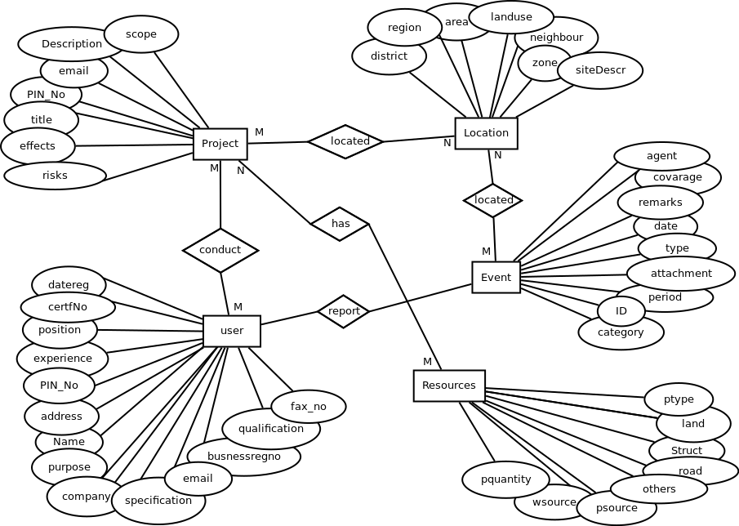

Figure 4. ER- Diagram

Interface Design
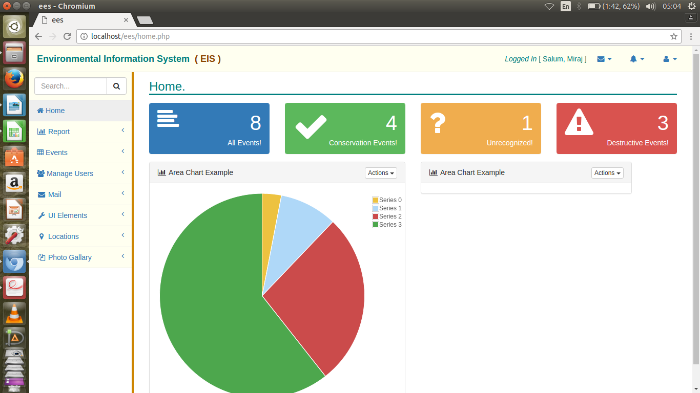
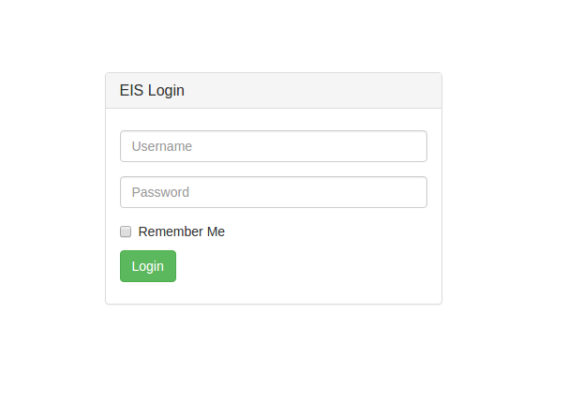

Appendix A1

References
Ian Sommerville: Software Engineering, Eighth Edition (2001)
NEMC website, www.nemc.or.tz.

Appendix A2

Project Budget
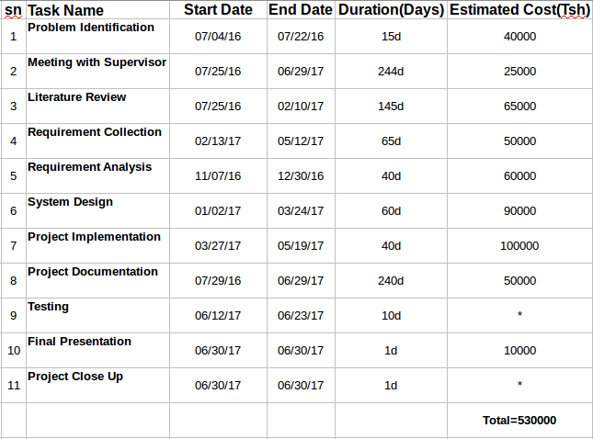

Appendix A3

Project Schedule
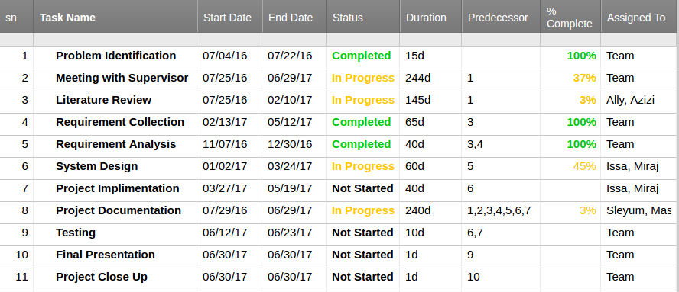
Schedule Table

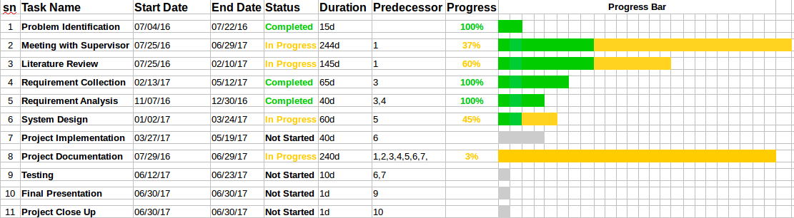

Progress graph

Appendix A4
Expert Registration Form




Appendix A5
List of Environmental Certified Experts (2016)
